* Load data
* Generate formulas
* Death
  + Time-dependent
    - Group 1
    - Group 2
* AMI
  + Time-dependent
    - Group 1
    - Group 2
* Stroke
  + Time-dependent
    - Group 1
    - Group 2

# library(devtools)

# install_github("michaelyanwang/dcalasso")

library(survival)

library(dcalasso)

## Loading required package: mgcv

## Loading required package: nlme

## This is mgcv 1.9-1. For overview type 'help("mgcv-package")'.

## Loading required package: glmnet

## Loading required package: Matrix

## Loaded glmnet 4.1-8

## Loading required package: doParallel

## Loading required package: foreach

## Loading required package: iterators

## Loading required package: parallel

## Loading required package: MASS

library(profvis)

library(rms)

## Loading required package: Hmisc

##

## Attaching package: 'Hmisc'

## The following objects are masked from 'package:base':

##

## format.pval, units

library(glmnet)

# Helper functions

dac_BIC <- function(cph_mod) {

return(cph_mod$loglik / cph_mod$n + log(cph_mod$nevent) * length(cph_tv$coefficients))

}

concordance_index <- function(mod, data, time_col="stop", event_col="event", cph=TRUE) {

time <- data[, time_col]

status <- data[, event_col]

# Survival package automatically centers the linear predictors

if (cph) {

x <- predict(mod, newdata=data)

} else {

x <- scale(predict(mod, newdata=data)$fit, scale=F)

}

n <- length(time)

ord <- order(time, -status)

time <- time[ord]

status <- status[ord]

x <- x[ord]

wh <- which(status == 1)

total <- concordant <- 0

# Loop over event rows

for (i in wh) {

# Get indices for all subjects that have later times (time[j] > time[i])

later_times <- which(time > time[i])

# Get the predictions for those subjects

x_later <- x[later_times]

x_i <- x[i]

# Compare predictions for concordance

concordant <- concordant + sum(x_later < x_i) + 0.5 * sum(x_later == x_i)

total <- total + length(later_times)

}

# Calculate concordance

concordance <- concordant / total

return(concordance)

}

scale_data <- function(df_train, df_test, cont_var) {

train_means <- colMeans(df_train[, cont_var])

train_sd <- apply(df_train[, cont_var], 2, sd)

df_train[, cont_var] <- scale(df_train[, cont_var], center=train_means, scale=train_sd)

df_test[, cont_var] <- scale(df_test[, cont_var], center=train_means, scale=train_sd)

return(list(train=df_train, test=df_test))

}

load_data <- function(path_train, path_test, cont_var, tv=T) {

df_train <- read.csv(path_train)

df_test <- read.csv(path_test)

scale_res <- scale_data(df_train, df_test, cont_var)

df_train <- scale_res$train

df_test <- scale_res$test

df_train[df_train == "True"] <- 1

df_train[df_train == "False"] <- 0

df_test[df_test == "True"] <- 1

df_test[df_test == "False"] <- 0

if (tv) {

df_train["event"] <- as.integer(df_train$event)

df_test["event"] <- as.integer(df_test$event)

df_train <- df_train[df_train$stop > df_train$start,]

df_test <- df_test[df_test$stop > df_test$start,]

} else {

df_train[c("death", "ami", "stroke")] <- lapply(df_train[c("death", "ami", "stroke")], as.integer)

df_test[c("death", "ami", "stroke")] <- lapply(df_test[c("death", "ami", "stroke")], as.integer)

}

return(list(train=df_train, test=df_test))

}

# fit_cox <- function(df_train, df_test, form, cont_var){

# x_var <- all.vars(form[[3]])

# cat_var <- setdiff(x_var, cont_var)

# rcs_var <- paste0("rcs_", cont_var)

# new_var <- c()

#

# time_col <- all.vars(form[[2]])[1]

# event_col <- all.vars(form[[2]])[2]

#

# # Build X matrix with manually created rcs columns

# X <- df_train[, cat_var]

# X_test <- df_test[, cat_var]

# for (var in cont_var) {

# rcs_var <- rcspline.eval(df_train[, var], nk=5, inclx=T)

# rcs_var_test <- rcspline.eval(df_test[, var], nk=5, inclx=T)

#

# colnames(rcs_var) <- paste0("rcs_", var, "_", seq_len(ncol(rcs_var)))

# colnames(rcs_var_test) <- paste0("rcs_", var, "_", seq_len(ncol(rcs_var_test)))

#

# new_var <- append(new_var, colnames(rcs_var))

#

# X <- cbind(X, rcs_var)

# X_test <- cbind(X_test, rcs_var_test)

# }

#

# # Add interaction columns where necessary

# term_labels <- attr(terms(form), "term.labels")

# int_terms <- term_labels[grepl(":", term_labels)]

# if (length(int_terms) > 0) {

# for (int_term in int_terms) {

# # Extract which variables are in the interaction

# vars <- unlist(strsplit(int_term, ":"))

#

# if (grepl("rcs\\(", vars[1])) {

# var1 <- gsub("rcs\\(|\\)", "", vars[1])

# }

#

# if (grepl("rcs\\(", vars[2])) {

# var2 <- gsub("rcs\\(|\\)", "", vars[2])

# }

#

# cols1 <- new_var[grepl(var1, new_var)]

# cols2 <- new_var[grepl(var2, new_var)]

#

# for (c1 in cols1) {

# for (c2 in cols2) {

# int_var <- as.data.frame(X[, c1] * X[, c2])

# colnames(int_var) <- paste0(c1, "_X_", c2)

#

# new_var <- append(new_var, paste0(c1, "_X_", c2))

# X <- cbind(X, int_var)

# }

# }

#

# }

# }

# new_var <- append(new_var, cat_var)

#

# y <- Surv(df_train[, time_col], df_train[, event_col])

# cv_fit <- cv.glmnet(as.matrix(X), y, family="cox")

# coef_cv <- coef(cv_fit, s="lambda.min")

#

# # Turn into CPH object

# data <- cbind(X, df_train[, c(time_col, event_col)])

# data_test <- cbind(X_test, df_test[, c(time_col, event_col)])

#

# cph <- coxph(as.formula(paste0("Surv(", time_col, ", ", event_col, ") ~ ", paste(new_var, collapse="+"))), data, x=T, init=as.numeric(coef_cv), iter.max=0)

#

# conc_train <- concordance(cph, newdata=data)$concordance

# conc_test <- concordance(cph, newdata=data_test)$concordance

#

# return(list(cph=cph, conc_train=conc_train, conc_test=conc_test))

# }

fit_cox <- function(df_train, df_test, form, gr_i){

# Define null model and variable scope

null_form <- as.formula(paste0(deparse(form[[2]]), " ~ factor(cpap_treated)"))

scope <- as.formula(paste0("~ ", paste(deparse(form[[3]]), collapse="")))

# scope <- update(scope, . ~ . - factor(cpap_treated))

null_mod <- coxph(null_form, df_train)

# Compute and evaluate

step_mod <- stepAIC(null_mod, scope=list(lower=as.formula("~ factor(cpap_treated)"), upper=scope), direction="both")

# Save model to file

# saveRDS(step_mod, paste0("Models/cph_", gr_i, ".rds"))

conc_train <- concordance(step_mod, newdata=df_train)$concordance

conc_test <- concordance(step_mod, newdata=df_test)$concordance

return(list(cph=step_mod, conc_train=conc_train, conc_test=conc_test))

}

fit_dac <- function(df_train, form, gamma_values=seq(0.5, 2, by=0.5), K=20) {

mods <- list()

bics <- c()

j <- 1

for (i in seq_along(gamma_values)) {

gamma <- gamma_values[i]

penalties <- c(0, rep(gamma, length(attr(terms(form), "term.labels")) - 1))

dac <- dcalasso(form, data=df_train, gamma=penalties, K=K)

mods[[j]] <- dac

bics <- c(bics, dac$BIC.opt)

j <- j + 1

}

dac_opt <- mods[[which(bics == min(bics))]]

return(dac_opt)

}

run_models <- function(vec_forms, df_train, df_test, time_col, event_col, cont_var, prof_out_file, gr_i, K=20, bigd=T) {

assign("df_train", df_train, envir=.GlobalEnv)

i <- 1

for (form in vec_forms) {

print(paste("### FORMULA", i, "###"))

# Train models

prof <- profvis({

if (nrow(df_train) > 1000000) {

cph <- coxph(form, df_train, x=T)

conc_train <- concordance(cph, newdata=df_train)$concordance

conc_test <- concordance(cph, newdata=df_test)$concordance

} else {

cph_list <- fit_cox(df_train, df_test, form, cont_var)

cph <- cph_list$cph

conc_train <- cph_list$conc_train

conc_test <- cph_list$conc_test

}

if (bigd) {

try({

dac <- fit_dac(df_train, form, K=K)

print("--- DAC RESULTS ---")

print(summary(dac))

conc_train_dac <- concordance_index(dac, df_train, time_col, event_col, cph=F)

conc_test_dac <- concordance_index(dac, df_test, time_col, event_col, cph=F)

}, silent=T

)

}

# Evaluations

zph <- cox.zph(cph)

# Print summaries and plot

print("--- SURVIVAL RESULTS ---")

print(summary(cph))

plot(zph, resid=F)

termplot(cph)

# Compute concordance index

print("--- CONCORDANCE RESULTS ---")

cat("C-index train:", conc_train,

"\nC-index test:", conc_test

)

if (bigd) {

try({

cat("\nC-index DAC train:", conc_train_dac,

"\nC-index DAC test:", conc_test_dac)

}, silent=T)

}

})

# Save profiling results

htmlwidgets::saveWidget(prof, paste0("Profiling/dac_form", i, "_", prof_out_file))

i <- i + 1

}

}

**Load data**

cont_var <- c("time_to_cpap_start", "time_to_cpap_end", "alder", "bmi", "hba1c", "GFR", "kolesterol", "systoliskt", "DispInkKEHB04", "Raks_AndelArblosInk", "Raks_AndelSjukInk", "Raks_AndelEkBisInk")

# Load data

# tind_load <- load_data("/vault/marja987_amed/subsets_thesis_marijn/Data/ndr_survival_times_train.csv",

# "/vault/marja987_amed/subsets_thesis_marijn/Data/ndr_survival_times_test.csv",

# cont_var, tv=F)

# df_survival_times_train <- tind_load$train

# df_survival_times_test <- tind_load$test

death_load <- load_data("/vault/marja987_amed/subsets_thesis_marijn/Data/death_tv_train.csv",

"/vault/marja987_amed/subsets_thesis_marijn/Data/death_tv_test.csv",

setdiff(cont_var, c("time_to_cpap_start", "time_to_cpap_end")))

df_death_tv_train <- death_load$train

df_death_tv_test <- death_load$test

ami_load <- load_data("/vault/marja987_amed/subsets_thesis_marijn/Data/ami_tv_train.csv",

"/vault/marja987_amed/subsets_thesis_marijn/Data/ami_tv_train.csv",

setdiff(cont_var, c("time_to_cpap_start", "time_to_cpap_end")))

df_ami_tv_train <- ami_load$train

df_ami_tv_test <- ami_load$test

stroke_load <- load_data("/vault/marja987_amed/subsets_thesis_marijn/Data/stroke_tv_train.csv",

"/vault/marja987_amed/subsets_thesis_marijn/Data/stroke_tv_test.csv",

setdiff(cont_var, c("time_to_cpap_start", "time_to_cpap_end")))

df_stroke_tv_train <- stroke_load$train

df_stroke_tv_test <- stroke_load$test

cont_var <- c("time_to_cpap_start", "time_to_cpap_end", "alder", "bmi", "hba1c", "GFR", "kolesterol", "systoliskt", "DispInkKEHB04", "Raks_AndelArblosInk", "Raks_AndelSjukInk", "Raks_AndelEkBisInk")

cont_var_sleep <- c("time_to_cpap_start", "time_to_cpap_end", "alder", "bmi", "hba1c", "GFR", "kolesterol", "systoliskt", "DispInkKEHB04", "Raks_AndelArblosInk", "Raks_AndelSjukInk", "Raks_AndelEkBisInk", "IV_AHI", "IV_ODI", "IV_AverageSaturation")

# Load data

# tind_sub_load <- load_data("/vault/marja987_amed/subsets_thesis_marijn/Data/ndr_sesar_survival_times_train.csv",

# "/vault/marja987_amed/subsets_thesis_marijn/Data/ndr_sesar_survival_times_test.csv",

# cont_var_sleep, tv=F)

# df_survival_times_sub_train <- tind_sub_load$train

# df_survival_times_sub_test <- tind_sub_load$test

death_sub_load <- load_data("/vault/marja987_amed/subsets_thesis_marijn/Data/death_sub_tv_train.csv",

"/vault/marja987_amed/subsets_thesis_marijn/Data/death_sub_tv_test.csv",

setdiff(cont_var_sleep, c("time_to_cpap_start", "time_to_cpap_end")))

df_death_sub_tv_train <- death_sub_load$train

df_death_sub_tv_test <- death_sub_load$test

ami_sub_load <- load_data("/vault/marja987_amed/subsets_thesis_marijn/Data/ami_sub_tv_train.csv",

"/vault/marja987_amed/subsets_thesis_marijn/Data/ami_sub_tv_train.csv",

setdiff(cont_var_sleep, c("time_to_cpap_start", "time_to_cpap_end")))

df_ami_sub_tv_train <- ami_sub_load$train

df_ami_sub_tv_test <- ami_sub_load$test

stroke_sub_load <- load_data("/vault/marja987_amed/subsets_thesis_marijn/Data/stroke_sub_tv_train.csv",

"/vault/marja987_amed/subsets_thesis_marijn/Data/stroke_sub_tv_test.csv",

setdiff(cont_var_sleep, c("time_to_cpap_start", "time_to_cpap_end")))

df_stroke_sub_tv_train <- stroke_sub_load$train

df_stroke_sub_tv_test <- stroke_sub_load$test

**Generate formulas**

base_form <- . ~ factor(cpap_treated) + rcs(alder) + factor(sex) + rcs(bmi) + factor(rokare) + factor(ami_history) + factor(stroke_history) + factor(Civil) + factor(HushallsTyp_RTB) + factor(Sun2000niva_old) + rcs(DispInkKEHB04) + rcs(Raks_AndelArblosInk) + rcs(Raks_AndelSjukInk) + rcs(Raks_AndelEkBisInk) + factor(FodelseLand_EU27_2020) + factor(antithrombotic_agents) + factor(antihypertensive_comb) + factor(lipid_modifying_agents) + factor(cpap_treated):factor(antithrombotic_agents) + factor(cpap_treated):factor(antihypertensive_comb) + factor(cpap_treated):factor(lipid_modifying_agents) + rcs(alder):rcs(bmi)

list_forms <- list()

for (time_setting in c("tind", "tdep")) {

if (time_setting == "tind") {

# In the time-independent formulas, the time and event columns are named accordingly

for (event in c("death", "ami", "stroke")) {

# Create both a spline and categorized instance for updating later

list_forms[[paste0("form_", event, "_", time_setting, "_spl")]] <- update(base_form, paste0("Surv(time_to_", event, ", ", event, ") ~ . + rcs(time_to_cpap_start) + rcs(time_to_cpap_end)"))

list_forms[[paste0("form_", event, "_", time_setting, "_cat")]] <- update(base_form, paste0("Surv(time_to_", event, ", ", event, ") ~ . + rcs(time_to_cpap_start) + rcs(time_to_cpap_end)"))

}

} else {

# In the time-dependent formulas, the time and event columns are start, stop, event always

list_forms[[paste0("form_", time_setting, "_spl")]] <- update(base_form, "Surv(start, stop, event) ~ .")

}

}

# Add spline or categorized variables, respectively

for (type in c("spline", "categorized")) {

i <- 1

for (form_name in names(list_forms)) {

if (grepl("_spl", form_name)) {

list_forms[[i]] <- update(list_forms[[i]], paste(". ~ . + rcs(hba1c) + rcs(GFR) + rcs(kolesterol) + rcs(systoliskt) + rcs(alder):rcs(GFR) + factor(cpap_treated):rcs(GFR)"))

} else if (grepl("_cat", form_name)) {

list_forms[[i]] <- update(list_forms[[i]], paste(". ~ . + factor(hba1c_high) + factor(GFR_high) + factor(kolesterol_high) + factor(systoliskt_high) + rcs(alder):factor(GFR_high) + factor(cpap_treated):factor(GFR_high)"))

}

i <- i + 1

}

}

# Create a copy that has sleep data for Group 2

list_forms_sleep <- list_forms

i <- 1

for (form in list_forms) {

list_forms_sleep[[i]] <- update(form, ". ~ . + rcs(IV_AHI) + rcs(IV_ODI) + rcs(IV_AverageSaturation)")

i <- i + 1

}

**Death**

**Time-dependent**

**Group 1**

# formula_cat_tdep,

run_models(c(list_forms[["form_tdep_spl"]], list_forms[["form_tdep_cat"]]), df_death_tv_train, df_death_tv_test, "stop", "event", cont_var, "prof_death_dep_g1.html")

## [1] "### FORMULA 1 ###"

## number of knots in rcs defaulting to 5

## number of knots in rcs defaulting to 5

## number of knots in rcs defaulting to 5

## number of knots in rcs defaulting to 5

## number of knots in rcs defaulting to 5

## number of knots in rcs defaulting to 5

## number of knots in rcs defaulting to 5

## number of knots in rcs defaulting to 5

## number of knots in rcs defaulting to 5

## number of knots in rcs defaulting to 5

## number of knots in rcs defaulting to 5

## number of knots in rcs defaulting to 5

## number of knots in rcs defaulting to 5

## number of knots in rcs defaulting to 5

## number of knots in rcs defaulting to 5

## number of knots in rcs defaulting to 5

## number of knots in rcs defaulting to 5

## number of knots in rcs defaulting to 5

## number of knots in rcs defaulting to 5

## number of knots in rcs defaulting to 5

## Warning in abs(bini)^gamma: longer object length is not a multiple of shorter

## object length

## number of knots in rcs defaulting to 5

## number of knots in rcs defaulting to 5

## number of knots in rcs defaulting to 5

## number of knots in rcs defaulting to 5

## number of knots in rcs defaulting to 5

## number of knots in rcs defaulting to 5

## number of knots in rcs defaulting to 5

## number of knots in rcs defaulting to 5

## number of knots in rcs defaulting to 5

## number of knots in rcs defaulting to 5

## Warning in abs(bini)^gamma: longer object length is not a multiple of shorter

## object length

## number of knots in rcs defaulting to 5

## number of knots in rcs defaulting to 5

## number of knots in rcs defaulting to 5

## number of knots in rcs defaulting to 5

## number of knots in rcs defaulting to 5

## number of knots in rcs defaulting to 5

## number of knots in rcs defaulting to 5

## number of knots in rcs defaulting to 5

## number of knots in rcs defaulting to 5

## number of knots in rcs defaulting to 5

## Warning in abs(bini)^gamma: longer object length is not a multiple of shorter

## object length

## number of knots in rcs defaulting to 5

## number of knots in rcs defaulting to 5

## number of knots in rcs defaulting to 5

## number of knots in rcs defaulting to 5

## number of knots in rcs defaulting to 5

## number of knots in rcs defaulting to 5

## number of knots in rcs defaulting to 5

## number of knots in rcs defaulting to 5

## number of knots in rcs defaulting to 5

## number of knots in rcs defaulting to 5

## Warning in abs(bini)^gamma: longer object length is not a multiple of shorter

## object length

## [1] "--- DAC RESULTS ---"

##

## Divide-and-conquer adaptive lasso for a Cox PH model, n= 7284917 .

##

## Initial estimator computed for K= 20 and one-step estimation with 2 iterations.

##

## Penalized summary:

## Penalized Est Std. Error

## factor(cpap_treated)1 -0.3702846 0.2118433

## rcs(alder)alder 0.7014610 0.2573131

## rcs(alder)alder' 0.0862635 0.7567930

## rcs(alder)alder'' -0.0533951 3.5724664

## rcs(alder)alder''' 3.8131610 5.7404454

## factor(sex)1 -0.3292682 0.0057118

## rcs(bmi)bmi -0.5954298 0.1999532

## rcs(bmi)bmi' 1.2133429 1.8148657

## rcs(bmi)bmi'' -0.3505252 8.1685663

## rcs(bmi)bmi''' -3.8370442 10.1701057

## factor(rokare)1 0.4231005 0.0073617

## factor(ami_history)1 0.1967525 0.0085838

## factor(stroke_history)1 0.3384400 0.0092799

## factor(Civil)1 -0.1231831 0.0076453

## factor(HushallsTyp_RTB)2 -0.2409332 0.0065973

## factor(HushallsTyp_RTB)3 -0.0701581 0.0101050

## factor(Sun2000niva_old)2 0.0332077 0.0095251

## factor(Sun2000niva_old)3 -0.0336706 0.0064250

## factor(Sun2000niva_old)4 -0.0650482 0.0093037

## factor(Sun2000niva_old)5 -0.1150355 0.0109223

## factor(Sun2000niva_old)6 -0.1599910 0.0108673

## factor(Sun2000niva_old)7 -0.2739015 0.0368690

## rcs(DispInkKEHB04)DispInkKEHB04 0.0179591 0.0487995

## rcs(DispInkKEHB04)DispInkKEHB04' -4.7775790 1.1391093

## rcs(DispInkKEHB04)DispInkKEHB04'' 5.1572988 3.6635849

## rcs(DispInkKEHB04)DispInkKEHB04''' 5.9487527 3.6461371

## rcs(Raks_AndelArblosInk)Raks_AndelArblosInk 0.5347487 0.1014848

## rcs(Raks_AndelArblosInk)Raks_AndelArblosInk' -6.7562238 48.4929447

## rcs(Raks_AndelArblosInk)Raks_AndelArblosInk'' 0.0833598 52.6247577

## rcs(Raks_AndelArblosInk)Raks_AndelArblosInk''' 12.1488546 4.7626437

## rcs(Raks_AndelSjukInk)Raks_AndelSjukInk 1.2959907 0.1566974

## rcs(Raks_AndelSjukInk)Raks_AndelSjukInk' -51.9994227 239.2448663

## rcs(Raks_AndelSjukInk)Raks_AndelSjukInk'' 6.9517771 276.6783305

## rcs(Raks_AndelSjukInk)Raks_AndelSjukInk''' 59.2523570 38.4404456

## rcs(Raks_AndelEkBisInk)Raks_AndelEkBisInk 0.4058300 0.0695553

## rcs(Raks_AndelEkBisInk)Raks_AndelEkBisInk' -8.4086246 13.1106866

## rcs(Raks_AndelEkBisInk)Raks_AndelEkBisInk'' 7.9119941 13.7428116

## factor(FodelseLand_EU27_2020)1 0.1256849 0.0074949

## factor(antithrombotic_agents)1 0.2183877 0.0057524

## factor(antihypertensive_comb)1 -0.0240591 0.0057563

## factor(lipid_modifying_agents)1 -0.1420829 0.0056154

## rcs(hba1c)hba1c -0.5860117 0.0185339

## rcs(hba1c)hba1c' 4.6428365 0.2563693

## rcs(hba1c)hba1c'' -9.3773059 0.8941112

## rcs(hba1c)hba1c''' 3.0858645 0.9225841

## rcs(GFR)GFR -1.0289514 0.1274711

## rcs(GFR)GFR' 2.1926888 0.9366031

## rcs(GFR)GFR'' -6.2568750 5.3387520

## rcs(GFR)GFR''' 6.7421385 8.4230323

## rcs(kolesterol)kolesterol -0.3447791 0.0130239

## rcs(kolesterol)kolesterol' 3.1101048 0.0995579

## rcs(kolesterol)kolesterol'' -11.5425546 0.3908515

## rcs(kolesterol)kolesterol''' 14.6700143 0.5692163

## rcs(systoliskt)systoliskt -0.4954975 0.0087708

## rcs(systoliskt)systoliskt' 1.1388124 0.0701941

## rcs(systoliskt)systoliskt'' -3.0954108 0.3632794

## rcs(systoliskt)systoliskt''' 3.2070597 0.6702091

## factor(cpap_treated)1:factor(antithrombotic_agents)1 0.0570500 0.0880402

## factor(cpap_treated)1:factor(antihypertensive_comb)1 0.0054404 0.0952475

## factor(cpap_treated)1:factor(lipid_modifying_agents)1 0.1415617 0.0887676

## rcs(alder)alder:rcs(bmi)bmi -0.0466390 0.1580380

## rcs(alder)alder':rcs(bmi)bmi 0.0445031 0.4916397

## rcs(alder)alder'':rcs(bmi)bmi -1.2033376 2.3968935

## rcs(alder)alder''':rcs(bmi)bmi 5.3885788 3.9430612

## rcs(alder)alder:rcs(bmi)bmi' -0.2805040 1.4548125

## rcs(alder)alder':rcs(bmi)bmi' 1.0474600 4.4599453

## rcs(alder)alder'':rcs(bmi)bmi' 0.6287234 21.6387038

## rcs(alder)alder''':rcs(bmi)bmi' -9.3240012 35.6521830

## rcs(alder)alder:rcs(bmi)bmi'' 1.7636820 6.5340169

## rcs(alder)alder':rcs(bmi)bmi'' -1.9760830 20.1078644

## rcs(alder)alder'':rcs(bmi)bmi'' -10.6057440 97.9437203

## rcs(alder)alder''':rcs(bmi)bmi'' 1.9166859 162.3358432

## rcs(alder)alder:rcs(bmi)bmi''' -2.6591145 8.1013934

## rcs(alder)alder':rcs(bmi)bmi''' -1.0528018 25.0910062

## rcs(alder)alder'':rcs(bmi)bmi''' 24.8782607 122.8946055

## rcs(alder)alder''':rcs(bmi)bmi''' 30.5731525 205.1694907

## rcs(alder)alder:rcs(GFR)GFR 0.0735488 0.1050075

## rcs(alder)alder':rcs(GFR)GFR 0.0165337 0.3115956

## rcs(alder)alder'':rcs(GFR)GFR 0.1608518 1.4810759

## rcs(alder)alder''':rcs(GFR)GFR 0.0097614 2.4032458

## rcs(alder)alder:rcs(GFR)GFR' 0.5071164 0.7813677

## rcs(alder)alder':rcs(GFR)GFR' -0.0137708 2.2778916

## rcs(alder)alder'':rcs(GFR)GFR' 1.0769411 10.7266639

## rcs(alder)alder''':rcs(GFR)GFR' -5.3499131 17.2842977

## rcs(alder)alder:rcs(GFR)GFR'' -2.0998377 4.3992407

## rcs(alder)alder':rcs(GFR)GFR'' 1.7104552 13.0724842

## rcs(alder)alder'':rcs(GFR)GFR'' -7.8073929 62.6672546

## rcs(alder)alder''':rcs(GFR)GFR'' -4.8016665 103.2071258

## rcs(alder)alder:rcs(GFR)GFR''' 1.9219810 6.8396257

## rcs(alder)alder':rcs(GFR)GFR''' -4.2713499 20.7990399

## rcs(alder)alder'':rcs(GFR)GFR''' 2.2003491 101.7871895

## rcs(alder)alder''':rcs(GFR)GFR''' 84.7050416 171.7459954

## factor(cpap_treated)1:rcs(GFR)GFR -0.0227394 0.1198867

## factor(cpap_treated)1:rcs(GFR)GFR' -0.0659945 0.9028629

## factor(cpap_treated)1:rcs(GFR)GFR'' -0.9819877 5.5678850

## factor(cpap_treated)1:rcs(GFR)GFR''' 4.6568372 9.4186419

## z value Pr(>|z|)

## factor(cpap_treated)1 -1.7479 0.0804784 .

## rcs(alder)alder 2.7261 0.0064088 **

## rcs(alder)alder' 0.1140 0.9092492

## rcs(alder)alder'' -0.0149 0.9880750

## rcs(alder)alder''' 0.6643 0.5065225

## factor(sex)1 -57.6469 < 2.2e-16 ***

## rcs(bmi)bmi -2.9778 0.0029028 **

## rcs(bmi)bmi' 0.6686 0.5037775

## rcs(bmi)bmi'' -0.0429 0.9657721

## rcs(bmi)bmi''' -0.3773 0.7059607

## factor(rokare)1 57.4730 < 2.2e-16 ***

## factor(ami_history)1 22.9215 < 2.2e-16 ***

## factor(stroke_history)1 36.4704 < 2.2e-16 ***

## factor(Civil)1 -16.1122 < 2.2e-16 ***

## factor(HushallsTyp_RTB)2 -36.5199 < 2.2e-16 ***

## factor(HushallsTyp_RTB)3 -6.9429 3.842e-12 ***

## factor(Sun2000niva_old)2 3.4863 0.0004897 ***

## factor(Sun2000niva_old)3 -5.2406 1.601e-07 ***

## factor(Sun2000niva_old)4 -6.9916 2.717e-12 ***

## factor(Sun2000niva_old)5 -10.5322 < 2.2e-16 ***

## factor(Sun2000niva_old)6 -14.7223 < 2.2e-16 ***

## factor(Sun2000niva_old)7 -7.4291 1.094e-13 ***

## rcs(DispInkKEHB04)DispInkKEHB04 0.3680 0.7128600

## rcs(DispInkKEHB04)DispInkKEHB04' -4.1941 2.739e-05 ***

## rcs(DispInkKEHB04)DispInkKEHB04'' 1.4077 0.1592142

## rcs(DispInkKEHB04)DispInkKEHB04''' 1.6315 0.1027802

## rcs(Raks_AndelArblosInk)Raks_AndelArblosInk 5.2693 1.370e-07 ***

## rcs(Raks_AndelArblosInk)Raks_AndelArblosInk' -0.1393 0.8891942

## rcs(Raks_AndelArblosInk)Raks_AndelArblosInk'' 0.0016 0.9987361

## rcs(Raks_AndelArblosInk)Raks_AndelArblosInk''' 2.5509 0.0107456 *

## rcs(Raks_AndelSjukInk)Raks_AndelSjukInk 8.2707 < 2.2e-16 ***

## rcs(Raks_AndelSjukInk)Raks_AndelSjukInk' -0.2173 0.8279371

## rcs(Raks_AndelSjukInk)Raks_AndelSjukInk'' 0.0251 0.9799546

## rcs(Raks_AndelSjukInk)Raks_AndelSjukInk''' 1.5414 0.1232179

## rcs(Raks_AndelEkBisInk)Raks_AndelEkBisInk 5.8346 5.391e-09 ***

## rcs(Raks_AndelEkBisInk)Raks_AndelEkBisInk' -0.6414 0.5212911

## rcs(Raks_AndelEkBisInk)Raks_AndelEkBisInk'' 0.5757 0.5648053

## factor(FodelseLand_EU27_2020)1 16.7695 < 2.2e-16 ***

## factor(antithrombotic_agents)1 37.9647 < 2.2e-16 ***

## factor(antihypertensive_comb)1 -4.1796 2.920e-05 ***

## factor(lipid_modifying_agents)1 -25.3022 < 2.2e-16 ***

## rcs(hba1c)hba1c -31.6183 < 2.2e-16 ***

## rcs(hba1c)hba1c' 18.1100 < 2.2e-16 ***

## rcs(hba1c)hba1c'' -10.4879 < 2.2e-16 ***

## rcs(hba1c)hba1c''' 3.3448 0.0008234 ***

## rcs(GFR)GFR -8.0720 6.914e-16 ***

## rcs(GFR)GFR' 2.3411 0.0192266 *

## rcs(GFR)GFR'' -1.1720 0.2412078

## rcs(GFR)GFR''' 0.8004 0.4234555

## rcs(kolesterol)kolesterol -26.4728 < 2.2e-16 ***

## rcs(kolesterol)kolesterol' 31.2391 < 2.2e-16 ***

## rcs(kolesterol)kolesterol'' -29.5318 < 2.2e-16 ***

## rcs(kolesterol)kolesterol''' 25.7723 < 2.2e-16 ***

## rcs(systoliskt)systoliskt -56.4939 < 2.2e-16 ***

## rcs(systoliskt)systoliskt' 16.2238 < 2.2e-16 ***

## rcs(systoliskt)systoliskt'' -8.5207 < 2.2e-16 ***

## rcs(systoliskt)systoliskt''' 4.7852 1.708e-06 ***

## factor(cpap_treated)1:factor(antithrombotic_agents)1 0.6480 0.5169852

## factor(cpap_treated)1:factor(antihypertensive_comb)1 0.0571 0.9544505

## factor(cpap_treated)1:factor(lipid_modifying_agents)1 1.5947 0.1107691

## rcs(alder)alder:rcs(bmi)bmi -0.2951 0.7679077

## rcs(alder)alder':rcs(bmi)bmi 0.0905 0.9278742

## rcs(alder)alder'':rcs(bmi)bmi -0.5020 0.6156391

## rcs(alder)alder''':rcs(bmi)bmi 1.3666 0.1717514

## rcs(alder)alder:rcs(bmi)bmi' -0.1928 0.8471069

## rcs(alder)alder':rcs(bmi)bmi' 0.2349 0.8143179

## rcs(alder)alder'':rcs(bmi)bmi' 0.0291 0.9768203

## rcs(alder)alder''':rcs(bmi)bmi' -0.2615 0.7936863

## rcs(alder)alder:rcs(bmi)bmi'' 0.2699 0.7872194

## rcs(alder)alder':rcs(bmi)bmi'' -0.0983 0.9217146

## rcs(alder)alder'':rcs(bmi)bmi'' -0.1083 0.9137704

## rcs(alder)alder''':rcs(bmi)bmi'' 0.0118 0.9905797

## rcs(alder)alder:rcs(bmi)bmi''' -0.3282 0.7427383

## rcs(alder)alder':rcs(bmi)bmi''' -0.0420 0.9665311

## rcs(alder)alder'':rcs(bmi)bmi''' 0.2024 0.8395761

## rcs(alder)alder''':rcs(bmi)bmi''' 0.1490 0.8815425

## rcs(alder)alder:rcs(GFR)GFR 0.7004 0.4836685

## rcs(alder)alder':rcs(GFR)GFR 0.0531 0.9576830

## rcs(alder)alder'':rcs(GFR)GFR 0.1086 0.9135160

## rcs(alder)alder''':rcs(GFR)GFR 0.0041 0.9967592

## rcs(alder)alder:rcs(GFR)GFR' 0.6490 0.5163311

## rcs(alder)alder':rcs(GFR)GFR' -0.0060 0.9951765

## rcs(alder)alder'':rcs(GFR)GFR' 0.1004 0.9200279

## rcs(alder)alder''':rcs(GFR)GFR' -0.3095 0.7569226

## rcs(alder)alder:rcs(GFR)GFR'' -0.4773 0.6331355

## rcs(alder)alder':rcs(GFR)GFR'' 0.1308 0.8958988

## rcs(alder)alder'':rcs(GFR)GFR'' -0.1246 0.9008522

## rcs(alder)alder''':rcs(GFR)GFR'' -0.0465 0.9628922

## rcs(alder)alder:rcs(GFR)GFR''' 0.2810 0.7787052

## rcs(alder)alder':rcs(GFR)GFR''' -0.2054 0.8372887

## rcs(alder)alder'':rcs(GFR)GFR''' 0.0216 0.9827534

## rcs(alder)alder''':rcs(GFR)GFR''' 0.4932 0.6218716

## factor(cpap_treated)1:rcs(GFR)GFR -0.1897 0.8495646

## factor(cpap_treated)1:rcs(GFR)GFR' -0.0731 0.9417308

## factor(cpap_treated)1:rcs(GFR)GFR'' -0.1764 0.8600061

## factor(cpap_treated)1:rcs(GFR)GFR''' 0.4944 0.6210042

## ---

## Signif. codes: 0 '***' 0.001 '**' 0.01 '*' 0.05 '.' 0.1 ' ' 1

##

## BIC = 8202.851 with lambda = 1e-10

## [1] "--- SURVIVAL RESULTS ---"

## Call:

## coxph(formula = form, data = df_train, x = T)

##

## n= 7284917, number of events= 159570

##

## coef exp(coef)

## factor(cpap_treated)1 -3.491e-01 7.053e-01

## rcs(alder)alder 8.430e-01 2.323e+00

## rcs(alder)alder' -9.272e-01 3.956e-01

## rcs(alder)alder'' 8.868e+00 7.102e+03

## rcs(alder)alder''' -1.713e+01 3.629e-08

## factor(sex)1 -3.344e-01 7.158e-01

## rcs(bmi)bmi -4.605e-01 6.310e-01

## rcs(bmi)bmi' -2.060e+00 1.274e-01

## rcs(bmi)bmi'' 1.858e+01 1.171e+08

## rcs(bmi)bmi''' -3.097e+01 3.547e-14

## factor(rokare)1 4.104e-01 1.507e+00

## factor(ami_history)1 1.921e-01 1.212e+00

## factor(stroke_history)1 3.347e-01 1.397e+00

## factor(Civil)1 -9.581e-02 9.086e-01

## factor(HushallsTyp_RTB)2 -2.228e-01 8.003e-01

## factor(HushallsTyp_RTB)3 -5.235e-02 9.490e-01

## factor(Sun2000niva_old)2 2.359e-02 1.024e+00

## factor(Sun2000niva_old)3 -4.179e-02 9.591e-01

## factor(Sun2000niva_old)4 -6.685e-02 9.353e-01

## factor(Sun2000niva_old)5 -1.126e-01 8.935e-01

## factor(Sun2000niva_old)6 -1.563e-01 8.553e-01

## factor(Sun2000niva_old)7 -2.503e-01 7.785e-01

## rcs(DispInkKEHB04)DispInkKEHB04 3.049e-02 1.031e+00

## rcs(DispInkKEHB04)DispInkKEHB04' -8.868e+00 1.408e-04

## rcs(DispInkKEHB04)DispInkKEHB04'' 1.663e+01 1.669e+07

## rcs(DispInkKEHB04)DispInkKEHB04''' -3.176e+00 4.175e-02

## rcs(Raks_AndelArblosInk)Raks_AndelArblosInk 2.932e+00 1.877e+01

## rcs(Raks_AndelArblosInk)Raks_AndelArblosInk' -1.314e+03 0.000e+00

## rcs(Raks_AndelArblosInk)Raks_AndelArblosInk'' 1.421e+03 Inf

## rcs(Raks_AndelArblosInk)Raks_AndelArblosInk''' -1.194e+02 1.356e-52

## rcs(Raks_AndelSjukInk)Raks_AndelSjukInk 9.405e+00 1.215e+04

## rcs(Raks_AndelSjukInk)Raks_AndelSjukInk' -1.286e+04 0.000e+00

## rcs(Raks_AndelSjukInk)Raks_AndelSjukInk'' 1.482e+04 Inf

## rcs(Raks_AndelSjukInk)Raks_AndelSjukInk''' -1.990e+03 0.000e+00

## rcs(Raks_AndelEkBisInk)Raks_AndelEkBisInk 2.237e+00 9.368e+00

## rcs(Raks_AndelEkBisInk)Raks_AndelEkBisInk' -3.878e+02 3.668e-169

## rcs(Raks_AndelEkBisInk)Raks_AndelEkBisInk'' 4.059e+02 1.902e+176

## factor(FodelseLand_EU27_2020)1 1.618e-01 1.176e+00

## factor(antithrombotic_agents)1 2.227e-01 1.249e+00

## factor(antihypertensive_comb)1 -8.805e-03 9.912e-01

## factor(lipid_modifying_agents)1 -1.297e-01 8.784e-01

## rcs(hba1c)hba1c -7.704e-01 4.628e-01

## rcs(hba1c)hba1c' 7.633e+00 2.066e+03

## rcs(hba1c)hba1c'' -1.984e+01 2.415e-09

## rcs(hba1c)hba1c''' 1.357e+01 7.836e+05

## rcs(GFR)GFR -1.186e+00 3.053e-01

## rcs(GFR)GFR' 2.109e+00 8.237e+00

## rcs(GFR)GFR'' -2.106e+00 1.217e-01

## rcs(GFR)GFR''' -3.522e+00 2.955e-02

## rcs(kolesterol)kolesterol -3.593e-01 6.982e-01

## rcs(kolesterol)kolesterol' 3.209e+00 2.475e+01

## rcs(kolesterol)kolesterol'' -1.187e+01 6.983e-06

## rcs(kolesterol)kolesterol''' 1.504e+01 3.401e+06

## rcs(systoliskt)systoliskt -4.990e-01 6.072e-01

## rcs(systoliskt)systoliskt' 1.222e+00 3.395e+00

## rcs(systoliskt)systoliskt'' -3.565e+00 2.830e-02

## rcs(systoliskt)systoliskt''' 4.062e+00 5.807e+01

## factor(cpap_treated)1:factor(antithrombotic_agents)1 4.827e-02 1.049e+00

## factor(cpap_treated)1:factor(antihypertensive_comb)1 1.350e-02 1.014e+00

## factor(cpap_treated)1:factor(lipid_modifying_agents)1 1.272e-01 1.136e+00

## rcs(alder)alder:rcs(bmi)bmi 4.151e-01 1.514e+00

## rcs(alder)alder':rcs(bmi)bmi -1.433e+00 2.387e-01

## rcs(alder)alder'':rcs(bmi)bmi 8.717e+00 6.108e+03

## rcs(alder)alder''':rcs(bmi)bmi -1.593e+01 1.203e-07

## rcs(alder)alder:rcs(bmi)bmi' -4.821e+00 8.062e-03

## rcs(alder)alder':rcs(bmi)bmi' 1.789e+01 5.864e+07

## rcs(alder)alder'':rcs(bmi)bmi' -9.656e+01 1.161e-42

## rcs(alder)alder''':rcs(bmi)bmi' 1.701e+02 7.177e+73

## rcs(alder)alder:rcs(bmi)bmi'' 2.136e+01 1.892e+09

## rcs(alder)alder':rcs(bmi)bmi'' -8.295e+01 9.415e-37

## rcs(alder)alder'':rcs(bmi)bmi'' 4.341e+02 3.435e+188

## rcs(alder)alder''':rcs(bmi)bmi'' -7.630e+02 0.000e+00

## rcs(alder)alder:rcs(bmi)bmi''' -2.547e+01 8.673e-12

## rcs(alder)alder':rcs(bmi)bmi''' 1.026e+02 3.463e+44

## rcs(alder)alder'':rcs(bmi)bmi''' -5.244e+02 1.829e-228

## rcs(alder)alder''':rcs(bmi)bmi''' 9.216e+02 Inf

## rcs(alder)alder:rcs(GFR)GFR -1.456e-01 8.645e-01

## rcs(alder)alder':rcs(GFR)GFR 3.106e-01 1.364e+00

## rcs(alder)alder'':rcs(GFR)GFR -4.197e-01 6.572e-01

## rcs(alder)alder''':rcs(GFR)GFR 1.789e-01 1.196e+00

## rcs(alder)alder:rcs(GFR)GFR' 1.304e+00 3.683e+00

## rcs(alder)alder':rcs(GFR)GFR' 7.749e-01 2.170e+00

## rcs(alder)alder'':rcs(GFR)GFR' -6.652e+00 1.291e-03

## rcs(alder)alder''':rcs(GFR)GFR' 5.848e+00 3.466e+02

## rcs(alder)alder:rcs(GFR)GFR'' -3.526e+00 2.942e-02

## rcs(alder)alder':rcs(GFR)GFR'' -9.729e+00 5.954e-05

## rcs(alder)alder'':rcs(GFR)GFR'' 4.940e+01 2.855e+21

## rcs(alder)alder''':rcs(GFR)GFR'' -4.815e+01 1.230e-21

## rcs(alder)alder:rcs(GFR)GFR''' 6.054e-01 1.832e+00

## rcs(alder)alder':rcs(GFR)GFR''' 1.954e+01 3.058e+08

## rcs(alder)alder'':rcs(GFR)GFR''' -8.623e+01 3.568e-38

## rcs(alder)alder''':rcs(GFR)GFR''' 9.395e+01 6.336e+40

## factor(cpap_treated)1:rcs(GFR)GFR -2.114e-02 9.791e-01

## factor(cpap_treated)1:rcs(GFR)GFR' -3.587e-01 6.986e-01

## factor(cpap_treated)1:rcs(GFR)GFR'' 2.194e+00 8.968e+00

## factor(cpap_treated)1:rcs(GFR)GFR''' -2.697e+00 6.740e-02

## se(coef) z

## factor(cpap_treated)1 2.214e-01 -1.576

## rcs(alder)alder 2.612e-01 3.227

## rcs(alder)alder' 7.654e-01 -1.211

## rcs(alder)alder'' 3.603e+00 2.461

## rcs(alder)alder''' 5.774e+00 -2.967

## factor(sex)1 5.711e-03 -58.551

## rcs(bmi)bmi 2.040e-01 -2.257

## rcs(bmi)bmi' 1.843e+00 -1.118

## rcs(bmi)bmi'' 8.299e+00 2.239

## rcs(bmi)bmi''' 1.035e+01 -2.991

## factor(rokare)1 7.366e-03 55.716

## factor(ami_history)1 8.580e-03 22.386

## factor(stroke_history)1 9.273e-03 36.091

## factor(Civil)1 7.640e-03 -12.541

## factor(HushallsTyp_RTB)2 6.597e-03 -33.775

## factor(HushallsTyp_RTB)3 1.011e-02 -5.178

## factor(Sun2000niva_old)2 9.530e-03 2.476

## factor(Sun2000niva_old)3 6.421e-03 -6.508

## factor(Sun2000niva_old)4 9.303e-03 -7.185

## factor(Sun2000niva_old)5 1.092e-02 -10.312

## factor(Sun2000niva_old)6 1.087e-02 -14.373

## factor(Sun2000niva_old)7 3.765e-02 -6.650

## rcs(DispInkKEHB04)DispInkKEHB04 5.807e-02 0.525

## rcs(DispInkKEHB04)DispInkKEHB04' 1.218e+00 -7.279

## rcs(DispInkKEHB04)DispInkKEHB04'' 3.832e+00 4.340

## rcs(DispInkKEHB04)DispInkKEHB04''' 3.746e+00 -0.848

## rcs(Raks_AndelArblosInk)Raks_AndelArblosInk 1.021e-01 28.708

## rcs(Raks_AndelArblosInk)Raks_AndelArblosInk' 4.879e+01 -26.930

## rcs(Raks_AndelArblosInk)Raks_AndelArblosInk'' 5.294e+01 26.843

## rcs(Raks_AndelArblosInk)Raks_AndelArblosInk''' 4.791e+00 -24.927

## rcs(Raks_AndelSjukInk)Raks_AndelSjukInk 1.571e-01 59.851

## rcs(Raks_AndelSjukInk)Raks_AndelSjukInk' 2.403e+02 -53.528

## rcs(Raks_AndelSjukInk)Raks_AndelSjukInk'' 2.780e+02 53.319

## rcs(Raks_AndelSjukInk)Raks_AndelSjukInk''' 3.864e+01 -51.492

## rcs(Raks_AndelEkBisInk)Raks_AndelEkBisInk 6.982e-02 32.041

## rcs(Raks_AndelEkBisInk)Raks_AndelEkBisInk' 1.320e+01 -29.378

## rcs(Raks_AndelEkBisInk)Raks_AndelEkBisInk'' 1.384e+01 29.330

## factor(FodelseLand_EU27_2020)1 7.500e-03 21.574

## factor(antithrombotic_agents)1 5.750e-03 38.735

## factor(antihypertensive_comb)1 5.755e-03 -1.530

## factor(lipid_modifying_agents)1 5.613e-03 -23.106

## rcs(hba1c)hba1c 1.856e-02 -41.515

## rcs(hba1c)hba1c' 2.565e-01 29.759

## rcs(hba1c)hba1c'' 8.944e-01 -22.184

## rcs(hba1c)hba1c''' 9.227e-01 14.709

## rcs(GFR)GFR 1.289e-01 -9.206

## rcs(GFR)GFR' 9.454e-01 2.230

## rcs(GFR)GFR'' 5.394e+00 -0.390

## rcs(GFR)GFR''' 8.526e+00 -0.413

## rcs(kolesterol)kolesterol 1.303e-02 -27.569

## rcs(kolesterol)kolesterol' 9.959e-02 32.223

## rcs(kolesterol)kolesterol'' 3.909e-01 -30.369

## rcs(kolesterol)kolesterol''' 5.693e-01 26.419

## rcs(systoliskt)systoliskt 8.774e-03 -56.867

## rcs(systoliskt)systoliskt' 7.020e-02 17.412

## rcs(systoliskt)systoliskt'' 3.632e-01 -9.814

## rcs(systoliskt)systoliskt''' 6.701e-01 6.062

## factor(cpap_treated)1:factor(antithrombotic_agents)1 9.261e-02 0.521

## factor(cpap_treated)1:factor(antihypertensive_comb)1 1.019e-01 0.132

## factor(cpap_treated)1:factor(lipid_modifying_agents)1 9.385e-02 1.356

## rcs(alder)alder:rcs(bmi)bmi 1.620e-01 2.562

## rcs(alder)alder':rcs(bmi)bmi 5.007e-01 -2.862

## rcs(alder)alder'':rcs(bmi)bmi 2.430e+00 3.588

## rcs(alder)alder''':rcs(bmi)bmi 3.982e+00 -4.002

## rcs(alder)alder:rcs(bmi)bmi' 1.482e+00 -3.253

## rcs(alder)alder':rcs(bmi)bmi' 4.522e+00 3.956

## rcs(alder)alder'':rcs(bmi)bmi' 2.186e+01 -4.417

## rcs(alder)alder''':rcs(bmi)bmi' 3.591e+01 4.736

## rcs(alder)alder:rcs(bmi)bmi'' 6.661e+00 3.207

## rcs(alder)alder':rcs(bmi)bmi'' 2.040e+01 -4.066

## rcs(alder)alder'':rcs(bmi)bmi'' 9.902e+01 4.384

## rcs(alder)alder''':rcs(bmi)bmi'' 1.636e+02 -4.664

## rcs(alder)alder:rcs(bmi)bmi''' 8.278e+00 -3.077

## rcs(alder)alder':rcs(bmi)bmi''' 2.551e+01 4.021

## rcs(alder)alder'':rcs(bmi)bmi''' 1.244e+02 -4.214

## rcs(alder)alder''':rcs(bmi)bmi''' 2.070e+02 4.451

## rcs(alder)alder:rcs(GFR)GFR 1.063e-01 -1.369

## rcs(alder)alder':rcs(GFR)GFR 3.147e-01 0.987

## rcs(alder)alder'':rcs(GFR)GFR 1.492e+00 -0.281

## rcs(alder)alder''':rcs(GFR)GFR 2.415e+00 0.074

## rcs(alder)alder:rcs(GFR)GFR' 7.901e-01 1.650

## rcs(alder)alder':rcs(GFR)GFR' 2.297e+00 0.337

## rcs(alder)alder'':rcs(GFR)GFR' 1.079e+01 -0.616

## rcs(alder)alder''':rcs(GFR)GFR' 1.735e+01 0.337

## rcs(alder)alder:rcs(GFR)GFR'' 4.453e+00 -0.792

## rcs(alder)alder':rcs(GFR)GFR'' 1.319e+01 -0.737

## rcs(alder)alder'':rcs(GFR)GFR'' 6.311e+01 0.783

## rcs(alder)alder''':rcs(GFR)GFR'' 1.037e+02 -0.464

## rcs(alder)alder:rcs(GFR)GFR''' 6.939e+00 0.087

## rcs(alder)alder':rcs(GFR)GFR''' 2.103e+01 0.929

## rcs(alder)alder'':rcs(GFR)GFR''' 1.027e+02 -0.840

## rcs(alder)alder''':rcs(GFR)GFR''' 1.728e+02 0.544

## factor(cpap_treated)1:rcs(GFR)GFR 1.248e-01 -0.169

## factor(cpap_treated)1:rcs(GFR)GFR' 9.541e-01 -0.376

## factor(cpap_treated)1:rcs(GFR)GFR'' 6.005e+00 0.365

## factor(cpap_treated)1:rcs(GFR)GFR''' 1.039e+01 -0.259

## Pr(>|z|)

## factor(cpap_treated)1 0.114925

## rcs(alder)alder 0.001249 **

## rcs(alder)alder' 0.225728

## rcs(alder)alder'' 0.013845 *

## rcs(alder)alder''' 0.003005 **

## factor(sex)1 < 2e-16 ***

## rcs(bmi)bmi 0.023990 *

## rcs(bmi)bmi' 0.263579

## rcs(bmi)bmi'' 0.025184 *

## rcs(bmi)bmi''' 0.002777 **

## factor(rokare)1 < 2e-16 ***

## factor(ami_history)1 < 2e-16 ***

## factor(stroke_history)1 < 2e-16 ***

## factor(Civil)1 < 2e-16 ***

## factor(HushallsTyp_RTB)2 < 2e-16 ***

## factor(HushallsTyp_RTB)3 2.25e-07 ***

## factor(Sun2000niva_old)2 0.013292 *

## factor(Sun2000niva_old)3 7.62e-11 ***

## factor(Sun2000niva_old)4 6.72e-13 ***

## factor(Sun2000niva_old)5 < 2e-16 ***

## factor(Sun2000niva_old)6 < 2e-16 ***

## factor(Sun2000niva_old)7 2.94e-11 ***

## rcs(DispInkKEHB04)DispInkKEHB04 0.599567

## rcs(DispInkKEHB04)DispInkKEHB04' 3.37e-13 ***

## rcs(DispInkKEHB04)DispInkKEHB04'' 1.42e-05 ***

## rcs(DispInkKEHB04)DispInkKEHB04''' 0.396494

## rcs(Raks_AndelArblosInk)Raks_AndelArblosInk < 2e-16 ***

## rcs(Raks_AndelArblosInk)Raks_AndelArblosInk' < 2e-16 ***

## rcs(Raks_AndelArblosInk)Raks_AndelArblosInk'' < 2e-16 ***

## rcs(Raks_AndelArblosInk)Raks_AndelArblosInk''' < 2e-16 ***

## rcs(Raks_AndelSjukInk)Raks_AndelSjukInk < 2e-16 ***

## rcs(Raks_AndelSjukInk)Raks_AndelSjukInk' < 2e-16 ***

## rcs(Raks_AndelSjukInk)Raks_AndelSjukInk'' < 2e-16 ***

## rcs(Raks_AndelSjukInk)Raks_AndelSjukInk''' < 2e-16 ***

## rcs(Raks_AndelEkBisInk)Raks_AndelEkBisInk < 2e-16 ***

## rcs(Raks_AndelEkBisInk)Raks_AndelEkBisInk' < 2e-16 ***

## rcs(Raks_AndelEkBisInk)Raks_AndelEkBisInk'' < 2e-16 ***

## factor(FodelseLand_EU27_2020)1 < 2e-16 ***

## factor(antithrombotic_agents)1 < 2e-16 ***

## factor(antihypertensive_comb)1 0.125984

## factor(lipid_modifying_agents)1 < 2e-16 ***

## rcs(hba1c)hba1c < 2e-16 ***

## rcs(hba1c)hba1c' < 2e-16 ***

## rcs(hba1c)hba1c'' < 2e-16 ***

## rcs(hba1c)hba1c''' < 2e-16 ***

## rcs(GFR)GFR < 2e-16 ***

## rcs(GFR)GFR' 0.025716 *

## rcs(GFR)GFR'' 0.696227

## rcs(GFR)GFR''' 0.679586

## rcs(kolesterol)kolesterol < 2e-16 ***

## rcs(kolesterol)kolesterol' < 2e-16 ***

## rcs(kolesterol)kolesterol'' < 2e-16 ***

## rcs(kolesterol)kolesterol''' < 2e-16 ***

## rcs(systoliskt)systoliskt < 2e-16 ***

## rcs(systoliskt)systoliskt' < 2e-16 ***

## rcs(systoliskt)systoliskt'' < 2e-16 ***

## rcs(systoliskt)systoliskt''' 1.35e-09 ***

## factor(cpap_treated)1:factor(antithrombotic_agents)1 0.602234

## factor(cpap_treated)1:factor(antihypertensive_comb)1 0.894612

## factor(cpap_treated)1:factor(lipid_modifying_agents)1 0.175254

## rcs(alder)alder:rcs(bmi)bmi 0.010422 *

## rcs(alder)alder':rcs(bmi)bmi 0.004215 **

## rcs(alder)alder'':rcs(bmi)bmi 0.000334 ***

## rcs(alder)alder''':rcs(bmi)bmi 6.29e-05 ***

## rcs(alder)alder:rcs(bmi)bmi' 0.001143 **

## rcs(alder)alder':rcs(bmi)bmi' 7.63e-05 ***

## rcs(alder)alder'':rcs(bmi)bmi' 1.00e-05 ***

## rcs(alder)alder''':rcs(bmi)bmi' 2.18e-06 ***

## rcs(alder)alder:rcs(bmi)bmi'' 0.001342 **

## rcs(alder)alder':rcs(bmi)bmi'' 4.78e-05 ***

## rcs(alder)alder'':rcs(bmi)bmi'' 1.16e-05 ***

## rcs(alder)alder''':rcs(bmi)bmi'' 3.09e-06 ***

## rcs(alder)alder:rcs(bmi)bmi''' 0.002091 **

## rcs(alder)alder':rcs(bmi)bmi''' 5.80e-05 ***

## rcs(alder)alder'':rcs(bmi)bmi''' 2.51e-05 ***

## rcs(alder)alder''':rcs(bmi)bmi''' 8.53e-06 ***

## rcs(alder)alder:rcs(GFR)GFR 0.170884

## rcs(alder)alder':rcs(GFR)GFR 0.323506

## rcs(alder)alder'':rcs(GFR)GFR 0.778472

## rcs(alder)alder''':rcs(GFR)GFR 0.940951

## rcs(alder)alder:rcs(GFR)GFR' 0.098895 .

## rcs(alder)alder':rcs(GFR)GFR' 0.735856

## rcs(alder)alder'':rcs(GFR)GFR' 0.537682

## rcs(alder)alder''':rcs(GFR)GFR' 0.736106

## rcs(alder)alder:rcs(GFR)GFR'' 0.428451

## rcs(alder)alder':rcs(GFR)GFR'' 0.460921

## rcs(alder)alder'':rcs(GFR)GFR'' 0.433715

## rcs(alder)alder''':rcs(GFR)GFR'' 0.642430

## rcs(alder)alder:rcs(GFR)GFR''' 0.930470

## rcs(alder)alder':rcs(GFR)GFR''' 0.352865

## rcs(alder)alder'':rcs(GFR)GFR''' 0.400921

## rcs(alder)alder''':rcs(GFR)GFR''' 0.586647

## factor(cpap_treated)1:rcs(GFR)GFR 0.865507

## factor(cpap_treated)1:rcs(GFR)GFR' 0.706992

## factor(cpap_treated)1:rcs(GFR)GFR'' 0.714909

## factor(cpap_treated)1:rcs(GFR)GFR''' 0.795265

## ---

## Signif. codes: 0 '***' 0.001 '**' 0.01 '*' 0.05 '.' 0.1 ' ' 1

##

## exp(coef) exp(-coef)

## factor(cpap_treated)1 7.053e-01 1.418e+00

## rcs(alder)alder 2.323e+00 4.304e-01

## rcs(alder)alder' 3.956e-01 2.528e+00

## rcs(alder)alder'' 7.102e+03 1.408e-04

## rcs(alder)alder''' 3.629e-08 2.756e+07

## factor(sex)1 7.158e-01 1.397e+00

## rcs(bmi)bmi 6.310e-01 1.585e+00

## rcs(bmi)bmi' 1.274e-01 7.847e+00

## rcs(bmi)bmi'' 1.171e+08 8.539e-09

## rcs(bmi)bmi''' 3.547e-14 2.820e+13

## factor(rokare)1 1.507e+00 6.634e-01

## factor(ami_history)1 1.212e+00 8.252e-01

## factor(stroke_history)1 1.397e+00 7.156e-01

## factor(Civil)1 9.086e-01 1.101e+00

## factor(HushallsTyp_RTB)2 8.003e-01 1.250e+00

## factor(HushallsTyp_RTB)3 9.490e-01 1.054e+00

## factor(Sun2000niva_old)2 1.024e+00 9.767e-01

## factor(Sun2000niva_old)3 9.591e-01 1.043e+00

## factor(Sun2000niva_old)4 9.353e-01 1.069e+00

## factor(Sun2000niva_old)5 8.935e-01 1.119e+00

## factor(Sun2000niva_old)6 8.553e-01 1.169e+00

## factor(Sun2000niva_old)7 7.785e-01 1.284e+00

## rcs(DispInkKEHB04)DispInkKEHB04 1.031e+00 9.700e-01

## rcs(DispInkKEHB04)DispInkKEHB04' 1.408e-04 7.102e+03

## rcs(DispInkKEHB04)DispInkKEHB04'' 1.669e+07 5.990e-08

## rcs(DispInkKEHB04)DispInkKEHB04''' 4.175e-02 2.395e+01

## rcs(Raks_AndelArblosInk)Raks_AndelArblosInk 1.877e+01 5.328e-02

## rcs(Raks_AndelArblosInk)Raks_AndelArblosInk' 0.000e+00 Inf

## rcs(Raks_AndelArblosInk)Raks_AndelArblosInk'' Inf 0.000e+00

## rcs(Raks_AndelArblosInk)Raks_AndelArblosInk''' 1.356e-52 7.375e+51

## rcs(Raks_AndelSjukInk)Raks_AndelSjukInk 1.215e+04 8.231e-05

## rcs(Raks_AndelSjukInk)Raks_AndelSjukInk' 0.000e+00 Inf

## rcs(Raks_AndelSjukInk)Raks_AndelSjukInk'' Inf 0.000e+00

## rcs(Raks_AndelSjukInk)Raks_AndelSjukInk''' 0.000e+00 Inf

## rcs(Raks_AndelEkBisInk)Raks_AndelEkBisInk 9.368e+00 1.068e-01

## rcs(Raks_AndelEkBisInk)Raks_AndelEkBisInk' 3.668e-169 2.727e+168

## rcs(Raks_AndelEkBisInk)Raks_AndelEkBisInk'' 1.902e+176 5.259e-177

## factor(FodelseLand_EU27_2020)1 1.176e+00 8.506e-01

## factor(antithrombotic_agents)1 1.249e+00 8.003e-01

## factor(antihypertensive_comb)1 9.912e-01 1.009e+00

## factor(lipid_modifying_agents)1 8.784e-01 1.138e+00

## rcs(hba1c)hba1c 4.628e-01 2.161e+00

## rcs(hba1c)hba1c' 2.066e+03 4.840e-04

## rcs(hba1c)hba1c'' 2.415e-09 4.141e+08

## rcs(hba1c)hba1c''' 7.836e+05 1.276e-06

## rcs(GFR)GFR 3.053e-01 3.275e+00

## rcs(GFR)GFR' 8.237e+00 1.214e-01

## rcs(GFR)GFR'' 1.217e-01 8.215e+00

## rcs(GFR)GFR''' 2.955e-02 3.384e+01

## rcs(kolesterol)kolesterol 6.982e-01 1.432e+00

## rcs(kolesterol)kolesterol' 2.475e+01 4.040e-02

## rcs(kolesterol)kolesterol'' 6.983e-06 1.432e+05

## rcs(kolesterol)kolesterol''' 3.401e+06 2.940e-07

## rcs(systoliskt)systoliskt 6.072e-01 1.647e+00

## rcs(systoliskt)systoliskt' 3.395e+00 2.946e-01

## rcs(systoliskt)systoliskt'' 2.830e-02 3.534e+01

## rcs(systoliskt)systoliskt''' 5.807e+01 1.722e-02

## factor(cpap_treated)1:factor(antithrombotic_agents)1 1.049e+00 9.529e-01

## factor(cpap_treated)1:factor(antihypertensive_comb)1 1.014e+00 9.866e-01

## factor(cpap_treated)1:factor(lipid_modifying_agents)1 1.136e+00 8.806e-01

## rcs(alder)alder:rcs(bmi)bmi 1.514e+00 6.603e-01

## rcs(alder)alder':rcs(bmi)bmi 2.387e-01 4.190e+00

## rcs(alder)alder'':rcs(bmi)bmi 6.108e+03 1.637e-04

## rcs(alder)alder''':rcs(bmi)bmi 1.203e-07 8.314e+06

## rcs(alder)alder:rcs(bmi)bmi' 8.062e-03 1.240e+02

## rcs(alder)alder':rcs(bmi)bmi' 5.864e+07 1.705e-08

## rcs(alder)alder'':rcs(bmi)bmi' 1.161e-42 8.611e+41

## rcs(alder)alder''':rcs(bmi)bmi' 7.177e+73 1.393e-74

## rcs(alder)alder:rcs(bmi)bmi'' 1.892e+09 5.286e-10

## rcs(alder)alder':rcs(bmi)bmi'' 9.415e-37 1.062e+36

## rcs(alder)alder'':rcs(bmi)bmi'' 3.435e+188 2.911e-189

## rcs(alder)alder''':rcs(bmi)bmi'' 0.000e+00 Inf

## rcs(alder)alder:rcs(bmi)bmi''' 8.673e-12 1.153e+11

## rcs(alder)alder':rcs(bmi)bmi''' 3.463e+44 2.888e-45

## rcs(alder)alder'':rcs(bmi)bmi''' 1.829e-228 5.468e+227

## rcs(alder)alder''':rcs(bmi)bmi''' Inf 0.000e+00

## rcs(alder)alder:rcs(GFR)GFR 8.645e-01 1.157e+00

## rcs(alder)alder':rcs(GFR)GFR 1.364e+00 7.330e-01

## rcs(alder)alder'':rcs(GFR)GFR 6.572e-01 1.522e+00

## rcs(alder)alder''':rcs(GFR)GFR 1.196e+00 8.362e-01

## rcs(alder)alder:rcs(GFR)GFR' 3.683e+00 2.715e-01

## rcs(alder)alder':rcs(GFR)GFR' 2.170e+00 4.608e-01

## rcs(alder)alder'':rcs(GFR)GFR' 1.291e-03 7.744e+02

## rcs(alder)alder''':rcs(GFR)GFR' 3.466e+02 2.885e-03

## rcs(alder)alder:rcs(GFR)GFR'' 2.942e-02 3.400e+01

## rcs(alder)alder':rcs(GFR)GFR'' 5.954e-05 1.680e+04

## rcs(alder)alder'':rcs(GFR)GFR'' 2.855e+21 3.502e-22

## rcs(alder)alder''':rcs(GFR)GFR'' 1.230e-21 8.130e+20

## rcs(alder)alder:rcs(GFR)GFR''' 1.832e+00 5.458e-01

## rcs(alder)alder':rcs(GFR)GFR''' 3.058e+08 3.270e-09

## rcs(alder)alder'':rcs(GFR)GFR''' 3.568e-38 2.802e+37

## rcs(alder)alder''':rcs(GFR)GFR''' 6.336e+40 1.578e-41

## factor(cpap_treated)1:rcs(GFR)GFR 9.791e-01 1.021e+00

## factor(cpap_treated)1:rcs(GFR)GFR' 6.986e-01 1.431e+00

## factor(cpap_treated)1:rcs(GFR)GFR'' 8.968e+00 1.115e-01

## factor(cpap_treated)1:rcs(GFR)GFR''' 6.740e-02 1.484e+01

## lower .95 upper .95

## factor(cpap_treated)1 4.570e-01 1.089e+00

## rcs(alder)alder 1.392e+00 3.876e+00

## rcs(alder)alder' 8.826e-02 1.773e+00

## rcs(alder)alder'' 6.087e+00 8.287e+06

## rcs(alder)alder''' 4.417e-13 2.981e-03

## factor(sex)1 7.078e-01 7.238e-01

## rcs(bmi)bmi 4.230e-01 9.411e-01

## rcs(bmi)bmi' 3.441e-03 4.719e+00

## rcs(bmi)bmi'' 1.010e+01 1.358e+15

## rcs(bmi)bmi''' 5.462e-23 2.303e-05

## factor(rokare)1 1.486e+00 1.529e+00

## factor(ami_history)1 1.192e+00 1.232e+00

## factor(stroke_history)1 1.372e+00 1.423e+00

## factor(Civil)1 8.951e-01 9.223e-01

## factor(HushallsTyp_RTB)2 7.900e-01 8.107e-01

## factor(HushallsTyp_RTB)3 9.304e-01 9.680e-01

## factor(Sun2000niva_old)2 1.005e+00 1.043e+00

## factor(Sun2000niva_old)3 9.471e-01 9.712e-01

## factor(Sun2000niva_old)4 9.184e-01 9.526e-01

## factor(Sun2000niva_old)5 8.746e-01 9.128e-01

## factor(Sun2000niva_old)6 8.373e-01 8.737e-01

## factor(Sun2000niva_old)7 7.232e-01 8.382e-01

## rcs(DispInkKEHB04)DispInkKEHB04 9.200e-01 1.155e+00

## rcs(DispInkKEHB04)DispInkKEHB04' 1.293e-05 1.533e-03

## rcs(DispInkKEHB04)DispInkKEHB04'' 9.140e+03 3.049e+10

## rcs(DispInkKEHB04)DispInkKEHB04''' 2.705e-05 6.443e+01

## rcs(Raks_AndelArblosInk)Raks_AndelArblosInk 1.536e+01 2.293e+01

## rcs(Raks_AndelArblosInk)Raks_AndelArblosInk' 0.000e+00 0.000e+00

## rcs(Raks_AndelArblosInk)Raks_AndelArblosInk'' Inf Inf

## rcs(Raks_AndelArblosInk)Raks_AndelArblosInk''' 1.132e-56 1.624e-48

## rcs(Raks_AndelSjukInk)Raks_AndelSjukInk 8.929e+03 1.653e+04

## rcs(Raks_AndelSjukInk)Raks_AndelSjukInk' 0.000e+00 0.000e+00

## rcs(Raks_AndelSjukInk)Raks_AndelSjukInk'' Inf Inf

## rcs(Raks_AndelSjukInk)Raks_AndelSjukInk''' 0.000e+00 0.000e+00

## rcs(Raks_AndelEkBisInk)Raks_AndelEkBisInk 8.169e+00 1.074e+01

## rcs(Raks_AndelEkBisInk)Raks_AndelEkBisInk' 2.124e-180 6.334e-158

## rcs(Raks_AndelEkBisInk)Raks_AndelEkBisInk'' 3.159e+164 1.145e+188

## factor(FodelseLand_EU27_2020)1 1.158e+00 1.193e+00

## factor(antithrombotic_agents)1 1.235e+00 1.264e+00

## factor(antihypertensive_comb)1 9.801e-01 1.002e+00

## factor(lipid_modifying_agents)1 8.688e-01 8.881e-01

## rcs(hba1c)hba1c 4.463e-01 4.800e-01

## rcs(hba1c)hba1c' 1.250e+03 3.416e+03

## rcs(hba1c)hba1c'' 4.184e-10 1.394e-08

## rcs(hba1c)hba1c''' 1.284e+05 4.781e+06

## rcs(GFR)GFR 2.372e-01 3.930e-01

## rcs(GFR)GFR' 1.291e+00 5.253e+01

## rcs(GFR)GFR'' 3.119e-06 4.751e+03

## rcs(GFR)GFR''' 1.633e-09 5.347e+05

## rcs(kolesterol)kolesterol 6.806e-01 7.163e-01

## rcs(kolesterol)kolesterol' 2.036e+01 3.009e+01

## rcs(kolesterol)kolesterol'' 3.246e-06 1.502e-05

## rcs(kolesterol)kolesterol''' 1.115e+06 1.038e+07

## rcs(systoliskt)systoliskt 5.968e-01 6.177e-01

## rcs(systoliskt)systoliskt' 2.958e+00 3.896e+00

## rcs(systoliskt)systoliskt'' 1.389e-02 5.767e-02

## rcs(systoliskt)systoliskt''' 1.562e+01 2.160e+02

## factor(cpap_treated)1:factor(antithrombotic_agents)1 8.753e-01 1.258e+00

## factor(cpap_treated)1:factor(antihypertensive_comb)1 8.301e-01 1.238e+00

## factor(cpap_treated)1:factor(lipid_modifying_agents)1 9.449e-01 1.365e+00

## rcs(alder)alder:rcs(bmi)bmi 1.102e+00 2.081e+00

## rcs(alder)alder':rcs(bmi)bmi 8.946e-02 6.367e-01

## rcs(alder)alder'':rcs(bmi)bmi 5.219e+01 7.150e+05

## rcs(alder)alder''':rcs(bmi)bmi 4.910e-11 2.947e-04

## rcs(alder)alder:rcs(bmi)bmi' 4.415e-04 1.472e-01

## rcs(alder)alder':rcs(bmi)bmi' 8.301e+03 4.143e+11

## rcs(alder)alder'':rcs(bmi)bmi' 2.851e-61 4.731e-24

## rcs(alder)alder''':rcs(bmi)bmi' 1.965e+43 2.621e+104

## rcs(alder)alder:rcs(bmi)bmi'' 4.046e+03 8.845e+14

## rcs(alder)alder':rcs(bmi)bmi'' 4.061e-54 2.183e-19

## rcs(alder)alder'':rcs(bmi)bmi'' 1.790e+104 6.590e+272

## rcs(alder)alder''':rcs(bmi)bmi'' 0.000e+00 7.595e-193

## rcs(alder)alder:rcs(bmi)bmi''' 7.798e-19 9.646e-05

## rcs(alder)alder':rcs(bmi)bmi''' 6.743e+22 1.779e+66

## rcs(alder)alder'':rcs(bmi)bmi''' 0.000e+00 1.549e-122

## rcs(alder)alder''':rcs(bmi)bmi''' 1.040e+224 Inf

## rcs(alder)alder:rcs(GFR)GFR 7.018e-01 1.065e+00

## rcs(alder)alder':rcs(GFR)GFR 7.363e-01 2.528e+00

## rcs(alder)alder'':rcs(GFR)GFR 3.529e-02 1.224e+01

## rcs(alder)alder''':rcs(GFR)GFR 1.052e-02 1.359e+02

## rcs(alder)alder:rcs(GFR)GFR' 7.829e-01 1.733e+01

## rcs(alder)alder':rcs(GFR)GFR' 2.406e-02 1.958e+02

## rcs(alder)alder'':rcs(GFR)GFR' 8.392e-13 1.987e+06

## rcs(alder)alder''':rcs(GFR)GFR' 5.875e-13 2.045e+17

## rcs(alder)alder:rcs(GFR)GFR'' 4.764e-06 1.816e+02

## rcs(alder)alder':rcs(GFR)GFR'' 3.495e-16 1.014e+07

## rcs(alder)alder'':rcs(GFR)GFR'' 5.480e-33 1.488e+75

## rcs(alder)alder''':rcs(GFR)GFR'' 6.643e-110 2.278e+67

## rcs(alder)alder:rcs(GFR)GFR''' 2.273e-06 1.477e+06

## rcs(alder)alder':rcs(GFR)GFR''' 3.838e-10 2.437e+26

## rcs(alder)alder'':rcs(GFR)GFR''' 1.493e-125 8.527e+49

## rcs(alder)alder''':rcs(GFR)GFR''' 5.215e-107 7.698e+187

## factor(cpap_treated)1:rcs(GFR)GFR 7.666e-01 1.250e+00

## factor(cpap_treated)1:rcs(GFR)GFR' 1.077e-01 4.533e+00

## factor(cpap_treated)1:rcs(GFR)GFR'' 6.932e-05 1.160e+06

## factor(cpap_treated)1:rcs(GFR)GFR''' 9.575e-11 4.745e+07

##

## Concordance= 0.812 (se = 0.001 )

## Likelihood ratio test= 224745 on 96 df, p=<2e-16

## Wald test = 206572 on 96 df, p=<2e-16

## Score (logrank) test = 321942 on 96 df, p=<2e-16

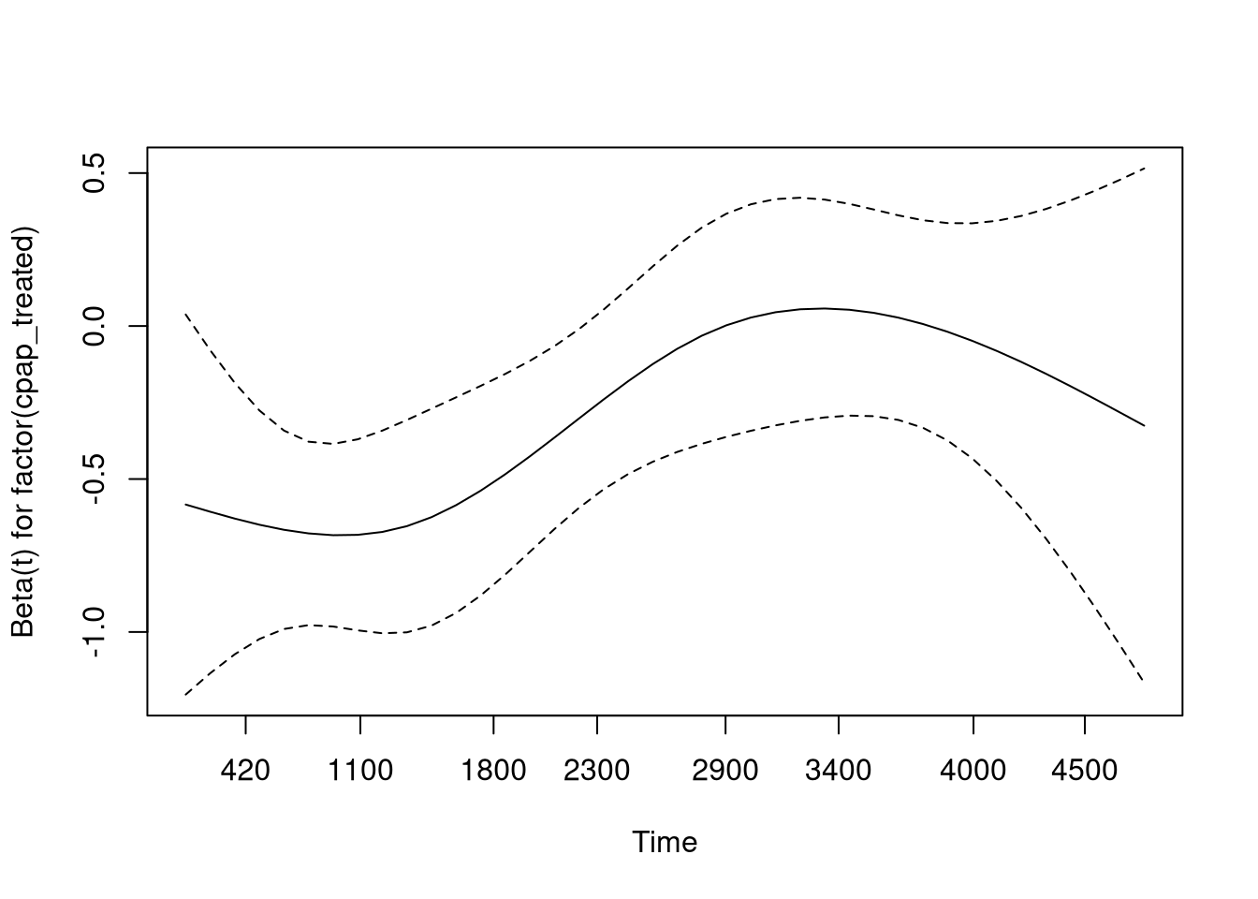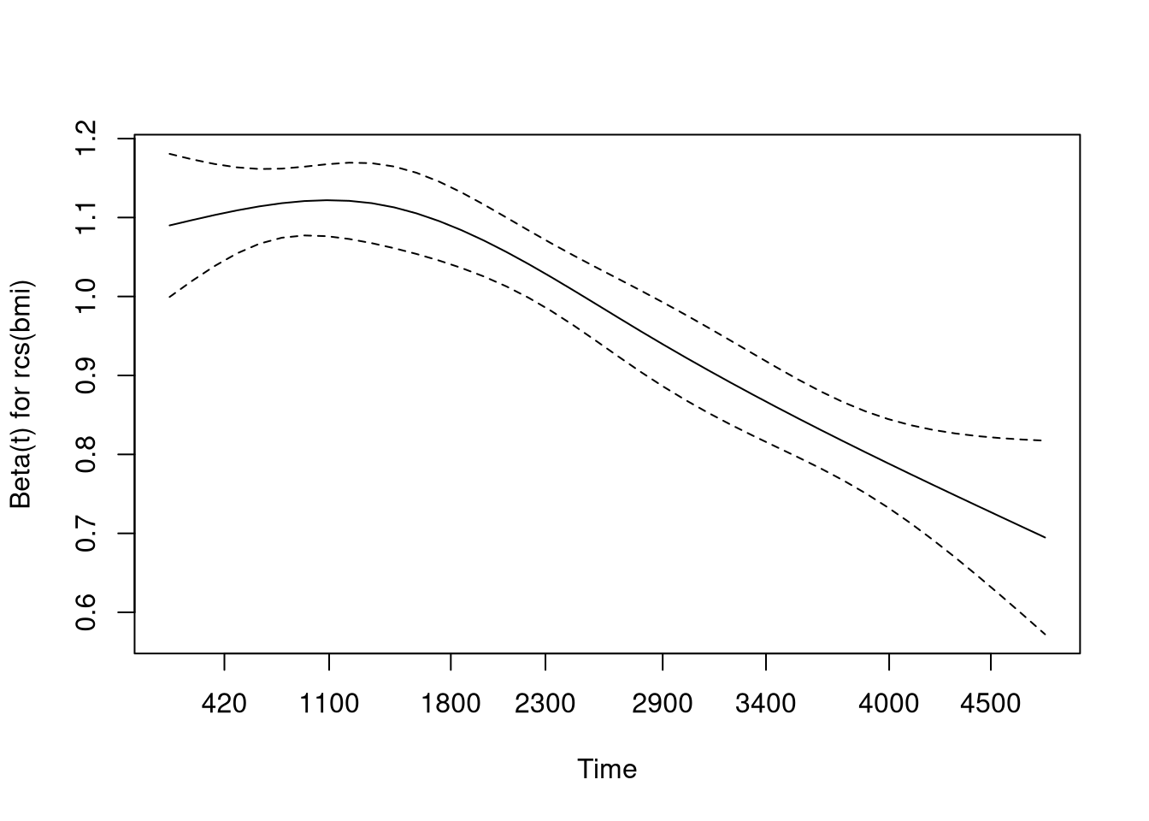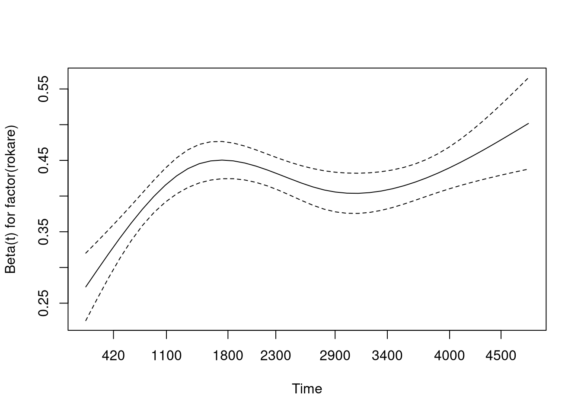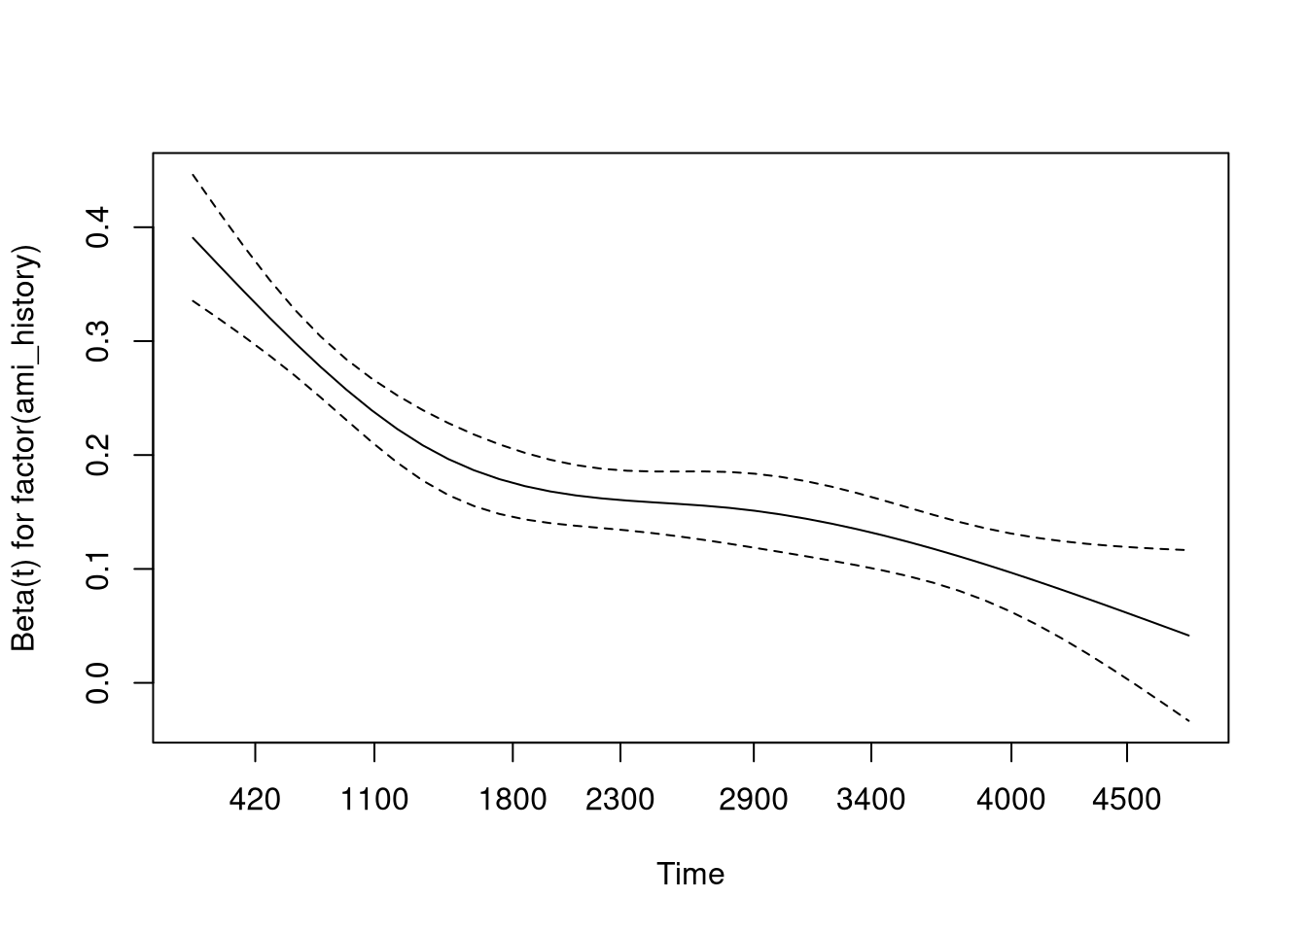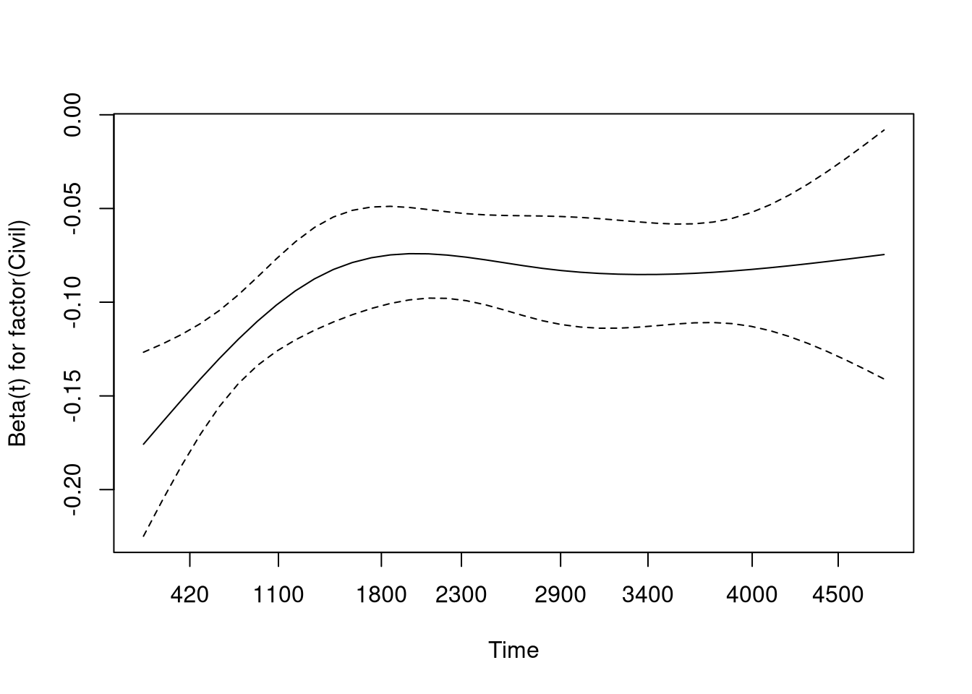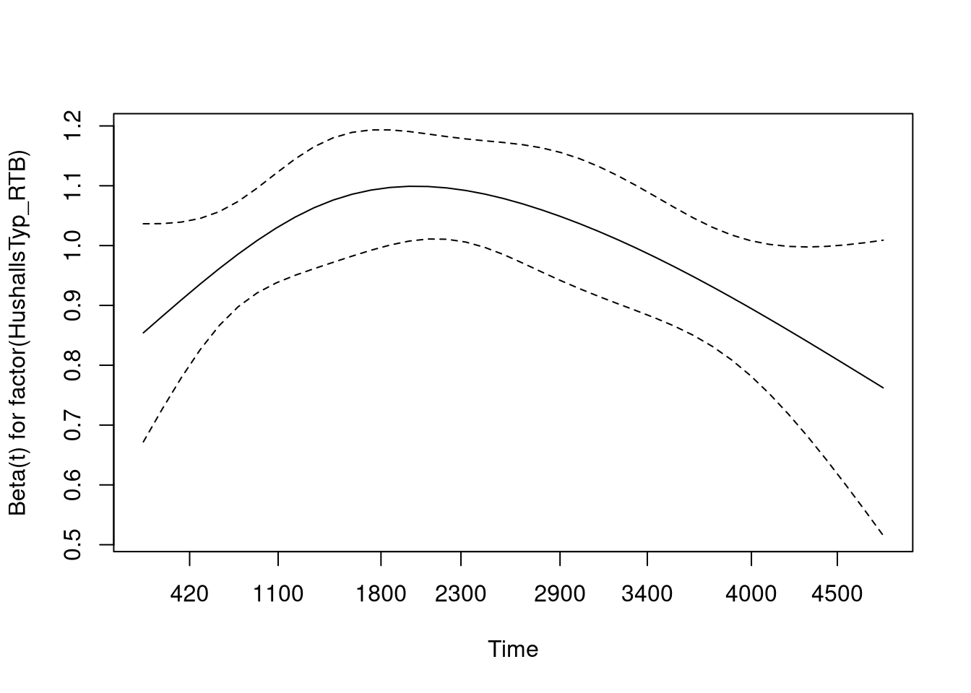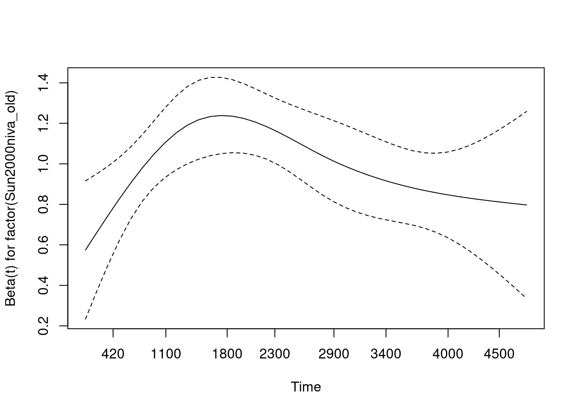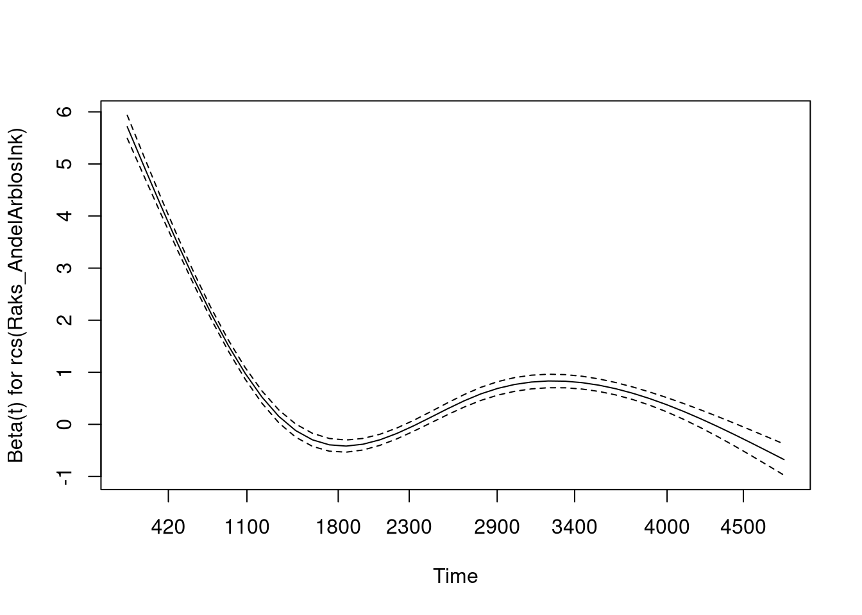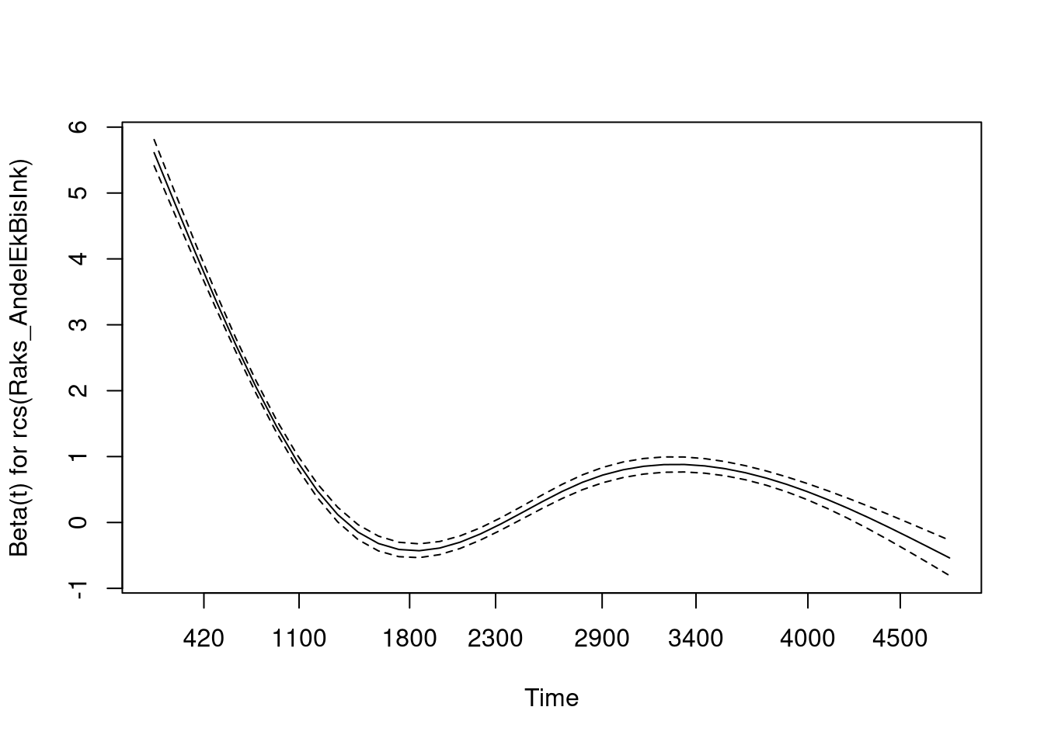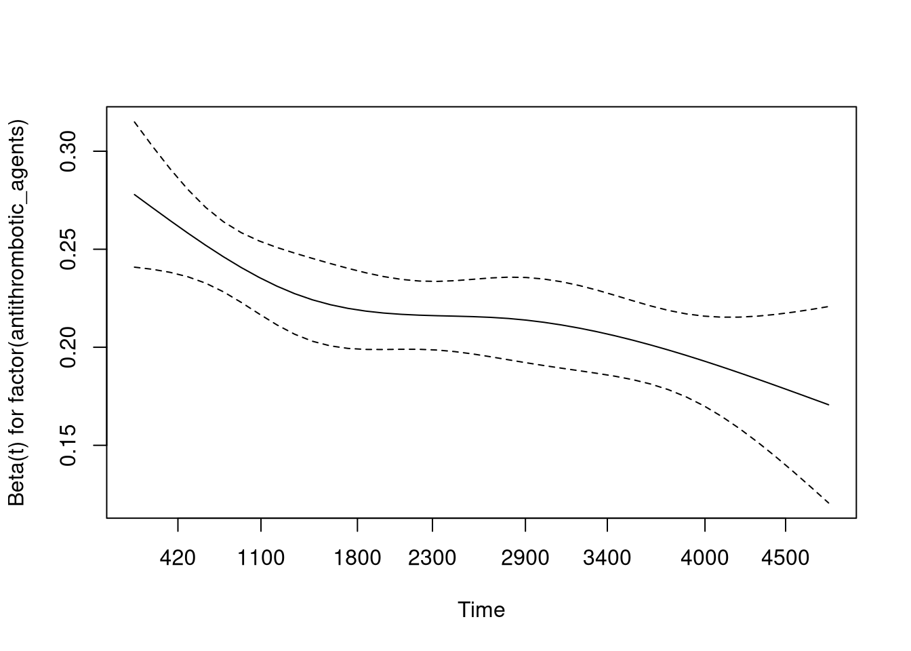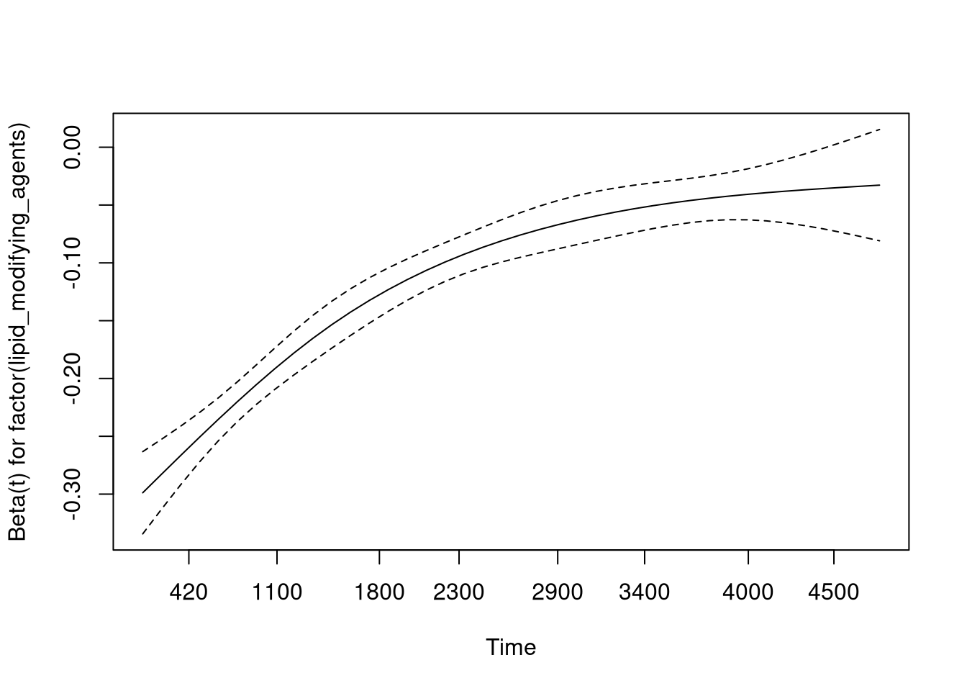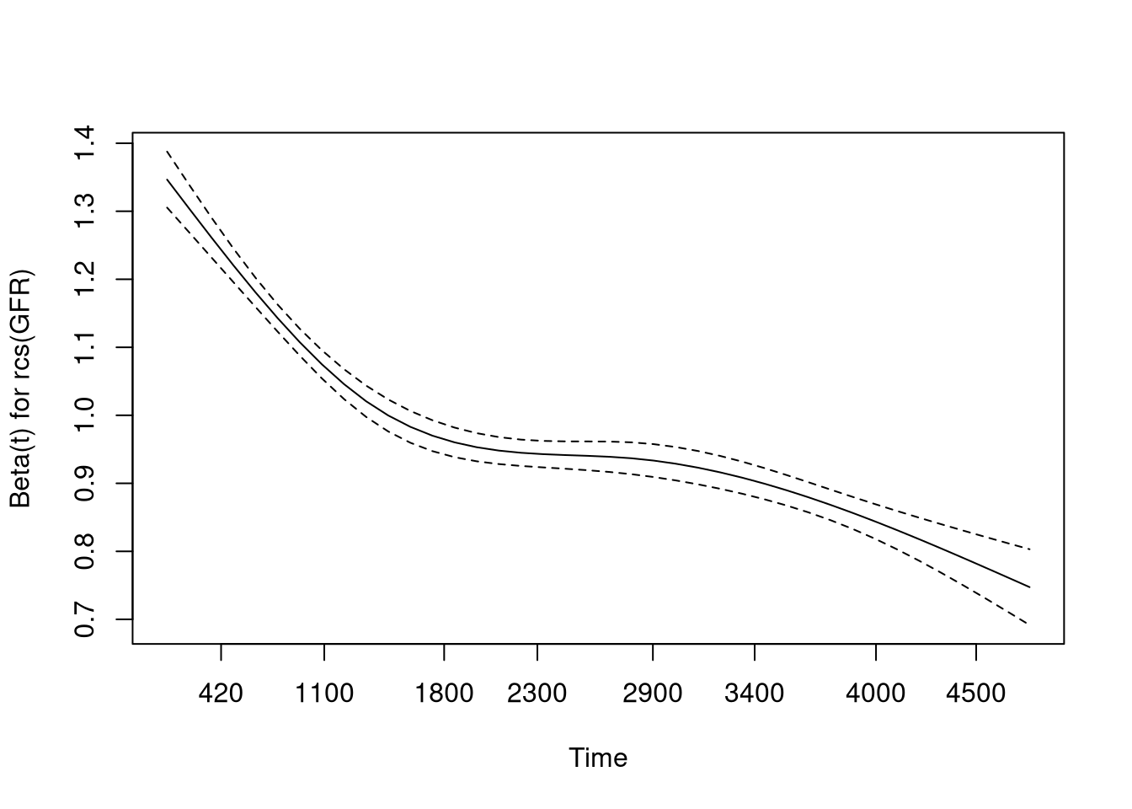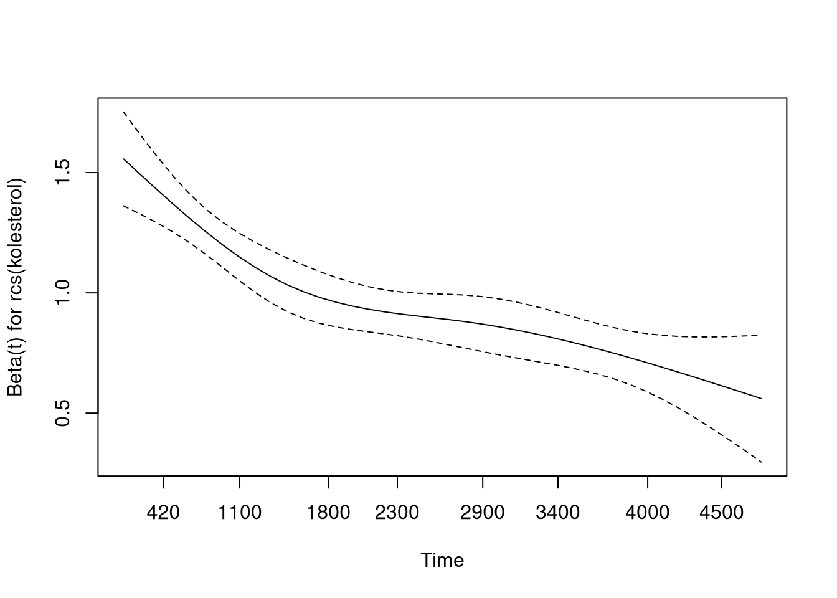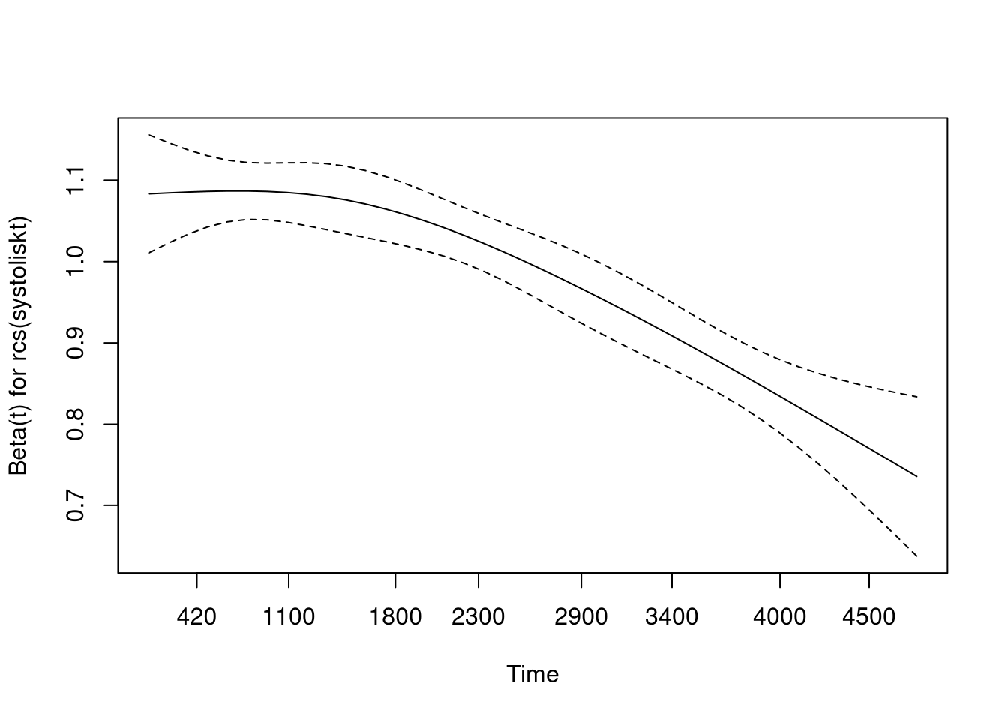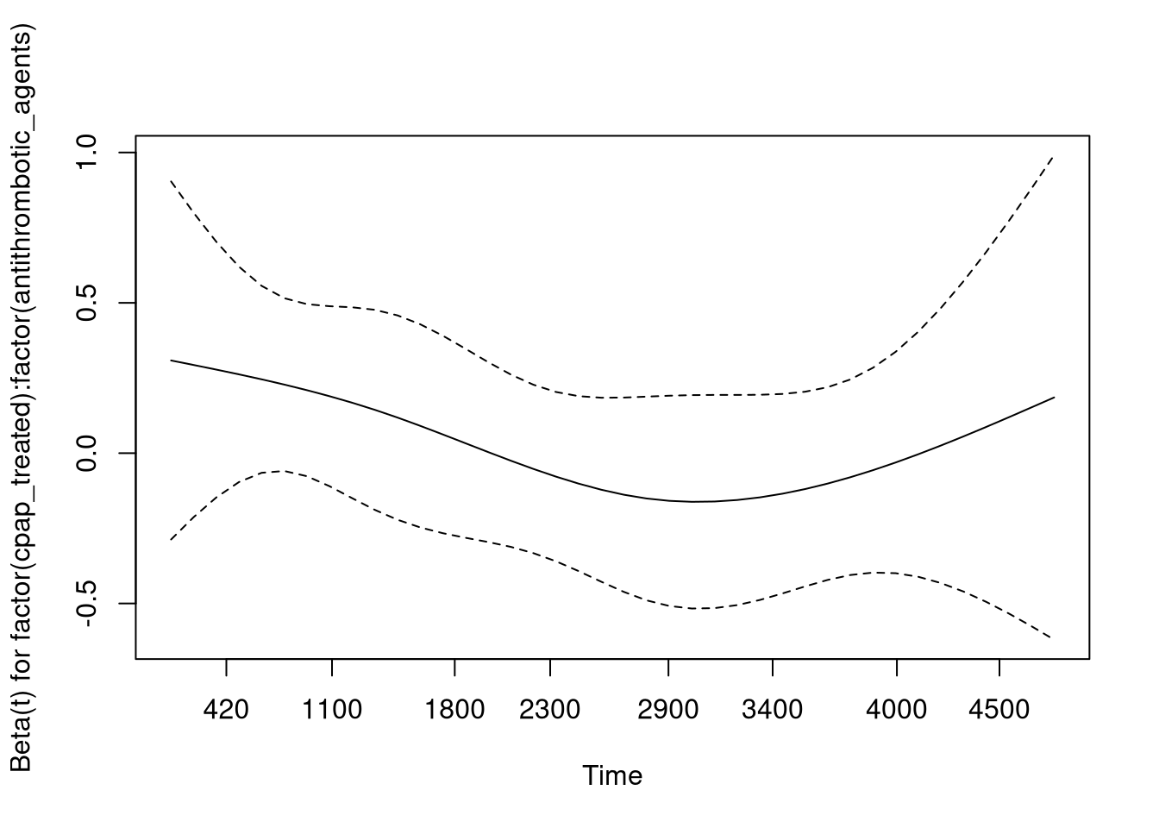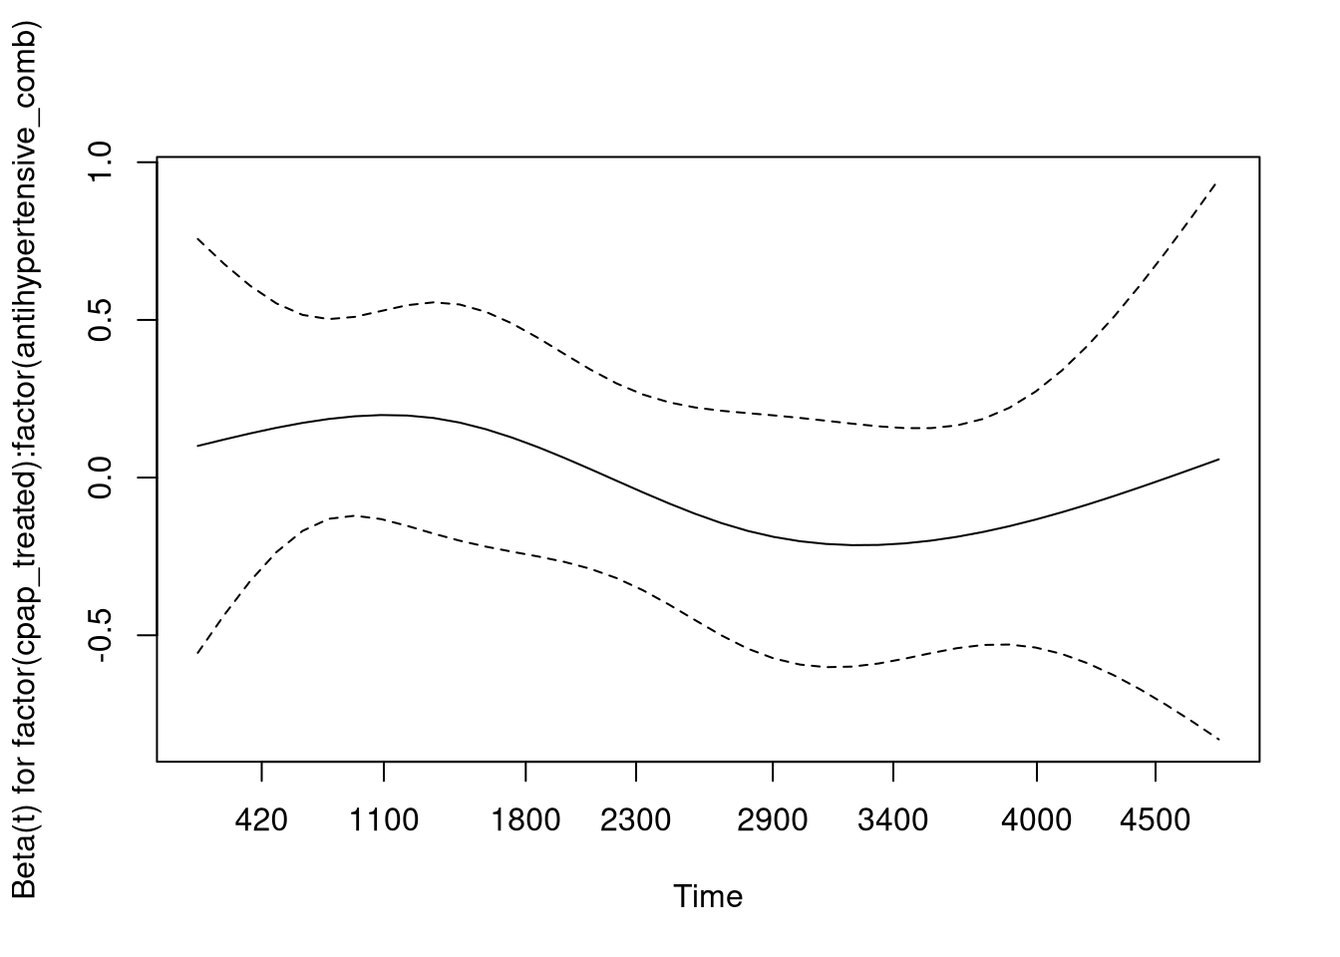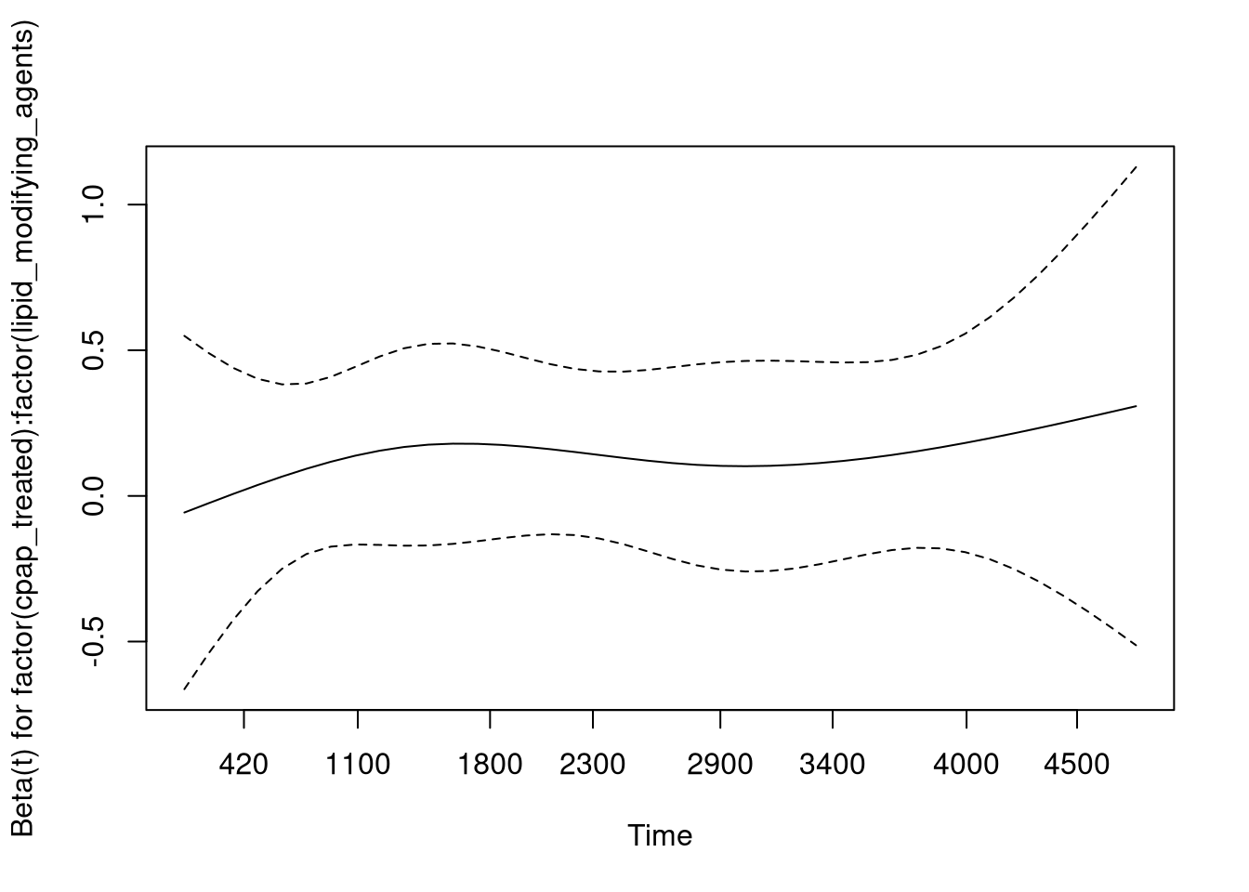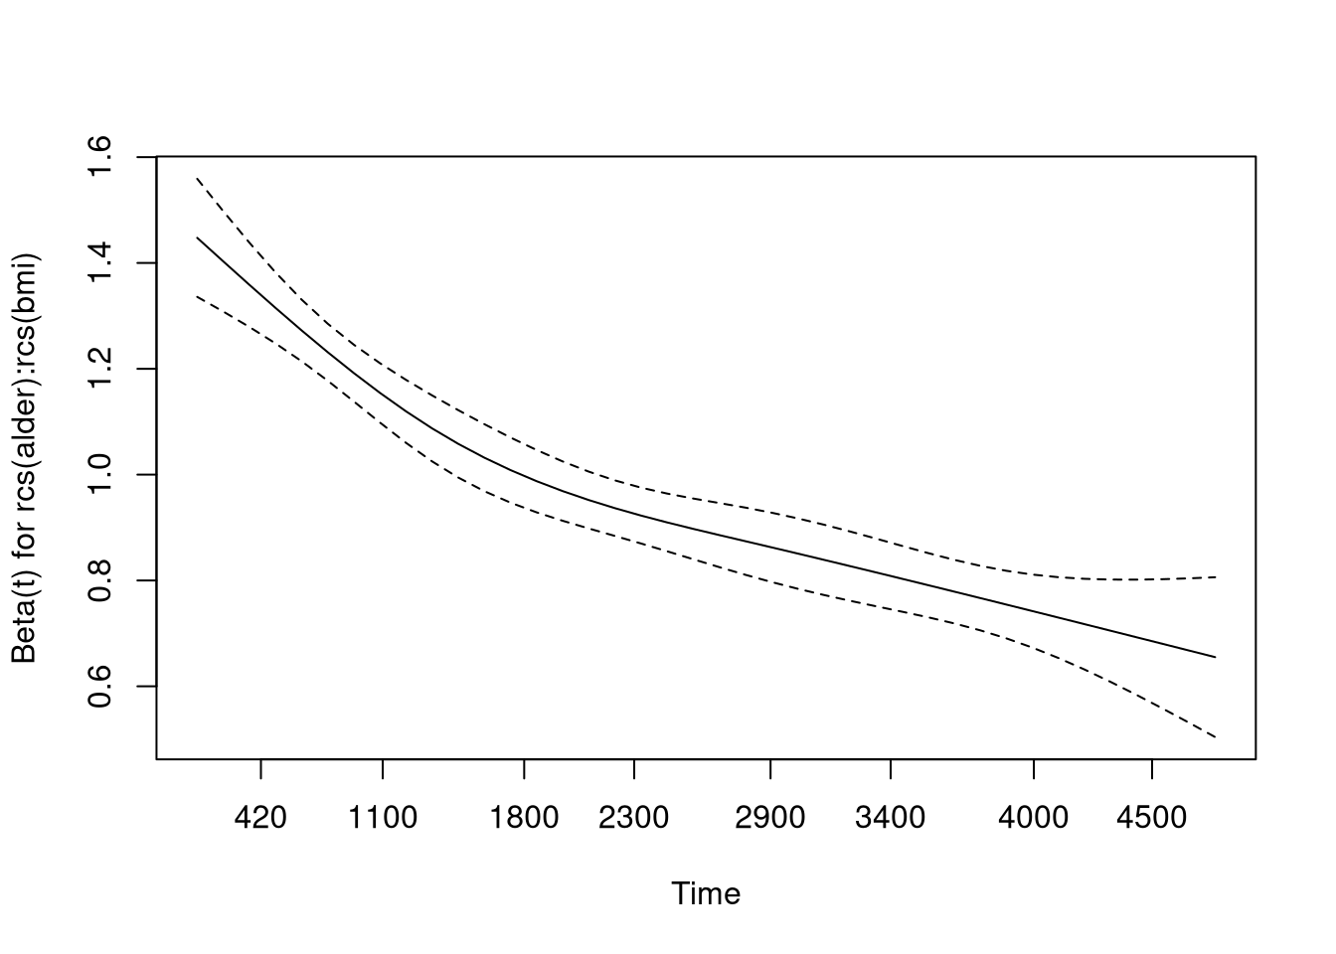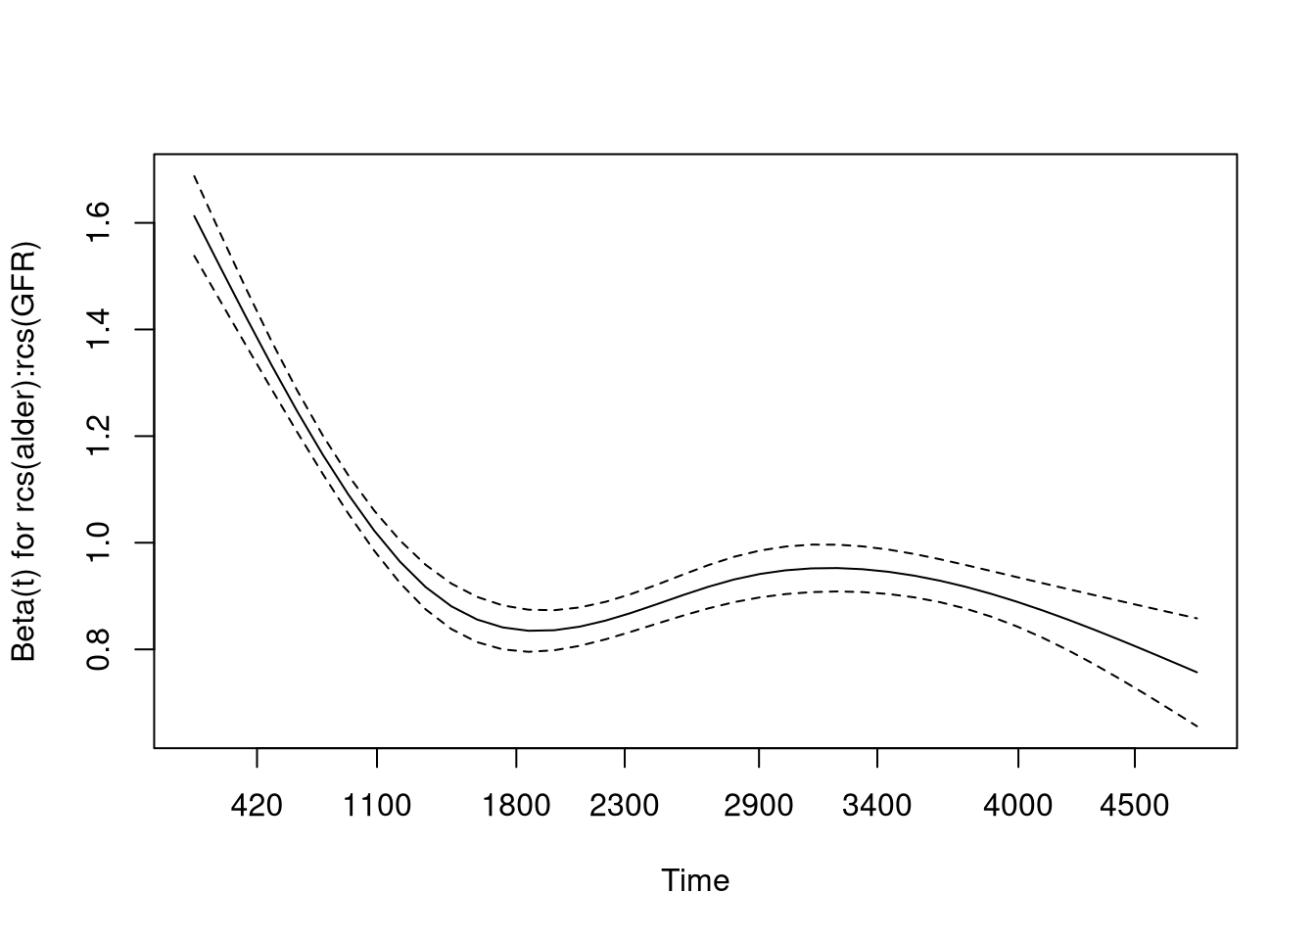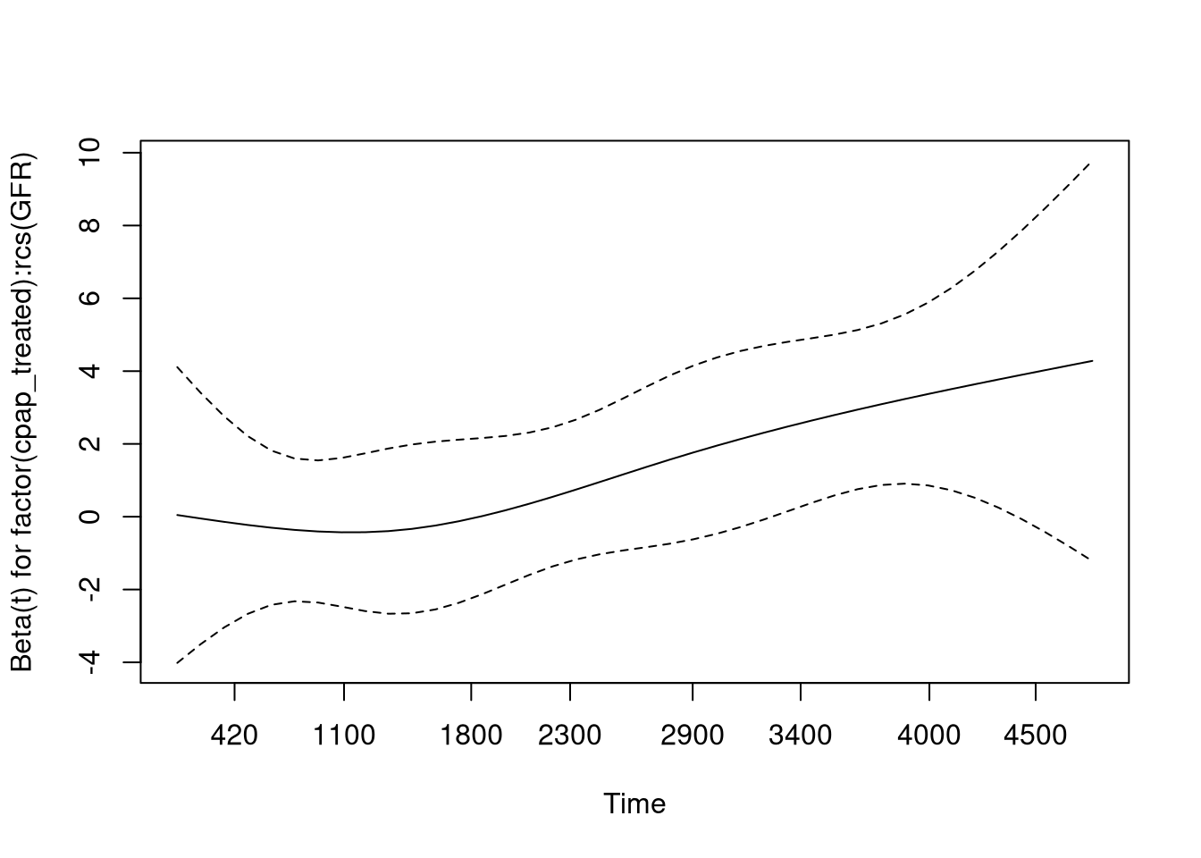

## Warning in termplot(cph): 'model' appears to involve interactions: see the help

## page

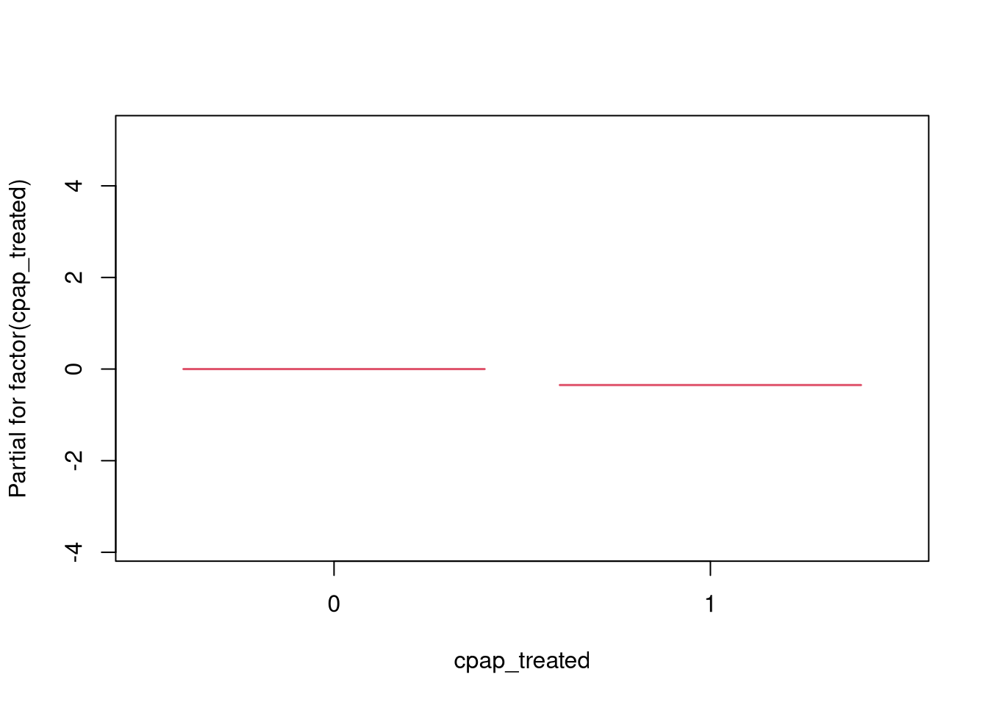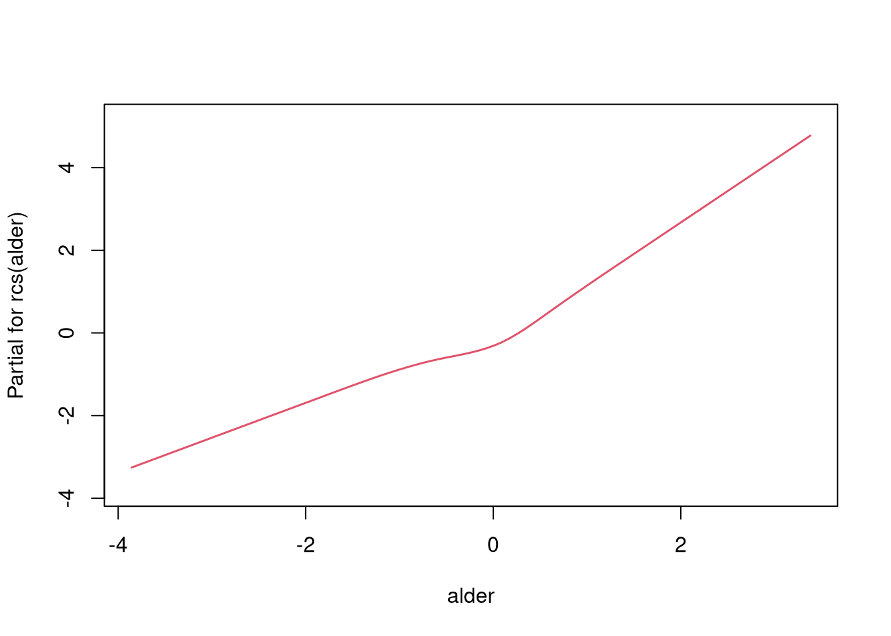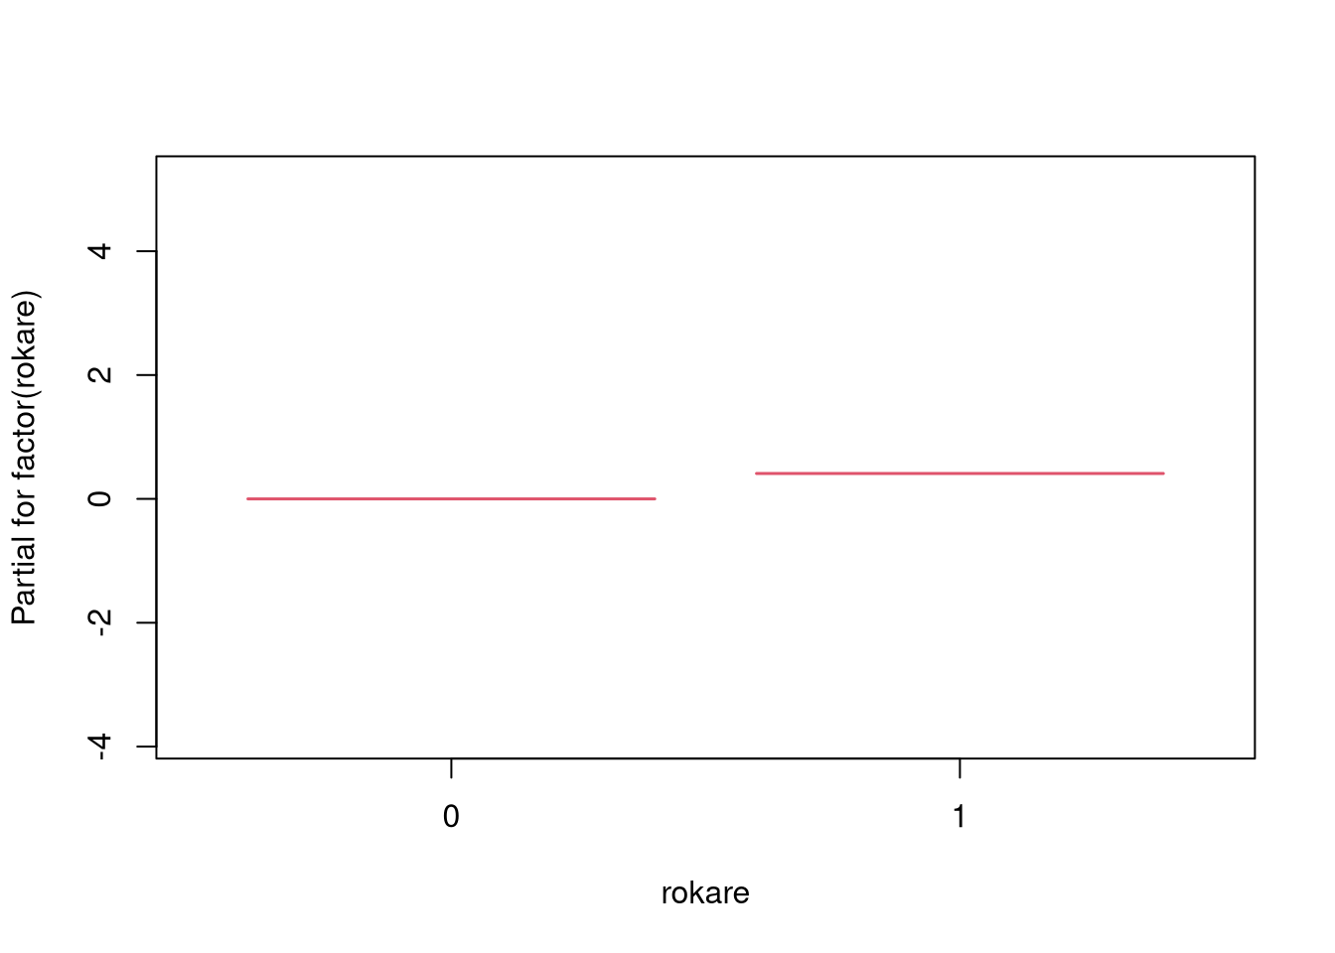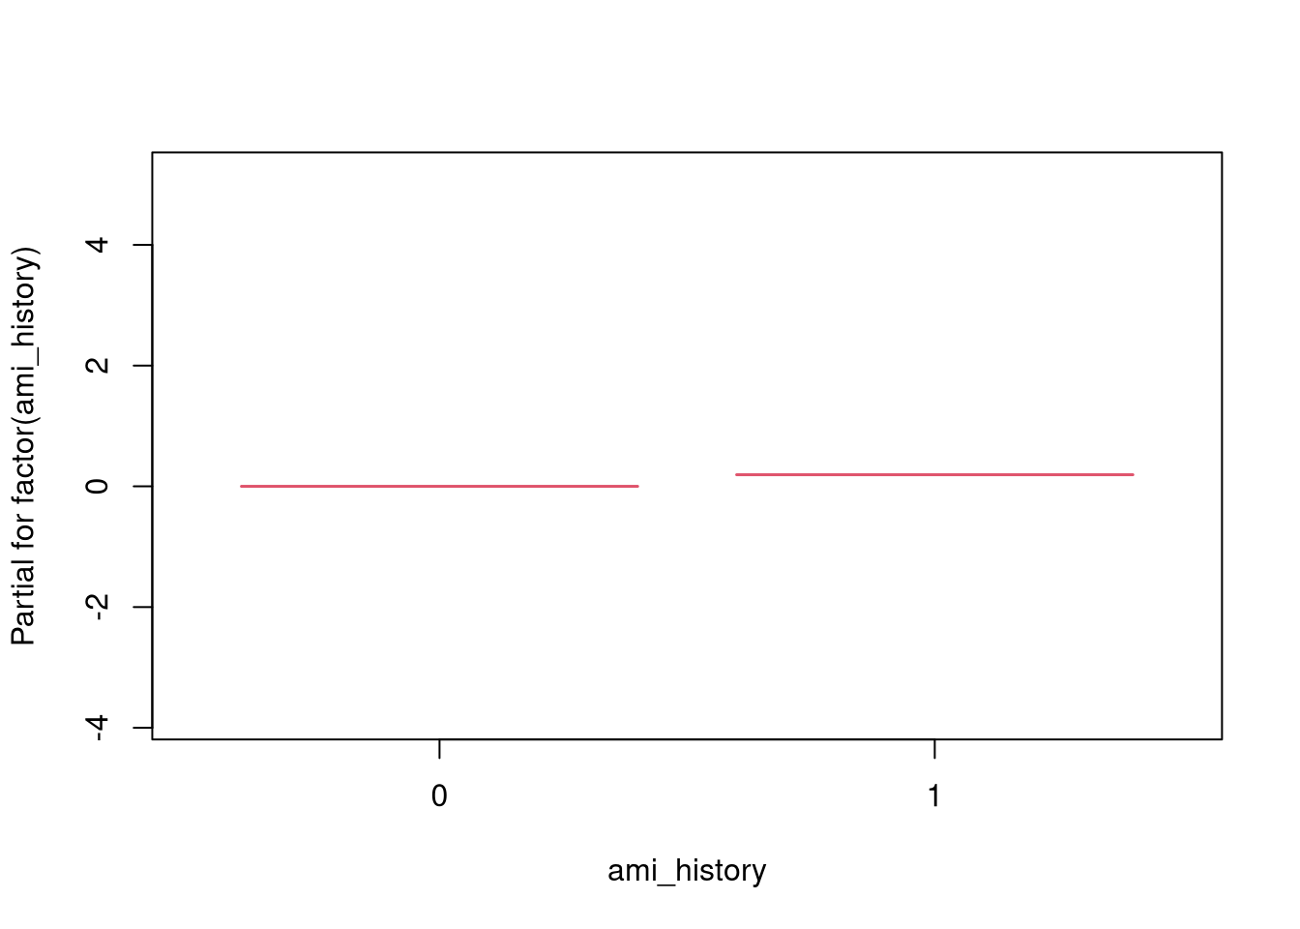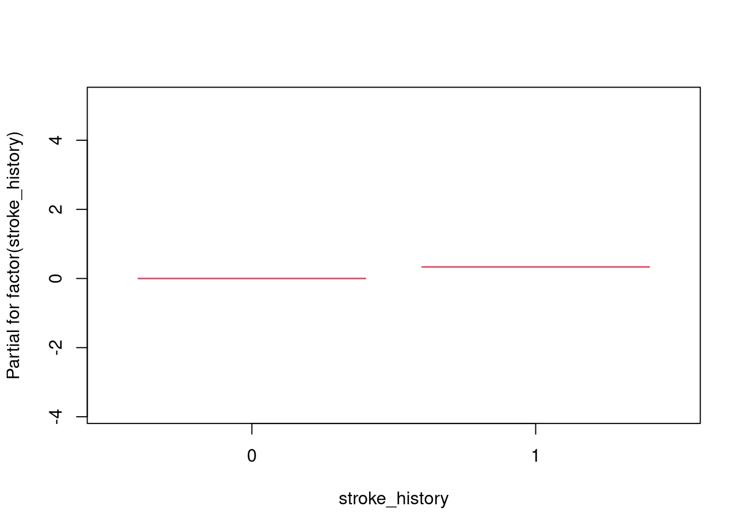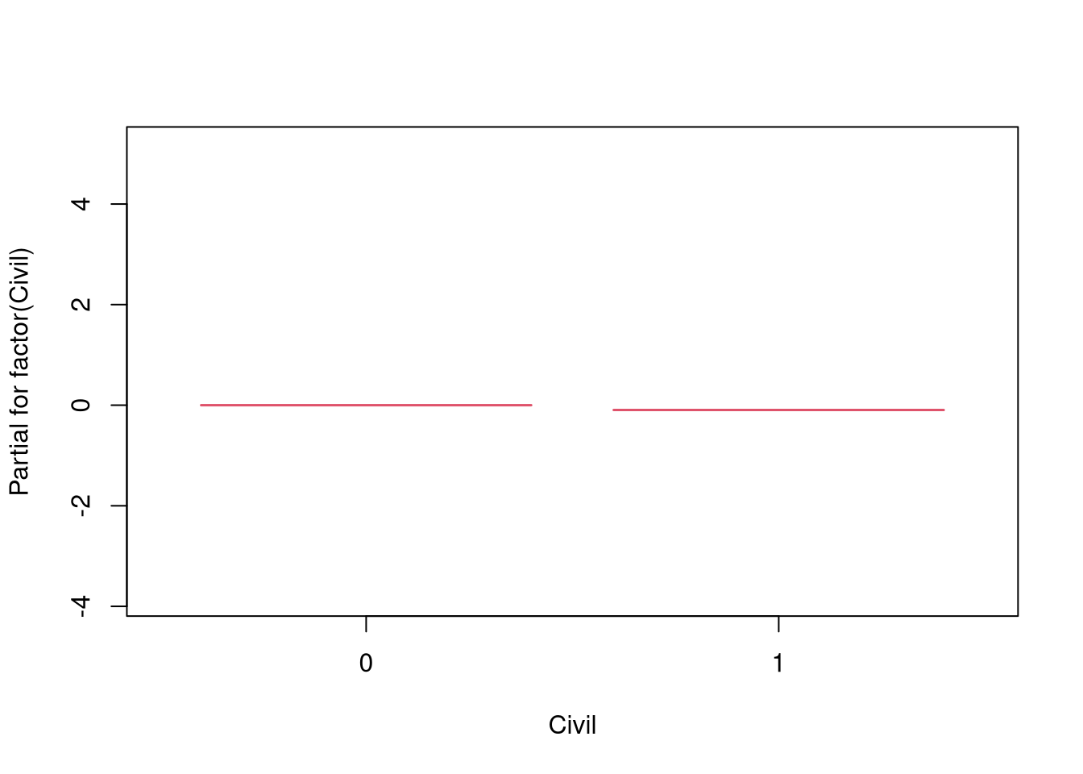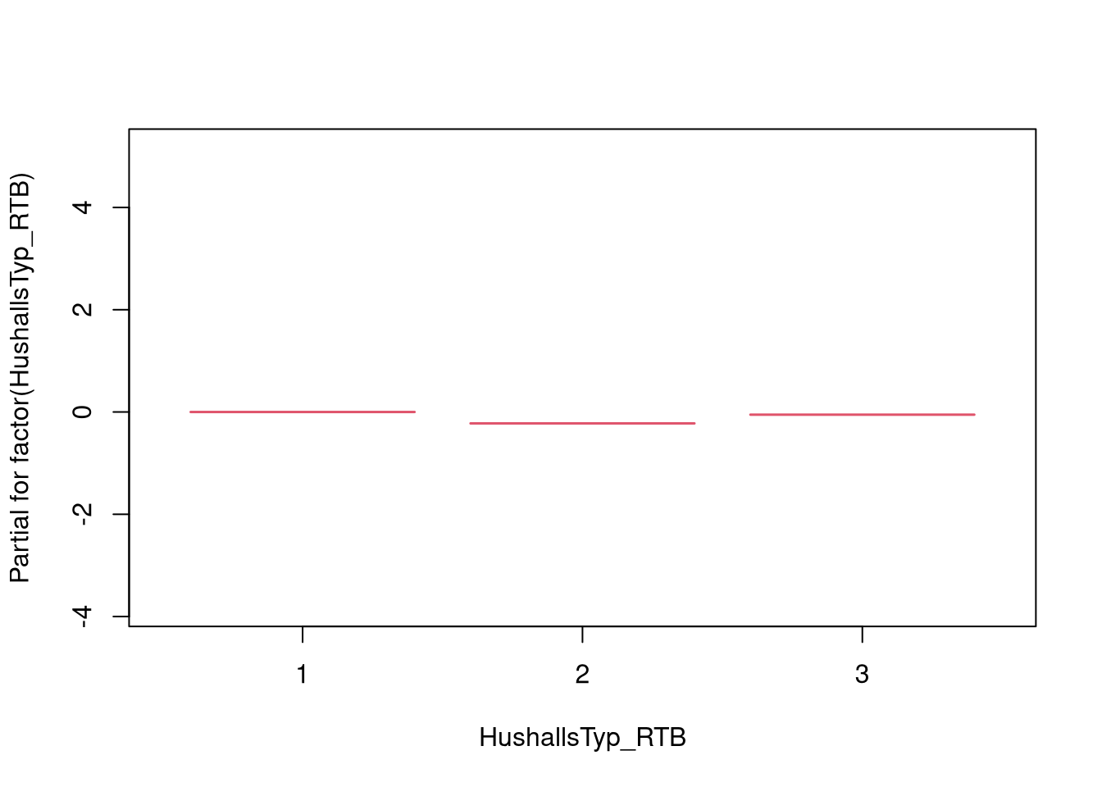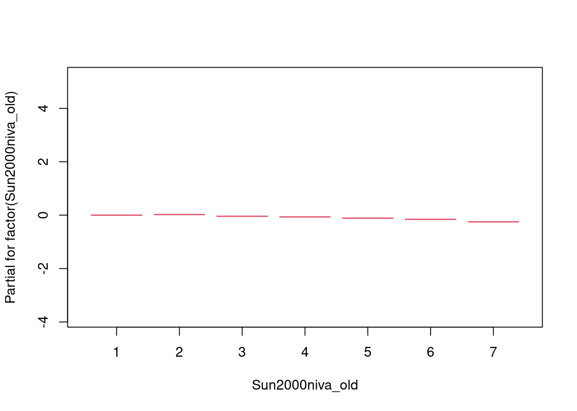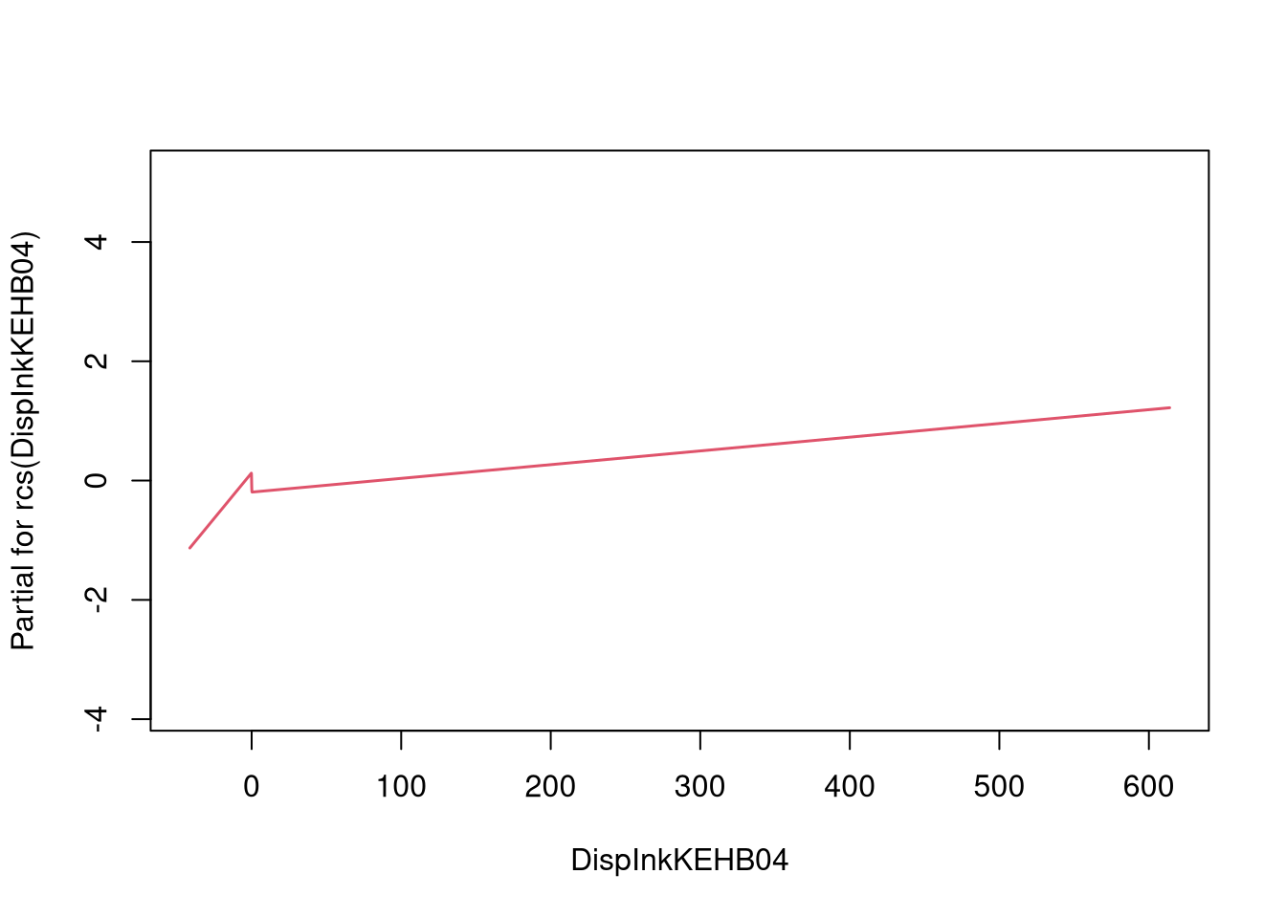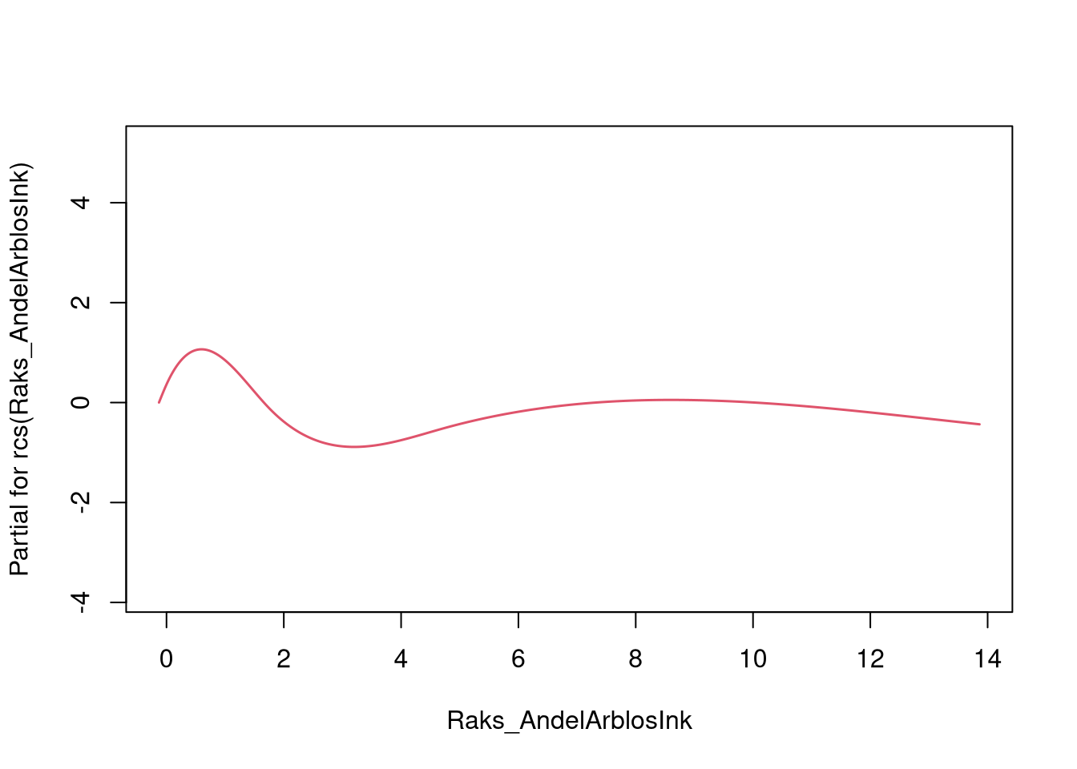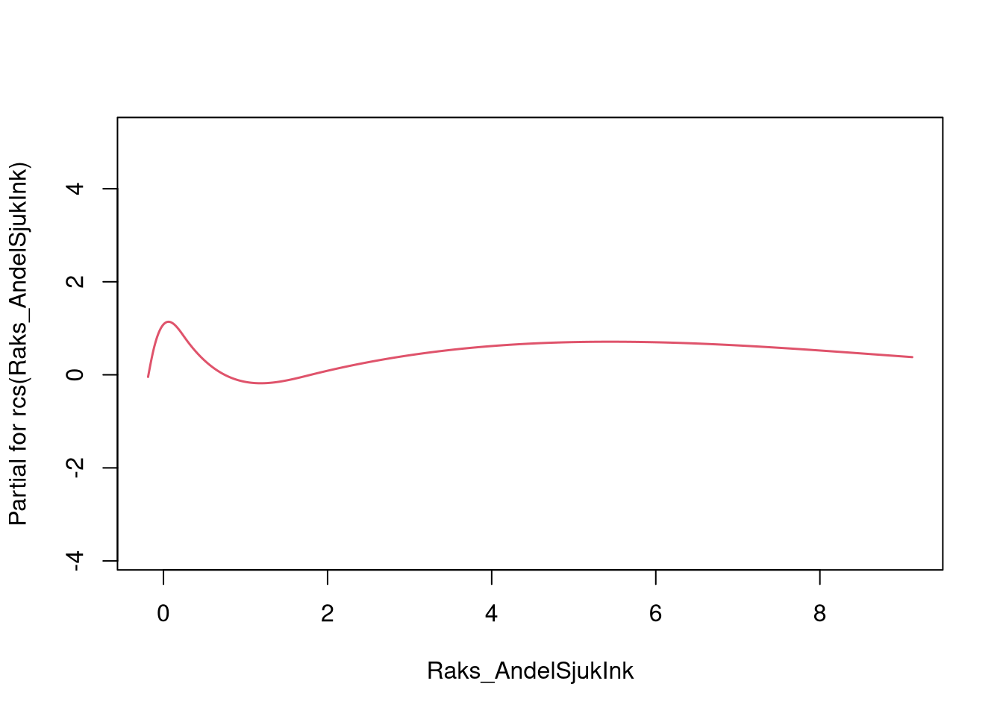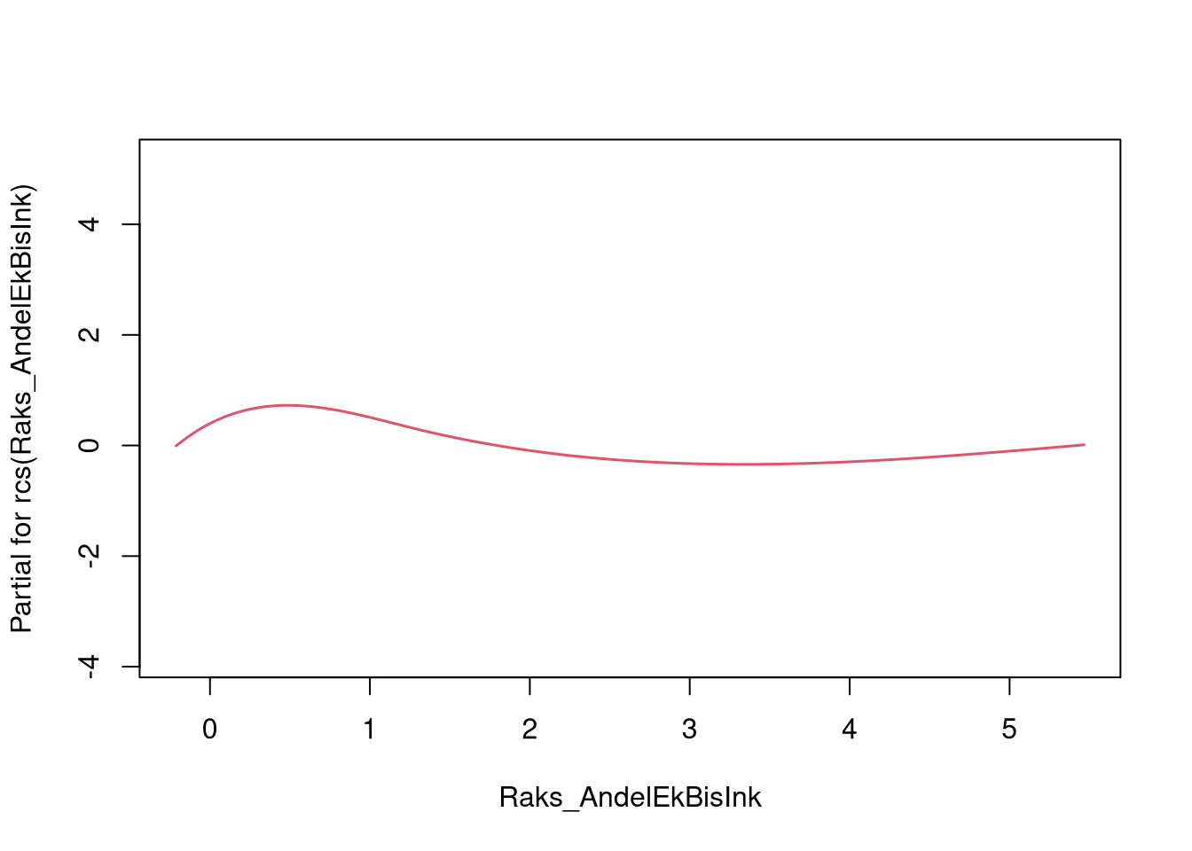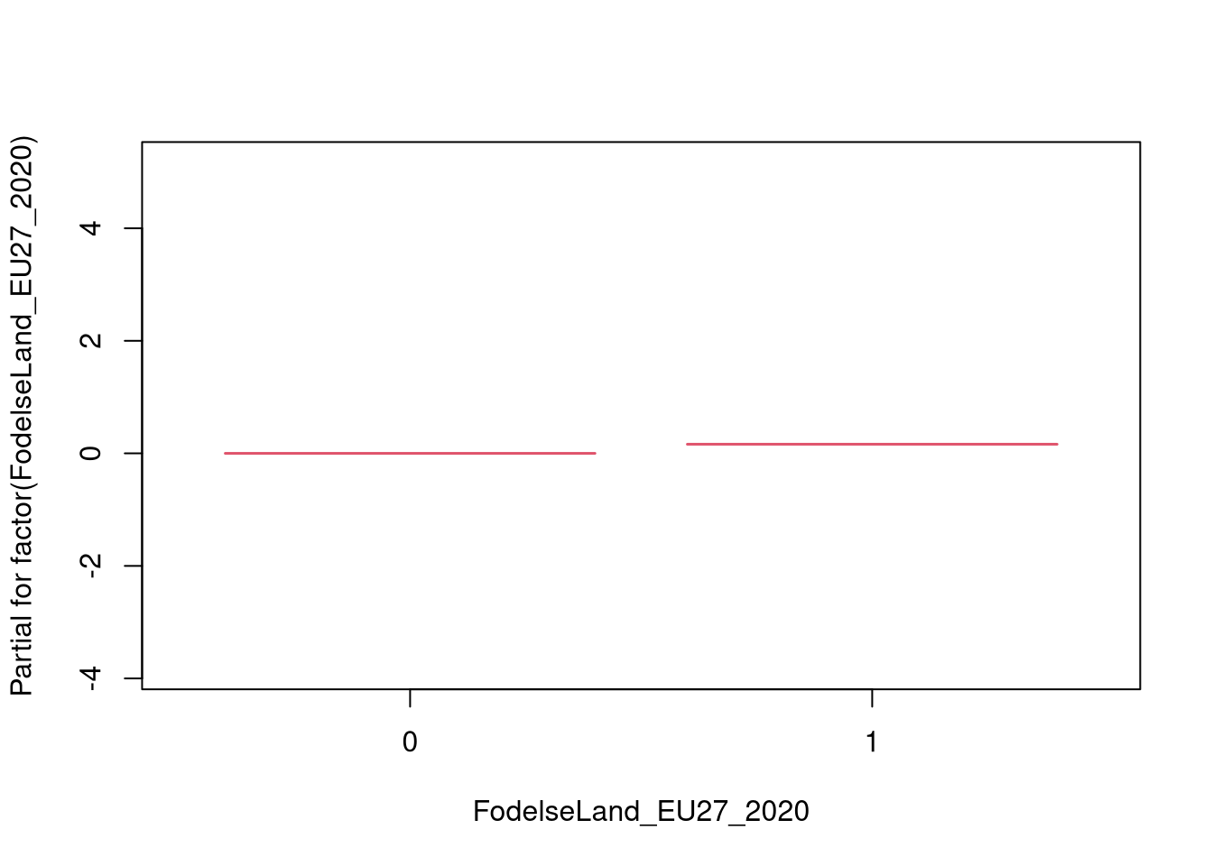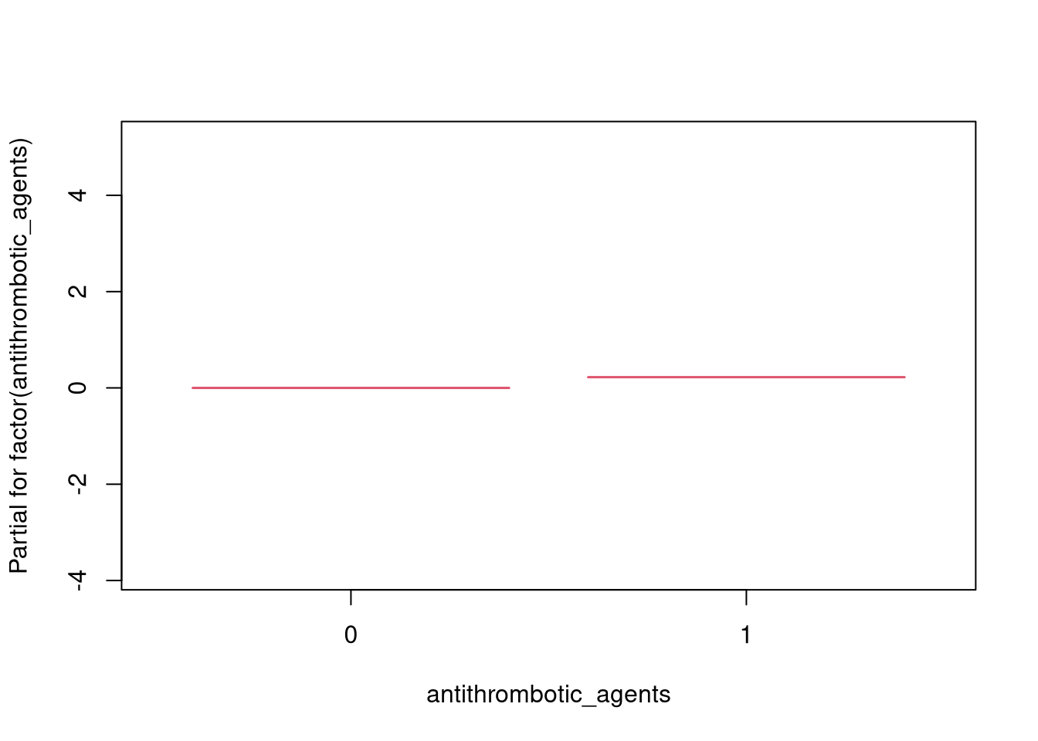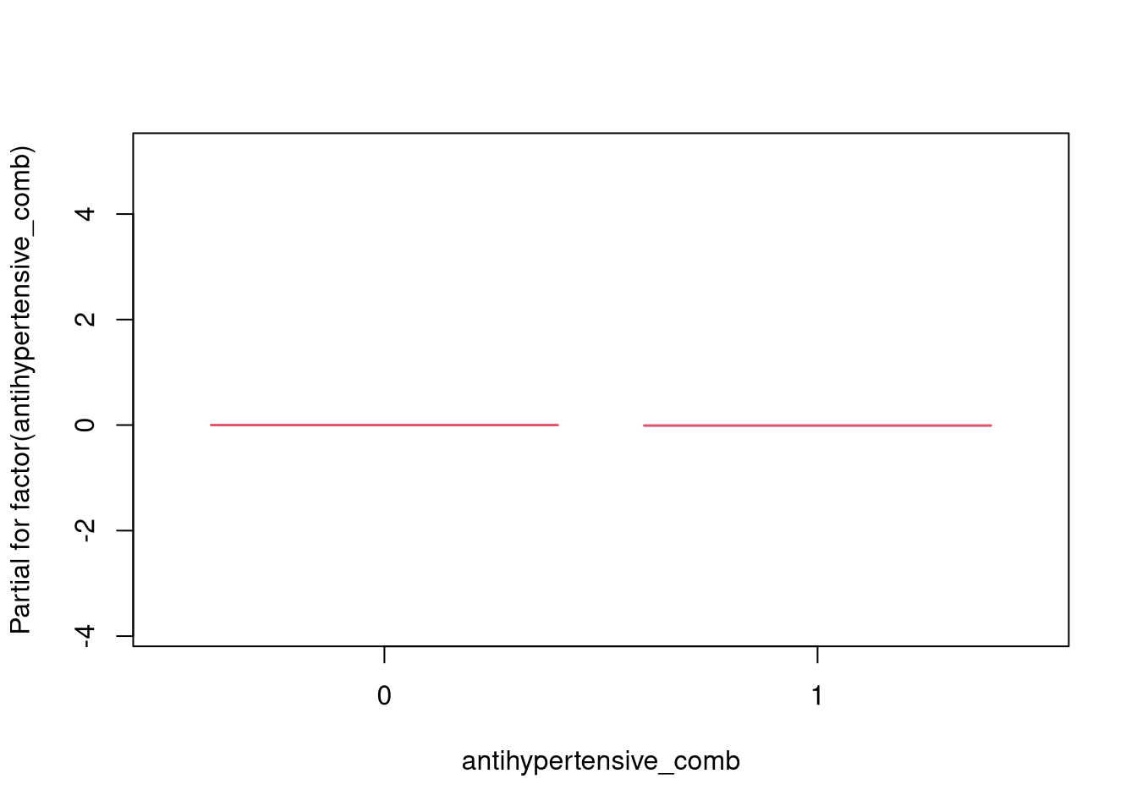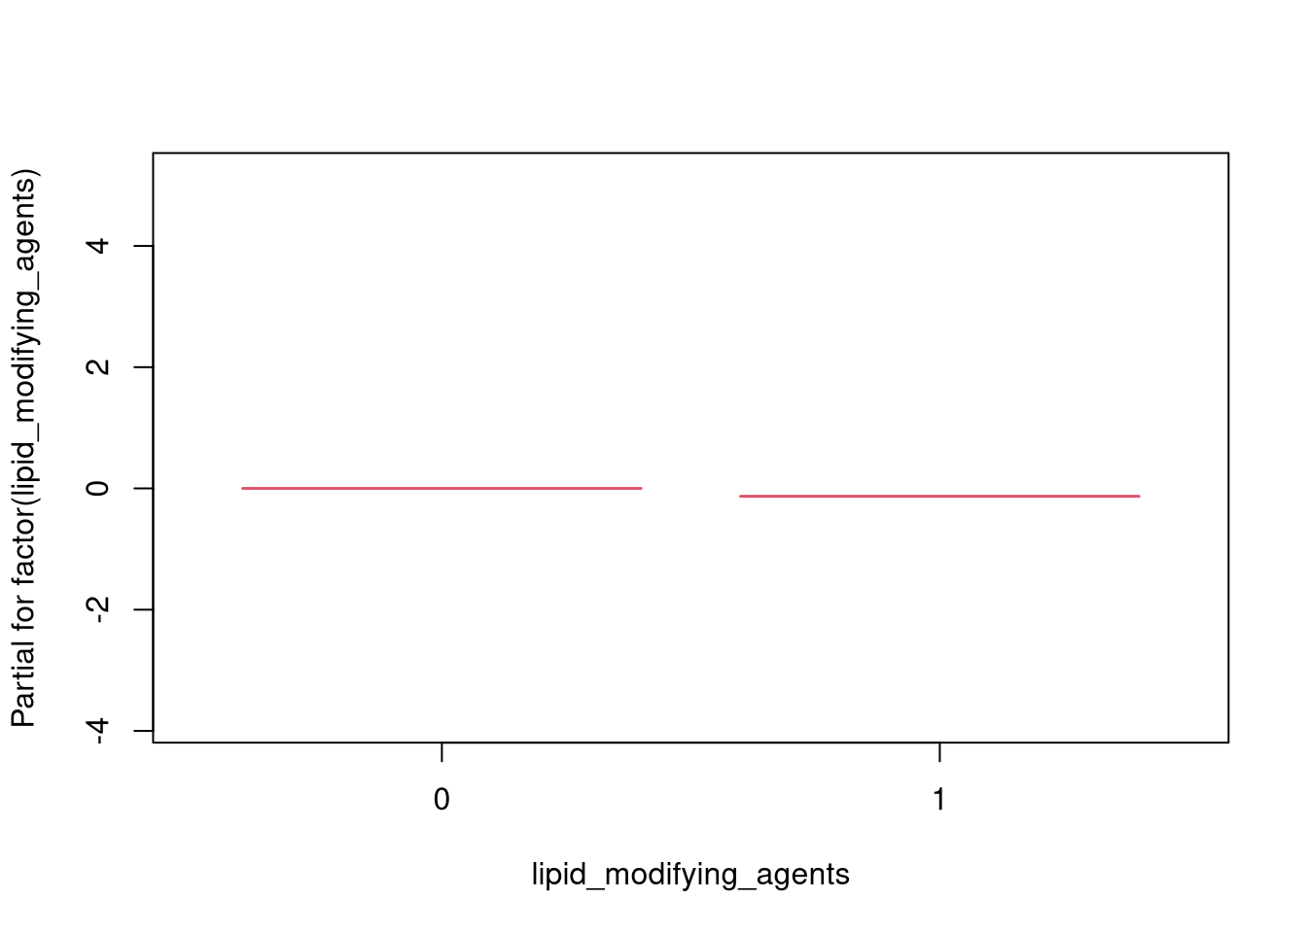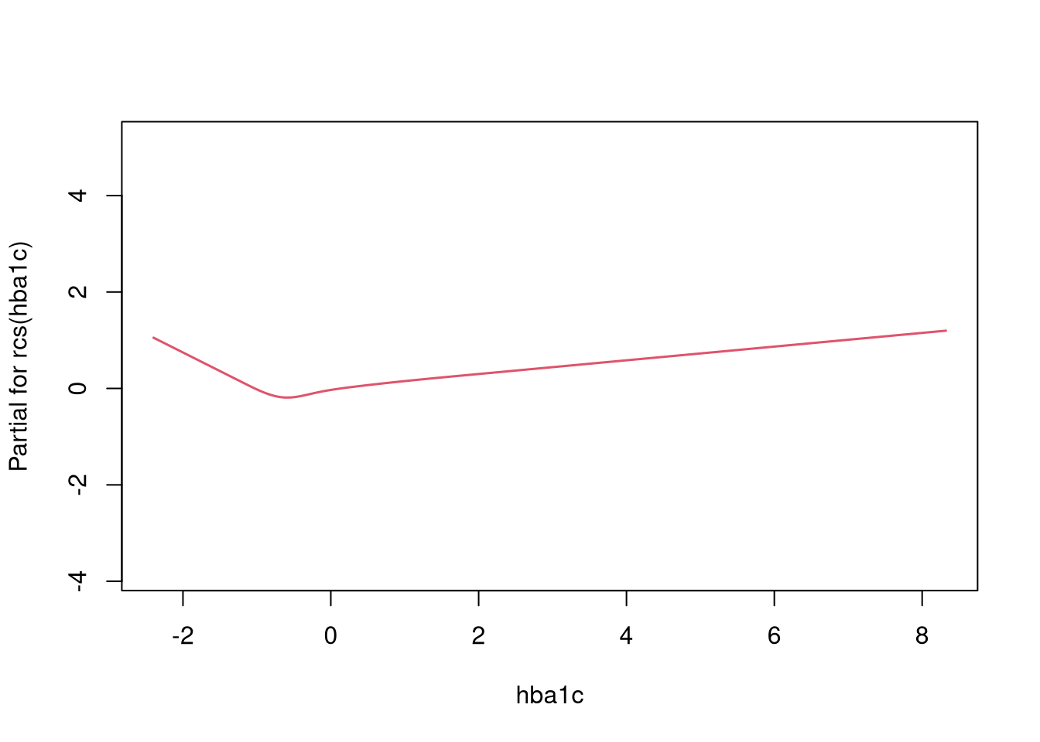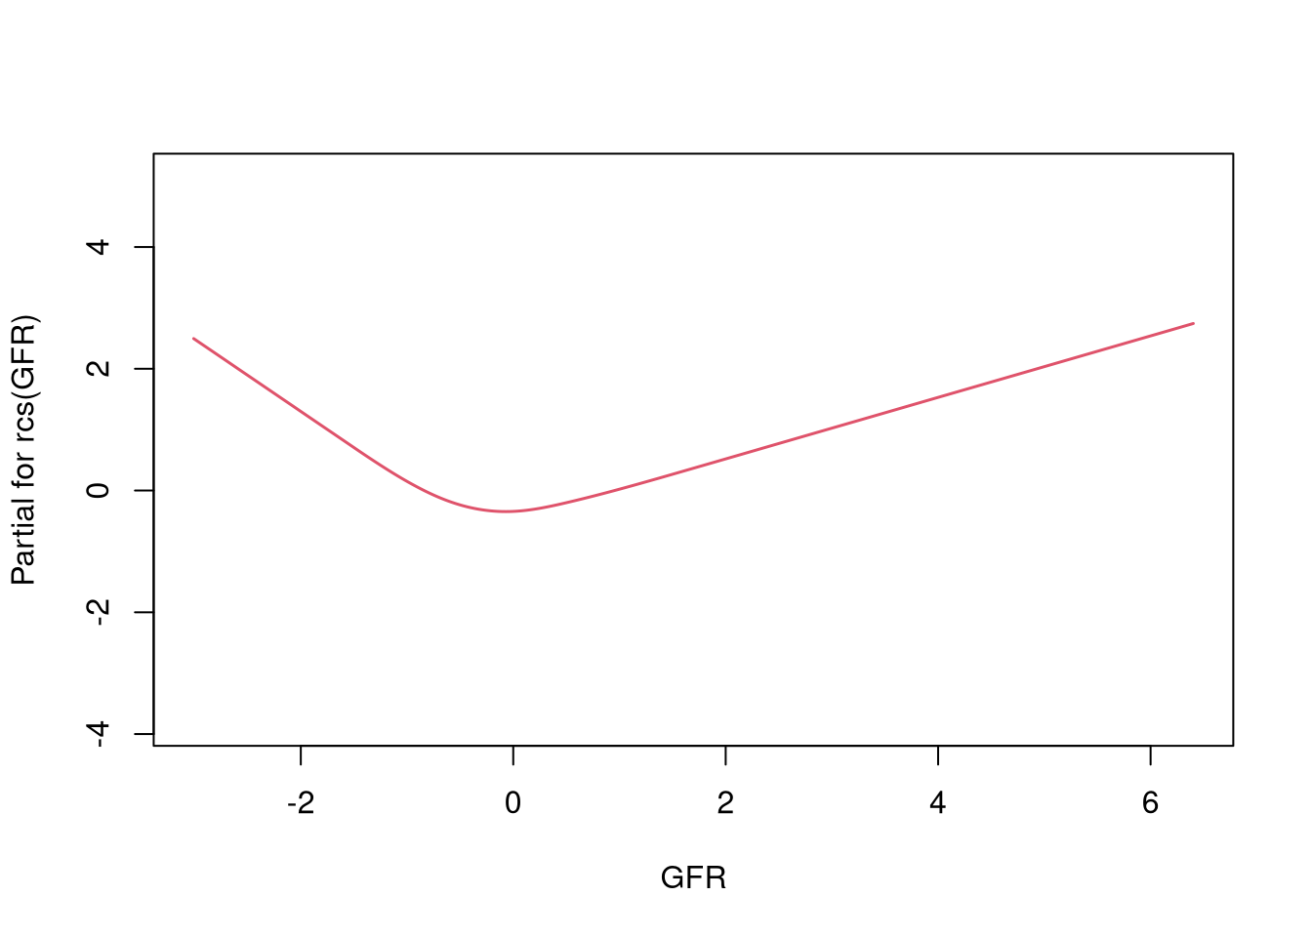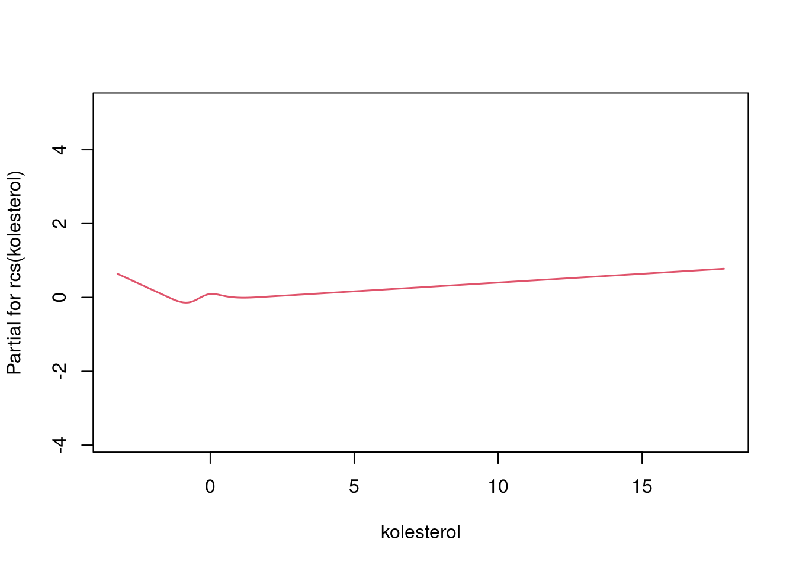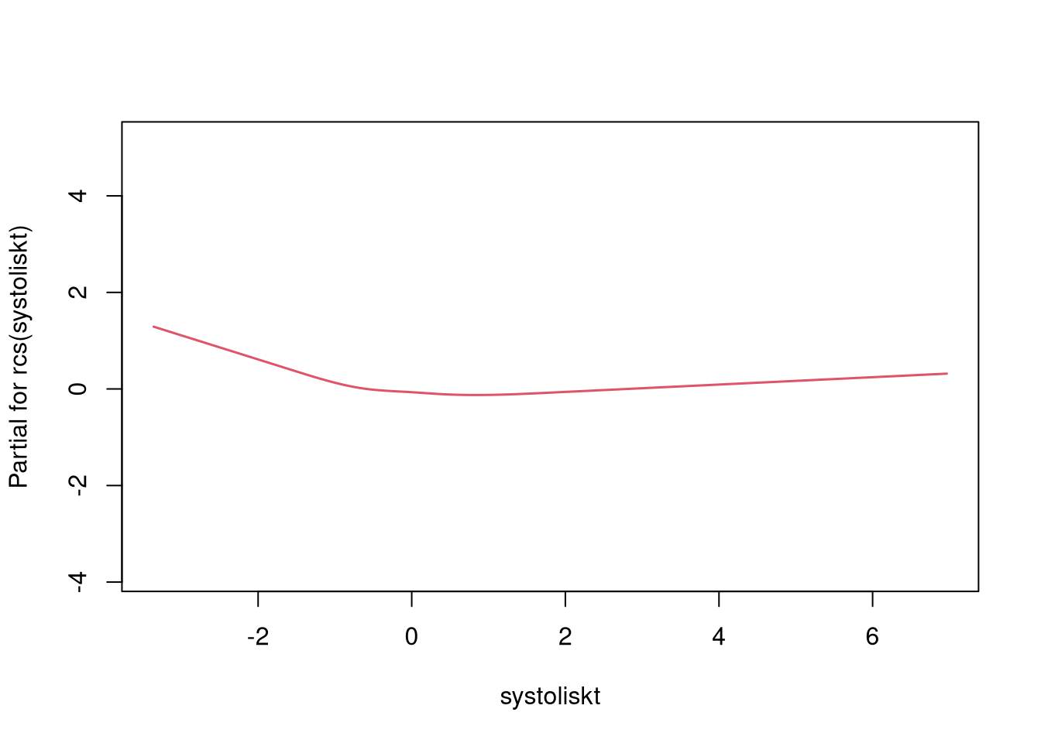

## [1] "--- CONCORDANCE RESULTS ---"

## C-index train: 0.8115603

## C-index test: 0.8118397

## C-index DAC train: 0.8252279

## C-index DAC test: 0.8250712

**Group 2**

run_models(c(list_forms_sleep[["form_tdep_spl"]], list_forms_sleep[["form_tdep_cat"]]), df_death_sub_tv_train, df_death_sub_tv_test, "stop", "event", cont_var, "prof_death_dep_g2.html", bigd=F)

## [1] "### FORMULA 1 ###"

## Start: AIC=13087.75

## Surv(start, stop, event) ~ factor(cpap_treated)

## number of knots in rcs defaulting to 5

## number of knots in rcs defaulting to 5

## number of knots in rcs defaulting to 5

## number of knots in rcs defaulting to 5

## number of knots in rcs defaulting to 5

## number of knots in rcs defaulting to 5

## number of knots in rcs defaulting to 5

## number of knots in rcs defaulting to 5

## number of knots in rcs defaulting to 5

## number of knots in rcs defaulting to 5

## number of knots in rcs defaulting to 5

## number of knots in rcs defaulting to 5

## number of knots in rcs defaulting to 5

## Df AIC

## + rcs(alder) 4 12625

## + rcs(GFR) 4 12752

## + factor(antithrombotic_agents) 1 12937

## + rcs(systoliskt) 4 13018

## + factor(antihypertensive_comb) 1 13025

## + factor(Sun2000niva_old) 6 13026

## + rcs(IV_AverageSaturation) 4 13032

## + rcs(DispInkKEHB04) 4 13047

## + factor(ami_history) 1 13047

## + factor(stroke_history) 1 13051

## + rcs(bmi) 4 13056

## + factor(HushallsTyp_RTB) 2 13057

## + factor(Civil) 1 13058

## + rcs(IV_AHI) 4 13066

## + factor(sex) 1 13070

## + factor(FodelseLand_EU27_2020) 1 13070

## + rcs(kolesterol) 4 13075

## + rcs(IV_ODI) 4 13075

## + factor(lipid_modifying_agents) 1 13078

## + rcs(Raks_AndelSjukInk) 4 13080

## + rcs(Raks_AndelEkBisInk) 3 13081

## + rcs(hba1c) 4 13085

## <none> 13088

## + factor(rokare) 1 13089

## + rcs(Raks_AndelArblosInk) 4 13093

## number of knots in rcs defaulting to 5

##

## Step: AIC=12624.72

## Surv(start, stop, event) ~ factor(cpap_treated) + rcs(alder)

## number of knots in rcs defaulting to 5

## number of knots in rcs defaulting to 5

## number of knots in rcs defaulting to 5

## number of knots in rcs defaulting to 5

## number of knots in rcs defaulting to 5

## number of knots in rcs defaulting to 5

## number of knots in rcs defaulting to 5

## number of knots in rcs defaulting to 5

## number of knots in rcs defaulting to 5

## number of knots in rcs defaulting to 5

## number of knots in rcs defaulting to 5

## number of knots in rcs defaulting to 5

## number of knots in rcs defaulting to 5

## number of knots in rcs defaulting to 5

## number of knots in rcs defaulting to 5

## number of knots in rcs defaulting to 5

## number of knots in rcs defaulting to 5

## number of knots in rcs defaulting to 5

## number of knots in rcs defaulting to 5

## number of knots in rcs defaulting to 5

## number of knots in rcs defaulting to 5

## number of knots in rcs defaulting to 5

## number of knots in rcs defaulting to 5

## number of knots in rcs defaulting to 5

## number of knots in rcs defaulting to 5

## number of knots in rcs defaulting to 5

## number of knots in rcs defaulting to 5

## number of knots in rcs defaulting to 5

## number of knots in rcs defaulting to 5

## number of knots in rcs defaulting to 5

## number of knots in rcs defaulting to 5

## number of knots in rcs defaulting to 5

## number of knots in rcs defaulting to 5

## number of knots in rcs defaulting to 5

## number of knots in rcs defaulting to 5

## Df AIC

## + rcs(GFR) 4 12448

## + rcs(IV_AverageSaturation) 4 12561

## + rcs(systoliskt) 4 12561

## + rcs(bmi) 4 12584

## + factor(antithrombotic_agents) 1 12586

## + factor(sex) 1 12595

## + factor(HushallsTyp_RTB) 2 12598

## + rcs(IV_ODI) 4 12600

## + rcs(DispInkKEHB04) 4 12601

## + factor(antihypertensive_comb) 1 12602

## + rcs(IV_AHI) 4 12603

## + factor(ami_history) 1 12606

## + rcs(hba1c) 4 12608

## + factor(Sun2000niva_old) 6 12608

## + factor(stroke_history) 1 12609

## + rcs(kolesterol) 4 12616

## + rcs(Raks_AndelSjukInk) 4 12619

## + factor(rokare) 1 12619

## + rcs(Raks_AndelEkBisInk) 3 12624

## + factor(FodelseLand_EU27_2020) 1 12624

## <none> 12625

## + factor(lipid_modifying_agents) 1 12626

## + factor(Civil) 1 12627

## + rcs(Raks_AndelArblosInk) 4 12631

## - rcs(alder) 4 13088

## number of knots in rcs defaulting to 5

## number of knots in rcs defaulting to 5

##

## Step: AIC=12448.27

## Surv(start, stop, event) ~ factor(cpap_treated) + rcs(alder) +

## rcs(GFR)

## number of knots in rcs defaulting to 5

## number of knots in rcs defaulting to 5

## number of knots in rcs defaulting to 5

## number of knots in rcs defaulting to 5

## number of knots in rcs defaulting to 5

## number of knots in rcs defaulting to 5

## number of knots in rcs defaulting to 5

## number of knots in rcs defaulting to 5

## number of knots in rcs defaulting to 5

## number of knots in rcs defaulting to 5

## number of knots in rcs defaulting to 5

## number of knots in rcs defaulting to 5

## number of knots in rcs defaulting to 5

## number of knots in rcs defaulting to 5

## number of knots in rcs defaulting to 5

## number of knots in rcs defaulting to 5

## number of knots in rcs defaulting to 5

## number of knots in rcs defaulting to 5

## number of knots in rcs defaulting to 5

## number of knots in rcs defaulting to 5

## number of knots in rcs defaulting to 5

## number of knots in rcs defaulting to 5

## number of knots in rcs defaulting to 5

## number of knots in rcs defaulting to 5

## number of knots in rcs defaulting to 5

## number of knots in rcs defaulting to 5

## number of knots in rcs defaulting to 5

## number of knots in rcs defaulting to 5

## number of knots in rcs defaulting to 5

## number of knots in rcs defaulting to 5

## number of knots in rcs defaulting to 5

## number of knots in rcs defaulting to 5

## number of knots in rcs defaulting to 5

## number of knots in rcs defaulting to 5

## number of knots in rcs defaulting to 5

## number of knots in rcs defaulting to 5

## number of knots in rcs defaulting to 5

## number of knots in rcs defaulting to 5

## number of knots in rcs defaulting to 5

## number of knots in rcs defaulting to 5

## number of knots in rcs defaulting to 5

## number of knots in rcs defaulting to 5

## number of knots in rcs defaulting to 5

## number of knots in rcs defaulting to 5

## number of knots in rcs defaulting to 5

## number of knots in rcs defaulting to 5

## number of knots in rcs defaulting to 5

## number of knots in rcs defaulting to 5

## number of knots in rcs defaulting to 5

## number of knots in rcs defaulting to 5

## number of knots in rcs defaulting to 5

## number of knots in rcs defaulting to 5

## number of knots in rcs defaulting to 5

## number of knots in rcs defaulting to 5

## number of knots in rcs defaulting to 5

## number of knots in rcs defaulting to 5

## number of knots in rcs defaulting to 5

## number of knots in rcs defaulting to 5

## number of knots in rcs defaulting to 5

## number of knots in rcs defaulting to 5

## number of knots in rcs defaulting to 5

## Df AIC

## + rcs(systoliskt) 4 12391

## + rcs(IV_AverageSaturation) 4 12403

## + factor(sex) 1 12414

## + rcs(bmi) 4 12416

## + factor(HushallsTyp_RTB) 2 12423

## + factor(antithrombotic_agents) 1 12424

## + rcs(alder):rcs(GFR) 16 12427

## + rcs(DispInkKEHB04) 4 12433

## + rcs(IV_ODI) 4 12435

## + factor(ami_history) 1 12435

## + factor(stroke_history) 1 12437

## + factor(antihypertensive_comb) 1 12437

## + rcs(IV_AHI) 4 12438

## + factor(Sun2000niva_old) 6 12439

## + rcs(hba1c) 4 12441

## + factor(cpap_treated):rcs(GFR) 4 12442

## + rcs(Raks_AndelSjukInk) 4 12443

## + factor(rokare) 1 12443

## + rcs(kolesterol) 4 12445

## + rcs(Raks_AndelEkBisInk) 3 12447

## + factor(FodelseLand_EU27_2020) 1 12447

## <none> 12448

## + factor(Civil) 1 12450

## + factor(lipid_modifying_agents) 1 12450

## + rcs(Raks_AndelArblosInk) 4 12454

## - rcs(GFR) 4 12625

## - rcs(alder) 4 12752

## number of knots in rcs defaulting to 5

## number of knots in rcs defaulting to 5

## number of knots in rcs defaulting to 5

##

## Step: AIC=12391.36

## Surv(start, stop, event) ~ factor(cpap_treated) + rcs(alder) +

## rcs(GFR) + rcs(systoliskt)

## number of knots in rcs defaulting to 5

## number of knots in rcs defaulting to 5

## number of knots in rcs defaulting to 5

## number of knots in rcs defaulting to 5

## number of knots in rcs defaulting to 5

## number of knots in rcs defaulting to 5

## number of knots in rcs defaulting to 5

## number of knots in rcs defaulting to 5

## number of knots in rcs defaulting to 5

## number of knots in rcs defaulting to 5

## number of knots in rcs defaulting to 5

## number of knots in rcs defaulting to 5

## number of knots in rcs defaulting to 5

## number of knots in rcs defaulting to 5

## number of knots in rcs defaulting to 5

## number of knots in rcs defaulting to 5

## number of knots in rcs defaulting to 5

## number of knots in rcs defaulting to 5

## number of knots in rcs defaulting to 5

## number of knots in rcs defaulting to 5

## number of knots in rcs defaulting to 5

## number of knots in rcs defaulting to 5

## number of knots in rcs defaulting to 5

## number of knots in rcs defaulting to 5

## number of knots in rcs defaulting to 5

## number of knots in rcs defaulting to 5

## number of knots in rcs defaulting to 5

## number of knots in rcs defaulting to 5

## number of knots in rcs defaulting to 5

## number of knots in rcs defaulting to 5

## number of knots in rcs defaulting to 5

## number of knots in rcs defaulting to 5

## number of knots in rcs defaulting to 5

## number of knots in rcs defaulting to 5

## number of knots in rcs defaulting to 5

## number of knots in rcs defaulting to 5

## number of knots in rcs defaulting to 5

## number of knots in rcs defaulting to 5

## number of knots in rcs defaulting to 5

## number of knots in rcs defaulting to 5

## number of knots in rcs defaulting to 5

## number of knots in rcs defaulting to 5

## number of knots in rcs defaulting to 5

## number of knots in rcs defaulting to 5

## number of knots in rcs defaulting to 5

## number of knots in rcs defaulting to 5

## number of knots in rcs defaulting to 5

## number of knots in rcs defaulting to 5

## number of knots in rcs defaulting to 5

## number of knots in rcs defaulting to 5

## number of knots in rcs defaulting to 5

## number of knots in rcs defaulting to 5

## number of knots in rcs defaulting to 5

## number of knots in rcs defaulting to 5

## number of knots in rcs defaulting to 5

## number of knots in rcs defaulting to 5

## number of knots in rcs defaulting to 5

## number of knots in rcs defaulting to 5

## number of knots in rcs defaulting to 5

## number of knots in rcs defaulting to 5

## number of knots in rcs defaulting to 5

## number of knots in rcs defaulting to 5

## number of knots in rcs defaulting to 5

## number of knots in rcs defaulting to 5

## number of knots in rcs defaulting to 5

## number of knots in rcs defaulting to 5

## number of knots in rcs defaulting to 5

## number of knots in rcs defaulting to 5

## number of knots in rcs defaulting to 5

## number of knots in rcs defaulting to 5

## number of knots in rcs defaulting to 5

## number of knots in rcs defaulting to 5

## number of knots in rcs defaulting to 5

## number of knots in rcs defaulting to 5

## number of knots in rcs defaulting to 5

## number of knots in rcs defaulting to 5

## number of knots in rcs defaulting to 5

## number of knots in rcs defaulting to 5

## number of knots in rcs defaulting to 5

## number of knots in rcs defaulting to 5

## number of knots in rcs defaulting to 5

## number of knots in rcs defaulting to 5

## number of knots in rcs defaulting to 5

## number of knots in rcs defaulting to 5

## number of knots in rcs defaulting to 5

## Df AIC

## + rcs(IV_AverageSaturation) 4 12350

## + factor(sex) 1 12360

## + rcs(bmi) 4 12360

## + factor(HushallsTyp_RTB) 2 12366

## + rcs(alder):rcs(GFR) 16 12371

## + factor(antithrombotic_agents) 1 12372

## + rcs(IV_ODI) 4 12377

## + rcs(DispInkKEHB04) 4 12377

## + factor(antihypertensive_comb) 1 12378

## + factor(stroke_history) 1 12379

## + factor(ami_history) 1 12380

## + rcs(IV_AHI) 4 12381

## + factor(Sun2000niva_old) 6 12382

## + factor(cpap_treated):rcs(GFR) 4 12385

## + rcs(hba1c) 4 12386

## + rcs(Raks_AndelSjukInk) 4 12386

## + factor(rokare) 1 12387

## + factor(FodelseLand_EU27_2020) 1 12389

## + rcs(Raks_AndelEkBisInk) 3 12390

## + rcs(kolesterol) 4 12390

## <none> 12391

## + factor(Civil) 1 12393

## + factor(lipid_modifying_agents) 1 12393

## + rcs(Raks_AndelArblosInk) 4 12397

## - rcs(systoliskt) 4 12448

## - rcs(GFR) 4 12561

## - rcs(alder) 4 12700

## number of knots in rcs defaulting to 5

## number of knots in rcs defaulting to 5

## number of knots in rcs defaulting to 5

## number of knots in rcs defaulting to 5

##

## Step: AIC=12350.27

## Surv(start, stop, event) ~ factor(cpap_treated) + rcs(alder) +

## rcs(GFR) + rcs(systoliskt) + rcs(IV_AverageSaturation)

## number of knots in rcs defaulting to 5

## number of knots in rcs defaulting to 5

## number of knots in rcs defaulting to 5

## number of knots in rcs defaulting to 5

## number of knots in rcs defaulting to 5

## number of knots in rcs defaulting to 5

## number of knots in rcs defaulting to 5

## number of knots in rcs defaulting to 5

## number of knots in rcs defaulting to 5

## number of knots in rcs defaulting to 5

## number of knots in rcs defaulting to 5

## number of knots in rcs defaulting to 5

## number of knots in rcs defaulting to 5

## number of knots in rcs defaulting to 5

## number of knots in rcs defaulting to 5

## number of knots in rcs defaulting to 5

## number of knots in rcs defaulting to 5

## number of knots in rcs defaulting to 5

## number of knots in rcs defaulting to 5

## number of knots in rcs defaulting to 5

## number of knots in rcs defaulting to 5

## number of knots in rcs defaulting to 5

## number of knots in rcs defaulting to 5

## number of knots in rcs defaulting to 5

## number of knots in rcs defaulting to 5

## number of knots in rcs defaulting to 5

## number of knots in rcs defaulting to 5

## number of knots in rcs defaulting to 5

## number of knots in rcs defaulting to 5

## number of knots in rcs defaulting to 5

## number of knots in rcs defaulting to 5

## number of knots in rcs defaulting to 5

## number of knots in rcs defaulting to 5

## number of knots in rcs defaulting to 5

## number of knots in rcs defaulting to 5

## number of knots in rcs defaulting to 5

## number of knots in rcs defaulting to 5

## number of knots in rcs defaulting to 5

## number of knots in rcs defaulting to 5

## number of knots in rcs defaulting to 5

## number of knots in rcs defaulting to 5

## number of knots in rcs defaulting to 5

## number of knots in rcs defaulting to 5

## number of knots in rcs defaulting to 5

## number of knots in rcs defaulting to 5

## number of knots in rcs defaulting to 5

## number of knots in rcs defaulting to 5

## number of knots in rcs defaulting to 5

## number of knots in rcs defaulting to 5

## number of knots in rcs defaulting to 5

## number of knots in rcs defaulting to 5

## number of knots in rcs defaulting to 5

## number of knots in rcs defaulting to 5

## number of knots in rcs defaulting to 5

## number of knots in rcs defaulting to 5

## number of knots in rcs defaulting to 5

## number of knots in rcs defaulting to 5

## number of knots in rcs defaulting to 5

## number of knots in rcs defaulting to 5

## number of knots in rcs defaulting to 5

## number of knots in rcs defaulting to 5

## number of knots in rcs defaulting to 5

## number of knots in rcs defaulting to 5

## number of knots in rcs defaulting to 5

## number of knots in rcs defaulting to 5

## number of knots in rcs defaulting to 5

## number of knots in rcs defaulting to 5

## number of knots in rcs defaulting to 5

## number of knots in rcs defaulting to 5

## number of knots in rcs defaulting to 5

## number of knots in rcs defaulting to 5

## number of knots in rcs defaulting to 5

## number of knots in rcs defaulting to 5

## number of knots in rcs defaulting to 5

## number of knots in rcs defaulting to 5

## number of knots in rcs defaulting to 5

## number of knots in rcs defaulting to 5

## number of knots in rcs defaulting to 5

## number of knots in rcs defaulting to 5

## number of knots in rcs defaulting to 5

## number of knots in rcs defaulting to 5

## number of knots in rcs defaulting to 5

## number of knots in rcs defaulting to 5

## number of knots in rcs defaulting to 5

## number of knots in rcs defaulting to 5

## number of knots in rcs defaulting to 5

## number of knots in rcs defaulting to 5

## number of knots in rcs defaulting to 5

## number of knots in rcs defaulting to 5

## number of knots in rcs defaulting to 5

## number of knots in rcs defaulting to 5

## number of knots in rcs defaulting to 5

## number of knots in rcs defaulting to 5

## number of knots in rcs defaulting to 5

## number of knots in rcs defaulting to 5

## number of knots in rcs defaulting to 5

## number of knots in rcs defaulting to 5

## number of knots in rcs defaulting to 5

## number of knots in rcs defaulting to 5

## number of knots in rcs defaulting to 5

## number of knots in rcs defaulting to 5

## number of knots in rcs defaulting to 5

## number of knots in rcs defaulting to 5

## number of knots in rcs defaulting to 5

## number of knots in rcs defaulting to 5

## number of knots in rcs defaulting to 5

## number of knots in rcs defaulting to 5

## number of knots in rcs defaulting to 5

## number of knots in rcs defaulting to 5

## Df AIC

## + factor(sex) 1 12314

## + factor(HushallsTyp_RTB) 2 12328

## + rcs(bmi) 4 12330

## + rcs(alder):rcs(GFR) 16 12332

## + factor(antithrombotic_agents) 1 12333

## + factor(stroke_history) 1 12336

## + factor(antihypertensive_comb) 1 12338

## + rcs(DispInkKEHB04) 4 12338

## + factor(ami_history) 1 12339

## + factor(cpap_treated):rcs(GFR) 4 12344

## + rcs(hba1c) 4 12345

## + factor(Sun2000niva_old) 6 12345

## + rcs(Raks_AndelSjukInk) 4 12345

## + factor(rokare) 1 12347

## + factor(FodelseLand_EU27_2020) 1 12348

## + rcs(kolesterol) 4 12348

## + rcs(Raks_AndelEkBisInk) 3 12349

## <none> 12350

## + rcs(IV_ODI) 4 12352

## + factor(Civil) 1 12352

## + factor(lipid_modifying_agents) 1 12352

## + rcs(IV_AHI) 4 12354

## + rcs(Raks_AndelArblosInk) 4 12356

## - rcs(IV_AverageSaturation) 4 12391

## - rcs(systoliskt) 4 12403

## - rcs(GFR) 4 12502

## - rcs(alder) 4 12668

## number of knots in rcs defaulting to 5

## number of knots in rcs defaulting to 5

## number of knots in rcs defaulting to 5

## number of knots in rcs defaulting to 5

##

## Step: AIC=12313.96

## Surv(start, stop, event) ~ factor(cpap_treated) + rcs(alder) +

## rcs(GFR) + rcs(systoliskt) + rcs(IV_AverageSaturation) +

## factor(sex)

## number of knots in rcs defaulting to 5

## number of knots in rcs defaulting to 5

## number of knots in rcs defaulting to 5

## number of knots in rcs defaulting to 5

## number of knots in rcs defaulting to 5

## number of knots in rcs defaulting to 5

## number of knots in rcs defaulting to 5

## number of knots in rcs defaulting to 5

## number of knots in rcs defaulting to 5

## number of knots in rcs defaulting to 5

## number of knots in rcs defaulting to 5

## number of knots in rcs defaulting to 5

## number of knots in rcs defaulting to 5

## number of knots in rcs defaulting to 5

## number of knots in rcs defaulting to 5

## number of knots in rcs defaulting to 5

## number of knots in rcs defaulting to 5

## number of knots in rcs defaulting to 5

## number of knots in rcs defaulting to 5

## number of knots in rcs defaulting to 5

## number of knots in rcs defaulting to 5

## number of knots in rcs defaulting to 5

## number of knots in rcs defaulting to 5

## number of knots in rcs defaulting to 5

## number of knots in rcs defaulting to 5

## number of knots in rcs defaulting to 5

## number of knots in rcs defaulting to 5

## number of knots in rcs defaulting to 5

## number of knots in rcs defaulting to 5

## number of knots in rcs defaulting to 5

## number of knots in rcs defaulting to 5

## number of knots in rcs defaulting to 5

## number of knots in rcs defaulting to 5

## number of knots in rcs defaulting to 5

## number of knots in rcs defaulting to 5

## number of knots in rcs defaulting to 5

## number of knots in rcs defaulting to 5

## number of knots in rcs defaulting to 5

## number of knots in rcs defaulting to 5

## number of knots in rcs defaulting to 5

## number of knots in rcs defaulting to 5

## number of knots in rcs defaulting to 5

## number of knots in rcs defaulting to 5

## number of knots in rcs defaulting to 5

## number of knots in rcs defaulting to 5

## number of knots in rcs defaulting to 5

## number of knots in rcs defaulting to 5

## number of knots in rcs defaulting to 5

## number of knots in rcs defaulting to 5

## number of knots in rcs defaulting to 5

## number of knots in rcs defaulting to 5

## number of knots in rcs defaulting to 5

## number of knots in rcs defaulting to 5

## number of knots in rcs defaulting to 5

## number of knots in rcs defaulting to 5

## number of knots in rcs defaulting to 5

## number of knots in rcs defaulting to 5

## number of knots in rcs defaulting to 5

## number of knots in rcs defaulting to 5

## number of knots in rcs defaulting to 5

## number of knots in rcs defaulting to 5

## number of knots in rcs defaulting to 5

## number of knots in rcs defaulting to 5

## number of knots in rcs defaulting to 5

## number of knots in rcs defaulting to 5

## number of knots in rcs defaulting to 5

## number of knots in rcs defaulting to 5

## number of knots in rcs defaulting to 5

## number of knots in rcs defaulting to 5

## number of knots in rcs defaulting to 5

## number of knots in rcs defaulting to 5

## number of knots in rcs defaulting to 5

## number of knots in rcs defaulting to 5

## number of knots in rcs defaulting to 5

## number of knots in rcs defaulting to 5

## number of knots in rcs defaulting to 5

## number of knots in rcs defaulting to 5

## number of knots in rcs defaulting to 5

## number of knots in rcs defaulting to 5

## number of knots in rcs defaulting to 5

## number of knots in rcs defaulting to 5

## number of knots in rcs defaulting to 5

## number of knots in rcs defaulting to 5

## number of knots in rcs defaulting to 5

## number of knots in rcs defaulting to 5

## number of knots in rcs defaulting to 5

## number of knots in rcs defaulting to 5

## number of knots in rcs defaulting to 5

## number of knots in rcs defaulting to 5

## number of knots in rcs defaulting to 5

## number of knots in rcs defaulting to 5

## number of knots in rcs defaulting to 5

## number of knots in rcs defaulting to 5

## number of knots in rcs defaulting to 5

## number of knots in rcs defaulting to 5

## number of knots in rcs defaulting to 5

## number of knots in rcs defaulting to 5

## number of knots in rcs defaulting to 5

## number of knots in rcs defaulting to 5

## number of knots in rcs defaulting to 5

## number of knots in rcs defaulting to 5

## number of knots in rcs defaulting to 5

## number of knots in rcs defaulting to 5

## number of knots in rcs defaulting to 5

## number of knots in rcs defaulting to 5

## number of knots in rcs defaulting to 5

## number of knots in rcs defaulting to 5

## number of knots in rcs defaulting to 5

## number of knots in rcs defaulting to 5

## Df AIC

## + factor(HushallsTyp_RTB) 2 12278

## + rcs(bmi) 4 12288

## + rcs(DispInkKEHB04) 4 12293

## + rcs(alder):rcs(GFR) 16 12298

## + factor(stroke_history) 1 12300

## + factor(antithrombotic_agents) 1 12302

## + factor(antihypertensive_comb) 1 12303

## + factor(ami_history) 1 12306

## + factor(Sun2000niva_old) 6 12306

## + factor(cpap_treated):rcs(GFR) 4 12307

## + rcs(Raks_AndelSjukInk) 4 12308

## + rcs(hba1c) 4 12308

## + factor(rokare) 1 12311

## + factor(FodelseLand_EU27_2020) 1 12312

## + rcs(Raks_AndelEkBisInk) 3 12313

## <none> 12314

## + rcs(IV_ODI) 4 12314

## + rcs(kolesterol) 4 12314

## + factor(Civil) 1 12314

## + factor(lipid_modifying_agents) 1 12316

## + rcs(IV_AHI) 4 12318

## + rcs(Raks_AndelArblosInk) 4 12320

## - factor(sex) 1 12350

## - rcs(IV_AverageSaturation) 4 12360

## - rcs(systoliskt) 4 12363

## - rcs(GFR) 4 12469

## - rcs(alder) 4 12644

## number of knots in rcs defaulting to 5

## number of knots in rcs defaulting to 5

## number of knots in rcs defaulting to 5

## number of knots in rcs defaulting to 5

##

## Step: AIC=12278.42

## Surv(start, stop, event) ~ factor(cpap_treated) + rcs(alder) +

## rcs(GFR) + rcs(systoliskt) + rcs(IV_AverageSaturation) +

## factor(sex) + factor(HushallsTyp_RTB)

## number of knots in rcs defaulting to 5

## number of knots in rcs defaulting to 5

## number of knots in rcs defaulting to 5

## number of knots in rcs defaulting to 5

## number of knots in rcs defaulting to 5

## number of knots in rcs defaulting to 5

## number of knots in rcs defaulting to 5

## number of knots in rcs defaulting to 5

## number of knots in rcs defaulting to 5

## number of knots in rcs defaulting to 5

## number of knots in rcs defaulting to 5

## number of knots in rcs defaulting to 5

## number of knots in rcs defaulting to 5

## number of knots in rcs defaulting to 5

## number of knots in rcs defaulting to 5

## number of knots in rcs defaulting to 5

## number of knots in rcs defaulting to 5

## number of knots in rcs defaulting to 5

## number of knots in rcs defaulting to 5

## number of knots in rcs defaulting to 5

## number of knots in rcs defaulting to 5

## number of knots in rcs defaulting to 5

## number of knots in rcs defaulting to 5

## number of knots in rcs defaulting to 5

## number of knots in rcs defaulting to 5

## number of knots in rcs defaulting to 5

## number of knots in rcs defaulting to 5

## number of knots in rcs defaulting to 5

## number of knots in rcs defaulting to 5

## number of knots in rcs defaulting to 5

## number of knots in rcs defaulting to 5

## number of knots in rcs defaulting to 5

## number of knots in rcs defaulting to 5

## number of knots in rcs defaulting to 5

## number of knots in rcs defaulting to 5

## number of knots in rcs defaulting to 5

## number of knots in rcs defaulting to 5

## number of knots in rcs defaulting to 5

## number of knots in rcs defaulting to 5

## number of knots in rcs defaulting to 5

## number of knots in rcs defaulting to 5

## number of knots in rcs defaulting to 5

## number of knots in rcs defaulting to 5

## number of knots in rcs defaulting to 5

## number of knots in rcs defaulting to 5

## number of knots in rcs defaulting to 5

## number of knots in rcs defaulting to 5

## number of knots in rcs defaulting to 5

## number of knots in rcs defaulting to 5

## number of knots in rcs defaulting to 5

## number of knots in rcs defaulting to 5

## number of knots in rcs defaulting to 5

## number of knots in rcs defaulting to 5

## number of knots in rcs defaulting to 5

## number of knots in rcs defaulting to 5

## number of knots in rcs defaulting to 5

## number of knots in rcs defaulting to 5

## number of knots in rcs defaulting to 5

## number of knots in rcs defaulting to 5

## number of knots in rcs defaulting to 5

## number of knots in rcs defaulting to 5

## number of knots in rcs defaulting to 5

## number of knots in rcs defaulting to 5

## number of knots in rcs defaulting to 5

## number of knots in rcs defaulting to 5

## number of knots in rcs defaulting to 5

## number of knots in rcs defaulting to 5

## number of knots in rcs defaulting to 5

## number of knots in rcs defaulting to 5

## number of knots in rcs defaulting to 5

## number of knots in rcs defaulting to 5

## number of knots in rcs defaulting to 5

## number of knots in rcs defaulting to 5

## number of knots in rcs defaulting to 5

## number of knots in rcs defaulting to 5

## number of knots in rcs defaulting to 5

## number of knots in rcs defaulting to 5

## number of knots in rcs defaulting to 5

## number of knots in rcs defaulting to 5

## number of knots in rcs defaulting to 5

## number of knots in rcs defaulting to 5

## number of knots in rcs defaulting to 5

## number of knots in rcs defaulting to 5

## number of knots in rcs defaulting to 5

## number of knots in rcs defaulting to 5

## number of knots in rcs defaulting to 5

## number of knots in rcs defaulting to 5

## number of knots in rcs defaulting to 5

## number of knots in rcs defaulting to 5

## number of knots in rcs defaulting to 5

## number of knots in rcs defaulting to 5

## number of knots in rcs defaulting to 5

## number of knots in rcs defaulting to 5

## number of knots in rcs defaulting to 5

## number of knots in rcs defaulting to 5

## number of knots in rcs defaulting to 5

## number of knots in rcs defaulting to 5

## number of knots in rcs defaulting to 5

## number of knots in rcs defaulting to 5

## number of knots in rcs defaulting to 5

## number of knots in rcs defaulting to 5

## number of knots in rcs defaulting to 5

## number of knots in rcs defaulting to 5

## number of knots in rcs defaulting to 5

## number of knots in rcs defaulting to 5

## number of knots in rcs defaulting to 5

## number of knots in rcs defaulting to 5

## number of knots in rcs defaulting to 5

## number of knots in rcs defaulting to 5

## Df AIC

## + rcs(bmi) 4 12253

## + rcs(alder):rcs(GFR) 16 12262

## + factor(stroke_history) 1 12264

## + factor(antithrombotic_agents) 1 12266

## + factor(antihypertensive_comb) 1 12267

## + factor(Sun2000niva_old) 6 12268

## + factor(ami_history) 1 12270

## + rcs(DispInkKEHB04) 4 12272

## + rcs(Raks_AndelSjukInk) 4 12273

## + factor(cpap_treated):rcs(GFR) 4 12273

## + rcs(hba1c) 4 12274

## + factor(FodelseLand_EU27_2020) 1 12276

## + factor(rokare) 1 12277

## + rcs(Raks_AndelEkBisInk) 3 12277

## + rcs(IV_ODI) 4 12278

## <none> 12278

## + rcs(kolesterol) 4 12279

## + factor(Civil) 1 12280

## + factor(lipid_modifying_agents) 1 12280

## + rcs(IV_AHI) 4 12283

## + rcs(Raks_AndelArblosInk) 4 12285

## - factor(HushallsTyp_RTB) 2 12314

## - rcs(IV_AverageSaturation) 4 12320

## - rcs(systoliskt) 4 12326

## - factor(sex) 1 12328

## - rcs(GFR) 4 12434

## - rcs(alder) 4 12608

## number of knots in rcs defaulting to 5

## number of knots in rcs defaulting to 5

## number of knots in rcs defaulting to 5

## number of knots in rcs defaulting to 5

## number of knots in rcs defaulting to 5

##

## Step: AIC=12253.33

## Surv(start, stop, event) ~ factor(cpap_treated) + rcs(alder) +

## rcs(GFR) + rcs(systoliskt) + rcs(IV_AverageSaturation) +

## factor(sex) + factor(HushallsTyp_RTB) + rcs(bmi)

## number of knots in rcs defaulting to 5

## number of knots in rcs defaulting to 5

## number of knots in rcs defaulting to 5

## number of knots in rcs defaulting to 5

## number of knots in rcs defaulting to 5

## number of knots in rcs defaulting to 5

## number of knots in rcs defaulting to 5

## number of knots in rcs defaulting to 5

## number of knots in rcs defaulting to 5

## number of knots in rcs defaulting to 5

## number of knots in rcs defaulting to 5

## number of knots in rcs defaulting to 5

## number of knots in rcs defaulting to 5

## number of knots in rcs defaulting to 5

## number of knots in rcs defaulting to 5

## number of knots in rcs defaulting to 5

## number of knots in rcs defaulting to 5

## number of knots in rcs defaulting to 5

## number of knots in rcs defaulting to 5

## number of knots in rcs defaulting to 5

## number of knots in rcs defaulting to 5

## number of knots in rcs defaulting to 5

## number of knots in rcs defaulting to 5

## number of knots in rcs defaulting to 5

## number of knots in rcs defaulting to 5

## number of knots in rcs defaulting to 5

## number of knots in rcs defaulting to 5

## number of knots in rcs defaulting to 5

## number of knots in rcs defaulting to 5

## number of knots in rcs defaulting to 5

## number of knots in rcs defaulting to 5

## number of knots in rcs defaulting to 5

## number of knots in rcs defaulting to 5

## number of knots in rcs defaulting to 5

## number of knots in rcs defaulting to 5

## number of knots in rcs defaulting to 5

## number of knots in rcs defaulting to 5

## number of knots in rcs defaulting to 5

## number of knots in rcs defaulting to 5

## number of knots in rcs defaulting to 5

## number of knots in rcs defaulting to 5

## number of knots in rcs defaulting to 5

## number of knots in rcs defaulting to 5

## number of knots in rcs defaulting to 5

## number of knots in rcs defaulting to 5

## number of knots in rcs defaulting to 5

## number of knots in rcs defaulting to 5

## number of knots in rcs defaulting to 5

## number of knots in rcs defaulting to 5

## number of knots in rcs defaulting to 5

## number of knots in rcs defaulting to 5

## number of knots in rcs defaulting to 5

## number of knots in rcs defaulting to 5

## number of knots in rcs defaulting to 5

## number of knots in rcs defaulting to 5

## number of knots in rcs defaulting to 5

## number of knots in rcs defaulting to 5

## number of knots in rcs defaulting to 5

## number of knots in rcs defaulting to 5

## number of knots in rcs defaulting to 5

## number of knots in rcs defaulting to 5

## number of knots in rcs defaulting to 5

## number of knots in rcs defaulting to 5

## number of knots in rcs defaulting to 5

## number of knots in rcs defaulting to 5

## number of knots in rcs defaulting to 5

## number of knots in rcs defaulting to 5

## number of knots in rcs defaulting to 5

## number of knots in rcs defaulting to 5

## number of knots in rcs defaulting to 5

## number of knots in rcs defaulting to 5

## number of knots in rcs defaulting to 5

## number of knots in rcs defaulting to 5

## number of knots in rcs defaulting to 5

## number of knots in rcs defaulting to 5

## number of knots in rcs defaulting to 5

## number of knots in rcs defaulting to 5

## number of knots in rcs defaulting to 5

## number of knots in rcs defaulting to 5

## number of knots in rcs defaulting to 5

## number of knots in rcs defaulting to 5

## number of knots in rcs defaulting to 5

## number of knots in rcs defaulting to 5

## number of knots in rcs defaulting to 5

## number of knots in rcs defaulting to 5

## number of knots in rcs defaulting to 5

## number of knots in rcs defaulting to 5

## number of knots in rcs defaulting to 5

## number of knots in rcs defaulting to 5

## number of knots in rcs defaulting to 5

## number of knots in rcs defaulting to 5

## number of knots in rcs defaulting to 5

## number of knots in rcs defaulting to 5

## number of knots in rcs defaulting to 5

## number of knots in rcs defaulting to 5

## number of knots in rcs defaulting to 5

## number of knots in rcs defaulting to 5

## number of knots in rcs defaulting to 5

## number of knots in rcs defaulting to 5

## number of knots in rcs defaulting to 5

## number of knots in rcs defaulting to 5

## number of knots in rcs defaulting to 5

## number of knots in rcs defaulting to 5

## number of knots in rcs defaulting to 5

## number of knots in rcs defaulting to 5

## number of knots in rcs defaulting to 5

## number of knots in rcs defaulting to 5

## number of knots in rcs defaulting to 5

## number of knots in rcs defaulting to 5

## number of knots in rcs defaulting to 5

## number of knots in rcs defaulting to 5

## number of knots in rcs defaulting to 5

## number of knots in rcs defaulting to 5

## number of knots in rcs defaulting to 5

## number of knots in rcs defaulting to 5

## number of knots in rcs defaulting to 5

## number of knots in rcs defaulting to 5

## number of knots in rcs defaulting to 5

## number of knots in rcs defaulting to 5

## number of knots in rcs defaulting to 5

## number of knots in rcs defaulting to 5

## number of knots in rcs defaulting to 5

## number of knots in rcs defaulting to 5

## number of knots in rcs defaulting to 5

## number of knots in rcs defaulting to 5

## number of knots in rcs defaulting to 5

## number of knots in rcs defaulting to 5

## number of knots in rcs defaulting to 5

## number of knots in rcs defaulting to 5

## number of knots in rcs defaulting to 5

## number of knots in rcs defaulting to 5

## number of knots in rcs defaulting to 5

## number of knots in rcs defaulting to 5

## number of knots in rcs defaulting to 5

## number of knots in rcs defaulting to 5

## number of knots in rcs defaulting to 5

## number of knots in rcs defaulting to 5

## number of knots in rcs defaulting to 5

## Df AIC

## + rcs(alder):rcs(GFR) 16 12238

## + factor(stroke_history) 1 12239

## + factor(antithrombotic_agents) 1 12241

## + factor(antihypertensive_comb) 1 12241

## + factor(Sun2000niva_old) 6 12244

## + factor(ami_history) 1 12245

## + factor(cpap_treated):rcs(GFR) 4 12248

## + rcs(DispInkKEHB04) 4 12249

## + rcs(Raks_AndelSjukInk) 4 12250

## + rcs(hba1c) 4 12250

## + factor(FodelseLand_EU27_2020) 1 12251

## + factor(rokare) 1 12252

## + rcs(Raks_AndelEkBisInk) 3 12252

## <none> 12253

## + rcs(kolesterol) 4 12253

## + rcs(IV_ODI) 4 12254

## + factor(Civil) 1 12255

## + factor(lipid_modifying_agents) 1 12255

## + rcs(IV_AHI) 4 12259

## + rcs(Raks_AndelArblosInk) 4 12260

## + rcs(alder):rcs(bmi) 16 12277

## - rcs(bmi) 4 12278

## - rcs(IV_AverageSaturation) 4 12281

## - factor(HushallsTyp_RTB) 2 12288

## - rcs(systoliskt) 4 12300

## - factor(sex) 1 12309

## - rcs(GFR) 4 12406

## - rcs(alder) 4 12577

## number of knots in rcs defaulting to 5

## number of knots in rcs defaulting to 5

## number of knots in rcs defaulting to 5

## number of knots in rcs defaulting to 5

## number of knots in rcs defaulting to 5

##

## Step: AIC=12238.14

## Surv(start, stop, event) ~ factor(cpap_treated) + rcs(alder) +

## rcs(GFR) + rcs(systoliskt) + rcs(IV_AverageSaturation) +

## factor(sex) + factor(HushallsTyp_RTB) + rcs(bmi) + rcs(alder):rcs(GFR)

## number of knots in rcs defaulting to 5

## number of knots in rcs defaulting to 5

## number of knots in rcs defaulting to 5

## number of knots in rcs defaulting to 5

## number of knots in rcs defaulting to 5

## number of knots in rcs defaulting to 5

## number of knots in rcs defaulting to 5

## number of knots in rcs defaulting to 5

## number of knots in rcs defaulting to 5

## number of knots in rcs defaulting to 5

## number of knots in rcs defaulting to 5

## number of knots in rcs defaulting to 5

## number of knots in rcs defaulting to 5

## number of knots in rcs defaulting to 5

## number of knots in rcs defaulting to 5

## number of knots in rcs defaulting to 5

## number of knots in rcs defaulting to 5

## number of knots in rcs defaulting to 5

## number of knots in rcs defaulting to 5

## number of knots in rcs defaulting to 5

## number of knots in rcs defaulting to 5

## number of knots in rcs defaulting to 5

## number of knots in rcs defaulting to 5

## number of knots in rcs defaulting to 5

## number of knots in rcs defaulting to 5

## number of knots in rcs defaulting to 5

## number of knots in rcs defaulting to 5

## number of knots in rcs defaulting to 5

## number of knots in rcs defaulting to 5

## number of knots in rcs defaulting to 5

## number of knots in rcs defaulting to 5

## number of knots in rcs defaulting to 5

## number of knots in rcs defaulting to 5

## number of knots in rcs defaulting to 5

## number of knots in rcs defaulting to 5

## number of knots in rcs defaulting to 5

## number of knots in rcs defaulting to 5

## number of knots in rcs defaulting to 5

## number of knots in rcs defaulting to 5

## number of knots in rcs defaulting to 5

## number of knots in rcs defaulting to 5

## number of knots in rcs defaulting to 5

## number of knots in rcs defaulting to 5

## number of knots in rcs defaulting to 5

## number of knots in rcs defaulting to 5

## number of knots in rcs defaulting to 5

## number of knots in rcs defaulting to 5

## number of knots in rcs defaulting to 5

## number of knots in rcs defaulting to 5

## number of knots in rcs defaulting to 5

## number of knots in rcs defaulting to 5

## number of knots in rcs defaulting to 5

## number of knots in rcs defaulting to 5

## number of knots in rcs defaulting to 5

## number of knots in rcs defaulting to 5

## number of knots in rcs defaulting to 5

## number of knots in rcs defaulting to 5

## number of knots in rcs defaulting to 5

## number of knots in rcs defaulting to 5

## number of knots in rcs defaulting to 5

## number of knots in rcs defaulting to 5

## number of knots in rcs defaulting to 5

## number of knots in rcs defaulting to 5

## number of knots in rcs defaulting to 5

## number of knots in rcs defaulting to 5

## number of knots in rcs defaulting to 5

## number of knots in rcs defaulting to 5

## number of knots in rcs defaulting to 5

## number of knots in rcs defaulting to 5

## number of knots in rcs defaulting to 5

## number of knots in rcs defaulting to 5

## number of knots in rcs defaulting to 5

## number of knots in rcs defaulting to 5

## number of knots in rcs defaulting to 5

## number of knots in rcs defaulting to 5

## number of knots in rcs defaulting to 5

## number of knots in rcs defaulting to 5

## number of knots in rcs defaulting to 5

## number of knots in rcs defaulting to 5

## number of knots in rcs defaulting to 5

## number of knots in rcs defaulting to 5

## number of knots in rcs defaulting to 5

## number of knots in rcs defaulting to 5

## number of knots in rcs defaulting to 5

## number of knots in rcs defaulting to 5

## number of knots in rcs defaulting to 5

## number of knots in rcs defaulting to 5

## number of knots in rcs defaulting to 5

## number of knots in rcs defaulting to 5

## number of knots in rcs defaulting to 5

## number of knots in rcs defaulting to 5

## number of knots in rcs defaulting to 5

## number of knots in rcs defaulting to 5

## number of knots in rcs defaulting to 5

## number of knots in rcs defaulting to 5

## number of knots in rcs defaulting to 5

## number of knots in rcs defaulting to 5

## number of knots in rcs defaulting to 5

## number of knots in rcs defaulting to 5

## number of knots in rcs defaulting to 5

## number of knots in rcs defaulting to 5

## number of knots in rcs defaulting to 5

## number of knots in rcs defaulting to 5

## number of knots in rcs defaulting to 5

## number of knots in rcs defaulting to 5

## number of knots in rcs defaulting to 5

## number of knots in rcs defaulting to 5

## number of knots in rcs defaulting to 5

## number of knots in rcs defaulting to 5

## number of knots in rcs defaulting to 5

## number of knots in rcs defaulting to 5

## number of knots in rcs defaulting to 5

## number of knots in rcs defaulting to 5

## number of knots in rcs defaulting to 5

## number of knots in rcs defaulting to 5

## number of knots in rcs defaulting to 5

## number of knots in rcs defaulting to 5

## number of knots in rcs defaulting to 5

## number of knots in rcs defaulting to 5

## number of knots in rcs defaulting to 5

## number of knots in rcs defaulting to 5

## number of knots in rcs defaulting to 5

## number of knots in rcs defaulting to 5

## number of knots in rcs defaulting to 5

## number of knots in rcs defaulting to 5

## number of knots in rcs defaulting to 5

## number of knots in rcs defaulting to 5

## number of knots in rcs defaulting to 5

## number of knots in rcs defaulting to 5

## number of knots in rcs defaulting to 5

## Df AIC

## + factor(stroke_history) 1 12224

## + factor(antithrombotic_agents) 1 12225

## + factor(antihypertensive_comb) 1 12227

## + factor(Sun2000niva_old) 6 12229

## + factor(ami_history) 1 12229

## + rcs(DispInkKEHB04) 4 12233

## + factor(cpap_treated):rcs(GFR) 4 12233

## + rcs(Raks_AndelSjukInk) 4 12235

## + rcs(hba1c) 4 12236

## + factor(rokare) 1 12236

## + factor(FodelseLand_EU27_2020) 1 12236

## + rcs(Raks_AndelEkBisInk) 3 12237

## <none> 12238

## + rcs(kolesterol) 4 12238

## + factor(Civil) 1 12240

## + rcs(IV_ODI) 4 12240

## + factor(lipid_modifying_agents) 1 12240

## + rcs(Raks_AndelArblosInk) 4 12244

## + rcs(IV_AHI) 4 12244

## - rcs(alder):rcs(GFR) 16 12253

## + rcs(alder):rcs(bmi) 16 12257

## - rcs(bmi) 4 12262

## - rcs(IV_AverageSaturation) 4 12263

## - factor(HushallsTyp_RTB) 2 12274

## - rcs(systoliskt) 4 12284

## - factor(sex) 1 12292

## number of knots in rcs defaulting to 5

## number of knots in rcs defaulting to 5

## number of knots in rcs defaulting to 5

## number of knots in rcs defaulting to 5

## number of knots in rcs defaulting to 5

##

## Step: AIC=12223.82

## Surv(start, stop, event) ~ factor(cpap_treated) + rcs(alder) +

## rcs(GFR) + rcs(systoliskt) + rcs(IV_AverageSaturation) +

## factor(sex) + factor(HushallsTyp_RTB) + rcs(bmi) + factor(stroke_history) +

## rcs(alder):rcs(GFR)

## number of knots in rcs defaulting to 5

## number of knots in rcs defaulting to 5

## number of knots in rcs defaulting to 5

## number of knots in rcs defaulting to 5

## number of knots in rcs defaulting to 5

## number of knots in rcs defaulting to 5

## number of knots in rcs defaulting to 5

## number of knots in rcs defaulting to 5

## number of knots in rcs defaulting to 5

## number of knots in rcs defaulting to 5

## number of knots in rcs defaulting to 5

## number of knots in rcs defaulting to 5

## number of knots in rcs defaulting to 5

## number of knots in rcs defaulting to 5

## number of knots in rcs defaulting to 5

## number of knots in rcs defaulting to 5

## number of knots in rcs defaulting to 5

## number of knots in rcs defaulting to 5

## number of knots in rcs defaulting to 5

## number of knots in rcs defaulting to 5

## number of knots in rcs defaulting to 5

## number of knots in rcs defaulting to 5

## number of knots in rcs defaulting to 5

## number of knots in rcs defaulting to 5

## number of knots in rcs defaulting to 5

## number of knots in rcs defaulting to 5

## number of knots in rcs defaulting to 5

## number of knots in rcs defaulting to 5

## number of knots in rcs defaulting to 5

## number of knots in rcs defaulting to 5

## number of knots in rcs defaulting to 5

## number of knots in rcs defaulting to 5

## number of knots in rcs defaulting to 5

## number of knots in rcs defaulting to 5

## number of knots in rcs defaulting to 5

## number of knots in rcs defaulting to 5

## number of knots in rcs defaulting to 5

## number of knots in rcs defaulting to 5

## number of knots in rcs defaulting to 5

## number of knots in rcs defaulting to 5

## number of knots in rcs defaulting to 5

## number of knots in rcs defaulting to 5

## number of knots in rcs defaulting to 5

## number of knots in rcs defaulting to 5

## number of knots in rcs defaulting to 5

## number of knots in rcs defaulting to 5

## number of knots in rcs defaulting to 5

## number of knots in rcs defaulting to 5

## number of knots in rcs defaulting to 5

## number of knots in rcs defaulting to 5

## number of knots in rcs defaulting to 5

## number of knots in rcs defaulting to 5

## number of knots in rcs defaulting to 5

## number of knots in rcs defaulting to 5

## number of knots in rcs defaulting to 5

## number of knots in rcs defaulting to 5

## number of knots in rcs defaulting to 5

## number of knots in rcs defaulting to 5

## number of knots in rcs defaulting to 5

## number of knots in rcs defaulting to 5

## number of knots in rcs defaulting to 5

## number of knots in rcs defaulting to 5

## number of knots in rcs defaulting to 5

## number of knots in rcs defaulting to 5

## number of knots in rcs defaulting to 5

## number of knots in rcs defaulting to 5

## number of knots in rcs defaulting to 5

## number of knots in rcs defaulting to 5

## number of knots in rcs defaulting to 5

## number of knots in rcs defaulting to 5

## number of knots in rcs defaulting to 5

## number of knots in rcs defaulting to 5

## number of knots in rcs defaulting to 5

## number of knots in rcs defaulting to 5

## number of knots in rcs defaulting to 5

## number of knots in rcs defaulting to 5

## number of knots in rcs defaulting to 5

## number of knots in rcs defaulting to 5

## number of knots in rcs defaulting to 5

## number of knots in rcs defaulting to 5

## number of knots in rcs defaulting to 5

## number of knots in rcs defaulting to 5

## number of knots in rcs defaulting to 5

## number of knots in rcs defaulting to 5

## number of knots in rcs defaulting to 5

## number of knots in rcs defaulting to 5

## number of knots in rcs defaulting to 5

## number of knots in rcs defaulting to 5

## number of knots in rcs defaulting to 5

## number of knots in rcs defaulting to 5

## number of knots in rcs defaulting to 5

## number of knots in rcs defaulting to 5

## number of knots in rcs defaulting to 5

## number of knots in rcs defaulting to 5

## number of knots in rcs defaulting to 5

## number of knots in rcs defaulting to 5

## number of knots in rcs defaulting to 5

## number of knots in rcs defaulting to 5

## number of knots in rcs defaulting to 5

## number of knots in rcs defaulting to 5

## number of knots in rcs defaulting to 5

## number of knots in rcs defaulting to 5

## number of knots in rcs defaulting to 5

## number of knots in rcs defaulting to 5

## number of knots in rcs defaulting to 5

## number of knots in rcs defaulting to 5

## number of knots in rcs defaulting to 5

## number of knots in rcs defaulting to 5

## number of knots in rcs defaulting to 5

## number of knots in rcs defaulting to 5

## number of knots in rcs defaulting to 5

## number of knots in rcs defaulting to 5

## number of knots in rcs defaulting to 5

## number of knots in rcs defaulting to 5

## number of knots in rcs defaulting to 5

## number of knots in rcs defaulting to 5

## number of knots in rcs defaulting to 5

## number of knots in rcs defaulting to 5

## number of knots in rcs defaulting to 5

## number of knots in rcs defaulting to 5

## number of knots in rcs defaulting to 5

## number of knots in rcs defaulting to 5

## number of knots in rcs defaulting to 5

## number of knots in rcs defaulting to 5

## number of knots in rcs defaulting to 5

## number of knots in rcs defaulting to 5

## number of knots in rcs defaulting to 5

## number of knots in rcs defaulting to 5

## number of knots in rcs defaulting to 5

## number of knots in rcs defaulting to 5

## Df AIC

## + factor(antihypertensive_comb) 1 12214

## + factor(Sun2000niva_old) 6 12215

## + factor(ami_history) 1 12215

## + factor(antithrombotic_agents) 1 12215

## + factor(cpap_treated):rcs(GFR) 4 12218

## + rcs(DispInkKEHB04) 4 12219

## + rcs(Raks_AndelSjukInk) 4 12221

## + rcs(hba1c) 4 12222

## + factor(rokare) 1 12222

## + factor(FodelseLand_EU27_2020) 1 12222

## + rcs(Raks_AndelEkBisInk) 3 12222

## <none> 12224

## + rcs(kolesterol) 4 12224

## + rcs(IV_ODI) 4 12225

## + factor(Civil) 1 12225

## + factor(lipid_modifying_agents) 1 12226

## + rcs(Raks_AndelArblosInk) 4 12229

## + rcs(IV_AHI) 4 12230

## - factor(stroke_history) 1 12238

## - rcs(alder):rcs(GFR) 16 12239

## + rcs(alder):rcs(bmi) 16 12243

## - rcs(bmi) 4 12248

## - rcs(IV_AverageSaturation) 4 12249

## - factor(HushallsTyp_RTB) 2 12260

## - rcs(systoliskt) 4 12271

## - factor(sex) 1 12278

## number of knots in rcs defaulting to 5

## number of knots in rcs defaulting to 5

## number of knots in rcs defaulting to 5

## number of knots in rcs defaulting to 5

## number of knots in rcs defaulting to 5

##

## Step: AIC=12213.56

## Surv(start, stop, event) ~ factor(cpap_treated) + rcs(alder) +

## rcs(GFR) + rcs(systoliskt) + rcs(IV_AverageSaturation) +

## factor(sex) + factor(HushallsTyp_RTB) + rcs(bmi) + factor(stroke_history) +

## factor(antihypertensive_comb) + rcs(alder):rcs(GFR)

## number of knots in rcs defaulting to 5

## number of knots in rcs defaulting to 5

## number of knots in rcs defaulting to 5

## number of knots in rcs defaulting to 5

## number of knots in rcs defaulting to 5

## number of knots in rcs defaulting to 5

## number of knots in rcs defaulting to 5

## number of knots in rcs defaulting to 5

## number of knots in rcs defaulting to 5

## number of knots in rcs defaulting to 5

## number of knots in rcs defaulting to 5

## number of knots in rcs defaulting to 5

## number of knots in rcs defaulting to 5

## number of knots in rcs defaulting to 5

## number of knots in rcs defaulting to 5

## number of knots in rcs defaulting to 5

## number of knots in rcs defaulting to 5

## number of knots in rcs defaulting to 5

## number of knots in rcs defaulting to 5

## number of knots in rcs defaulting to 5

## number of knots in rcs defaulting to 5

## number of knots in rcs defaulting to 5

## number of knots in rcs defaulting to 5

## number of knots in rcs defaulting to 5

## number of knots in rcs defaulting to 5

## number of knots in rcs defaulting to 5

## number of knots in rcs defaulting to 5

## number of knots in rcs defaulting to 5

## number of knots in rcs defaulting to 5

## number of knots in rcs defaulting to 5

## number of knots in rcs defaulting to 5

## number of knots in rcs defaulting to 5

## number of knots in rcs defaulting to 5

## number of knots in rcs defaulting to 5

## number of knots in rcs defaulting to 5

## number of knots in rcs defaulting to 5

## number of knots in rcs defaulting to 5

## number of knots in rcs defaulting to 5

## number of knots in rcs defaulting to 5

## number of knots in rcs defaulting to 5

## number of knots in rcs defaulting to 5

## number of knots in rcs defaulting to 5

## number of knots in rcs defaulting to 5

## number of knots in rcs defaulting to 5

## number of knots in rcs defaulting to 5

## number of knots in rcs defaulting to 5

## number of knots in rcs defaulting to 5

## number of knots in rcs defaulting to 5

## number of knots in rcs defaulting to 5

## number of knots in rcs defaulting to 5

## number of knots in rcs defaulting to 5

## number of knots in rcs defaulting to 5

## number of knots in rcs defaulting to 5

## number of knots in rcs defaulting to 5

## number of knots in rcs defaulting to 5

## number of knots in rcs defaulting to 5

## number of knots in rcs defaulting to 5

## number of knots in rcs defaulting to 5

## number of knots in rcs defaulting to 5

## number of knots in rcs defaulting to 5

## number of knots in rcs defaulting to 5

## number of knots in rcs defaulting to 5

## number of knots in rcs defaulting to 5

## number of knots in rcs defaulting to 5

## number of knots in rcs defaulting to 5

## number of knots in rcs defaulting to 5

## number of knots in rcs defaulting to 5

## number of knots in rcs defaulting to 5

## number of knots in rcs defaulting to 5

## number of knots in rcs defaulting to 5

## number of knots in rcs defaulting to 5

## number of knots in rcs defaulting to 5

## number of knots in rcs defaulting to 5

## number of knots in rcs defaulting to 5

## number of knots in rcs defaulting to 5

## number of knots in rcs defaulting to 5

## number of knots in rcs defaulting to 5

## number of knots in rcs defaulting to 5

## number of knots in rcs defaulting to 5

## number of knots in rcs defaulting to 5

## number of knots in rcs defaulting to 5

## number of knots in rcs defaulting to 5

## number of knots in rcs defaulting to 5

## number of knots in rcs defaulting to 5

## number of knots in rcs defaulting to 5

## number of knots in rcs defaulting to 5

## number of knots in rcs defaulting to 5

## number of knots in rcs defaulting to 5

## number of knots in rcs defaulting to 5

## number of knots in rcs defaulting to 5

## number of knots in rcs defaulting to 5

## number of knots in rcs defaulting to 5

## number of knots in rcs defaulting to 5

## number of knots in rcs defaulting to 5

## number of knots in rcs defaulting to 5

## number of knots in rcs defaulting to 5

## number of knots in rcs defaulting to 5

## number of knots in rcs defaulting to 5

## number of knots in rcs defaulting to 5

## number of knots in rcs defaulting to 5

## number of knots in rcs defaulting to 5

## number of knots in rcs defaulting to 5

## number of knots in rcs defaulting to 5

## number of knots in rcs defaulting to 5

## number of knots in rcs defaulting to 5

## number of knots in rcs defaulting to 5

## number of knots in rcs defaulting to 5

## number of knots in rcs defaulting to 5

## number of knots in rcs defaulting to 5

## number of knots in rcs defaulting to 5

## number of knots in rcs defaulting to 5

## number of knots in rcs defaulting to 5

## number of knots in rcs defaulting to 5

## number of knots in rcs defaulting to 5

## number of knots in rcs defaulting to 5

## number of knots in rcs defaulting to 5

## number of knots in rcs defaulting to 5

## number of knots in rcs defaulting to 5

## number of knots in rcs defaulting to 5

## number of knots in rcs defaulting to 5

## number of knots in rcs defaulting to 5

## number of knots in rcs defaulting to 5

## number of knots in rcs defaulting to 5

## number of knots in rcs defaulting to 5

## number of knots in rcs defaulting to 5

## number of knots in rcs defaulting to 5

## number of knots in rcs defaulting to 5

## number of knots in rcs defaulting to 5

## number of knots in rcs defaulting to 5

## number of knots in rcs defaulting to 5

## number of knots in rcs defaulting to 5

## number of knots in rcs defaulting to 5

## number of knots in rcs defaulting to 5

## number of knots in rcs defaulting to 5

## number of knots in rcs defaulting to 5

## Df AIC

## + factor(Sun2000niva_old) 6 12205

## + factor(ami_history) 1 12206

## + rcs(DispInkKEHB04) 4 12207

## + factor(cpap_treated):rcs(GFR) 4 12208

## + factor(antithrombotic_agents) 1 12209

## + factor(cpap_treated):factor(antihypertensive_comb) 1 12210

## + rcs(Raks_AndelSjukInk) 4 12211

## + factor(rokare) 1 12211

## + rcs(hba1c) 4 12212

## + rcs(Raks_AndelEkBisInk) 3 12212

## + factor(FodelseLand_EU27_2020) 1 12213

## <none> 12214

## + rcs(kolesterol) 4 12214

## + rcs(IV_ODI) 4 12214

## + factor(lipid_modifying_agents) 1 12214

## + factor(Civil) 1 12215

## + rcs(IV_AHI) 4 12219

## + rcs(Raks_AndelArblosInk) 4 12219

## - factor(antihypertensive_comb) 1 12224

## - factor(stroke_history) 1 12227

## - rcs(alder):rcs(GFR) 16 12228

## + rcs(alder):rcs(bmi) 16 12233

## - rcs(IV_AverageSaturation) 4 12238

## - rcs(bmi) 4 12238

## - factor(HushallsTyp_RTB) 2 12251

## - rcs(systoliskt) 4 12263

## - factor(sex) 1 12266

## number of knots in rcs defaulting to 5

## number of knots in rcs defaulting to 5

## number of knots in rcs defaulting to 5

## number of knots in rcs defaulting to 5

## number of knots in rcs defaulting to 5

##

## Step: AIC=12205.08

## Surv(start, stop, event) ~ factor(cpap_treated) + rcs(alder) +

## rcs(GFR) + rcs(systoliskt) + rcs(IV_AverageSaturation) +

## factor(sex) + factor(HushallsTyp_RTB) + rcs(bmi) + factor(stroke_history) +

## factor(antihypertensive_comb) + factor(Sun2000niva_old) +

## rcs(alder):rcs(GFR)

## number of knots in rcs defaulting to 5

## number of knots in rcs defaulting to 5

## number of knots in rcs defaulting to 5

## number of knots in rcs defaulting to 5

## number of knots in rcs defaulting to 5

## number of knots in rcs defaulting to 5

## number of knots in rcs defaulting to 5

## number of knots in rcs defaulting to 5

## number of knots in rcs defaulting to 5

## number of knots in rcs defaulting to 5

## number of knots in rcs defaulting to 5

## number of knots in rcs defaulting to 5

## number of knots in rcs defaulting to 5

## number of knots in rcs defaulting to 5

## number of knots in rcs defaulting to 5

## number of knots in rcs defaulting to 5

## number of knots in rcs defaulting to 5

## number of knots in rcs defaulting to 5

## number of knots in rcs defaulting to 5

## number of knots in rcs defaulting to 5

## number of knots in rcs defaulting to 5

## number of knots in rcs defaulting to 5

## number of knots in rcs defaulting to 5

## number of knots in rcs defaulting to 5

## number of knots in rcs defaulting to 5

## number of knots in rcs defaulting to 5

## number of knots in rcs defaulting to 5

## number of knots in rcs defaulting to 5

## number of knots in rcs defaulting to 5

## number of knots in rcs defaulting to 5

## number of knots in rcs defaulting to 5

## number of knots in rcs defaulting to 5

## number of knots in rcs defaulting to 5

## number of knots in rcs defaulting to 5

## number of knots in rcs defaulting to 5

## number of knots in rcs defaulting to 5

## number of knots in rcs defaulting to 5

## number of knots in rcs defaulting to 5

## number of knots in rcs defaulting to 5

## number of knots in rcs defaulting to 5

## number of knots in rcs defaulting to 5

## number of knots in rcs defaulting to 5

## number of knots in rcs defaulting to 5

## number of knots in rcs defaulting to 5

## number of knots in rcs defaulting to 5

## number of knots in rcs defaulting to 5

## number of knots in rcs defaulting to 5

## number of knots in rcs defaulting to 5

## number of knots in rcs defaulting to 5

## number of knots in rcs defaulting to 5

## number of knots in rcs defaulting to 5

## number of knots in rcs defaulting to 5

## number of knots in rcs defaulting to 5

## number of knots in rcs defaulting to 5

## number of knots in rcs defaulting to 5

## number of knots in rcs defaulting to 5

## number of knots in rcs defaulting to 5

## number of knots in rcs defaulting to 5

## number of knots in rcs defaulting to 5

## number of knots in rcs defaulting to 5

## number of knots in rcs defaulting to 5

## number of knots in rcs defaulting to 5

## number of knots in rcs defaulting to 5

## number of knots in rcs defaulting to 5

## number of knots in rcs defaulting to 5

## number of knots in rcs defaulting to 5

## number of knots in rcs defaulting to 5

## number of knots in rcs defaulting to 5

## number of knots in rcs defaulting to 5

## number of knots in rcs defaulting to 5

## number of knots in rcs defaulting to 5

## number of knots in rcs defaulting to 5

## number of knots in rcs defaulting to 5

## number of knots in rcs defaulting to 5

## number of knots in rcs defaulting to 5

## number of knots in rcs defaulting to 5

## number of knots in rcs defaulting to 5

## number of knots in rcs defaulting to 5

## number of knots in rcs defaulting to 5

## number of knots in rcs defaulting to 5

## number of knots in rcs defaulting to 5

## number of knots in rcs defaulting to 5

## number of knots in rcs defaulting to 5

## number of knots in rcs defaulting to 5

## number of knots in rcs defaulting to 5

## number of knots in rcs defaulting to 5

## number of knots in rcs defaulting to 5

## number of knots in rcs defaulting to 5

## number of knots in rcs defaulting to 5

## number of knots in rcs defaulting to 5

## number of knots in rcs defaulting to 5

## number of knots in rcs defaulting to 5

## number of knots in rcs defaulting to 5

## number of knots in rcs defaulting to 5

## number of knots in rcs defaulting to 5

## number of knots in rcs defaulting to 5

## number of knots in rcs defaulting to 5

## number of knots in rcs defaulting to 5

## number of knots in rcs defaulting to 5

## number of knots in rcs defaulting to 5

## number of knots in rcs defaulting to 5

## number of knots in rcs defaulting to 5

## number of knots in rcs defaulting to 5

## number of knots in rcs defaulting to 5

## number of knots in rcs defaulting to 5

## number of knots in rcs defaulting to 5

## number of knots in rcs defaulting to 5

## number of knots in rcs defaulting to 5

## number of knots in rcs defaulting to 5

## number of knots in rcs defaulting to 5

## number of knots in rcs defaulting to 5

## number of knots in rcs defaulting to 5

## number of knots in rcs defaulting to 5

## number of knots in rcs defaulting to 5

## number of knots in rcs defaulting to 5

## number of knots in rcs defaulting to 5

## number of knots in rcs defaulting to 5

## number of knots in rcs defaulting to 5

## number of knots in rcs defaulting to 5

## number of knots in rcs defaulting to 5

## number of knots in rcs defaulting to 5

## number of knots in rcs defaulting to 5

## number of knots in rcs defaulting to 5

## number of knots in rcs defaulting to 5

## number of knots in rcs defaulting to 5

## number of knots in rcs defaulting to 5

## number of knots in rcs defaulting to 5

## number of knots in rcs defaulting to 5

## number of knots in rcs defaulting to 5

## number of knots in rcs defaulting to 5

## number of knots in rcs defaulting to 5

## number of knots in rcs defaulting to 5

## number of knots in rcs defaulting to 5

## number of knots in rcs defaulting to 5

## number of knots in rcs defaulting to 5

## Df AIC

## + factor(ami_history) 1 12198

## + factor(cpap_treated):rcs(GFR) 4 12199

## + factor(antithrombotic_agents) 1 12200

## + factor(cpap_treated):factor(antihypertensive_comb) 1 12202

## + rcs(Raks_AndelSjukInk) 4 12202

## + rcs(hba1c) 4 12203

## + factor(rokare) 1 12203

## + rcs(Raks_AndelEkBisInk) 3 12204

## + rcs(DispInkKEHB04) 4 12204

## + factor(FodelseLand_EU27_2020) 1 12204

## <none> 12205

## + rcs(kolesterol) 4 12205

## + factor(lipid_modifying_agents) 1 12206

## + rcs(IV_ODI) 4 12206

## + factor(Civil) 1 12206

## + rcs(Raks_AndelArblosInk) 4 12211

## + rcs(IV_AHI) 4 12211

## - factor(Sun2000niva_old) 6 12214

## - factor(antihypertensive_comb) 1 12215

## - factor(stroke_history) 1 12218

## - rcs(alder):rcs(GFR) 16 12220

## + rcs(alder):rcs(bmi) 16 12224

## - rcs(IV_AverageSaturation) 4 12228

## - rcs(bmi) 4 12229

## - factor(HushallsTyp_RTB) 2 12245

## - rcs(systoliskt) 4 12255

## - factor(sex) 1 12261

## number of knots in rcs defaulting to 5

## number of knots in rcs defaulting to 5

## number of knots in rcs defaulting to 5

## number of knots in rcs defaulting to 5

## number of knots in rcs defaulting to 5

##

## Step: AIC=12198.06

## Surv(start, stop, event) ~ factor(cpap_treated) + rcs(alder) +

## rcs(GFR) + rcs(systoliskt) + rcs(IV_AverageSaturation) +

## factor(sex) + factor(HushallsTyp_RTB) + rcs(bmi) + factor(stroke_history) +

## factor(antihypertensive_comb) + factor(Sun2000niva_old) +

## factor(ami_history) + rcs(alder):rcs(GFR)

## number of knots in rcs defaulting to 5

## number of knots in rcs defaulting to 5

## number of knots in rcs defaulting to 5

## number of knots in rcs defaulting to 5

## number of knots in rcs defaulting to 5

## number of knots in rcs defaulting to 5

## number of knots in rcs defaulting to 5

## number of knots in rcs defaulting to 5

## number of knots in rcs defaulting to 5

## number of knots in rcs defaulting to 5

## number of knots in rcs defaulting to 5

## number of knots in rcs defaulting to 5

## number of knots in rcs defaulting to 5

## number of knots in rcs defaulting to 5

## number of knots in rcs defaulting to 5

## number of knots in rcs defaulting to 5

## number of knots in rcs defaulting to 5

## number of knots in rcs defaulting to 5

## number of knots in rcs defaulting to 5

## number of knots in rcs defaulting to 5

## number of knots in rcs defaulting to 5

## number of knots in rcs defaulting to 5

## number of knots in rcs defaulting to 5

## number of knots in rcs defaulting to 5

## number of knots in rcs defaulting to 5

## number of knots in rcs defaulting to 5

## number of knots in rcs defaulting to 5

## number of knots in rcs defaulting to 5

## number of knots in rcs defaulting to 5

## number of knots in rcs defaulting to 5

## number of knots in rcs defaulting to 5

## number of knots in rcs defaulting to 5

## number of knots in rcs defaulting to 5

## number of knots in rcs defaulting to 5

## number of knots in rcs defaulting to 5

## number of knots in rcs defaulting to 5

## number of knots in rcs defaulting to 5

## number of knots in rcs defaulting to 5

## number of knots in rcs defaulting to 5

## number of knots in rcs defaulting to 5

## number of knots in rcs defaulting to 5

## number of knots in rcs defaulting to 5

## number of knots in rcs defaulting to 5

## number of knots in rcs defaulting to 5

## number of knots in rcs defaulting to 5

## number of knots in rcs defaulting to 5

## number of knots in rcs defaulting to 5

## number of knots in rcs defaulting to 5

## number of knots in rcs defaulting to 5

## number of knots in rcs defaulting to 5

## number of knots in rcs defaulting to 5

## number of knots in rcs defaulting to 5

## number of knots in rcs defaulting to 5

## number of knots in rcs defaulting to 5

## number of knots in rcs defaulting to 5

## number of knots in rcs defaulting to 5

## number of knots in rcs defaulting to 5

## number of knots in rcs defaulting to 5

## number of knots in rcs defaulting to 5

## number of knots in rcs defaulting to 5

## number of knots in rcs defaulting to 5

## number of knots in rcs defaulting to 5

## number of knots in rcs defaulting to 5

## number of knots in rcs defaulting to 5

## number of knots in rcs defaulting to 5

## number of knots in rcs defaulting to 5

## number of knots in rcs defaulting to 5

## number of knots in rcs defaulting to 5

## number of knots in rcs defaulting to 5

## number of knots in rcs defaulting to 5

## number of knots in rcs defaulting to 5

## number of knots in rcs defaulting to 5

## number of knots in rcs defaulting to 5

## number of knots in rcs defaulting to 5

## number of knots in rcs defaulting to 5

## number of knots in rcs defaulting to 5

## number of knots in rcs defaulting to 5

## number of knots in rcs defaulting to 5

## number of knots in rcs defaulting to 5

## number of knots in rcs defaulting to 5

## number of knots in rcs defaulting to 5

## number of knots in rcs defaulting to 5

## number of knots in rcs defaulting to 5

## number of knots in rcs defaulting to 5

## number of knots in rcs defaulting to 5

## number of knots in rcs defaulting to 5

## number of knots in rcs defaulting to 5

## number of knots in rcs defaulting to 5

## number of knots in rcs defaulting to 5

## number of knots in rcs defaulting to 5

## number of knots in rcs defaulting to 5

## number of knots in rcs defaulting to 5

## number of knots in rcs defaulting to 5

## number of knots in rcs defaulting to 5

## number of knots in rcs defaulting to 5

## number of knots in rcs defaulting to 5

## number of knots in rcs defaulting to 5

## number of knots in rcs defaulting to 5

## number of knots in rcs defaulting to 5

## number of knots in rcs defaulting to 5

## number of knots in rcs defaulting to 5

## number of knots in rcs defaulting to 5

## number of knots in rcs defaulting to 5

## number of knots in rcs defaulting to 5

## number of knots in rcs defaulting to 5

## number of knots in rcs defaulting to 5

## number of knots in rcs defaulting to 5

## number of knots in rcs defaulting to 5

## number of knots in rcs defaulting to 5

## number of knots in rcs defaulting to 5

## number of knots in rcs defaulting to 5

## number of knots in rcs defaulting to 5

## number of knots in rcs defaulting to 5

## number of knots in rcs defaulting to 5

## number of knots in rcs defaulting to 5

## number of knots in rcs defaulting to 5

## number of knots in rcs defaulting to 5

## number of knots in rcs defaulting to 5

## number of knots in rcs defaulting to 5

## number of knots in rcs defaulting to 5

## number of knots in rcs defaulting to 5

## number of knots in rcs defaulting to 5

## number of knots in rcs defaulting to 5

## number of knots in rcs defaulting to 5

## number of knots in rcs defaulting to 5

## number of knots in rcs defaulting to 5

## number of knots in rcs defaulting to 5

## number of knots in rcs defaulting to 5

## number of knots in rcs defaulting to 5

## number of knots in rcs defaulting to 5

## number of knots in rcs defaulting to 5

## number of knots in rcs defaulting to 5

## number of knots in rcs defaulting to 5

## number of knots in rcs defaulting to 5

## number of knots in rcs defaulting to 5

## Df AIC

## + factor(cpap_treated):rcs(GFR) 4 12192

## + factor(cpap_treated):factor(antihypertensive_comb) 1 12195

## + rcs(Raks_AndelSjukInk) 4 12195

## + rcs(hba1c) 4 12196

## + factor(antithrombotic_agents) 1 12196

## + rcs(Raks_AndelEkBisInk) 3 12196

## + factor(rokare) 1 12196

## + factor(lipid_modifying_agents) 1 12197

## + factor(FodelseLand_EU27_2020) 1 12197

## + rcs(DispInkKEHB04) 4 12198

## <none> 12198

## + rcs(kolesterol) 4 12198

## + rcs(IV_ODI) 4 12199

## + factor(Civil) 1 12199

## + rcs(IV_AHI) 4 12204

## + rcs(Raks_AndelArblosInk) 4 12204

## - factor(ami_history) 1 12205

## - factor(Sun2000niva_old) 6 12206

## - factor(antihypertensive_comb) 1 12207

## - factor(stroke_history) 1 12210

## - rcs(alder):rcs(GFR) 16 12214

## + rcs(alder):rcs(bmi) 16 12217

## - rcs(IV_AverageSaturation) 4 12220

## - rcs(bmi) 4 12222

## - factor(HushallsTyp_RTB) 2 12239

## - rcs(systoliskt) 4 12246

## - factor(sex) 1 12250

## number of knots in rcs defaulting to 5

## number of knots in rcs defaulting to 5

## number of knots in rcs defaulting to 5

## number of knots in rcs defaulting to 5

## number of knots in rcs defaulting to 5

##

## Step: AIC=12191.88

## Surv(start, stop, event) ~ factor(cpap_treated) + rcs(alder) +

## rcs(GFR) + rcs(systoliskt) + rcs(IV_AverageSaturation) +

## factor(sex) + factor(HushallsTyp_RTB) + rcs(bmi) + factor(stroke_history) +

## factor(antihypertensive_comb) + factor(Sun2000niva_old) +

## factor(ami_history) + rcs(alder):rcs(GFR) + factor(cpap_treated):rcs(GFR)

## number of knots in rcs defaulting to 5

## number of knots in rcs defaulting to 5

## number of knots in rcs defaulting to 5

## number of knots in rcs defaulting to 5

## number of knots in rcs defaulting to 5

## number of knots in rcs defaulting to 5

## number of knots in rcs defaulting to 5

## number of knots in rcs defaulting to 5

## number of knots in rcs defaulting to 5

## number of knots in rcs defaulting to 5

## number of knots in rcs defaulting to 5

## number of knots in rcs defaulting to 5

## number of knots in rcs defaulting to 5

## number of knots in rcs defaulting to 5

## number of knots in rcs defaulting to 5

## number of knots in rcs defaulting to 5

## number of knots in rcs defaulting to 5

## number of knots in rcs defaulting to 5

## number of knots in rcs defaulting to 5

## number of knots in rcs defaulting to 5

## number of knots in rcs defaulting to 5

## number of knots in rcs defaulting to 5

## number of knots in rcs defaulting to 5

## number of knots in rcs defaulting to 5

## number of knots in rcs defaulting to 5

## number of knots in rcs defaulting to 5

## number of knots in rcs defaulting to 5

## number of knots in rcs defaulting to 5

## number of knots in rcs defaulting to 5

## number of knots in rcs defaulting to 5

## number of knots in rcs defaulting to 5

## number of knots in rcs defaulting to 5

## number of knots in rcs defaulting to 5

## number of knots in rcs defaulting to 5

## number of knots in rcs defaulting to 5

## number of knots in rcs defaulting to 5

## number of knots in rcs defaulting to 5

## number of knots in rcs defaulting to 5

## number of knots in rcs defaulting to 5

## number of knots in rcs defaulting to 5

## number of knots in rcs defaulting to 5

## number of knots in rcs defaulting to 5

## number of knots in rcs defaulting to 5

## number of knots in rcs defaulting to 5

## number of knots in rcs defaulting to 5

## number of knots in rcs defaulting to 5

## number of knots in rcs defaulting to 5

## number of knots in rcs defaulting to 5

## number of knots in rcs defaulting to 5

## number of knots in rcs defaulting to 5

## number of knots in rcs defaulting to 5

## number of knots in rcs defaulting to 5

## number of knots in rcs defaulting to 5

## number of knots in rcs defaulting to 5

## number of knots in rcs defaulting to 5

## number of knots in rcs defaulting to 5

## number of knots in rcs defaulting to 5

## number of knots in rcs defaulting to 5

## number of knots in rcs defaulting to 5

## number of knots in rcs defaulting to 5

## number of knots in rcs defaulting to 5

## number of knots in rcs defaulting to 5

## number of knots in rcs defaulting to 5

## number of knots in rcs defaulting to 5

## number of knots in rcs defaulting to 5

## number of knots in rcs defaulting to 5

## number of knots in rcs defaulting to 5

## number of knots in rcs defaulting to 5

## number of knots in rcs defaulting to 5

## number of knots in rcs defaulting to 5

## number of knots in rcs defaulting to 5

## number of knots in rcs defaulting to 5

## number of knots in rcs defaulting to 5

## number of knots in rcs defaulting to 5

## number of knots in rcs defaulting to 5

## number of knots in rcs defaulting to 5

## number of knots in rcs defaulting to 5

## number of knots in rcs defaulting to 5

## number of knots in rcs defaulting to 5

## number of knots in rcs defaulting to 5

## number of knots in rcs defaulting to 5

## number of knots in rcs defaulting to 5

## number of knots in rcs defaulting to 5

## number of knots in rcs defaulting to 5

## number of knots in rcs defaulting to 5

## number of knots in rcs defaulting to 5

## number of knots in rcs defaulting to 5

## number of knots in rcs defaulting to 5

## number of knots in rcs defaulting to 5

## number of knots in rcs defaulting to 5

## number of knots in rcs defaulting to 5

## number of knots in rcs defaulting to 5

## number of knots in rcs defaulting to 5

## number of knots in rcs defaulting to 5

## number of knots in rcs defaulting to 5

## number of knots in rcs defaulting to 5

## number of knots in rcs defaulting to 5

## number of knots in rcs defaulting to 5

## number of knots in rcs defaulting to 5

## number of knots in rcs defaulting to 5

## number of knots in rcs defaulting to 5

## number of knots in rcs defaulting to 5

## number of knots in rcs defaulting to 5

## number of knots in rcs defaulting to 5

## number of knots in rcs defaulting to 5

## number of knots in rcs defaulting to 5

## number of knots in rcs defaulting to 5

## number of knots in rcs defaulting to 5

## number of knots in rcs defaulting to 5

## number of knots in rcs defaulting to 5

## number of knots in rcs defaulting to 5

## number of knots in rcs defaulting to 5

## number of knots in rcs defaulting to 5

## number of knots in rcs defaulting to 5

## number of knots in rcs defaulting to 5

## number of knots in rcs defaulting to 5

## number of knots in rcs defaulting to 5

## number of knots in rcs defaulting to 5

## number of knots in rcs defaulting to 5

## number of knots in rcs defaulting to 5

## number of knots in rcs defaulting to 5

## number of knots in rcs defaulting to 5

## number of knots in rcs defaulting to 5

## number of knots in rcs defaulting to 5

## number of knots in rcs defaulting to 5

## number of knots in rcs defaulting to 5

## number of knots in rcs defaulting to 5

## number of knots in rcs defaulting to 5

## number of knots in rcs defaulting to 5

## number of knots in rcs defaulting to 5

## number of knots in rcs defaulting to 5

## number of knots in rcs defaulting to 5

## number of knots in rcs defaulting to 5

## number of knots in rcs defaulting to 5

## number of knots in rcs defaulting to 5

## Df AIC

## + rcs(Raks_AndelSjukInk) 4 12189

## + factor(cpap_treated):factor(antihypertensive_comb) 1 12190

## + rcs(Raks_AndelEkBisInk) 3 12190

## + rcs(hba1c) 4 12190

## + factor(rokare) 1 12190

## + factor(lipid_modifying_agents) 1 12191

## + factor(antithrombotic_agents) 1 12191

## + factor(FodelseLand_EU27_2020) 1 12191

## <none> 12192

## + rcs(DispInkKEHB04) 4 12192

## + rcs(kolesterol) 4 12192

## + factor(Civil) 1 12193

## + rcs(IV_ODI) 4 12194

## + rcs(IV_AHI) 4 12197

## + rcs(Raks_AndelArblosInk) 4 12198

## - factor(cpap_treated):rcs(GFR) 4 12198

## - factor(ami_history) 1 12199

## - factor(antihypertensive_comb) 1 12200

## - factor(Sun2000niva_old) 6 12201

## - factor(stroke_history) 1 12204

## - rcs(alder):rcs(GFR) 16 12208

## + rcs(alder):rcs(bmi) 16 12211

## - rcs(IV_AverageSaturation) 4 12214

## - rcs(bmi) 4 12216

## - factor(HushallsTyp_RTB) 2 12231

## - rcs(systoliskt) 4 12239

## - factor(sex) 1 12244

## number of knots in rcs defaulting to 5

## number of knots in rcs defaulting to 5

## number of knots in rcs defaulting to 5

## number of knots in rcs defaulting to 5

## number of knots in rcs defaulting to 5

## number of knots in rcs defaulting to 5

##

## Step: AIC=12189.21

## Surv(start, stop, event) ~ factor(cpap_treated) + rcs(alder) +

## rcs(GFR) + rcs(systoliskt) + rcs(IV_AverageSaturation) +

## factor(sex) + factor(HushallsTyp_RTB) + rcs(bmi) + factor(stroke_history) +

## factor(antihypertensive_comb) + factor(Sun2000niva_old) +

## factor(ami_history) + rcs(Raks_AndelSjukInk) + rcs(alder):rcs(GFR) +

## factor(cpap_treated):rcs(GFR)

## number of knots in rcs defaulting to 5

## number of knots in rcs defaulting to 5

## number of knots in rcs defaulting to 5

## number of knots in rcs defaulting to 5

## number of knots in rcs defaulting to 5

## number of knots in rcs defaulting to 5

## number of knots in rcs defaulting to 5

## number of knots in rcs defaulting to 5

## number of knots in rcs defaulting to 5

## number of knots in rcs defaulting to 5

## number of knots in rcs defaulting to 5

## number of knots in rcs defaulting to 5

## number of knots in rcs defaulting to 5

## number of knots in rcs defaulting to 5

## number of knots in rcs defaulting to 5

## number of knots in rcs defaulting to 5

## number of knots in rcs defaulting to 5

## number of knots in rcs defaulting to 5

## number of knots in rcs defaulting to 5

## number of knots in rcs defaulting to 5

## number of knots in rcs defaulting to 5

## number of knots in rcs defaulting to 5

## number of knots in rcs defaulting to 5

## number of knots in rcs defaulting to 5

## number of knots in rcs defaulting to 5

## number of knots in rcs defaulting to 5

## number of knots in rcs defaulting to 5

## number of knots in rcs defaulting to 5

## number of knots in rcs defaulting to 5

## number of knots in rcs defaulting to 5

## number of knots in rcs defaulting to 5

## number of knots in rcs defaulting to 5

## number of knots in rcs defaulting to 5

## number of knots in rcs defaulting to 5

## number of knots in rcs defaulting to 5

## number of knots in rcs defaulting to 5

## number of knots in rcs defaulting to 5

## number of knots in rcs defaulting to 5

## number of knots in rcs defaulting to 5

## number of knots in rcs defaulting to 5

## number of knots in rcs defaulting to 5

## number of knots in rcs defaulting to 5

## number of knots in rcs defaulting to 5

## number of knots in rcs defaulting to 5

## number of knots in rcs defaulting to 5

## number of knots in rcs defaulting to 5

## number of knots in rcs defaulting to 5

## number of knots in rcs defaulting to 5

## number of knots in rcs defaulting to 5

## number of knots in rcs defaulting to 5

## number of knots in rcs defaulting to 5

## number of knots in rcs defaulting to 5

## number of knots in rcs defaulting to 5

## number of knots in rcs defaulting to 5

## number of knots in rcs defaulting to 5

## number of knots in rcs defaulting to 5

## number of knots in rcs defaulting to 5

## number of knots in rcs defaulting to 5

## number of knots in rcs defaulting to 5

## number of knots in rcs defaulting to 5

## number of knots in rcs defaulting to 5

## number of knots in rcs defaulting to 5

## number of knots in rcs defaulting to 5

## number of knots in rcs defaulting to 5

## number of knots in rcs defaulting to 5

## number of knots in rcs defaulting to 5

## number of knots in rcs defaulting to 5

## number of knots in rcs defaulting to 5

## number of knots in rcs defaulting to 5

## number of knots in rcs defaulting to 5

## number of knots in rcs defaulting to 5

## number of knots in rcs defaulting to 5

## number of knots in rcs defaulting to 5

## number of knots in rcs defaulting to 5

## number of knots in rcs defaulting to 5

## number of knots in rcs defaulting to 5

## number of knots in rcs defaulting to 5

## number of knots in rcs defaulting to 5

## number of knots in rcs defaulting to 5

## number of knots in rcs defaulting to 5

## number of knots in rcs defaulting to 5

## number of knots in rcs defaulting to 5

## number of knots in rcs defaulting to 5

## number of knots in rcs defaulting to 5

## number of knots in rcs defaulting to 5

## number of knots in rcs defaulting to 5

## number of knots in rcs defaulting to 5

## number of knots in rcs defaulting to 5

## number of knots in rcs defaulting to 5

## number of knots in rcs defaulting to 5

## number of knots in rcs defaulting to 5

## number of knots in rcs defaulting to 5

## number of knots in rcs defaulting to 5

## number of knots in rcs defaulting to 5

## number of knots in rcs defaulting to 5

## number of knots in rcs defaulting to 5

## number of knots in rcs defaulting to 5

## number of knots in rcs defaulting to 5

## number of knots in rcs defaulting to 5

## number of knots in rcs defaulting to 5

## number of knots in rcs defaulting to 5

## number of knots in rcs defaulting to 5

## number of knots in rcs defaulting to 5

## number of knots in rcs defaulting to 5

## number of knots in rcs defaulting to 5

## number of knots in rcs defaulting to 5

## number of knots in rcs defaulting to 5

## number of knots in rcs defaulting to 5

## number of knots in rcs defaulting to 5

## number of knots in rcs defaulting to 5

## number of knots in rcs defaulting to 5

## number of knots in rcs defaulting to 5

## number of knots in rcs defaulting to 5

## number of knots in rcs defaulting to 5

## number of knots in rcs defaulting to 5

## number of knots in rcs defaulting to 5

## number of knots in rcs defaulting to 5

## number of knots in rcs defaulting to 5

## number of knots in rcs defaulting to 5

## number of knots in rcs defaulting to 5

## number of knots in rcs defaulting to 5

## number of knots in rcs defaulting to 5

## number of knots in rcs defaulting to 5

## number of knots in rcs defaulting to 5

## number of knots in rcs defaulting to 5

## number of knots in rcs defaulting to 5

## number of knots in rcs defaulting to 5

## number of knots in rcs defaulting to 5

## number of knots in rcs defaulting to 5

## number of knots in rcs defaulting to 5

## number of knots in rcs defaulting to 5

## number of knots in rcs defaulting to 5

## number of knots in rcs defaulting to 5

## number of knots in rcs defaulting to 5

## number of knots in rcs defaulting to 5

## number of knots in rcs defaulting to 5

## number of knots in rcs defaulting to 5

## number of knots in rcs defaulting to 5

## number of knots in rcs defaulting to 5

## number of knots in rcs defaulting to 5

## number of knots in rcs defaulting to 5

## number of knots in rcs defaulting to 5

## number of knots in rcs defaulting to 5

## number of knots in rcs defaulting to 5

## number of knots in rcs defaulting to 5

## number of knots in rcs defaulting to 5

## number of knots in rcs defaulting to 5

## number of knots in rcs defaulting to 5

## number of knots in rcs defaulting to 5

## number of knots in rcs defaulting to 5

## number of knots in rcs defaulting to 5

## number of knots in rcs defaulting to 5

## number of knots in rcs defaulting to 5

## number of knots in rcs defaulting to 5

## number of knots in rcs defaulting to 5

## number of knots in rcs defaulting to 5

## number of knots in rcs defaulting to 5

## number of knots in rcs defaulting to 5

## number of knots in rcs defaulting to 5

## Df AIC

## + rcs(hba1c) 4 12187

## + factor(cpap_treated):factor(antihypertensive_comb) 1 12187

## + factor(rokare) 1 12187

## + rcs(Raks_AndelEkBisInk) 3 12188

## + factor(lipid_modifying_agents) 1 12188

## + factor(antithrombotic_agents) 1 12188

## + factor(FodelseLand_EU27_2020) 1 12188

## + rcs(DispInkKEHB04) 4 12189

## <none> 12189

## + rcs(kolesterol) 4 12190

## + rcs(IV_ODI) 4 12191

## + factor(Civil) 1 12191

## - rcs(Raks_AndelSjukInk) 4 12192

## + rcs(IV_AHI) 4 12195

## + rcs(Raks_AndelArblosInk) 4 12195

## - factor(cpap_treated):rcs(GFR) 4 12195

## - factor(ami_history) 1 12196

## - factor(antihypertensive_comb) 1 12197

## - factor(Sun2000niva_old) 6 12198

## - factor(stroke_history) 1 12202

## - rcs(alder):rcs(GFR) 16 12205

## + rcs(alder):rcs(bmi) 16 12209

## - rcs(bmi) 4 12211

## - rcs(IV_AverageSaturation) 4 12212

## - factor(HushallsTyp_RTB) 2 12228

## - rcs(systoliskt) 4 12236

## - factor(sex) 1 12242

## number of knots in rcs defaulting to 5

## number of knots in rcs defaulting to 5

## number of knots in rcs defaulting to 5

## number of knots in rcs defaulting to 5

## number of knots in rcs defaulting to 5

## number of knots in rcs defaulting to 5

## number of knots in rcs defaulting to 5

##

## Step: AIC=12186.83

## Surv(start, stop, event) ~ factor(cpap_treated) + rcs(alder) +

## rcs(GFR) + rcs(systoliskt) + rcs(IV_AverageSaturation) +

## factor(sex) + factor(HushallsTyp_RTB) + rcs(bmi) + factor(stroke_history) +

## factor(antihypertensive_comb) + factor(Sun2000niva_old) +

## factor(ami_history) + rcs(Raks_AndelSjukInk) + rcs(hba1c) +

## rcs(alder):rcs(GFR) + factor(cpap_treated):rcs(GFR)

## number of knots in rcs defaulting to 5

## number of knots in rcs defaulting to 5

## number of knots in rcs defaulting to 5

## number of knots in rcs defaulting to 5

## number of knots in rcs defaulting to 5

## number of knots in rcs defaulting to 5

## number of knots in rcs defaulting to 5

## number of knots in rcs defaulting to 5

## number of knots in rcs defaulting to 5

## number of knots in rcs defaulting to 5

## number of knots in rcs defaulting to 5

## number of knots in rcs defaulting to 5

## number of knots in rcs defaulting to 5

## number of knots in rcs defaulting to 5

## number of knots in rcs defaulting to 5

## number of knots in rcs defaulting to 5

## number of knots in rcs defaulting to 5

## number of knots in rcs defaulting to 5

## number of knots in rcs defaulting to 5

## number of knots in rcs defaulting to 5

## number of knots in rcs defaulting to 5

## number of knots in rcs defaulting to 5

## number of knots in rcs defaulting to 5

## number of knots in rcs defaulting to 5

## number of knots in rcs defaulting to 5

## number of knots in rcs defaulting to 5

## number of knots in rcs defaulting to 5

## number of knots in rcs defaulting to 5

## number of knots in rcs defaulting to 5

## number of knots in rcs defaulting to 5

## number of knots in rcs defaulting to 5

## number of knots in rcs defaulting to 5

## number of knots in rcs defaulting to 5

## number of knots in rcs defaulting to 5

## number of knots in rcs defaulting to 5

## number of knots in rcs defaulting to 5

## number of knots in rcs defaulting to 5

## number of knots in rcs defaulting to 5

## number of knots in rcs defaulting to 5

## number of knots in rcs defaulting to 5

## number of knots in rcs defaulting to 5

## number of knots in rcs defaulting to 5

## number of knots in rcs defaulting to 5

## number of knots in rcs defaulting to 5

## number of knots in rcs defaulting to 5

## number of knots in rcs defaulting to 5

## number of knots in rcs defaulting to 5

## number of knots in rcs defaulting to 5

## number of knots in rcs defaulting to 5

## number of knots in rcs defaulting to 5

## number of knots in rcs defaulting to 5

## number of knots in rcs defaulting to 5

## number of knots in rcs defaulting to 5

## number of knots in rcs defaulting to 5

## number of knots in rcs defaulting to 5

## number of knots in rcs defaulting to 5

## number of knots in rcs defaulting to 5

## number of knots in rcs defaulting to 5

## number of knots in rcs defaulting to 5

## number of knots in rcs defaulting to 5

## number of knots in rcs defaulting to 5

## number of knots in rcs defaulting to 5

## number of knots in rcs defaulting to 5

## number of knots in rcs defaulting to 5

## number of knots in rcs defaulting to 5

## number of knots in rcs defaulting to 5

## number of knots in rcs defaulting to 5

## number of knots in rcs defaulting to 5

## number of knots in rcs defaulting to 5

## number of knots in rcs defaulting to 5

## number of knots in rcs defaulting to 5

## number of knots in rcs defaulting to 5

## number of knots in rcs defaulting to 5

## number of knots in rcs defaulting to 5

## number of knots in rcs defaulting to 5

## number of knots in rcs defaulting to 5

## number of knots in rcs defaulting to 5

## number of knots in rcs defaulting to 5

## number of knots in rcs defaulting to 5

## number of knots in rcs defaulting to 5

## number of knots in rcs defaulting to 5

## number of knots in rcs defaulting to 5

## number of knots in rcs defaulting to 5

## number of knots in rcs defaulting to 5

## number of knots in rcs defaulting to 5

## number of knots in rcs defaulting to 5

## number of knots in rcs defaulting to 5

## number of knots in rcs defaulting to 5

## number of knots in rcs defaulting to 5

## number of knots in rcs defaulting to 5

## number of knots in rcs defaulting to 5

## number of knots in rcs defaulting to 5

## number of knots in rcs defaulting to 5

## number of knots in rcs defaulting to 5

## number of knots in rcs defaulting to 5

## number of knots in rcs defaulting to 5

## number of knots in rcs defaulting to 5

## number of knots in rcs defaulting to 5

## number of knots in rcs defaulting to 5

## number of knots in rcs defaulting to 5

## number of knots in rcs defaulting to 5

## number of knots in rcs defaulting to 5

## number of knots in rcs defaulting to 5

## number of knots in rcs defaulting to 5

## number of knots in rcs defaulting to 5

## number of knots in rcs defaulting to 5

## number of knots in rcs defaulting to 5

## number of knots in rcs defaulting to 5

## number of knots in rcs defaulting to 5

## number of knots in rcs defaulting to 5

## number of knots in rcs defaulting to 5

## number of knots in rcs defaulting to 5

## number of knots in rcs defaulting to 5

## number of knots in rcs defaulting to 5

## number of knots in rcs defaulting to 5

## number of knots in rcs defaulting to 5

## number of knots in rcs defaulting to 5

## number of knots in rcs defaulting to 5

## number of knots in rcs defaulting to 5

## number of knots in rcs defaulting to 5

## number of knots in rcs defaulting to 5

## number of knots in rcs defaulting to 5

## number of knots in rcs defaulting to 5

## number of knots in rcs defaulting to 5

## number of knots in rcs defaulting to 5

## number of knots in rcs defaulting to 5

## number of knots in rcs defaulting to 5

## number of knots in rcs defaulting to 5

## number of knots in rcs defaulting to 5

## number of knots in rcs defaulting to 5

## number of knots in rcs defaulting to 5

## number of knots in rcs defaulting to 5

## number of knots in rcs defaulting to 5

## number of knots in rcs defaulting to 5

## number of knots in rcs defaulting to 5

## number of knots in rcs defaulting to 5

## number of knots in rcs defaulting to 5

## number of knots in rcs defaulting to 5

## number of knots in rcs defaulting to 5

## number of knots in rcs defaulting to 5

## number of knots in rcs defaulting to 5

## number of knots in rcs defaulting to 5

## number of knots in rcs defaulting to 5

## number of knots in rcs defaulting to 5

## number of knots in rcs defaulting to 5

## number of knots in rcs defaulting to 5

## number of knots in rcs defaulting to 5

## number of knots in rcs defaulting to 5

## number of knots in rcs defaulting to 5

## number of knots in rcs defaulting to 5

## number of knots in rcs defaulting to 5

## number of knots in rcs defaulting to 5

## number of knots in rcs defaulting to 5

## number of knots in rcs defaulting to 5

## number of knots in rcs defaulting to 5

## number of knots in rcs defaulting to 5

## number of knots in rcs defaulting to 5

## number of knots in rcs defaulting to 5

## number of knots in rcs defaulting to 5

## number of knots in rcs defaulting to 5

## number of knots in rcs defaulting to 5

## number of knots in rcs defaulting to 5

## number of knots in rcs defaulting to 5

## number of knots in rcs defaulting to 5

## number of knots in rcs defaulting to 5

## number of knots in rcs defaulting to 5

## number of knots in rcs defaulting to 5

## number of knots in rcs defaulting to 5

## number of knots in rcs defaulting to 5

## number of knots in rcs defaulting to 5

## number of knots in rcs defaulting to 5

## number of knots in rcs defaulting to 5

## number of knots in rcs defaulting to 5

## number of knots in rcs defaulting to 5

## number of knots in rcs defaulting to 5

## number of knots in rcs defaulting to 5

## number of knots in rcs defaulting to 5

## number of knots in rcs defaulting to 5

## number of knots in rcs defaulting to 5

## number of knots in rcs defaulting to 5

## number of knots in rcs defaulting to 5

## number of knots in rcs defaulting to 5

## number of knots in rcs defaulting to 5

## Df AIC

## + factor(cpap_treated):factor(antihypertensive_comb) 1 12185

## + factor(rokare) 1 12185

## + rcs(Raks_AndelEkBisInk) 3 12185

## + factor(antithrombotic_agents) 1 12186

## + factor(lipid_modifying_agents) 1 12186

## + factor(FodelseLand_EU27_2020) 1 12186

## <none> 12187

## + rcs(DispInkKEHB04) 4 12187

## + rcs(kolesterol) 4 12187

## + factor(Civil) 1 12188

## + rcs(IV_ODI) 4 12188

## - rcs(hba1c) 4 12189

## - rcs(Raks_AndelSjukInk) 4 12190

## + rcs(IV_AHI) 4 12192

## + rcs(Raks_AndelArblosInk) 4 12193

## - factor(cpap_treated):rcs(GFR) 4 12193

## - factor(ami_history) 1 12194

## - factor(antihypertensive_comb) 1 12195

## - factor(Sun2000niva_old) 6 12196

## - factor(stroke_history) 1 12199

## - rcs(alder):rcs(GFR) 16 12201

## + rcs(alder):rcs(bmi) 16 12206

## - rcs(bmi) 4 12209

## - rcs(IV_AverageSaturation) 4 12210

## - factor(HushallsTyp_RTB) 2 12224

## - rcs(systoliskt) 4 12232

## - factor(sex) 1 12240

## number of knots in rcs defaulting to 5

## number of knots in rcs defaulting to 5

## number of knots in rcs defaulting to 5

## number of knots in rcs defaulting to 5

## number of knots in rcs defaulting to 5

## number of knots in rcs defaulting to 5

## number of knots in rcs defaulting to 5

##

## Step: AIC=12184.7

## Surv(start, stop, event) ~ factor(cpap_treated) + rcs(alder) +

## rcs(GFR) + rcs(systoliskt) + rcs(IV_AverageSaturation) +

## factor(sex) + factor(HushallsTyp_RTB) + rcs(bmi) + factor(stroke_history) +

## factor(antihypertensive_comb) + factor(Sun2000niva_old) +

## factor(ami_history) + rcs(Raks_AndelSjukInk) + rcs(hba1c) +

## rcs(alder):rcs(GFR) + factor(cpap_treated):rcs(GFR) + factor(cpap_treated):factor(antihypertensive_comb)

## number of knots in rcs defaulting to 5

## number of knots in rcs defaulting to 5

## number of knots in rcs defaulting to 5

## number of knots in rcs defaulting to 5

## number of knots in rcs defaulting to 5

## number of knots in rcs defaulting to 5

## number of knots in rcs defaulting to 5

## number of knots in rcs defaulting to 5

## number of knots in rcs defaulting to 5

## number of knots in rcs defaulting to 5

## number of knots in rcs defaulting to 5

## number of knots in rcs defaulting to 5

## number of knots in rcs defaulting to 5

## number of knots in rcs defaulting to 5

## number of knots in rcs defaulting to 5

## number of knots in rcs defaulting to 5

## number of knots in rcs defaulting to 5

## number of knots in rcs defaulting to 5

## number of knots in rcs defaulting to 5

## number of knots in rcs defaulting to 5

## number of knots in rcs defaulting to 5

## number of knots in rcs defaulting to 5

## number of knots in rcs defaulting to 5

## number of knots in rcs defaulting to 5

## number of knots in rcs defaulting to 5

## number of knots in rcs defaulting to 5

## number of knots in rcs defaulting to 5

## number of knots in rcs defaulting to 5

## number of knots in rcs defaulting to 5

## number of knots in rcs defaulting to 5

## number of knots in rcs defaulting to 5

## number of knots in rcs defaulting to 5

## number of knots in rcs defaulting to 5

## number of knots in rcs defaulting to 5

## number of knots in rcs defaulting to 5

## number of knots in rcs defaulting to 5

## number of knots in rcs defaulting to 5

## number of knots in rcs defaulting to 5

## number of knots in rcs defaulting to 5

## number of knots in rcs defaulting to 5

## number of knots in rcs defaulting to 5

## number of knots in rcs defaulting to 5

## number of knots in rcs defaulting to 5

## number of knots in rcs defaulting to 5

## number of knots in rcs defaulting to 5

## number of knots in rcs defaulting to 5

## number of knots in rcs defaulting to 5

## number of knots in rcs defaulting to 5

## number of knots in rcs defaulting to 5

## number of knots in rcs defaulting to 5

## number of knots in rcs defaulting to 5

## number of knots in rcs defaulting to 5

## number of knots in rcs defaulting to 5

## number of knots in rcs defaulting to 5

## number of knots in rcs defaulting to 5

## number of knots in rcs defaulting to 5

## number of knots in rcs defaulting to 5

## number of knots in rcs defaulting to 5

## number of knots in rcs defaulting to 5

## number of knots in rcs defaulting to 5

## number of knots in rcs defaulting to 5

## number of knots in rcs defaulting to 5

## number of knots in rcs defaulting to 5

## number of knots in rcs defaulting to 5

## number of knots in rcs defaulting to 5

## number of knots in rcs defaulting to 5

## number of knots in rcs defaulting to 5

## number of knots in rcs defaulting to 5

## number of knots in rcs defaulting to 5

## number of knots in rcs defaulting to 5

## number of knots in rcs defaulting to 5

## number of knots in rcs defaulting to 5

## number of knots in rcs defaulting to 5

## number of knots in rcs defaulting to 5

## number of knots in rcs defaulting to 5

## number of knots in rcs defaulting to 5

## number of knots in rcs defaulting to 5

## number of knots in rcs defaulting to 5

## number of knots in rcs defaulting to 5

## number of knots in rcs defaulting to 5

## number of knots in rcs defaulting to 5

## number of knots in rcs defaulting to 5

## number of knots in rcs defaulting to 5

## number of knots in rcs defaulting to 5

## number of knots in rcs defaulting to 5

## number of knots in rcs defaulting to 5

## number of knots in rcs defaulting to 5

## number of knots in rcs defaulting to 5

## number of knots in rcs defaulting to 5

## number of knots in rcs defaulting to 5

## number of knots in rcs defaulting to 5

## number of knots in rcs defaulting to 5

## number of knots in rcs defaulting to 5

## number of knots in rcs defaulting to 5

## number of knots in rcs defaulting to 5

## number of knots in rcs defaulting to 5

## number of knots in rcs defaulting to 5

## number of knots in rcs defaulting to 5

## number of knots in rcs defaulting to 5

## number of knots in rcs defaulting to 5

## number of knots in rcs defaulting to 5

## number of knots in rcs defaulting to 5

## number of knots in rcs defaulting to 5

## number of knots in rcs defaulting to 5

## number of knots in rcs defaulting to 5

## number of knots in rcs defaulting to 5

## number of knots in rcs defaulting to 5

## number of knots in rcs defaulting to 5

## number of knots in rcs defaulting to 5

## number of knots in rcs defaulting to 5

## number of knots in rcs defaulting to 5

## number of knots in rcs defaulting to 5

## number of knots in rcs defaulting to 5

## number of knots in rcs defaulting to 5

## number of knots in rcs defaulting to 5

## number of knots in rcs defaulting to 5

## number of knots in rcs defaulting to 5

## number of knots in rcs defaulting to 5

## number of knots in rcs defaulting to 5

## number of knots in rcs defaulting to 5

## number of knots in rcs defaulting to 5

## number of knots in rcs defaulting to 5

## number of knots in rcs defaulting to 5

## number of knots in rcs defaulting to 5

## number of knots in rcs defaulting to 5

## number of knots in rcs defaulting to 5

## number of knots in rcs defaulting to 5

## number of knots in rcs defaulting to 5

## number of knots in rcs defaulting to 5

## number of knots in rcs defaulting to 5

## number of knots in rcs defaulting to 5

## number of knots in rcs defaulting to 5

## number of knots in rcs defaulting to 5

## number of knots in rcs defaulting to 5

## number of knots in rcs defaulting to 5

## number of knots in rcs defaulting to 5

## number of knots in rcs defaulting to 5

## number of knots in rcs defaulting to 5

## number of knots in rcs defaulting to 5

## number of knots in rcs defaulting to 5

## number of knots in rcs defaulting to 5

## number of knots in rcs defaulting to 5

## number of knots in rcs defaulting to 5

## number of knots in rcs defaulting to 5

## number of knots in rcs defaulting to 5

## number of knots in rcs defaulting to 5

## number of knots in rcs defaulting to 5

## number of knots in rcs defaulting to 5

## number of knots in rcs defaulting to 5

## number of knots in rcs defaulting to 5

## number of knots in rcs defaulting to 5

## number of knots in rcs defaulting to 5

## number of knots in rcs defaulting to 5

## number of knots in rcs defaulting to 5

## number of knots in rcs defaulting to 5

## number of knots in rcs defaulting to 5

## number of knots in rcs defaulting to 5

## number of knots in rcs defaulting to 5

## number of knots in rcs defaulting to 5

## number of knots in rcs defaulting to 5

## number of knots in rcs defaulting to 5

## number of knots in rcs defaulting to 5

## number of knots in rcs defaulting to 5

## number of knots in rcs defaulting to 5

## number of knots in rcs defaulting to 5

## number of knots in rcs defaulting to 5

## number of knots in rcs defaulting to 5

## number of knots in rcs defaulting to 5

## number of knots in rcs defaulting to 5

## number of knots in rcs defaulting to 5

## number of knots in rcs defaulting to 5

## number of knots in rcs defaulting to 5

## number of knots in rcs defaulting to 5

## number of knots in rcs defaulting to 5

## number of knots in rcs defaulting to 5

## number of knots in rcs defaulting to 5

## Df AIC

## + factor(rokare) 1 12183

## + rcs(Raks_AndelEkBisInk) 3 12183

## + factor(antithrombotic_agents) 1 12184

## + factor(lipid_modifying_agents) 1 12184

## + factor(FodelseLand_EU27_2020) 1 12184

## <none> 12185

## + rcs(DispInkKEHB04) 4 12185

## + rcs(kolesterol) 4 12185

## + factor(Civil) 1 12186

## + rcs(IV_ODI) 4 12186

## - factor(cpap_treated):factor(antihypertensive_comb) 1 12187

## - rcs(hba1c) 4 12187

## - rcs(Raks_AndelSjukInk) 4 12188

## - factor(cpap_treated):rcs(GFR) 4 12190

## + rcs(IV_AHI) 4 12190

## + rcs(Raks_AndelArblosInk) 4 12191

## - factor(ami_history) 1 12192

## - factor(Sun2000niva_old) 6 12194

## - factor(stroke_history) 1 12197

## - rcs(alder):rcs(GFR) 16 12199

## + rcs(alder):rcs(bmi) 16 12204

## - rcs(bmi) 4 12206

## - rcs(IV_AverageSaturation) 4 12208

## - factor(HushallsTyp_RTB) 2 12222

## - rcs(systoliskt) 4 12231

## - factor(sex) 1 12237

## number of knots in rcs defaulting to 5

## number of knots in rcs defaulting to 5

## number of knots in rcs defaulting to 5

## number of knots in rcs defaulting to 5

## number of knots in rcs defaulting to 5

## number of knots in rcs defaulting to 5

## number of knots in rcs defaulting to 5

##

## Step: AIC=12182.93

## Surv(start, stop, event) ~ factor(cpap_treated) + rcs(alder) +

## rcs(GFR) + rcs(systoliskt) + rcs(IV_AverageSaturation) +

## factor(sex) + factor(HushallsTyp_RTB) + rcs(bmi) + factor(stroke_history) +

## factor(antihypertensive_comb) + factor(Sun2000niva_old) +

## factor(ami_history) + rcs(Raks_AndelSjukInk) + rcs(hba1c) +

## factor(rokare) + rcs(alder):rcs(GFR) + factor(cpap_treated):rcs(GFR) +

## factor(cpap_treated):factor(antihypertensive_comb)

## number of knots in rcs defaulting to 5

## number of knots in rcs defaulting to 5

## number of knots in rcs defaulting to 5

## number of knots in rcs defaulting to 5

## number of knots in rcs defaulting to 5

## number of knots in rcs defaulting to 5

## number of knots in rcs defaulting to 5

## number of knots in rcs defaulting to 5

## number of knots in rcs defaulting to 5

## number of knots in rcs defaulting to 5

## number of knots in rcs defaulting to 5

## number of knots in rcs defaulting to 5

## number of knots in rcs defaulting to 5

## number of knots in rcs defaulting to 5

## number of knots in rcs defaulting to 5

## number of knots in rcs defaulting to 5

## number of knots in rcs defaulting to 5

## number of knots in rcs defaulting to 5

## number of knots in rcs defaulting to 5

## number of knots in rcs defaulting to 5

## number of knots in rcs defaulting to 5

## number of knots in rcs defaulting to 5

## number of knots in rcs defaulting to 5

## number of knots in rcs defaulting to 5

## number of knots in rcs defaulting to 5

## number of knots in rcs defaulting to 5

## number of knots in rcs defaulting to 5

## number of knots in rcs defaulting to 5

## number of knots in rcs defaulting to 5

## number of knots in rcs defaulting to 5

## number of knots in rcs defaulting to 5

## number of knots in rcs defaulting to 5

## number of knots in rcs defaulting to 5

## number of knots in rcs defaulting to 5

## number of knots in rcs defaulting to 5

## number of knots in rcs defaulting to 5

## number of knots in rcs defaulting to 5

## number of knots in rcs defaulting to 5

## number of knots in rcs defaulting to 5

## number of knots in rcs defaulting to 5

## number of knots in rcs defaulting to 5

## number of knots in rcs defaulting to 5

## number of knots in rcs defaulting to 5

## number of knots in rcs defaulting to 5

## number of knots in rcs defaulting to 5

## number of knots in rcs defaulting to 5

## number of knots in rcs defaulting to 5

## number of knots in rcs defaulting to 5

## number of knots in rcs defaulting to 5

## number of knots in rcs defaulting to 5

## number of knots in rcs defaulting to 5

## number of knots in rcs defaulting to 5

## number of knots in rcs defaulting to 5

## number of knots in rcs defaulting to 5

## number of knots in rcs defaulting to 5

## number of knots in rcs defaulting to 5

## number of knots in rcs defaulting to 5

## number of knots in rcs defaulting to 5

## number of knots in rcs defaulting to 5

## number of knots in rcs defaulting to 5

## number of knots in rcs defaulting to 5

## number of knots in rcs defaulting to 5

## number of knots in rcs defaulting to 5

## number of knots in rcs defaulting to 5

## number of knots in rcs defaulting to 5

## number of knots in rcs defaulting to 5

## number of knots in rcs defaulting to 5

## number of knots in rcs defaulting to 5

## number of knots in rcs defaulting to 5

## number of knots in rcs defaulting to 5

## number of knots in rcs defaulting to 5

## number of knots in rcs defaulting to 5

## number of knots in rcs defaulting to 5

## number of knots in rcs defaulting to 5

## number of knots in rcs defaulting to 5

## number of knots in rcs defaulting to 5

## number of knots in rcs defaulting to 5

## number of knots in rcs defaulting to 5

## number of knots in rcs defaulting to 5

## number of knots in rcs defaulting to 5

## number of knots in rcs defaulting to 5

## number of knots in rcs defaulting to 5

## number of knots in rcs defaulting to 5

## number of knots in rcs defaulting to 5

## number of knots in rcs defaulting to 5

## number of knots in rcs defaulting to 5

## number of knots in rcs defaulting to 5

## number of knots in rcs defaulting to 5

## number of knots in rcs defaulting to 5

## number of knots in rcs defaulting to 5

## number of knots in rcs defaulting to 5

## number of knots in rcs defaulting to 5

## number of knots in rcs defaulting to 5

## number of knots in rcs defaulting to 5

## number of knots in rcs defaulting to 5

## number of knots in rcs defaulting to 5

## number of knots in rcs defaulting to 5

## number of knots in rcs defaulting to 5

## number of knots in rcs defaulting to 5

## number of knots in rcs defaulting to 5

## number of knots in rcs defaulting to 5

## number of knots in rcs defaulting to 5

## number of knots in rcs defaulting to 5

## number of knots in rcs defaulting to 5

## number of knots in rcs defaulting to 5

## number of knots in rcs defaulting to 5

## number of knots in rcs defaulting to 5

## number of knots in rcs defaulting to 5

## number of knots in rcs defaulting to 5

## number of knots in rcs defaulting to 5

## number of knots in rcs defaulting to 5

## number of knots in rcs defaulting to 5

## number of knots in rcs defaulting to 5

## number of knots in rcs defaulting to 5

## number of knots in rcs defaulting to 5

## number of knots in rcs defaulting to 5

## number of knots in rcs defaulting to 5

## number of knots in rcs defaulting to 5

## number of knots in rcs defaulting to 5

## number of knots in rcs defaulting to 5

## number of knots in rcs defaulting to 5

## number of knots in rcs defaulting to 5

## number of knots in rcs defaulting to 5

## number of knots in rcs defaulting to 5

## number of knots in rcs defaulting to 5

## number of knots in rcs defaulting to 5

## number of knots in rcs defaulting to 5

## number of knots in rcs defaulting to 5

## number of knots in rcs defaulting to 5

## number of knots in rcs defaulting to 5

## number of knots in rcs defaulting to 5

## number of knots in rcs defaulting to 5

## number of knots in rcs defaulting to 5

## number of knots in rcs defaulting to 5

## number of knots in rcs defaulting to 5

## number of knots in rcs defaulting to 5

## number of knots in rcs defaulting to 5

## number of knots in rcs defaulting to 5

## number of knots in rcs defaulting to 5

## number of knots in rcs defaulting to 5

## number of knots in rcs defaulting to 5

## number of knots in rcs defaulting to 5

## number of knots in rcs defaulting to 5

## number of knots in rcs defaulting to 5

## number of knots in rcs defaulting to 5

## number of knots in rcs defaulting to 5

## number of knots in rcs defaulting to 5

## number of knots in rcs defaulting to 5

## number of knots in rcs defaulting to 5

## number of knots in rcs defaulting to 5

## number of knots in rcs defaulting to 5

## number of knots in rcs defaulting to 5

## number of knots in rcs defaulting to 5

## number of knots in rcs defaulting to 5

## number of knots in rcs defaulting to 5

## number of knots in rcs defaulting to 5

## number of knots in rcs defaulting to 5

## number of knots in rcs defaulting to 5

## number of knots in rcs defaulting to 5

## number of knots in rcs defaulting to 5

## number of knots in rcs defaulting to 5

## number of knots in rcs defaulting to 5

## number of knots in rcs defaulting to 5

## number of knots in rcs defaulting to 5

## number of knots in rcs defaulting to 5

## number of knots in rcs defaulting to 5

## number of knots in rcs defaulting to 5

## number of knots in rcs defaulting to 5

## number of knots in rcs defaulting to 5

## number of knots in rcs defaulting to 5

## number of knots in rcs defaulting to 5

## number of knots in rcs defaulting to 5

## number of knots in rcs defaulting to 5

## number of knots in rcs defaulting to 5

## number of knots in rcs defaulting to 5

## number of knots in rcs defaulting to 5

## Df AIC

## + rcs(Raks_AndelEkBisInk) 3 12182

## + factor(lipid_modifying_agents) 1 12182

## + factor(antithrombotic_agents) 1 12182

## + factor(FodelseLand_EU27_2020) 1 12182

## <none> 12183

## + rcs(kolesterol) 4 12184

## + rcs(DispInkKEHB04) 4 12184

## + factor(Civil) 1 12184

## + rcs(IV_ODI) 4 12184

## - factor(rokare) 1 12185

## - factor(cpap_treated):factor(antihypertensive_comb) 1 12185

## - rcs(hba1c) 4 12185

## - rcs(Raks_AndelSjukInk) 4 12186

## + rcs(IV_AHI) 4 12188

## - factor(cpap_treated):rcs(GFR) 4 12189

## + rcs(Raks_AndelArblosInk) 4 12189

## - factor(ami_history) 1 12190

## - factor(Sun2000niva_old) 6 12191

## - factor(stroke_history) 1 12195

## - rcs(alder):rcs(GFR) 16 12197

## + rcs(alder):rcs(bmi) 16 12202

## - rcs(bmi) 4 12205

## - rcs(IV_AverageSaturation) 4 12205

## - factor(HushallsTyp_RTB) 2 12218

## - rcs(systoliskt) 4 12229

## - factor(sex) 1 12235

## number of knots in rcs defaulting to 5

## number of knots in rcs defaulting to 5

## number of knots in rcs defaulting to 5

## number of knots in rcs defaulting to 5

## number of knots in rcs defaulting to 5

## number of knots in rcs defaulting to 5

## number of knots in rcs defaulting to 5

## number of knots in rcs defaulting to 5

##

## Step: AIC=12181.45

## Surv(start, stop, event) ~ factor(cpap_treated) + rcs(alder) +

## rcs(GFR) + rcs(systoliskt) + rcs(IV_AverageSaturation) +

## factor(sex) + factor(HushallsTyp_RTB) + rcs(bmi) + factor(stroke_history) +

## factor(antihypertensive_comb) + factor(Sun2000niva_old) +

## factor(ami_history) + rcs(Raks_AndelSjukInk) + rcs(hba1c) +

## factor(rokare) + rcs(Raks_AndelEkBisInk) + rcs(alder):rcs(GFR) +

## factor(cpap_treated):rcs(GFR) + factor(cpap_treated):factor(antihypertensive_comb)

## number of knots in rcs defaulting to 5

## number of knots in rcs defaulting to 5

## number of knots in rcs defaulting to 5

## number of knots in rcs defaulting to 5

## number of knots in rcs defaulting to 5

## number of knots in rcs defaulting to 5

## number of knots in rcs defaulting to 5

## number of knots in rcs defaulting to 5

## number of knots in rcs defaulting to 5

## number of knots in rcs defaulting to 5

## number of knots in rcs defaulting to 5

## number of knots in rcs defaulting to 5

## number of knots in rcs defaulting to 5

## number of knots in rcs defaulting to 5

## number of knots in rcs defaulting to 5

## number of knots in rcs defaulting to 5

## number of knots in rcs defaulting to 5

## number of knots in rcs defaulting to 5

## number of knots in rcs defaulting to 5

## number of knots in rcs defaulting to 5

## number of knots in rcs defaulting to 5

## number of knots in rcs defaulting to 5

## number of knots in rcs defaulting to 5

## number of knots in rcs defaulting to 5

## number of knots in rcs defaulting to 5

## number of knots in rcs defaulting to 5

## number of knots in rcs defaulting to 5

## number of knots in rcs defaulting to 5

## number of knots in rcs defaulting to 5

## number of knots in rcs defaulting to 5

## number of knots in rcs defaulting to 5

## number of knots in rcs defaulting to 5

## number of knots in rcs defaulting to 5

## number of knots in rcs defaulting to 5

## number of knots in rcs defaulting to 5

## number of knots in rcs defaulting to 5

## number of knots in rcs defaulting to 5

## number of knots in rcs defaulting to 5

## number of knots in rcs defaulting to 5

## number of knots in rcs defaulting to 5

## number of knots in rcs defaulting to 5

## number of knots in rcs defaulting to 5

## number of knots in rcs defaulting to 5

## number of knots in rcs defaulting to 5

## number of knots in rcs defaulting to 5

## number of knots in rcs defaulting to 5

## number of knots in rcs defaulting to 5

## number of knots in rcs defaulting to 5

## number of knots in rcs defaulting to 5

## number of knots in rcs defaulting to 5

## number of knots in rcs defaulting to 5

## number of knots in rcs defaulting to 5

## number of knots in rcs defaulting to 5

## number of knots in rcs defaulting to 5

## number of knots in rcs defaulting to 5

## number of knots in rcs defaulting to 5

## number of knots in rcs defaulting to 5

## number of knots in rcs defaulting to 5

## number of knots in rcs defaulting to 5

## number of knots in rcs defaulting to 5

## number of knots in rcs defaulting to 5

## number of knots in rcs defaulting to 5

## number of knots in rcs defaulting to 5

## number of knots in rcs defaulting to 5

## number of knots in rcs defaulting to 5

## number of knots in rcs defaulting to 5

## number of knots in rcs defaulting to 5

## number of knots in rcs defaulting to 5

## number of knots in rcs defaulting to 5

## number of knots in rcs defaulting to 5

## number of knots in rcs defaulting to 5

## number of knots in rcs defaulting to 5

## number of knots in rcs defaulting to 5

## number of knots in rcs defaulting to 5

## number of knots in rcs defaulting to 5

## number of knots in rcs defaulting to 5

## number of knots in rcs defaulting to 5

## number of knots in rcs defaulting to 5

## number of knots in rcs defaulting to 5

## number of knots in rcs defaulting to 5

## number of knots in rcs defaulting to 5

## number of knots in rcs defaulting to 5

## number of knots in rcs defaulting to 5

## number of knots in rcs defaulting to 5

## number of knots in rcs defaulting to 5

## number of knots in rcs defaulting to 5

## number of knots in rcs defaulting to 5

## number of knots in rcs defaulting to 5

## number of knots in rcs defaulting to 5

## number of knots in rcs defaulting to 5

## number of knots in rcs defaulting to 5

## number of knots in rcs defaulting to 5

## number of knots in rcs defaulting to 5

## number of knots in rcs defaulting to 5

## number of knots in rcs defaulting to 5

## number of knots in rcs defaulting to 5

## number of knots in rcs defaulting to 5

## number of knots in rcs defaulting to 5

## number of knots in rcs defaulting to 5

## number of knots in rcs defaulting to 5

## number of knots in rcs defaulting to 5

## number of knots in rcs defaulting to 5

## number of knots in rcs defaulting to 5

## number of knots in rcs defaulting to 5

## number of knots in rcs defaulting to 5

## number of knots in rcs defaulting to 5

## number of knots in rcs defaulting to 5

## number of knots in rcs defaulting to 5

## number of knots in rcs defaulting to 5

## number of knots in rcs defaulting to 5

## number of knots in rcs defaulting to 5

## number of knots in rcs defaulting to 5

## number of knots in rcs defaulting to 5

## number of knots in rcs defaulting to 5

## number of knots in rcs defaulting to 5

## number of knots in rcs defaulting to 5

## number of knots in rcs defaulting to 5

## number of knots in rcs defaulting to 5

## number of knots in rcs defaulting to 5

## number of knots in rcs defaulting to 5

## number of knots in rcs defaulting to 5

## number of knots in rcs defaulting to 5

## number of knots in rcs defaulting to 5

## number of knots in rcs defaulting to 5

## number of knots in rcs defaulting to 5

## number of knots in rcs defaulting to 5

## number of knots in rcs defaulting to 5

## number of knots in rcs defaulting to 5

## number of knots in rcs defaulting to 5

## number of knots in rcs defaulting to 5

## number of knots in rcs defaulting to 5

## number of knots in rcs defaulting to 5

## number of knots in rcs defaulting to 5

## number of knots in rcs defaulting to 5

## number of knots in rcs defaulting to 5

## number of knots in rcs defaulting to 5

## number of knots in rcs defaulting to 5

## number of knots in rcs defaulting to 5

## number of knots in rcs defaulting to 5

## number of knots in rcs defaulting to 5

## number of knots in rcs defaulting to 5

## number of knots in rcs defaulting to 5

## number of knots in rcs defaulting to 5

## number of knots in rcs defaulting to 5

## number of knots in rcs defaulting to 5

## number of knots in rcs defaulting to 5

## number of knots in rcs defaulting to 5

## number of knots in rcs defaulting to 5

## number of knots in rcs defaulting to 5

## number of knots in rcs defaulting to 5

## number of knots in rcs defaulting to 5

## number of knots in rcs defaulting to 5

## number of knots in rcs defaulting to 5

## number of knots in rcs defaulting to 5

## number of knots in rcs defaulting to 5

## number of knots in rcs defaulting to 5

## number of knots in rcs defaulting to 5

## number of knots in rcs defaulting to 5

## number of knots in rcs defaulting to 5

## number of knots in rcs defaulting to 5

## number of knots in rcs defaulting to 5

## number of knots in rcs defaulting to 5

## number of knots in rcs defaulting to 5

## number of knots in rcs defaulting to 5

## number of knots in rcs defaulting to 5

## number of knots in rcs defaulting to 5

## number of knots in rcs defaulting to 5

## number of knots in rcs defaulting to 5

## number of knots in rcs defaulting to 5

## number of knots in rcs defaulting to 5

## number of knots in rcs defaulting to 5

## number of knots in rcs defaulting to 5

## number of knots in rcs defaulting to 5

## number of knots in rcs defaulting to 5

## number of knots in rcs defaulting to 5

## number of knots in rcs defaulting to 5

## number of knots in rcs defaulting to 5

## number of knots in rcs defaulting to 5

## number of knots in rcs defaulting to 5

## number of knots in rcs defaulting to 5

## number of knots in rcs defaulting to 5

## number of knots in rcs defaulting to 5

## number of knots in rcs defaulting to 5

## number of knots in rcs defaulting to 5

## number of knots in rcs defaulting to 5

## number of knots in rcs defaulting to 5

## number of knots in rcs defaulting to 5

## number of knots in rcs defaulting to 5

## number of knots in rcs defaulting to 5

## number of knots in rcs defaulting to 5

## number of knots in rcs defaulting to 5

## number of knots in rcs defaulting to 5

## number of knots in rcs defaulting to 5

## number of knots in rcs defaulting to 5

## number of knots in rcs defaulting to 5

## number of knots in rcs defaulting to 5

## number of knots in rcs defaulting to 5

## number of knots in rcs defaulting to 5

## number of knots in rcs defaulting to 5

## Df AIC

## + rcs(DispInkKEHB04) 4 12180

## + factor(antithrombotic_agents) 1 12180

## + factor(lipid_modifying_agents) 1 12181

## <none> 12182

## + factor(FodelseLand_EU27_2020) 1 12182

## + rcs(kolesterol) 4 12182

## + rcs(IV_ODI) 4 12182

## + factor(Civil) 1 12183

## - rcs(Raks_AndelEkBisInk) 3 12183

## - factor(rokare) 1 12183

## - factor(cpap_treated):factor(antihypertensive_comb) 1 12183

## - rcs(Raks_AndelSjukInk) 4 12183

## - rcs(hba1c) 4 12184

## + rcs(IV_AHI) 4 12187

## - factor(cpap_treated):rcs(GFR) 4 12188

## + rcs(Raks_AndelArblosInk) 4 12188

## - factor(ami_history) 1 12188

## - factor(Sun2000niva_old) 6 12190

## - factor(stroke_history) 1 12193

## - rcs(alder):rcs(GFR) 16 12196

## + rcs(alder):rcs(bmi) 16 12201

## - rcs(IV_AverageSaturation) 4 12203

## - rcs(bmi) 4 12204

## - factor(HushallsTyp_RTB) 2 12217

## - rcs(systoliskt) 4 12227

## - factor(sex) 1 12233

## number of knots in rcs defaulting to 5

## number of knots in rcs defaulting to 5

## number of knots in rcs defaulting to 5

## number of knots in rcs defaulting to 5

## number of knots in rcs defaulting to 5

## number of knots in rcs defaulting to 5

## number of knots in rcs defaulting to 5

## number of knots in rcs defaulting to 5

## number of knots in rcs defaulting to 5

##

## Step: AIC=12179.83

## Surv(start, stop, event) ~ factor(cpap_treated) + rcs(alder) +

## rcs(GFR) + rcs(systoliskt) + rcs(IV_AverageSaturation) +

## factor(sex) + factor(HushallsTyp_RTB) + rcs(bmi) + factor(stroke_history) +

## factor(antihypertensive_comb) + factor(Sun2000niva_old) +

## factor(ami_history) + rcs(Raks_AndelSjukInk) + rcs(hba1c) +

## factor(rokare) + rcs(Raks_AndelEkBisInk) + rcs(DispInkKEHB04) +

## rcs(alder):rcs(GFR) + factor(cpap_treated):rcs(GFR) + factor(cpap_treated):factor(antihypertensive_comb)

## number of knots in rcs defaulting to 5

## number of knots in rcs defaulting to 5

## number of knots in rcs defaulting to 5

## number of knots in rcs defaulting to 5

## number of knots in rcs defaulting to 5

## number of knots in rcs defaulting to 5

## number of knots in rcs defaulting to 5

## number of knots in rcs defaulting to 5

## number of knots in rcs defaulting to 5

## number of knots in rcs defaulting to 5

## number of knots in rcs defaulting to 5

## number of knots in rcs defaulting to 5

## number of knots in rcs defaulting to 5

## number of knots in rcs defaulting to 5

## number of knots in rcs defaulting to 5

## number of knots in rcs defaulting to 5

## number of knots in rcs defaulting to 5

## number of knots in rcs defaulting to 5

## number of knots in rcs defaulting to 5

## number of knots in rcs defaulting to 5

## number of knots in rcs defaulting to 5

## number of knots in rcs defaulting to 5

## number of knots in rcs defaulting to 5

## number of knots in rcs defaulting to 5

## number of knots in rcs defaulting to 5

## number of knots in rcs defaulting to 5

## number of knots in rcs defaulting to 5

## number of knots in rcs defaulting to 5

## number of knots in rcs defaulting to 5

## number of knots in rcs defaulting to 5

## number of knots in rcs defaulting to 5

## number of knots in rcs defaulting to 5

## number of knots in rcs defaulting to 5

## number of knots in rcs defaulting to 5

## number of knots in rcs defaulting to 5

## number of knots in rcs defaulting to 5

## number of knots in rcs defaulting to 5

## number of knots in rcs defaulting to 5

## number of knots in rcs defaulting to 5

## number of knots in rcs defaulting to 5

## number of knots in rcs defaulting to 5

## number of knots in rcs defaulting to 5

## number of knots in rcs defaulting to 5

## number of knots in rcs defaulting to 5

## number of knots in rcs defaulting to 5

## number of knots in rcs defaulting to 5

## number of knots in rcs defaulting to 5

## number of knots in rcs defaulting to 5

## number of knots in rcs defaulting to 5

## number of knots in rcs defaulting to 5

## number of knots in rcs defaulting to 5

## number of knots in rcs defaulting to 5

## number of knots in rcs defaulting to 5

## number of knots in rcs defaulting to 5

## number of knots in rcs defaulting to 5

## number of knots in rcs defaulting to 5

## number of knots in rcs defaulting to 5

## number of knots in rcs defaulting to 5

## number of knots in rcs defaulting to 5

## number of knots in rcs defaulting to 5

## number of knots in rcs defaulting to 5

## number of knots in rcs defaulting to 5

## number of knots in rcs defaulting to 5

## number of knots in rcs defaulting to 5

## number of knots in rcs defaulting to 5

## number of knots in rcs defaulting to 5

## number of knots in rcs defaulting to 5

## number of knots in rcs defaulting to 5

## number of knots in rcs defaulting to 5

## number of knots in rcs defaulting to 5

## number of knots in rcs defaulting to 5

## number of knots in rcs defaulting to 5

## number of knots in rcs defaulting to 5

## number of knots in rcs defaulting to 5

## number of knots in rcs defaulting to 5

## number of knots in rcs defaulting to 5

## number of knots in rcs defaulting to 5

## number of knots in rcs defaulting to 5

## number of knots in rcs defaulting to 5

## number of knots in rcs defaulting to 5

## number of knots in rcs defaulting to 5

## number of knots in rcs defaulting to 5

## number of knots in rcs defaulting to 5

## number of knots in rcs defaulting to 5

## number of knots in rcs defaulting to 5

## number of knots in rcs defaulting to 5

## number of knots in rcs defaulting to 5

## number of knots in rcs defaulting to 5

## number of knots in rcs defaulting to 5

## number of knots in rcs defaulting to 5

## number of knots in rcs defaulting to 5

## number of knots in rcs defaulting to 5

## number of knots in rcs defaulting to 5

## number of knots in rcs defaulting to 5

## number of knots in rcs defaulting to 5

## number of knots in rcs defaulting to 5

## number of knots in rcs defaulting to 5

## number of knots in rcs defaulting to 5

## number of knots in rcs defaulting to 5

## number of knots in rcs defaulting to 5

## number of knots in rcs defaulting to 5

## number of knots in rcs defaulting to 5

## number of knots in rcs defaulting to 5

## number of knots in rcs defaulting to 5

## number of knots in rcs defaulting to 5

## number of knots in rcs defaulting to 5

## number of knots in rcs defaulting to 5

## number of knots in rcs defaulting to 5

## number of knots in rcs defaulting to 5

## number of knots in rcs defaulting to 5

## number of knots in rcs defaulting to 5

## number of knots in rcs defaulting to 5

## number of knots in rcs defaulting to 5

## number of knots in rcs defaulting to 5

## number of knots in rcs defaulting to 5

## number of knots in rcs defaulting to 5

## number of knots in rcs defaulting to 5

## number of knots in rcs defaulting to 5

## number of knots in rcs defaulting to 5

## number of knots in rcs defaulting to 5

## number of knots in rcs defaulting to 5

## number of knots in rcs defaulting to 5

## number of knots in rcs defaulting to 5

## number of knots in rcs defaulting to 5

## number of knots in rcs defaulting to 5

## number of knots in rcs defaulting to 5

## number of knots in rcs defaulting to 5

## number of knots in rcs defaulting to 5

## number of knots in rcs defaulting to 5

## number of knots in rcs defaulting to 5

## number of knots in rcs defaulting to 5

## number of knots in rcs defaulting to 5

## number of knots in rcs defaulting to 5

## number of knots in rcs defaulting to 5

## number of knots in rcs defaulting to 5

## number of knots in rcs defaulting to 5

## number of knots in rcs defaulting to 5

## number of knots in rcs defaulting to 5

## number of knots in rcs defaulting to 5

## number of knots in rcs defaulting to 5

## number of knots in rcs defaulting to 5

## number of knots in rcs defaulting to 5

## number of knots in rcs defaulting to 5

## number of knots in rcs defaulting to 5

## number of knots in rcs defaulting to 5

## number of knots in rcs defaulting to 5

## number of knots in rcs defaulting to 5

## number of knots in rcs defaulting to 5

## number of knots in rcs defaulting to 5

## number of knots in rcs defaulting to 5

## number of knots in rcs defaulting to 5

## number of knots in rcs defaulting to 5

## number of knots in rcs defaulting to 5

## number of knots in rcs defaulting to 5

## number of knots in rcs defaulting to 5

## number of knots in rcs defaulting to 5

## number of knots in rcs defaulting to 5

## number of knots in rcs defaulting to 5

## number of knots in rcs defaulting to 5

## number of knots in rcs defaulting to 5

## number of knots in rcs defaulting to 5

## number of knots in rcs defaulting to 5

## number of knots in rcs defaulting to 5

## number of knots in rcs defaulting to 5

## number of knots in rcs defaulting to 5

## number of knots in rcs defaulting to 5

## number of knots in rcs defaulting to 5

## number of knots in rcs defaulting to 5

## number of knots in rcs defaulting to 5

## number of knots in rcs defaulting to 5

## number of knots in rcs defaulting to 5

## number of knots in rcs defaulting to 5

## number of knots in rcs defaulting to 5

## number of knots in rcs defaulting to 5

## number of knots in rcs defaulting to 5

## number of knots in rcs defaulting to 5

## number of knots in rcs defaulting to 5

## number of knots in rcs defaulting to 5

## number of knots in rcs defaulting to 5

## number of knots in rcs defaulting to 5

## number of knots in rcs defaulting to 5

## number of knots in rcs defaulting to 5

## number of knots in rcs defaulting to 5

## number of knots in rcs defaulting to 5

## number of knots in rcs defaulting to 5

## number of knots in rcs defaulting to 5

## number of knots in rcs defaulting to 5

## number of knots in rcs defaulting to 5

## number of knots in rcs defaulting to 5

## number of knots in rcs defaulting to 5

## number of knots in rcs defaulting to 5

## number of knots in rcs defaulting to 5

## number of knots in rcs defaulting to 5

## number of knots in rcs defaulting to 5

## number of knots in rcs defaulting to 5

## number of knots in rcs defaulting to 5

## number of knots in rcs defaulting to 5

## number of knots in rcs defaulting to 5

## number of knots in rcs defaulting to 5

## number of knots in rcs defaulting to 5

## number of knots in rcs defaulting to 5

## number of knots in rcs defaulting to 5

## number of knots in rcs defaulting to 5

## number of knots in rcs defaulting to 5

## number of knots in rcs defaulting to 5

## number of knots in rcs defaulting to 5

## number of knots in rcs defaulting to 5

## number of knots in rcs defaulting to 5

## number of knots in rcs defaulting to 5

## number of knots in rcs defaulting to 5

## number of knots in rcs defaulting to 5

## number of knots in rcs defaulting to 5

## number of knots in rcs defaulting to 5

## number of knots in rcs defaulting to 5

## number of knots in rcs defaulting to 5

## number of knots in rcs defaulting to 5

## number of knots in rcs defaulting to 5

## number of knots in rcs defaulting to 5

## number of knots in rcs defaulting to 5

## number of knots in rcs defaulting to 5

## number of knots in rcs defaulting to 5

## number of knots in rcs defaulting to 5

## Df AIC

## + factor(FodelseLand_EU27_2020) 1 12178

## + factor(antithrombotic_agents) 1 12179

## + factor(lipid_modifying_agents) 1 12179

## <none> 12180

## + rcs(kolesterol) 4 12181

## + rcs(IV_ODI) 4 12181

## + factor(Civil) 1 12181

## - rcs(DispInkKEHB04) 4 12182

## - rcs(hba1c) 4 12182

## - factor(cpap_treated):factor(antihypertensive_comb) 1 12182

## - factor(rokare) 1 12182

## - rcs(Raks_AndelSjukInk) 4 12182

## - factor(Sun2000niva_old) 6 12183

## - rcs(Raks_AndelEkBisInk) 3 12184

## - factor(cpap_treated):rcs(GFR) 4 12185

## + rcs(IV_AHI) 4 12185

## - factor(ami_history) 1 12186

## + rcs(Raks_AndelArblosInk) 4 12187

## - factor(stroke_history) 1 12192

## - rcs(alder):rcs(GFR) 16 12195

## + rcs(alder):rcs(bmi) 16 12200

## - rcs(bmi) 4 12201

## - rcs(IV_AverageSaturation) 4 12201

## - factor(HushallsTyp_RTB) 2 12203

## - rcs(systoliskt) 4 12225

## - factor(sex) 1 12234

## number of knots in rcs defaulting to 5

## number of knots in rcs defaulting to 5

## number of knots in rcs defaulting to 5

## number of knots in rcs defaulting to 5

## number of knots in rcs defaulting to 5

## number of knots in rcs defaulting to 5

## number of knots in rcs defaulting to 5

## number of knots in rcs defaulting to 5

## number of knots in rcs defaulting to 5

##

## Step: AIC=12177.9

## Surv(start, stop, event) ~ factor(cpap_treated) + rcs(alder) +

## rcs(GFR) + rcs(systoliskt) + rcs(IV_AverageSaturation) +

## factor(sex) + factor(HushallsTyp_RTB) + rcs(bmi) + factor(stroke_history) +

## factor(antihypertensive_comb) + factor(Sun2000niva_old) +

## factor(ami_history) + rcs(Raks_AndelSjukInk) + rcs(hba1c) +

## factor(rokare) + rcs(Raks_AndelEkBisInk) + rcs(DispInkKEHB04) +

## factor(FodelseLand_EU27_2020) + rcs(alder):rcs(GFR) + factor(cpap_treated):rcs(GFR) +

## factor(cpap_treated):factor(antihypertensive_comb)

## number of knots in rcs defaulting to 5

## number of knots in rcs defaulting to 5

## number of knots in rcs defaulting to 5

## number of knots in rcs defaulting to 5

## number of knots in rcs defaulting to 5

## number of knots in rcs defaulting to 5

## number of knots in rcs defaulting to 5

## number of knots in rcs defaulting to 5

## number of knots in rcs defaulting to 5

## number of knots in rcs defaulting to 5

## number of knots in rcs defaulting to 5

## number of knots in rcs defaulting to 5

## number of knots in rcs defaulting to 5

## number of knots in rcs defaulting to 5

## number of knots in rcs defaulting to 5

## number of knots in rcs defaulting to 5

## number of knots in rcs defaulting to 5

## number of knots in rcs defaulting to 5

## number of knots in rcs defaulting to 5

## number of knots in rcs defaulting to 5

## number of knots in rcs defaulting to 5

## number of knots in rcs defaulting to 5

## number of knots in rcs defaulting to 5

## number of knots in rcs defaulting to 5

## number of knots in rcs defaulting to 5

## number of knots in rcs defaulting to 5

## number of knots in rcs defaulting to 5

## number of knots in rcs defaulting to 5

## number of knots in rcs defaulting to 5

## number of knots in rcs defaulting to 5

## number of knots in rcs defaulting to 5

## number of knots in rcs defaulting to 5

## number of knots in rcs defaulting to 5

## number of knots in rcs defaulting to 5

## number of knots in rcs defaulting to 5

## number of knots in rcs defaulting to 5

## number of knots in rcs defaulting to 5

## number of knots in rcs defaulting to 5

## number of knots in rcs defaulting to 5

## number of knots in rcs defaulting to 5

## number of knots in rcs defaulting to 5

## number of knots in rcs defaulting to 5

## number of knots in rcs defaulting to 5

## number of knots in rcs defaulting to 5

## number of knots in rcs defaulting to 5

## number of knots in rcs defaulting to 5

## number of knots in rcs defaulting to 5

## number of knots in rcs defaulting to 5

## number of knots in rcs defaulting to 5

## number of knots in rcs defaulting to 5

## number of knots in rcs defaulting to 5

## number of knots in rcs defaulting to 5

## number of knots in rcs defaulting to 5

## number of knots in rcs defaulting to 5

## number of knots in rcs defaulting to 5

## number of knots in rcs defaulting to 5

## number of knots in rcs defaulting to 5

## number of knots in rcs defaulting to 5

## number of knots in rcs defaulting to 5

## number of knots in rcs defaulting to 5

## number of knots in rcs defaulting to 5

## number of knots in rcs defaulting to 5

## number of knots in rcs defaulting to 5

## number of knots in rcs defaulting to 5

## number of knots in rcs defaulting to 5

## number of knots in rcs defaulting to 5

## number of knots in rcs defaulting to 5

## number of knots in rcs defaulting to 5

## number of knots in rcs defaulting to 5

## number of knots in rcs defaulting to 5

## number of knots in rcs defaulting to 5

## number of knots in rcs defaulting to 5

## number of knots in rcs defaulting to 5

## number of knots in rcs defaulting to 5

## number of knots in rcs defaulting to 5

## number of knots in rcs defaulting to 5

## number of knots in rcs defaulting to 5

## number of knots in rcs defaulting to 5

## number of knots in rcs defaulting to 5

## number of knots in rcs defaulting to 5

## number of knots in rcs defaulting to 5

## number of knots in rcs defaulting to 5

## number of knots in rcs defaulting to 5

## number of knots in rcs defaulting to 5

## number of knots in rcs defaulting to 5

## number of knots in rcs defaulting to 5

## number of knots in rcs defaulting to 5

## number of knots in rcs defaulting to 5

## number of knots in rcs defaulting to 5

## number of knots in rcs defaulting to 5

## number of knots in rcs defaulting to 5

## number of knots in rcs defaulting to 5

## number of knots in rcs defaulting to 5

## number of knots in rcs defaulting to 5

## number of knots in rcs defaulting to 5

## number of knots in rcs defaulting to 5

## number of knots in rcs defaulting to 5

## number of knots in rcs defaulting to 5

## number of knots in rcs defaulting to 5

## number of knots in rcs defaulting to 5

## number of knots in rcs defaulting to 5

## number of knots in rcs defaulting to 5

## number of knots in rcs defaulting to 5

## number of knots in rcs defaulting to 5

## number of knots in rcs defaulting to 5

## number of knots in rcs defaulting to 5

## number of knots in rcs defaulting to 5

## number of knots in rcs defaulting to 5

## number of knots in rcs defaulting to 5

## number of knots in rcs defaulting to 5

## number of knots in rcs defaulting to 5

## number of knots in rcs defaulting to 5

## number of knots in rcs defaulting to 5

## number of knots in rcs defaulting to 5

## number of knots in rcs defaulting to 5

## number of knots in rcs defaulting to 5

## number of knots in rcs defaulting to 5

## number of knots in rcs defaulting to 5

## number of knots in rcs defaulting to 5

## number of knots in rcs defaulting to 5

## number of knots in rcs defaulting to 5

## number of knots in rcs defaulting to 5

## number of knots in rcs defaulting to 5

## number of knots in rcs defaulting to 5

## number of knots in rcs defaulting to 5

## number of knots in rcs defaulting to 5

## number of knots in rcs defaulting to 5

## number of knots in rcs defaulting to 5

## number of knots in rcs defaulting to 5

## number of knots in rcs defaulting to 5

## number of knots in rcs defaulting to 5

## number of knots in rcs defaulting to 5

## number of knots in rcs defaulting to 5

## number of knots in rcs defaulting to 5

## number of knots in rcs defaulting to 5

## number of knots in rcs defaulting to 5

## number of knots in rcs defaulting to 5

## number of knots in rcs defaulting to 5

## number of knots in rcs defaulting to 5

## number of knots in rcs defaulting to 5

## number of knots in rcs defaulting to 5

## number of knots in rcs defaulting to 5

## number of knots in rcs defaulting to 5

## number of knots in rcs defaulting to 5

## number of knots in rcs defaulting to 5

## number of knots in rcs defaulting to 5

## number of knots in rcs defaulting to 5

## number of knots in rcs defaulting to 5

## number of knots in rcs defaulting to 5

## number of knots in rcs defaulting to 5

## number of knots in rcs defaulting to 5

## number of knots in rcs defaulting to 5

## number of knots in rcs defaulting to 5

## number of knots in rcs defaulting to 5

## number of knots in rcs defaulting to 5

## number of knots in rcs defaulting to 5

## number of knots in rcs defaulting to 5

## number of knots in rcs defaulting to 5

## number of knots in rcs defaulting to 5

## number of knots in rcs defaulting to 5

## number of knots in rcs defaulting to 5

## number of knots in rcs defaulting to 5

## number of knots in rcs defaulting to 5

## number of knots in rcs defaulting to 5

## number of knots in rcs defaulting to 5

## number of knots in rcs defaulting to 5

## number of knots in rcs defaulting to 5

## number of knots in rcs defaulting to 5

## number of knots in rcs defaulting to 5

## number of knots in rcs defaulting to 5

## number of knots in rcs defaulting to 5

## number of knots in rcs defaulting to 5

## number of knots in rcs defaulting to 5

## number of knots in rcs defaulting to 5

## number of knots in rcs defaulting to 5

## number of knots in rcs defaulting to 5

## number of knots in rcs defaulting to 5

## number of knots in rcs defaulting to 5

## number of knots in rcs defaulting to 5

## number of knots in rcs defaulting to 5

## number of knots in rcs defaulting to 5

## number of knots in rcs defaulting to 5

## number of knots in rcs defaulting to 5

## number of knots in rcs defaulting to 5

## number of knots in rcs defaulting to 5

## number of knots in rcs defaulting to 5

## number of knots in rcs defaulting to 5

## number of knots in rcs defaulting to 5

## number of knots in rcs defaulting to 5

## number of knots in rcs defaulting to 5

## number of knots in rcs defaulting to 5

## number of knots in rcs defaulting to 5

## number of knots in rcs defaulting to 5

## number of knots in rcs defaulting to 5

## number of knots in rcs defaulting to 5

## number of knots in rcs defaulting to 5

## number of knots in rcs defaulting to 5

## number of knots in rcs defaulting to 5

## number of knots in rcs defaulting to 5

## number of knots in rcs defaulting to 5

## number of knots in rcs defaulting to 5

## number of knots in rcs defaulting to 5

## number of knots in rcs defaulting to 5

## number of knots in rcs defaulting to 5

## number of knots in rcs defaulting to 5

## number of knots in rcs defaulting to 5

## number of knots in rcs defaulting to 5

## number of knots in rcs defaulting to 5

## number of knots in rcs defaulting to 5

## number of knots in rcs defaulting to 5

## number of knots in rcs defaulting to 5

## number of knots in rcs defaulting to 5

## number of knots in rcs defaulting to 5

## number of knots in rcs defaulting to 5

## number of knots in rcs defaulting to 5

## number of knots in rcs defaulting to 5

## number of knots in rcs defaulting to 5

## number of knots in rcs defaulting to 5

## number of knots in rcs defaulting to 5

## number of knots in rcs defaulting to 5

## number of knots in rcs defaulting to 5

## number of knots in rcs defaulting to 5

## Df AIC

## + factor(antithrombotic_agents) 1 12177

## + factor(lipid_modifying_agents) 1 12177

## <none> 12178

## + rcs(kolesterol) 4 12179

## + rcs(IV_ODI) 4 12179

## + factor(Civil) 1 12179

## - rcs(hba1c) 4 12180

## - factor(cpap_treated):factor(antihypertensive_comb) 1 12180

## - factor(Sun2000niva_old) 6 12180

## - factor(rokare) 1 12180

## - factor(FodelseLand_EU27_2020) 1 12180

## - rcs(Raks_AndelSjukInk) 4 12180

## - rcs(Raks_AndelEkBisInk) 3 12180

## - rcs(DispInkKEHB04) 4 12182

## - factor(cpap_treated):rcs(GFR) 4 12183

## + rcs(IV_AHI) 4 12183

## - factor(ami_history) 1 12184

## + rcs(Raks_AndelArblosInk) 4 12185

## - factor(stroke_history) 1 12189

## - rcs(alder):rcs(GFR) 16 12192

## + rcs(alder):rcs(bmi) 16 12197

## - rcs(bmi) 4 12200

## - rcs(IV_AverageSaturation) 4 12200

## - factor(HushallsTyp_RTB) 2 12200

## - rcs(systoliskt) 4 12223

## - factor(sex) 1 12232

## number of knots in rcs defaulting to 5

## number of knots in rcs defaulting to 5

## number of knots in rcs defaulting to 5

## number of knots in rcs defaulting to 5

## number of knots in rcs defaulting to 5

## number of knots in rcs defaulting to 5

## number of knots in rcs defaulting to 5

## number of knots in rcs defaulting to 5

## number of knots in rcs defaulting to 5

##

## Step: AIC=12176.97

## Surv(start, stop, event) ~ factor(cpap_treated) + rcs(alder) +

## rcs(GFR) + rcs(systoliskt) + rcs(IV_AverageSaturation) +

## factor(sex) + factor(HushallsTyp_RTB) + rcs(bmi) + factor(stroke_history) +

## factor(antihypertensive_comb) + factor(Sun2000niva_old) +

## factor(ami_history) + rcs(Raks_AndelSjukInk) + rcs(hba1c) +

## factor(rokare) + rcs(Raks_AndelEkBisInk) + rcs(DispInkKEHB04) +

## factor(FodelseLand_EU27_2020) + factor(antithrombotic_agents) +

## rcs(alder):rcs(GFR) + factor(cpap_treated):rcs(GFR) + factor(cpap_treated):factor(antihypertensive_comb)

## number of knots in rcs defaulting to 5

## number of knots in rcs defaulting to 5

## number of knots in rcs defaulting to 5

## number of knots in rcs defaulting to 5

## number of knots in rcs defaulting to 5

## number of knots in rcs defaulting to 5

## number of knots in rcs defaulting to 5

## number of knots in rcs defaulting to 5

## number of knots in rcs defaulting to 5

## number of knots in rcs defaulting to 5

## number of knots in rcs defaulting to 5

## number of knots in rcs defaulting to 5

## number of knots in rcs defaulting to 5

## number of knots in rcs defaulting to 5

## number of knots in rcs defaulting to 5

## number of knots in rcs defaulting to 5

## number of knots in rcs defaulting to 5

## number of knots in rcs defaulting to 5

## number of knots in rcs defaulting to 5

## number of knots in rcs defaulting to 5

## number of knots in rcs defaulting to 5

## number of knots in rcs defaulting to 5

## number of knots in rcs defaulting to 5

## number of knots in rcs defaulting to 5

## number of knots in rcs defaulting to 5

## number of knots in rcs defaulting to 5

## number of knots in rcs defaulting to 5

## number of knots in rcs defaulting to 5

## number of knots in rcs defaulting to 5

## number of knots in rcs defaulting to 5

## number of knots in rcs defaulting to 5

## number of knots in rcs defaulting to 5

## number of knots in rcs defaulting to 5

## number of knots in rcs defaulting to 5

## number of knots in rcs defaulting to 5

## number of knots in rcs defaulting to 5

## number of knots in rcs defaulting to 5

## number of knots in rcs defaulting to 5

## number of knots in rcs defaulting to 5

## number of knots in rcs defaulting to 5

## number of knots in rcs defaulting to 5

## number of knots in rcs defaulting to 5

## number of knots in rcs defaulting to 5

## number of knots in rcs defaulting to 5

## number of knots in rcs defaulting to 5

## number of knots in rcs defaulting to 5

## number of knots in rcs defaulting to 5

## number of knots in rcs defaulting to 5

## number of knots in rcs defaulting to 5

## number of knots in rcs defaulting to 5

## number of knots in rcs defaulting to 5

## number of knots in rcs defaulting to 5

## number of knots in rcs defaulting to 5

## number of knots in rcs defaulting to 5

## number of knots in rcs defaulting to 5

## number of knots in rcs defaulting to 5

## number of knots in rcs defaulting to 5

## number of knots in rcs defaulting to 5

## number of knots in rcs defaulting to 5

## number of knots in rcs defaulting to 5

## number of knots in rcs defaulting to 5

## number of knots in rcs defaulting to 5

## number of knots in rcs defaulting to 5

## number of knots in rcs defaulting to 5

## number of knots in rcs defaulting to 5

## number of knots in rcs defaulting to 5

## number of knots in rcs defaulting to 5

## number of knots in rcs defaulting to 5

## number of knots in rcs defaulting to 5

## number of knots in rcs defaulting to 5

## number of knots in rcs defaulting to 5

## number of knots in rcs defaulting to 5

## number of knots in rcs defaulting to 5

## number of knots in rcs defaulting to 5

## number of knots in rcs defaulting to 5

## number of knots in rcs defaulting to 5

## number of knots in rcs defaulting to 5

## number of knots in rcs defaulting to 5

## number of knots in rcs defaulting to 5

## number of knots in rcs defaulting to 5

## number of knots in rcs defaulting to 5

## number of knots in rcs defaulting to 5

## number of knots in rcs defaulting to 5

## number of knots in rcs defaulting to 5

## number of knots in rcs defaulting to 5

## number of knots in rcs defaulting to 5

## number of knots in rcs defaulting to 5

## number of knots in rcs defaulting to 5

## number of knots in rcs defaulting to 5

## number of knots in rcs defaulting to 5

## number of knots in rcs defaulting to 5

## number of knots in rcs defaulting to 5

## number of knots in rcs defaulting to 5

## number of knots in rcs defaulting to 5

## number of knots in rcs defaulting to 5

## number of knots in rcs defaulting to 5

## number of knots in rcs defaulting to 5

## number of knots in rcs defaulting to 5

## number of knots in rcs defaulting to 5

## number of knots in rcs defaulting to 5

## number of knots in rcs defaulting to 5

## number of knots in rcs defaulting to 5

## number of knots in rcs defaulting to 5

## number of knots in rcs defaulting to 5

## number of knots in rcs defaulting to 5

## number of knots in rcs defaulting to 5

## number of knots in rcs defaulting to 5

## number of knots in rcs defaulting to 5

## number of knots in rcs defaulting to 5

## number of knots in rcs defaulting to 5

## number of knots in rcs defaulting to 5

## number of knots in rcs defaulting to 5

## number of knots in rcs defaulting to 5

## number of knots in rcs defaulting to 5

## number of knots in rcs defaulting to 5

## number of knots in rcs defaulting to 5

## number of knots in rcs defaulting to 5

## number of knots in rcs defaulting to 5

## number of knots in rcs defaulting to 5

## number of knots in rcs defaulting to 5

## number of knots in rcs defaulting to 5

## number of knots in rcs defaulting to 5

## number of knots in rcs defaulting to 5

## number of knots in rcs defaulting to 5

## number of knots in rcs defaulting to 5

## number of knots in rcs defaulting to 5

## number of knots in rcs defaulting to 5

## number of knots in rcs defaulting to 5

## number of knots in rcs defaulting to 5

## number of knots in rcs defaulting to 5

## number of knots in rcs defaulting to 5

## number of knots in rcs defaulting to 5

## number of knots in rcs defaulting to 5

## number of knots in rcs defaulting to 5

## number of knots in rcs defaulting to 5

## number of knots in rcs defaulting to 5

## number of knots in rcs defaulting to 5

## number of knots in rcs defaulting to 5

## number of knots in rcs defaulting to 5

## number of knots in rcs defaulting to 5

## number of knots in rcs defaulting to 5

## number of knots in rcs defaulting to 5

## number of knots in rcs defaulting to 5

## number of knots in rcs defaulting to 5

## number of knots in rcs defaulting to 5

## number of knots in rcs defaulting to 5

## number of knots in rcs defaulting to 5

## number of knots in rcs defaulting to 5

## number of knots in rcs defaulting to 5

## number of knots in rcs defaulting to 5

## number of knots in rcs defaulting to 5

## number of knots in rcs defaulting to 5

## number of knots in rcs defaulting to 5

## number of knots in rcs defaulting to 5

## number of knots in rcs defaulting to 5

## number of knots in rcs defaulting to 5

## number of knots in rcs defaulting to 5

## number of knots in rcs defaulting to 5

## number of knots in rcs defaulting to 5

## number of knots in rcs defaulting to 5

## number of knots in rcs defaulting to 5

## number of knots in rcs defaulting to 5

## number of knots in rcs defaulting to 5

## number of knots in rcs defaulting to 5

## number of knots in rcs defaulting to 5

## number of knots in rcs defaulting to 5

## number of knots in rcs defaulting to 5

## number of knots in rcs defaulting to 5

## number of knots in rcs defaulting to 5

## number of knots in rcs defaulting to 5

## number of knots in rcs defaulting to 5

## number of knots in rcs defaulting to 5

## number of knots in rcs defaulting to 5

## number of knots in rcs defaulting to 5

## number of knots in rcs defaulting to 5

## number of knots in rcs defaulting to 5

## number of knots in rcs defaulting to 5

## number of knots in rcs defaulting to 5

## number of knots in rcs defaulting to 5

## number of knots in rcs defaulting to 5

## number of knots in rcs defaulting to 5

## number of knots in rcs defaulting to 5

## number of knots in rcs defaulting to 5

## number of knots in rcs defaulting to 5

## number of knots in rcs defaulting to 5

## number of knots in rcs defaulting to 5

## number of knots in rcs defaulting to 5

## number of knots in rcs defaulting to 5

## number of knots in rcs defaulting to 5

## number of knots in rcs defaulting to 5

## number of knots in rcs defaulting to 5

## number of knots in rcs defaulting to 5

## number of knots in rcs defaulting to 5

## number of knots in rcs defaulting to 5

## number of knots in rcs defaulting to 5

## number of knots in rcs defaulting to 5

## number of knots in rcs defaulting to 5

## number of knots in rcs defaulting to 5

## number of knots in rcs defaulting to 5

## number of knots in rcs defaulting to 5

## number of knots in rcs defaulting to 5

## number of knots in rcs defaulting to 5

## number of knots in rcs defaulting to 5

## number of knots in rcs defaulting to 5

## number of knots in rcs defaulting to 5

## number of knots in rcs defaulting to 5

## number of knots in rcs defaulting to 5

## number of knots in rcs defaulting to 5

## number of knots in rcs defaulting to 5

## number of knots in rcs defaulting to 5

## number of knots in rcs defaulting to 5

## number of knots in rcs defaulting to 5

## number of knots in rcs defaulting to 5

## number of knots in rcs defaulting to 5

## number of knots in rcs defaulting to 5

## number of knots in rcs defaulting to 5

## number of knots in rcs defaulting to 5

## number of knots in rcs defaulting to 5

## number of knots in rcs defaulting to 5

## number of knots in rcs defaulting to 5

## number of knots in rcs defaulting to 5

## number of knots in rcs defaulting to 5

## number of knots in rcs defaulting to 5

## number of knots in rcs defaulting to 5

## number of knots in rcs defaulting to 5

## number of knots in rcs defaulting to 5

## number of knots in rcs defaulting to 5

## number of knots in rcs defaulting to 5

## number of knots in rcs defaulting to 5

## number of knots in rcs defaulting to 5

## number of knots in rcs defaulting to 5

## Df AIC

## + factor(lipid_modifying_agents) 1 12175

## <none> 12177

## + factor(cpap_treated):factor(antithrombotic_agents) 1 12177

## - factor(antithrombotic_agents) 1 12178

## + rcs(kolesterol) 4 12178

## + rcs(IV_ODI) 4 12178

## + factor(Civil) 1 12178

## - factor(rokare) 1 12179

## - rcs(hba1c) 4 12179

## - rcs(Raks_AndelSjukInk) 4 12179

## - factor(cpap_treated):factor(antihypertensive_comb) 1 12179

## - factor(Sun2000niva_old) 6 12179

## - factor(FodelseLand_EU27_2020) 1 12179

## - rcs(Raks_AndelEkBisInk) 3 12180

## - rcs(DispInkKEHB04) 4 12180

## - factor(ami_history) 1 12181

## - factor(cpap_treated):rcs(GFR) 4 12182

## + rcs(IV_AHI) 4 12182

## + rcs(Raks_AndelArblosInk) 4 12184

## - factor(stroke_history) 1 12186

## - rcs(alder):rcs(GFR) 16 12191

## + rcs(alder):rcs(bmi) 16 12196

## - rcs(IV_AverageSaturation) 4 12198

## - rcs(bmi) 4 12199

## - factor(HushallsTyp_RTB) 2 12199

## - rcs(systoliskt) 4 12220

## - factor(sex) 1 12228

## number of knots in rcs defaulting to 5

## number of knots in rcs defaulting to 5

## number of knots in rcs defaulting to 5

## number of knots in rcs defaulting to 5

## number of knots in rcs defaulting to 5

## number of knots in rcs defaulting to 5

## number of knots in rcs defaulting to 5

## number of knots in rcs defaulting to 5

## number of knots in rcs defaulting to 5

##

## Step: AIC=12174.74

## Surv(start, stop, event) ~ factor(cpap_treated) + rcs(alder) +

## rcs(GFR) + rcs(systoliskt) + rcs(IV_AverageSaturation) +

## factor(sex) + factor(HushallsTyp_RTB) + rcs(bmi) + factor(stroke_history) +

## factor(antihypertensive_comb) + factor(Sun2000niva_old) +

## factor(ami_history) + rcs(Raks_AndelSjukInk) + rcs(hba1c) +

## factor(rokare) + rcs(Raks_AndelEkBisInk) + rcs(DispInkKEHB04) +

## factor(FodelseLand_EU27_2020) + factor(antithrombotic_agents) +

## factor(lipid_modifying_agents) + rcs(alder):rcs(GFR) + factor(cpap_treated):rcs(GFR) +

## factor(cpap_treated):factor(antihypertensive_comb)

## number of knots in rcs defaulting to 5

## number of knots in rcs defaulting to 5

## number of knots in rcs defaulting to 5

## number of knots in rcs defaulting to 5

## number of knots in rcs defaulting to 5

## number of knots in rcs defaulting to 5

## number of knots in rcs defaulting to 5

## number of knots in rcs defaulting to 5

## number of knots in rcs defaulting to 5

## number of knots in rcs defaulting to 5

## number of knots in rcs defaulting to 5

## number of knots in rcs defaulting to 5

## number of knots in rcs defaulting to 5

## number of knots in rcs defaulting to 5

## number of knots in rcs defaulting to 5

## number of knots in rcs defaulting to 5

## number of knots in rcs defaulting to 5

## number of knots in rcs defaulting to 5

## number of knots in rcs defaulting to 5

## number of knots in rcs defaulting to 5

## number of knots in rcs defaulting to 5

## number of knots in rcs defaulting to 5

## number of knots in rcs defaulting to 5

## number of knots in rcs defaulting to 5

## number of knots in rcs defaulting to 5

## number of knots in rcs defaulting to 5

## number of knots in rcs defaulting to 5

## number of knots in rcs defaulting to 5

## number of knots in rcs defaulting to 5

## number of knots in rcs defaulting to 5

## number of knots in rcs defaulting to 5

## number of knots in rcs defaulting to 5

## number of knots in rcs defaulting to 5

## number of knots in rcs defaulting to 5

## number of knots in rcs defaulting to 5

## number of knots in rcs defaulting to 5

## number of knots in rcs defaulting to 5

## number of knots in rcs defaulting to 5

## number of knots in rcs defaulting to 5

## number of knots in rcs defaulting to 5

## number of knots in rcs defaulting to 5

## number of knots in rcs defaulting to 5

## number of knots in rcs defaulting to 5

## number of knots in rcs defaulting to 5

## number of knots in rcs defaulting to 5

## number of knots in rcs defaulting to 5

## number of knots in rcs defaulting to 5

## number of knots in rcs defaulting to 5

## number of knots in rcs defaulting to 5

## number of knots in rcs defaulting to 5

## number of knots in rcs defaulting to 5

## number of knots in rcs defaulting to 5

## number of knots in rcs defaulting to 5

## number of knots in rcs defaulting to 5

## number of knots in rcs defaulting to 5

## number of knots in rcs defaulting to 5

## number of knots in rcs defaulting to 5

## number of knots in rcs defaulting to 5

## number of knots in rcs defaulting to 5

## number of knots in rcs defaulting to 5

## number of knots in rcs defaulting to 5

## number of knots in rcs defaulting to 5

## number of knots in rcs defaulting to 5

## number of knots in rcs defaulting to 5

## number of knots in rcs defaulting to 5

## number of knots in rcs defaulting to 5

## number of knots in rcs defaulting to 5

## number of knots in rcs defaulting to 5

## number of knots in rcs defaulting to 5

## number of knots in rcs defaulting to 5

## number of knots in rcs defaulting to 5

## number of knots in rcs defaulting to 5

## number of knots in rcs defaulting to 5

## number of knots in rcs defaulting to 5

## number of knots in rcs defaulting to 5

## number of knots in rcs defaulting to 5

## number of knots in rcs defaulting to 5

## number of knots in rcs defaulting to 5

## number of knots in rcs defaulting to 5

## number of knots in rcs defaulting to 5

## number of knots in rcs defaulting to 5

## number of knots in rcs defaulting to 5

## number of knots in rcs defaulting to 5

## number of knots in rcs defaulting to 5

## number of knots in rcs defaulting to 5

## number of knots in rcs defaulting to 5

## number of knots in rcs defaulting to 5

## number of knots in rcs defaulting to 5

## number of knots in rcs defaulting to 5

## number of knots in rcs defaulting to 5

## number of knots in rcs defaulting to 5

## number of knots in rcs defaulting to 5

## number of knots in rcs defaulting to 5

## number of knots in rcs defaulting to 5

## number of knots in rcs defaulting to 5

## number of knots in rcs defaulting to 5

## number of knots in rcs defaulting to 5

## number of knots in rcs defaulting to 5

## number of knots in rcs defaulting to 5

## number of knots in rcs defaulting to 5

## number of knots in rcs defaulting to 5

## number of knots in rcs defaulting to 5

## number of knots in rcs defaulting to 5

## number of knots in rcs defaulting to 5

## number of knots in rcs defaulting to 5

## number of knots in rcs defaulting to 5

## number of knots in rcs defaulting to 5

## number of knots in rcs defaulting to 5

## number of knots in rcs defaulting to 5

## number of knots in rcs defaulting to 5

## number of knots in rcs defaulting to 5

## number of knots in rcs defaulting to 5

## number of knots in rcs defaulting to 5

## number of knots in rcs defaulting to 5

## number of knots in rcs defaulting to 5

## number of knots in rcs defaulting to 5

## number of knots in rcs defaulting to 5

## number of knots in rcs defaulting to 5

## number of knots in rcs defaulting to 5

## number of knots in rcs defaulting to 5

## number of knots in rcs defaulting to 5

## number of knots in rcs defaulting to 5

## number of knots in rcs defaulting to 5

## number of knots in rcs defaulting to 5

## number of knots in rcs defaulting to 5

## number of knots in rcs defaulting to 5

## number of knots in rcs defaulting to 5

## number of knots in rcs defaulting to 5

## number of knots in rcs defaulting to 5

## number of knots in rcs defaulting to 5

## number of knots in rcs defaulting to 5

## number of knots in rcs defaulting to 5

## number of knots in rcs defaulting to 5

## number of knots in rcs defaulting to 5

## number of knots in rcs defaulting to 5

## number of knots in rcs defaulting to 5

## number of knots in rcs defaulting to 5

## number of knots in rcs defaulting to 5

## number of knots in rcs defaulting to 5

## number of knots in rcs defaulting to 5

## number of knots in rcs defaulting to 5

## number of knots in rcs defaulting to 5

## number of knots in rcs defaulting to 5

## number of knots in rcs defaulting to 5

## number of knots in rcs defaulting to 5

## number of knots in rcs defaulting to 5

## number of knots in rcs defaulting to 5

## number of knots in rcs defaulting to 5

## number of knots in rcs defaulting to 5

## number of knots in rcs defaulting to 5

## number of knots in rcs defaulting to 5

## number of knots in rcs defaulting to 5

## number of knots in rcs defaulting to 5

## number of knots in rcs defaulting to 5

## number of knots in rcs defaulting to 5

## number of knots in rcs defaulting to 5

## number of knots in rcs defaulting to 5

## number of knots in rcs defaulting to 5

## number of knots in rcs defaulting to 5

## number of knots in rcs defaulting to 5

## number of knots in rcs defaulting to 5

## number of knots in rcs defaulting to 5

## number of knots in rcs defaulting to 5

## number of knots in rcs defaulting to 5

## number of knots in rcs defaulting to 5

## number of knots in rcs defaulting to 5

## number of knots in rcs defaulting to 5

## number of knots in rcs defaulting to 5

## number of knots in rcs defaulting to 5

## number of knots in rcs defaulting to 5

## number of knots in rcs defaulting to 5

## number of knots in rcs defaulting to 5

## number of knots in rcs defaulting to 5

## number of knots in rcs defaulting to 5

## number of knots in rcs defaulting to 5

## number of knots in rcs defaulting to 5

## number of knots in rcs defaulting to 5

## number of knots in rcs defaulting to 5

## number of knots in rcs defaulting to 5

## number of knots in rcs defaulting to 5

## number of knots in rcs defaulting to 5

## number of knots in rcs defaulting to 5

## number of knots in rcs defaulting to 5

## number of knots in rcs defaulting to 5

## number of knots in rcs defaulting to 5

## number of knots in rcs defaulting to 5

## number of knots in rcs defaulting to 5

## number of knots in rcs defaulting to 5

## number of knots in rcs defaulting to 5

## number of knots in rcs defaulting to 5

## number of knots in rcs defaulting to 5

## number of knots in rcs defaulting to 5

## number of knots in rcs defaulting to 5

## number of knots in rcs defaulting to 5

## number of knots in rcs defaulting to 5

## number of knots in rcs defaulting to 5

## number of knots in rcs defaulting to 5

## number of knots in rcs defaulting to 5

## number of knots in rcs defaulting to 5

## number of knots in rcs defaulting to 5

## number of knots in rcs defaulting to 5

## number of knots in rcs defaulting to 5

## number of knots in rcs defaulting to 5

## number of knots in rcs defaulting to 5

## number of knots in rcs defaulting to 5

## number of knots in rcs defaulting to 5

## number of knots in rcs defaulting to 5

## number of knots in rcs defaulting to 5

## number of knots in rcs defaulting to 5

## number of knots in rcs defaulting to 5

## number of knots in rcs defaulting to 5

## number of knots in rcs defaulting to 5

## number of knots in rcs defaulting to 5

## number of knots in rcs defaulting to 5

## number of knots in rcs defaulting to 5

## number of knots in rcs defaulting to 5

## number of knots in rcs defaulting to 5

## number of knots in rcs defaulting to 5

## number of knots in rcs defaulting to 5

## number of knots in rcs defaulting to 5

## number of knots in rcs defaulting to 5

## number of knots in rcs defaulting to 5

## number of knots in rcs defaulting to 5

## number of knots in rcs defaulting to 5

## number of knots in rcs defaulting to 5

## number of knots in rcs defaulting to 5

## number of knots in rcs defaulting to 5

## number of knots in rcs defaulting to 5

## number of knots in rcs defaulting to 5

## number of knots in rcs defaulting to 5

## number of knots in rcs defaulting to 5

## number of knots in rcs defaulting to 5

## number of knots in rcs defaulting to 5

## number of knots in rcs defaulting to 5

## number of knots in rcs defaulting to 5

## number of knots in rcs defaulting to 5

## number of knots in rcs defaulting to 5

## number of knots in rcs defaulting to 5

## number of knots in rcs defaulting to 5

## number of knots in rcs defaulting to 5

## Df AIC

## <none> 12175

## + factor(cpap_treated):factor(lipid_modifying_agents) 1 12175

## + factor(cpap_treated):factor(antithrombotic_agents) 1 12175

## - rcs(hba1c) 4 12176

## + factor(Civil) 1 12176

## + rcs(IV_ODI) 4 12176

## - factor(rokare) 1 12176

## - rcs(Raks_AndelSjukInk) 4 12176

## + rcs(kolesterol) 4 12176

## - factor(cpap_treated):factor(antihypertensive_comb) 1 12176

## - factor(Sun2000niva_old) 6 12176

## - rcs(Raks_AndelEkBisInk) 3 12177

## - factor(lipid_modifying_agents) 1 12177

## - factor(FodelseLand_EU27_2020) 1 12177

## - factor(antithrombotic_agents) 1 12177

## - rcs(DispInkKEHB04) 4 12178

## - factor(ami_history) 1 12180

## - factor(cpap_treated):rcs(GFR) 4 12180

## + rcs(IV_AHI) 4 12181

## + rcs(Raks_AndelArblosInk) 4 12182

## - factor(stroke_history) 1 12184

## - rcs(alder):rcs(GFR) 16 12189

## + rcs(alder):rcs(bmi) 16 12194

## - rcs(IV_AverageSaturation) 4 12195

## - rcs(bmi) 4 12196

## - factor(HushallsTyp_RTB) 2 12196

## - rcs(systoliskt) 4 12219

## - factor(sex) 1 12227

## [1] "--- SURVIVAL RESULTS ---"

## Call:

## coxph(formula = Surv(start, stop, event) ~ factor(cpap_treated) +

## rcs(alder) + rcs(GFR) + rcs(systoliskt) + rcs(IV_AverageSaturation) +

## factor(sex) + factor(HushallsTyp_RTB) + rcs(bmi) + factor(stroke_history) +

## factor(antihypertensive_comb) + factor(Sun2000niva_old) +

## factor(ami_history) + rcs(Raks_AndelSjukInk) + rcs(hba1c) +

## factor(rokare) + rcs(Raks_AndelEkBisInk) + rcs(DispInkKEHB04) +

## factor(FodelseLand_EU27_2020) + factor(antithrombotic_agents) +

## factor(lipid_modifying_agents) + rcs(alder):rcs(GFR) + factor(cpap_treated):rcs(GFR) +

## factor(cpap_treated):factor(antihypertensive_comb), data = df_train)

##

## n= 155393, number of events= 782

##

## coef exp(coef)

## factor(cpap_treated)1 1.754e+00 5.776e+00

## rcs(alder)alder -2.304e-01 7.942e-01

## rcs(alder)alder' 8.904e-01 2.436e+00

## rcs(alder)alder'' -5.641e-01 5.689e-01

## rcs(alder)alder''' -2.594e+00 7.469e-02

## rcs(GFR)GFR -1.250e+00 2.865e-01

## rcs(GFR)GFR' 6.437e+00 6.246e+02

## rcs(GFR)GFR'' -5.483e+01 1.544e-24

## rcs(GFR)GFR''' 1.102e+02 7.591e+47

## rcs(systoliskt)systoliskt -6.051e-01 5.460e-01

## rcs(systoliskt)systoliskt' 1.426e+00 4.164e+00

## rcs(systoliskt)systoliskt'' -4.127e+00 1.613e-02

## rcs(systoliskt)systoliskt''' 5.020e+00 1.514e+02

## rcs(IV_AverageSaturation)IV_AverageSaturation -1.261e-01 8.815e-01

## rcs(IV_AverageSaturation)IV_AverageSaturation' -3.877e-01 6.786e-01

## rcs(IV_AverageSaturation)IV_AverageSaturation'' 3.358e+00 2.874e+01

## rcs(IV_AverageSaturation)IV_AverageSaturation''' -4.917e+00 7.323e-03

## factor(sex)1 -6.173e-01 5.394e-01

## factor(HushallsTyp_RTB)2 -4.286e-01 6.514e-01

## factor(HushallsTyp_RTB)3 -2.450e-01 7.827e-01

## rcs(bmi)bmi -8.151e-01 4.426e-01

## rcs(bmi)bmi' 5.685e+00 2.945e+02

## rcs(bmi)bmi'' -1.680e+01 5.070e-08

## rcs(bmi)bmi''' 1.327e+01 5.780e+05

## factor(stroke_history)1 5.347e-01 1.707e+00

## factor(antihypertensive_comb)1 4.647e-01 1.592e+00

## factor(Sun2000niva_old)2 -3.435e-02 9.662e-01

## factor(Sun2000niva_old)3 -6.315e-02 9.388e-01

## factor(Sun2000niva_old)4 -2.181e-01 8.040e-01

## factor(Sun2000niva_old)5 -3.552e-01 7.011e-01

## factor(Sun2000niva_old)6 -1.931e-01 8.244e-01

## factor(Sun2000niva_old)7 -1.445e+00 2.358e-01

## factor(ami_history)1 3.273e-01 1.387e+00

## rcs(Raks_AndelSjukInk)Raks_AndelSjukInk 1.153e-01 1.122e+00

## rcs(Raks_AndelSjukInk)Raks_AndelSjukInk' 8.506e+02 Inf

## rcs(Raks_AndelSjukInk)Raks_AndelSjukInk'' -1.004e+03 0.000e+00

## rcs(Raks_AndelSjukInk)Raks_AndelSjukInk''' 1.693e+02 3.430e+73

## rcs(hba1c)hba1c -8.009e-01 4.489e-01

## rcs(hba1c)hba1c' 1.099e+01 5.924e+04

## rcs(hba1c)hba1c'' -3.101e+01 3.399e-14

## rcs(hba1c)hba1c''' 2.586e+01 1.709e+11

## factor(rokare)1 2.115e-01 1.236e+00

## rcs(Raks_AndelEkBisInk)Raks_AndelEkBisInk 1.854e-01 1.204e+00

## rcs(Raks_AndelEkBisInk)Raks_AndelEkBisInk' 1.655e+01 1.544e+07

## rcs(Raks_AndelEkBisInk)Raks_AndelEkBisInk'' -1.806e+01 1.433e-08

## rcs(DispInkKEHB04)DispInkKEHB04 -4.414e-01 6.431e-01

## rcs(DispInkKEHB04)DispInkKEHB04' -3.517e+00 2.969e-02

## rcs(DispInkKEHB04)DispInkKEHB04'' 1.300e+01 4.413e+05

## rcs(DispInkKEHB04)DispInkKEHB04''' -1.352e+01 1.347e-06

## factor(FodelseLand_EU27_2020)1 2.043e-01 1.227e+00

## factor(antithrombotic_agents)1 1.840e-01 1.202e+00

## factor(lipid_modifying_agents)1 -1.663e-01 8.468e-01

## rcs(alder)alder:rcs(GFR)GFR -6.634e-02 9.358e-01

## rcs(alder)alder':rcs(GFR)GFR -3.987e-01 6.712e-01

## rcs(alder)alder'':rcs(GFR)GFR 6.973e+00 1.067e+03

## rcs(alder)alder''':rcs(GFR)GFR -1.641e+01 7.492e-08

## rcs(alder)alder:rcs(GFR)GFR' 3.753e+00 4.263e+01

## rcs(alder)alder':rcs(GFR)GFR' -9.379e+00 8.448e-05

## rcs(alder)alder'':rcs(GFR)GFR' 6.094e+01 2.924e+26

## rcs(alder)alder''':rcs(GFR)GFR' -8.837e+01 4.162e-39

## rcs(alder)alder:rcs(GFR)GFR'' -3.480e+01 7.686e-16

## rcs(alder)alder':rcs(GFR)GFR'' 1.261e+02 5.622e+54

## rcs(alder)alder'':rcs(GFR)GFR'' -9.260e+02 0.000e+00

## rcs(alder)alder''':rcs(GFR)GFR'' 1.508e+03 Inf

## rcs(alder)alder:rcs(GFR)GFR''' 6.822e+01 4.263e+29

## rcs(alder)alder':rcs(GFR)GFR''' -2.796e+02 3.893e-122

## rcs(alder)alder'':rcs(GFR)GFR''' 2.079e+03 Inf

## rcs(alder)alder''':rcs(GFR)GFR''' -3.434e+03 0.000e+00

## factor(cpap_treated)1:rcs(GFR)GFR 6.506e-01 1.917e+00

## factor(cpap_treated)1:rcs(GFR)GFR' -4.177e+00 1.534e-02

## factor(cpap_treated)1:rcs(GFR)GFR'' 2.588e+01 1.744e+11

## factor(cpap_treated)1:rcs(GFR)GFR''' -3.929e+01 8.599e-18

## factor(cpap_treated)1:factor(antihypertensive_comb)1 -3.372e-01 7.138e-01

## se(coef) z

## factor(cpap_treated)1 3.397e-01 5.162

## rcs(alder)alder 1.298e+00 -0.177

## rcs(alder)alder' 4.097e+00 0.217

## rcs(alder)alder'' 2.601e+01 -0.022

## rcs(alder)alder''' 4.193e+01 -0.062

## rcs(GFR)GFR 9.788e-01 -1.277

## rcs(GFR)GFR' 7.739e+00 0.832

## rcs(GFR)GFR'' 5.350e+01 -1.025

## rcs(GFR)GFR''' 8.931e+01 1.234

## rcs(systoliskt)systoliskt 1.133e-01 -5.341

## rcs(systoliskt)systoliskt' 8.858e-01 1.610

## rcs(systoliskt)systoliskt'' 4.902e+00 -0.842

## rcs(systoliskt)systoliskt''' 1.040e+01 0.483

## rcs(IV_AverageSaturation)IV_AverageSaturation 5.725e-02 -2.202

## rcs(IV_AverageSaturation)IV_AverageSaturation' 2.768e-01 -1.400

## rcs(IV_AverageSaturation)IV_AverageSaturation'' 3.018e+00 1.113

## rcs(IV_AverageSaturation)IV_AverageSaturation''' 1.211e+01 -0.406

## factor(sex)1 8.674e-02 -7.117

## factor(HushallsTyp_RTB)2 8.356e-02 -5.129

## factor(HushallsTyp_RTB)3 1.386e-01 -1.767

## rcs(bmi)bmi 1.840e-01 -4.430

## rcs(bmi)bmi' 1.689e+00 3.366

## rcs(bmi)bmi'' 6.863e+00 -2.447

## rcs(bmi)bmi''' 8.514e+00 1.558

## factor(stroke_history)1 1.481e-01 3.610

## factor(antihypertensive_comb)1 1.285e-01 3.616

## factor(Sun2000niva_old)2 1.361e-01 -0.252

## factor(Sun2000niva_old)3 1.034e-01 -0.611

## factor(Sun2000niva_old)4 1.296e-01 -1.683

## factor(Sun2000niva_old)5 1.498e-01 -2.371

## factor(Sun2000niva_old)6 1.436e-01 -1.345

## factor(Sun2000niva_old)7 7.154e-01 -2.020

## factor(ami_history)1 1.223e-01 2.675

## rcs(Raks_AndelSjukInk)Raks_AndelSjukInk 2.039e+00 0.057

## rcs(Raks_AndelSjukInk)Raks_AndelSjukInk' 1.781e+03 0.478

## rcs(Raks_AndelSjukInk)Raks_AndelSjukInk'' 2.027e+03 -0.495

## rcs(Raks_AndelSjukInk)Raks_AndelSjukInk''' 2.535e+02 0.668

## rcs(hba1c)hba1c 3.063e-01 -2.615

## rcs(hba1c)hba1c' 4.620e+00 2.379

## rcs(hba1c)hba1c'' 1.371e+01 -2.262

## rcs(hba1c)hba1c''' 1.230e+01 2.103

## factor(rokare)1 1.079e-01 1.960

## rcs(Raks_AndelEkBisInk)Raks_AndelEkBisInk 1.091e+00 0.170

## rcs(Raks_AndelEkBisInk)Raks_AndelEkBisInk' 2.167e+02 0.076

## rcs(Raks_AndelEkBisInk)Raks_AndelEkBisInk'' 2.245e+02 -0.080

## rcs(DispInkKEHB04)DispInkKEHB04 2.837e-01 -1.556

## rcs(DispInkKEHB04)DispInkKEHB04' 4.961e+00 -0.709

## rcs(DispInkKEHB04)DispInkKEHB04'' 1.806e+01 0.720

## rcs(DispInkKEHB04)DispInkKEHB04''' 2.142e+01 -0.631

## factor(FodelseLand_EU27_2020)1 1.005e-01 2.032

## factor(antithrombotic_agents)1 8.542e-02 2.154

## factor(lipid_modifying_agents)1 8.074e-02 -2.060

## rcs(alder)alder:rcs(GFR)GFR 7.327e-01 -0.091

## rcs(alder)alder':rcs(GFR)GFR 2.334e+00 -0.171

## rcs(alder)alder'':rcs(GFR)GFR 1.493e+01 0.467

## rcs(alder)alder''':rcs(GFR)GFR 2.425e+01 -0.677

## rcs(alder)alder:rcs(GFR)GFR' 5.813e+00 0.646

## rcs(alder)alder':rcs(GFR)GFR' 1.848e+01 -0.507

## rcs(alder)alder'':rcs(GFR)GFR' 1.182e+02 0.515

## rcs(alder)alder''':rcs(GFR)GFR' 1.916e+02 -0.461

## rcs(alder)alder:rcs(GFR)GFR'' 4.017e+01 -0.866

## rcs(alder)alder':rcs(GFR)GFR'' 1.286e+02 0.981

## rcs(alder)alder'':rcs(GFR)GFR'' 8.319e+02 -1.113

## rcs(alder)alder''':rcs(GFR)GFR'' 1.365e+03 1.105

## rcs(alder)alder:rcs(GFR)GFR''' 6.712e+01 1.017

## rcs(alder)alder':rcs(GFR)GFR''' 2.158e+02 -1.295

## rcs(alder)alder'':rcs(GFR)GFR''' 1.411e+03 1.473

## rcs(alder)alder''':rcs(GFR)GFR''' 2.342e+03 -1.466

## factor(cpap_treated)1:rcs(GFR)GFR 1.820e-01 3.575

## factor(cpap_treated)1:rcs(GFR)GFR' 1.448e+00 -2.886

## factor(cpap_treated)1:rcs(GFR)GFR'' 1.053e+01 2.457

## factor(cpap_treated)1:rcs(GFR)GFR''' 1.837e+01 -2.139

## factor(cpap_treated)1:factor(antihypertensive_comb)1 1.738e-01 -1.940

## Pr(>|z|)

## factor(cpap_treated)1 2.44e-07 ***

## rcs(alder)alder 0.859146

## rcs(alder)alder' 0.827968

## rcs(alder)alder'' 0.982698

## rcs(alder)alder''' 0.950659

## rcs(GFR)GFR 0.201618

## rcs(GFR)GFR' 0.405515

## rcs(GFR)GFR'' 0.305428

## rcs(GFR)GFR''' 0.217053

## rcs(systoliskt)systoliskt 9.24e-08 ***

## rcs(systoliskt)systoliskt' 0.107334

## rcs(systoliskt)systoliskt'' 0.399879

## rcs(systoliskt)systoliskt''' 0.629196

## rcs(IV_AverageSaturation)IV_AverageSaturation 0.027642 *

## rcs(IV_AverageSaturation)IV_AverageSaturation' 0.161421

## rcs(IV_AverageSaturation)IV_AverageSaturation'' 0.265830

## rcs(IV_AverageSaturation)IV_AverageSaturation''' 0.684835

## factor(sex)1 1.11e-12 ***

## factor(HushallsTyp_RTB)2 2.91e-07 ***

## factor(HushallsTyp_RTB)3 0.077206 .

## rcs(bmi)bmi 9.44e-06 ***

## rcs(bmi)bmi' 0.000763 ***

## rcs(bmi)bmi'' 0.014385 *

## rcs(bmi)bmi''' 0.119184

## factor(stroke_history)1 0.000306 ***

## factor(antihypertensive_comb)1 0.000299 ***

## factor(Sun2000niva_old)2 0.800759

## factor(Sun2000niva_old)3 0.541210

## factor(Sun2000niva_old)4 0.092374 .

## factor(Sun2000niva_old)5 0.017754 *

## factor(Sun2000niva_old)6 0.178590

## factor(Sun2000niva_old)7 0.043435 *

## factor(ami_history)1 0.007474 **

## rcs(Raks_AndelSjukInk)Raks_AndelSjukInk 0.954925

## rcs(Raks_AndelSjukInk)Raks_AndelSjukInk' 0.632953

## rcs(Raks_AndelSjukInk)Raks_AndelSjukInk'' 0.620433

## rcs(Raks_AndelSjukInk)Raks_AndelSjukInk''' 0.504136

## rcs(hba1c)hba1c 0.008925 **

## rcs(hba1c)hba1c' 0.017365 *

## rcs(hba1c)hba1c'' 0.023718 *

## rcs(hba1c)hba1c''' 0.035484 *

## factor(rokare)1 0.050049 .

## rcs(Raks_AndelEkBisInk)Raks_AndelEkBisInk 0.865091

## rcs(Raks_AndelEkBisInk)Raks_AndelEkBisInk' 0.939114

## rcs(Raks_AndelEkBisInk)Raks_AndelEkBisInk'' 0.935891

## rcs(DispInkKEHB04)DispInkKEHB04 0.119695

## rcs(DispInkKEHB04)DispInkKEHB04' 0.478340

## rcs(DispInkKEHB04)DispInkKEHB04'' 0.471820

## rcs(DispInkKEHB04)DispInkKEHB04''' 0.527917

## factor(FodelseLand_EU27_2020)1 0.042127 *

## factor(antithrombotic_agents)1 0.031217 *

## factor(lipid_modifying_agents)1 0.039393 *

## rcs(alder)alder:rcs(GFR)GFR 0.927853

## rcs(alder)alder':rcs(GFR)GFR 0.864339

## rcs(alder)alder'':rcs(GFR)GFR 0.640560

## rcs(alder)alder''':rcs(GFR)GFR 0.498721

## rcs(alder)alder:rcs(GFR)GFR' 0.518559

## rcs(alder)alder':rcs(GFR)GFR' 0.611805

## rcs(alder)alder'':rcs(GFR)GFR' 0.606206

## rcs(alder)alder''':rcs(GFR)GFR' 0.644648

## rcs(alder)alder:rcs(GFR)GFR'' 0.386328

## rcs(alder)alder':rcs(GFR)GFR'' 0.326811

## rcs(alder)alder'':rcs(GFR)GFR'' 0.265653

## rcs(alder)alder''':rcs(GFR)GFR'' 0.269103

## rcs(alder)alder:rcs(GFR)GFR''' 0.309382

## rcs(alder)alder':rcs(GFR)GFR''' 0.195222

## rcs(alder)alder'':rcs(GFR)GFR''' 0.140686

## rcs(alder)alder''':rcs(GFR)GFR''' 0.142649

## factor(cpap_treated)1:rcs(GFR)GFR 0.000350 ***

## factor(cpap_treated)1:rcs(GFR)GFR' 0.003905 **

## factor(cpap_treated)1:rcs(GFR)GFR'' 0.013996 *

## factor(cpap_treated)1:rcs(GFR)GFR''' 0.032415 *

## factor(cpap_treated)1:factor(antihypertensive_comb)1 0.052391 .

## ---

## Signif. codes: 0 '***' 0.001 '**' 0.01 '*' 0.05 '.' 0.1 ' ' 1

##

## exp(coef) exp(-coef)

## factor(cpap_treated)1 5.776e+00 1.731e-01

## rcs(alder)alder 7.942e-01 1.259e+00

## rcs(alder)alder' 2.436e+00 4.105e-01

## rcs(alder)alder'' 5.689e-01 1.758e+00

## rcs(alder)alder''' 7.469e-02 1.339e+01

## rcs(GFR)GFR 2.865e-01 3.490e+00

## rcs(GFR)GFR' 6.246e+02 1.601e-03

## rcs(GFR)GFR'' 1.544e-24 6.476e+23

## rcs(GFR)GFR''' 7.591e+47 1.317e-48

## rcs(systoliskt)systoliskt 5.460e-01 1.831e+00

## rcs(systoliskt)systoliskt' 4.164e+00 2.402e-01

## rcs(systoliskt)systoliskt'' 1.613e-02 6.199e+01

## rcs(systoliskt)systoliskt''' 1.514e+02 6.606e-03

## rcs(IV_AverageSaturation)IV_AverageSaturation 8.815e-01 1.134e+00

## rcs(IV_AverageSaturation)IV_AverageSaturation' 6.786e-01 1.474e+00

## rcs(IV_AverageSaturation)IV_AverageSaturation'' 2.874e+01 3.480e-02

## rcs(IV_AverageSaturation)IV_AverageSaturation''' 7.323e-03 1.366e+02

## factor(sex)1 5.394e-01 1.854e+00

## factor(HushallsTyp_RTB)2 6.514e-01 1.535e+00

## factor(HushallsTyp_RTB)3 7.827e-01 1.278e+00

## rcs(bmi)bmi 4.426e-01 2.259e+00

## rcs(bmi)bmi' 2.945e+02 3.396e-03

## rcs(bmi)bmi'' 5.070e-08 1.972e+07

## rcs(bmi)bmi''' 5.780e+05 1.730e-06

## factor(stroke_history)1 1.707e+00 5.859e-01

## factor(antihypertensive_comb)1 1.592e+00 6.283e-01

## factor(Sun2000niva_old)2 9.662e-01 1.035e+00

## factor(Sun2000niva_old)3 9.388e-01 1.065e+00

## factor(Sun2000niva_old)4 8.040e-01 1.244e+00

## factor(Sun2000niva_old)5 7.011e-01 1.426e+00

## factor(Sun2000niva_old)6 8.244e-01 1.213e+00

## factor(Sun2000niva_old)7 2.358e-01 4.241e+00

## factor(ami_history)1 1.387e+00 7.209e-01

## rcs(Raks_AndelSjukInk)Raks_AndelSjukInk 1.122e+00 8.911e-01

## rcs(Raks_AndelSjukInk)Raks_AndelSjukInk' Inf 0.000e+00

## rcs(Raks_AndelSjukInk)Raks_AndelSjukInk'' 0.000e+00 Inf

## rcs(Raks_AndelSjukInk)Raks_AndelSjukInk''' 3.430e+73 2.916e-74

## rcs(hba1c)hba1c 4.489e-01 2.228e+00

## rcs(hba1c)hba1c' 5.924e+04 1.688e-05

## rcs(hba1c)hba1c'' 3.399e-14 2.942e+13

## rcs(hba1c)hba1c''' 1.709e+11 5.852e-12

## factor(rokare)1 1.236e+00 8.094e-01

## rcs(Raks_AndelEkBisInk)Raks_AndelEkBisInk 1.204e+00 8.308e-01

## rcs(Raks_AndelEkBisInk)Raks_AndelEkBisInk' 1.544e+07 6.477e-08

## rcs(Raks_AndelEkBisInk)Raks_AndelEkBisInk'' 1.433e-08 6.978e+07

## rcs(DispInkKEHB04)DispInkKEHB04 6.431e-01 1.555e+00

## rcs(DispInkKEHB04)DispInkKEHB04' 2.969e-02 3.368e+01

## rcs(DispInkKEHB04)DispInkKEHB04'' 4.413e+05 2.266e-06

## rcs(DispInkKEHB04)DispInkKEHB04''' 1.347e-06 7.423e+05

## factor(FodelseLand_EU27_2020)1 1.227e+00 8.152e-01

## factor(antithrombotic_agents)1 1.202e+00 8.319e-01

## factor(lipid_modifying_agents)1 8.468e-01 1.181e+00

## rcs(alder)alder:rcs(GFR)GFR 9.358e-01 1.069e+00

## rcs(alder)alder':rcs(GFR)GFR 6.712e-01 1.490e+00

## rcs(alder)alder'':rcs(GFR)GFR 1.067e+03 9.373e-04

## rcs(alder)alder''':rcs(GFR)GFR 7.492e-08 1.335e+07

## rcs(alder)alder:rcs(GFR)GFR' 4.263e+01 2.346e-02

## rcs(alder)alder':rcs(GFR)GFR' 8.448e-05 1.184e+04

## rcs(alder)alder'':rcs(GFR)GFR' 2.924e+26 3.420e-27

## rcs(alder)alder''':rcs(GFR)GFR' 4.162e-39 2.402e+38

## rcs(alder)alder:rcs(GFR)GFR'' 7.686e-16 1.301e+15

## rcs(alder)alder':rcs(GFR)GFR'' 5.622e+54 1.779e-55

## rcs(alder)alder'':rcs(GFR)GFR'' 0.000e+00 Inf

## rcs(alder)alder''':rcs(GFR)GFR'' Inf 0.000e+00

## rcs(alder)alder:rcs(GFR)GFR''' 4.263e+29 2.346e-30

## rcs(alder)alder':rcs(GFR)GFR''' 3.893e-122 2.569e+121

## rcs(alder)alder'':rcs(GFR)GFR''' Inf 0.000e+00

## rcs(alder)alder''':rcs(GFR)GFR''' 0.000e+00 Inf

## factor(cpap_treated)1:rcs(GFR)GFR 1.917e+00 5.218e-01

## factor(cpap_treated)1:rcs(GFR)GFR' 1.534e-02 6.520e+01

## factor(cpap_treated)1:rcs(GFR)GFR'' 1.744e+11 5.734e-12

## factor(cpap_treated)1:rcs(GFR)GFR''' 8.599e-18 1.163e+17

## factor(cpap_treated)1:factor(antihypertensive_comb)1 7.138e-01 1.401e+00

## lower .95 upper .95

## factor(cpap_treated)1 2.968e+00 1.124e+01

## rcs(alder)alder 6.233e-02 1.012e+01

## rcs(alder)alder' 7.927e-04 7.487e+03

## rcs(alder)alder'' 4.108e-23 7.878e+21

## rcs(alder)alder''' 1.531e-37 3.644e+34

## rcs(GFR)GFR 4.207e-02 1.951e+00

## rcs(GFR)GFR' 1.616e-04 2.414e+09

## rcs(GFR)GFR'' 4.483e-70 5.319e+21

## rcs(GFR)GFR''' 7.191e-29 8.012e+123

## rcs(systoliskt)systoliskt 4.373e-01 6.818e-01

## rcs(systoliskt)systoliskt' 7.336e-01 2.363e+01

## rcs(systoliskt)systoliskt'' 1.083e-06 2.402e+02

## rcs(systoliskt)systoliskt''' 2.143e-07 1.069e+11

## rcs(IV_AverageSaturation)IV_AverageSaturation 7.880e-01 9.862e-01

## rcs(IV_AverageSaturation)IV_AverageSaturation' 3.945e-01 1.168e+00

## rcs(IV_AverageSaturation)IV_AverageSaturation'' 7.754e-02 1.065e+04

## rcs(IV_AverageSaturation)IV_AverageSaturation''' 3.575e-13 1.500e+08

## factor(sex)1 4.551e-01 6.394e-01

## factor(HushallsTyp_RTB)2 5.530e-01 7.674e-01

## factor(HushallsTyp_RTB)3 5.965e-01 1.027e+00

## rcs(bmi)bmi 3.086e-01 6.348e-01

## rcs(bmi)bmi' 1.075e+01 8.067e+03

## rcs(bmi)bmi'' 7.298e-14 3.523e-02

## rcs(bmi)bmi''' 3.269e-02 1.022e+13

## factor(stroke_history)1 1.277e+00 2.282e+00

## factor(antihypertensive_comb)1 1.237e+00 2.048e+00

## factor(Sun2000niva_old)2 7.400e-01 1.262e+00

## factor(Sun2000niva_old)3 7.667e-01 1.150e+00

## factor(Sun2000niva_old)4 6.237e-01 1.037e+00

## factor(Sun2000niva_old)5 5.227e-01 9.403e-01

## factor(Sun2000niva_old)6 6.222e-01 1.092e+00

## factor(Sun2000niva_old)7 5.802e-02 9.583e-01

## factor(ami_history)1 1.091e+00 1.763e+00

## rcs(Raks_AndelSjukInk)Raks_AndelSjukInk 2.063e-02 6.105e+01

## rcs(Raks_AndelSjukInk)Raks_AndelSjukInk' 0.000e+00 Inf

## rcs(Raks_AndelSjukInk)Raks_AndelSjukInk'' 0.000e+00 Inf

## rcs(Raks_AndelSjukInk)Raks_AndelSjukInk''' 5.968e-143 1.971e+289

## rcs(hba1c)hba1c 2.463e-01 8.182e-01

## rcs(hba1c)hba1c' 6.926e+00 5.067e+08

## rcs(hba1c)hba1c'' 7.233e-26 1.597e-02

## rcs(hba1c)hba1c''' 5.794e+00 5.040e+21

## factor(rokare)1 1.000e+00 1.527e+00

## rcs(Raks_AndelEkBisInk)Raks_AndelEkBisInk 1.418e-01 1.022e+01

## rcs(Raks_AndelEkBisInk)Raks_AndelEkBisInk' 5.375e-178 4.436e+191

## rcs(Raks_AndelEkBisInk)Raks_AndelEkBisInk'' 1.065e-199 1.929e+183

## rcs(DispInkKEHB04)DispInkKEHB04 3.688e-01 1.121e+00

## rcs(DispInkKEHB04)DispInkKEHB04' 1.779e-06 4.955e+02

## rcs(DispInkKEHB04)DispInkKEHB04'' 1.856e-10 1.049e+21

## rcs(DispInkKEHB04)DispInkKEHB04''' 7.944e-25 2.284e+12

## factor(FodelseLand_EU27_2020)1 1.007e+00 1.494e+00

## factor(antithrombotic_agents)1 1.017e+00 1.421e+00

## factor(lipid_modifying_agents)1 7.228e-01 9.920e-01

## rcs(alder)alder:rcs(GFR)GFR 2.226e-01 3.934e+00

## rcs(alder)alder':rcs(GFR)GFR 6.923e-03 6.507e+01

## rcs(alder)alder'':rcs(GFR)GFR 2.075e-10 5.485e+15

## rcs(alder)alder''':rcs(GFR)GFR 1.701e-28 3.299e+13

## rcs(alder)alder:rcs(GFR)GFR' 4.807e-04 3.781e+06

## rcs(alder)alder':rcs(GFR)GFR' 1.570e-20 4.547e+11

## rcs(alder)alder'':rcs(GFR)GFR' 6.919e-75 1.235e+127

## rcs(alder)alder''':rcs(GFR)GFR' 3.285e-202 5.274e+124

## rcs(alder)alder:rcs(GFR)GFR'' 4.899e-50 1.206e+19

## rcs(alder)alder':rcs(GFR)GFR'' 2.062e-55 1.533e+164

## rcs(alder)alder'':rcs(GFR)GFR'' 0.000e+00 9.070e+305

## rcs(alder)alder''':rcs(GFR)GFR'' 0.000e+00 Inf

## rcs(alder)alder:rcs(GFR)GFR''' 3.164e-28 5.743e+86

## rcs(alder)alder':rcs(GFR)GFR''' 7.562e-306 2.004e+62

## rcs(alder)alder'':rcs(GFR)GFR''' 4.742e-299 Inf

## rcs(alder)alder''':rcs(GFR)GFR''' 0.000e+00 Inf

## factor(cpap_treated)1:rcs(GFR)GFR 1.342e+00 2.738e+00

## factor(cpap_treated)1:rcs(GFR)GFR' 8.985e-04 2.618e-01

## factor(cpap_treated)1:rcs(GFR)GFR'' 1.886e+02 1.613e+20

## factor(cpap_treated)1:rcs(GFR)GFR''' 1.991e-33 3.713e-02

## factor(cpap_treated)1:factor(antihypertensive_comb)1 5.077e-01 1.003e+00

##

## Concordance= 0.813 (se = 0.009 )

## Likelihood ratio test= 1137 on 73 df, p=<2e-16

## Wald test = 1171 on 73 df, p=<2e-16

## Score (logrank) test = 1613 on 73 df, p=<2e-16

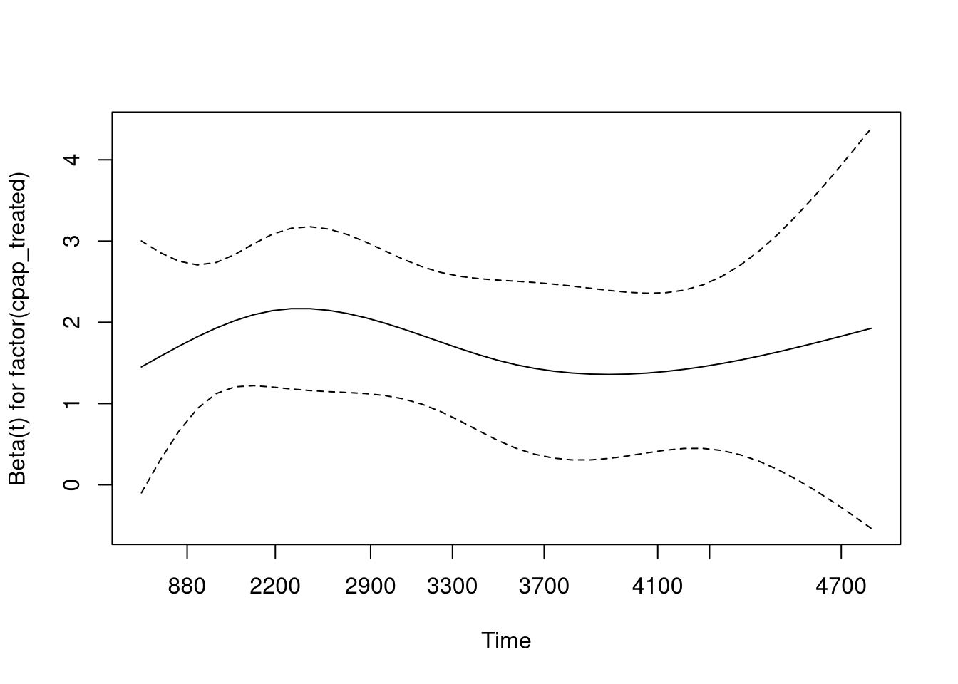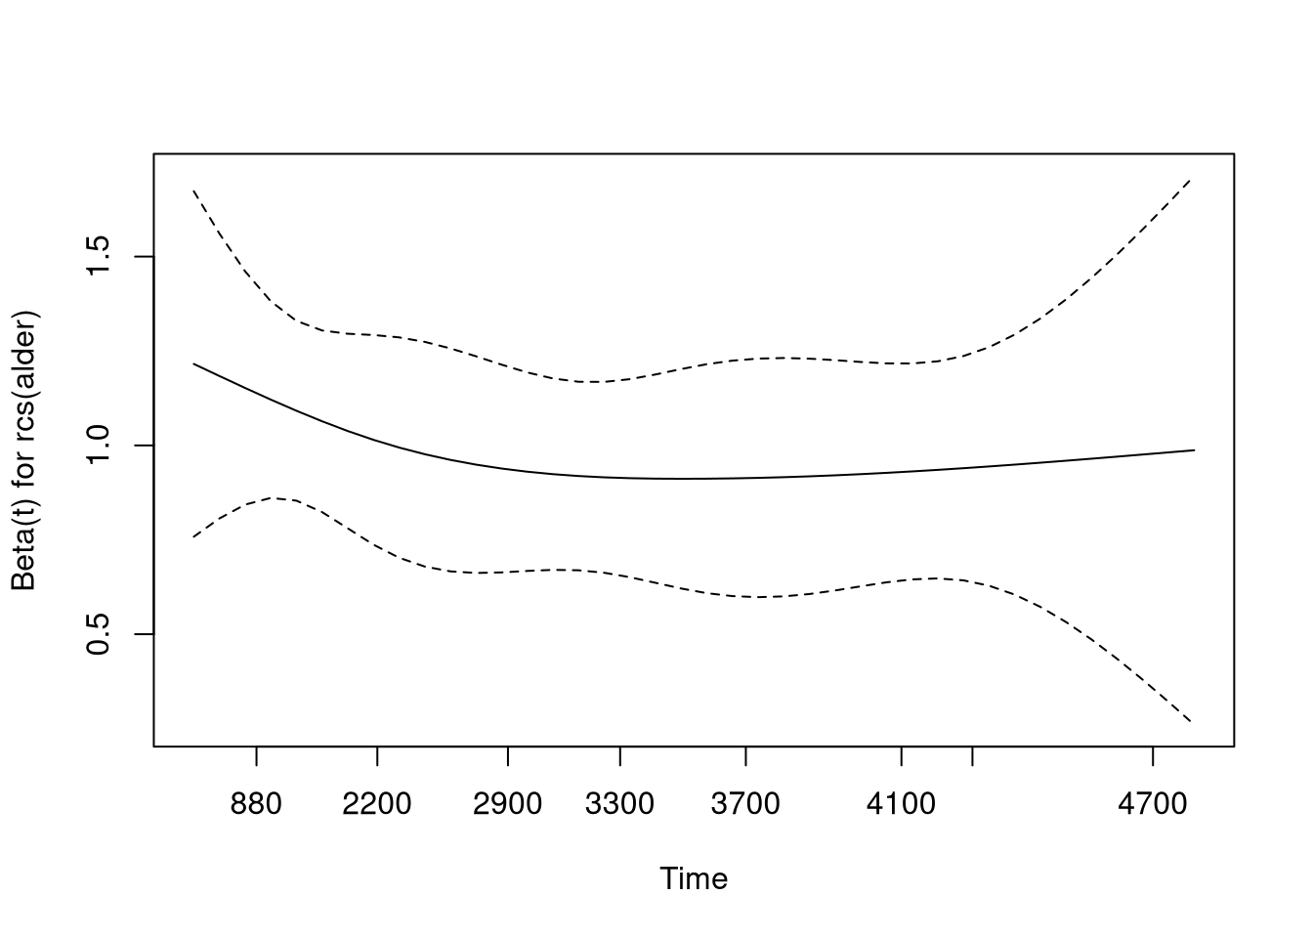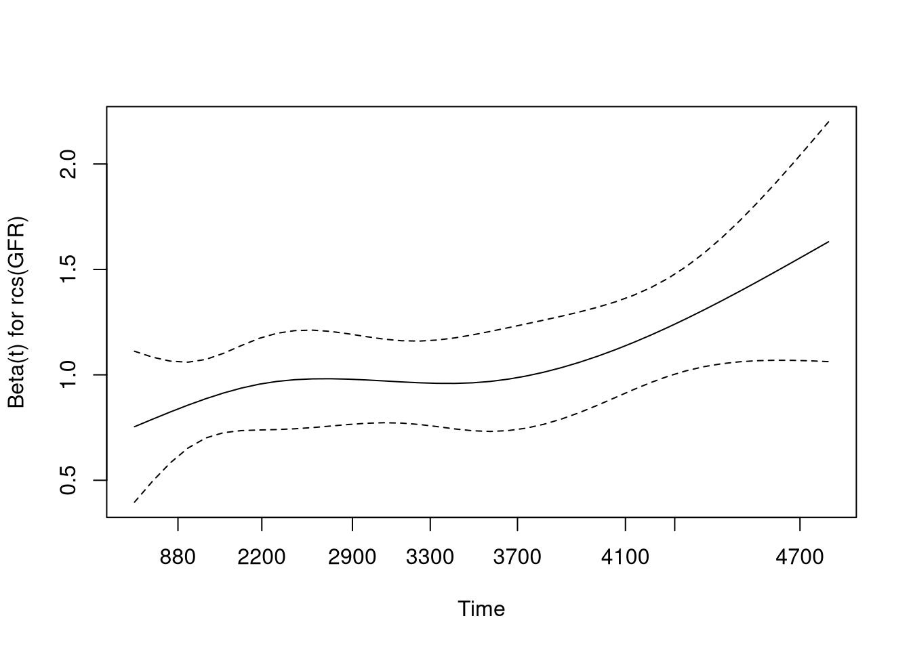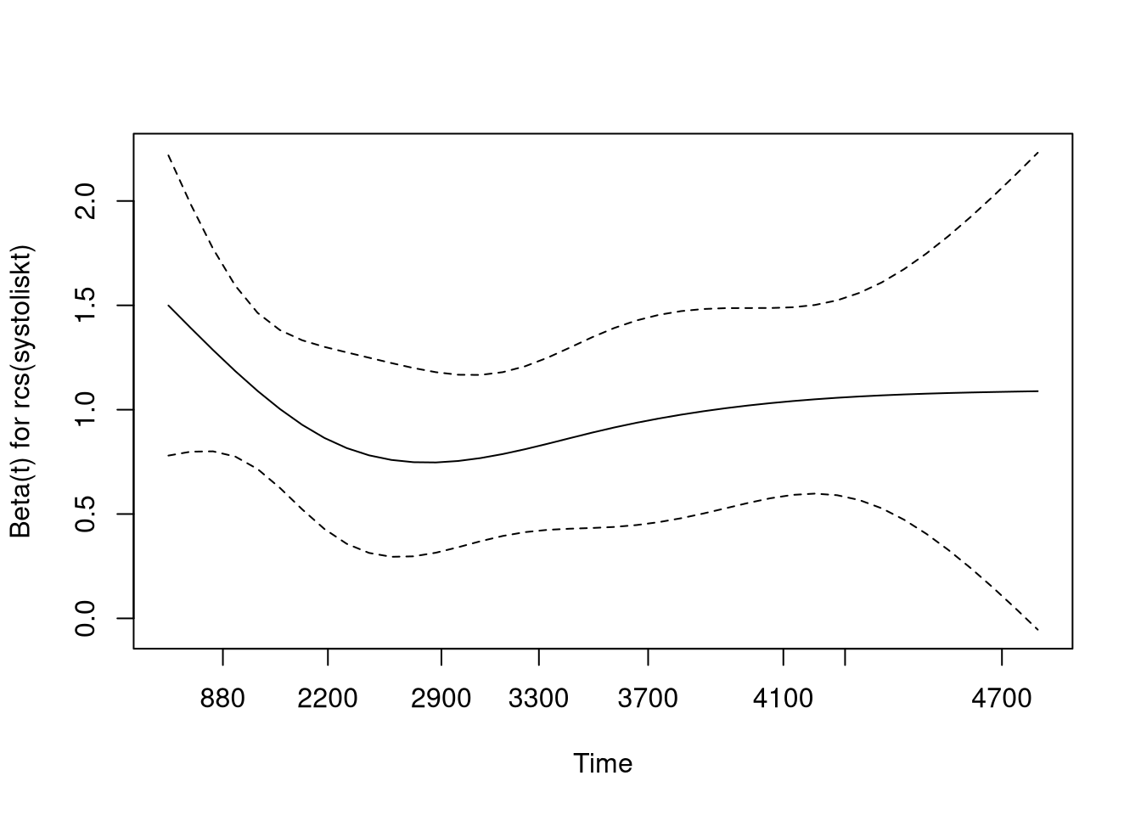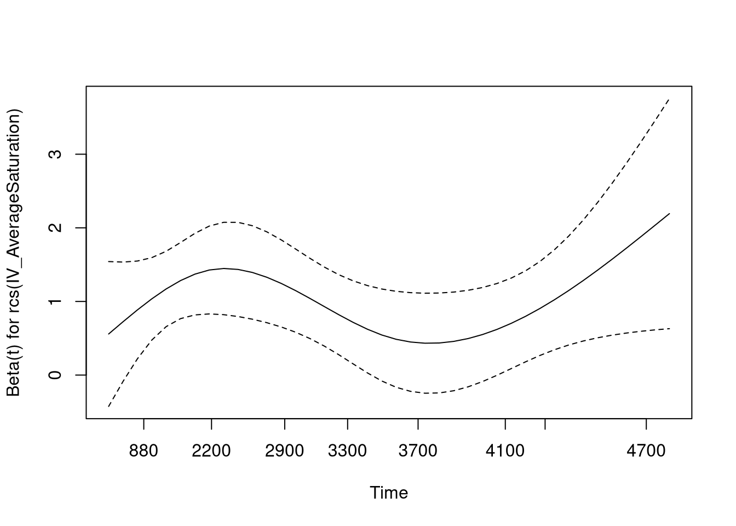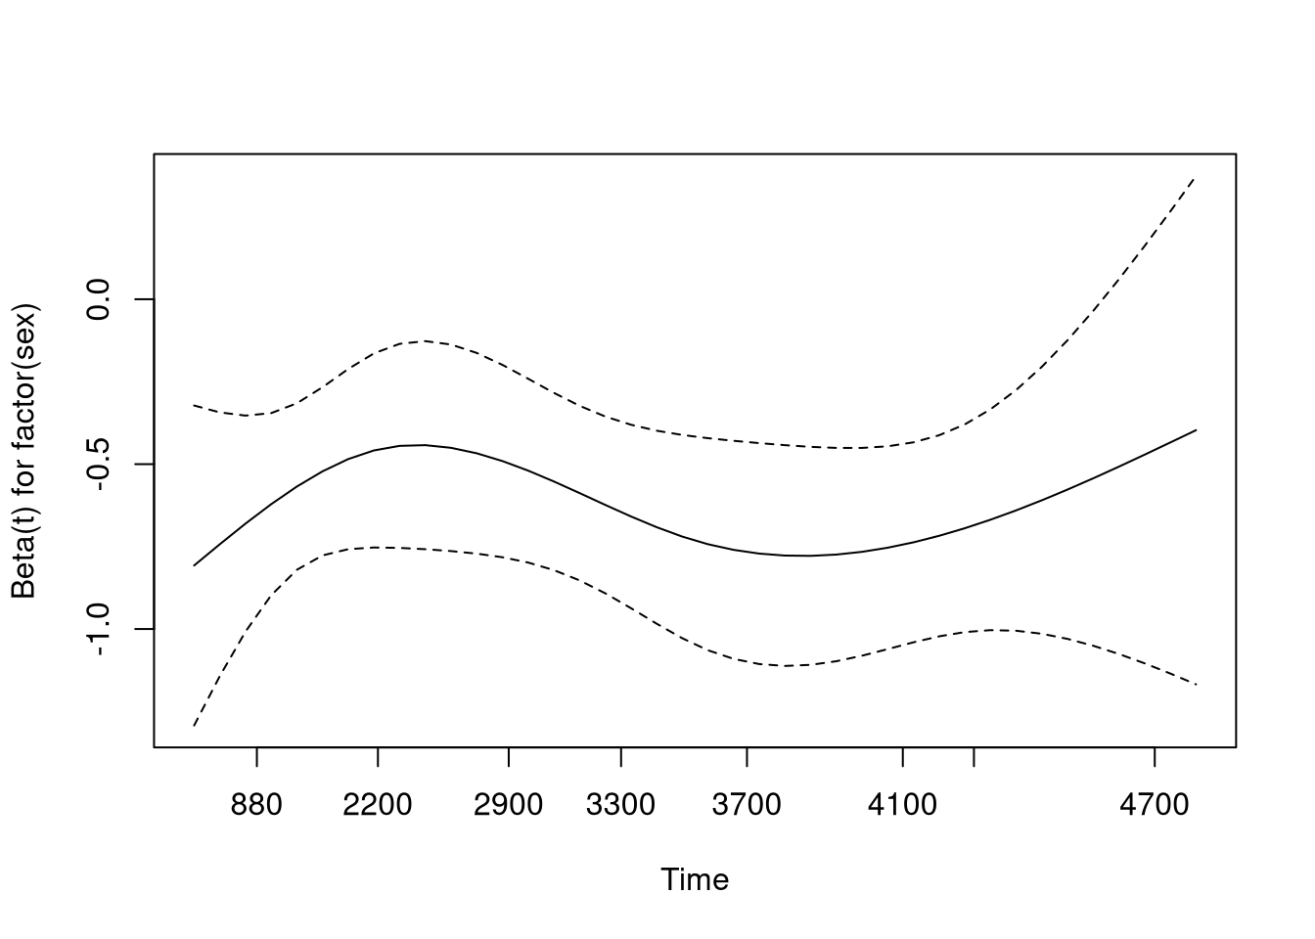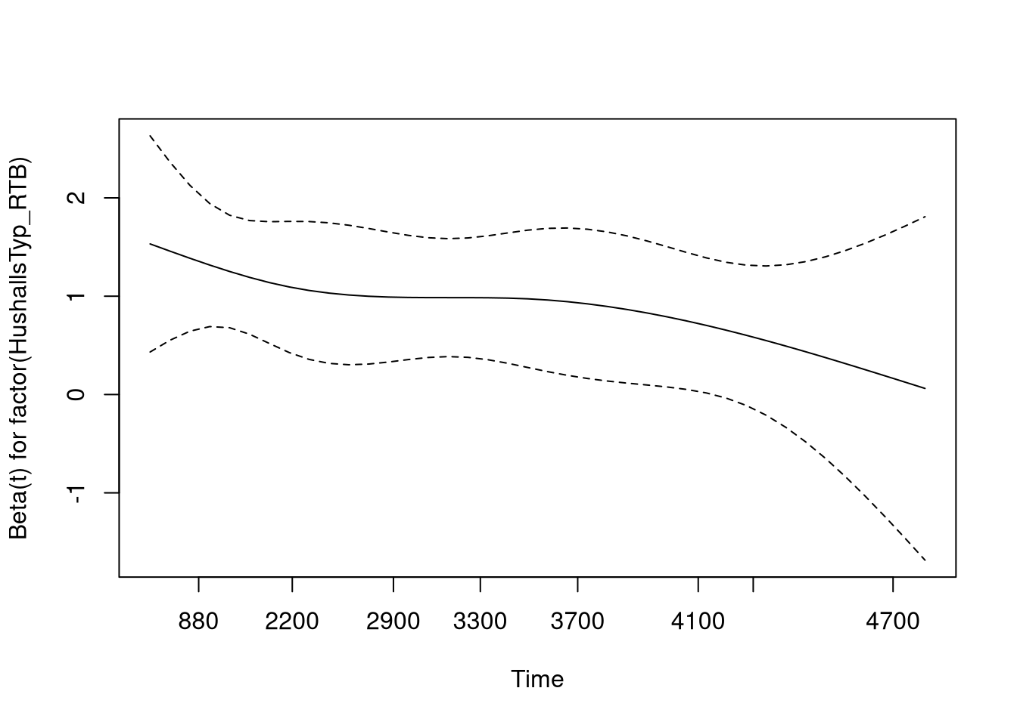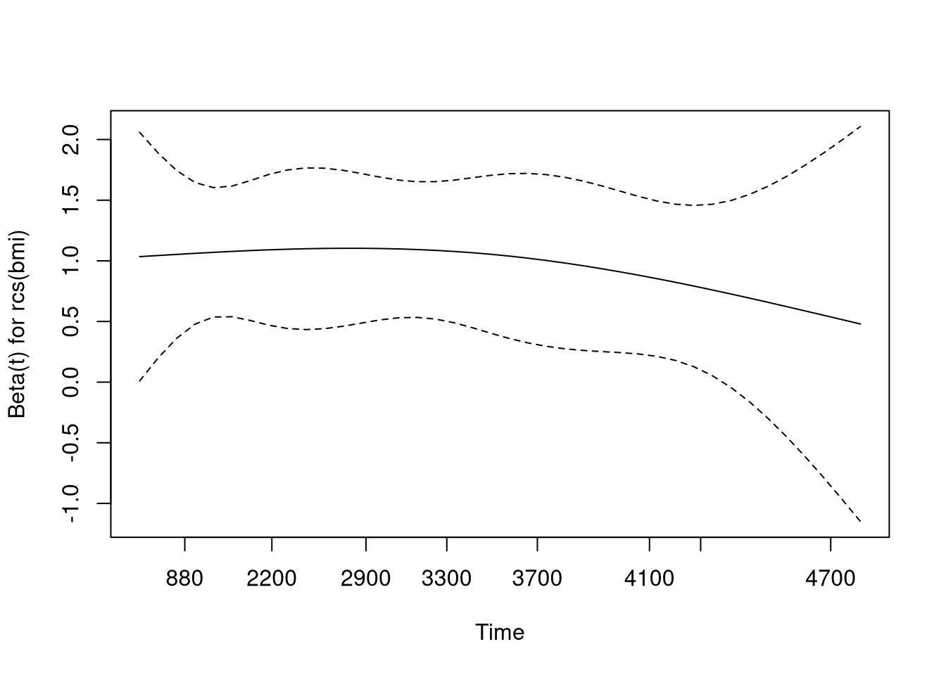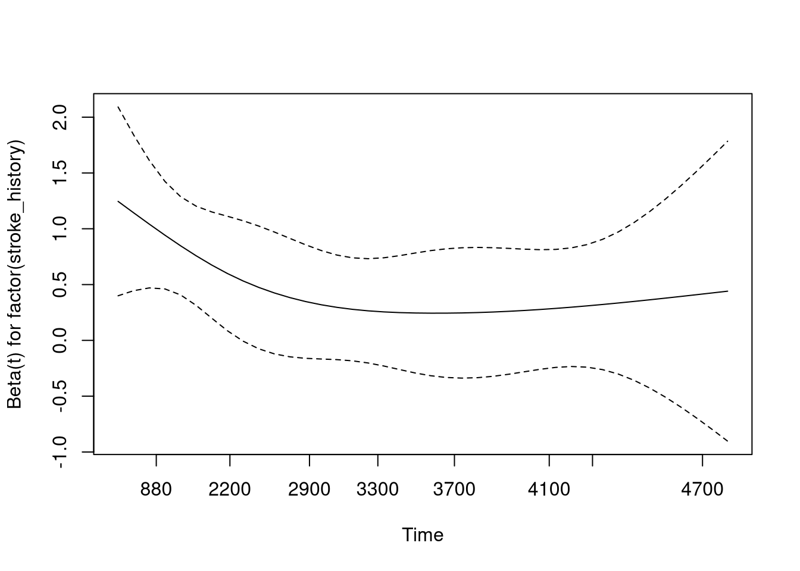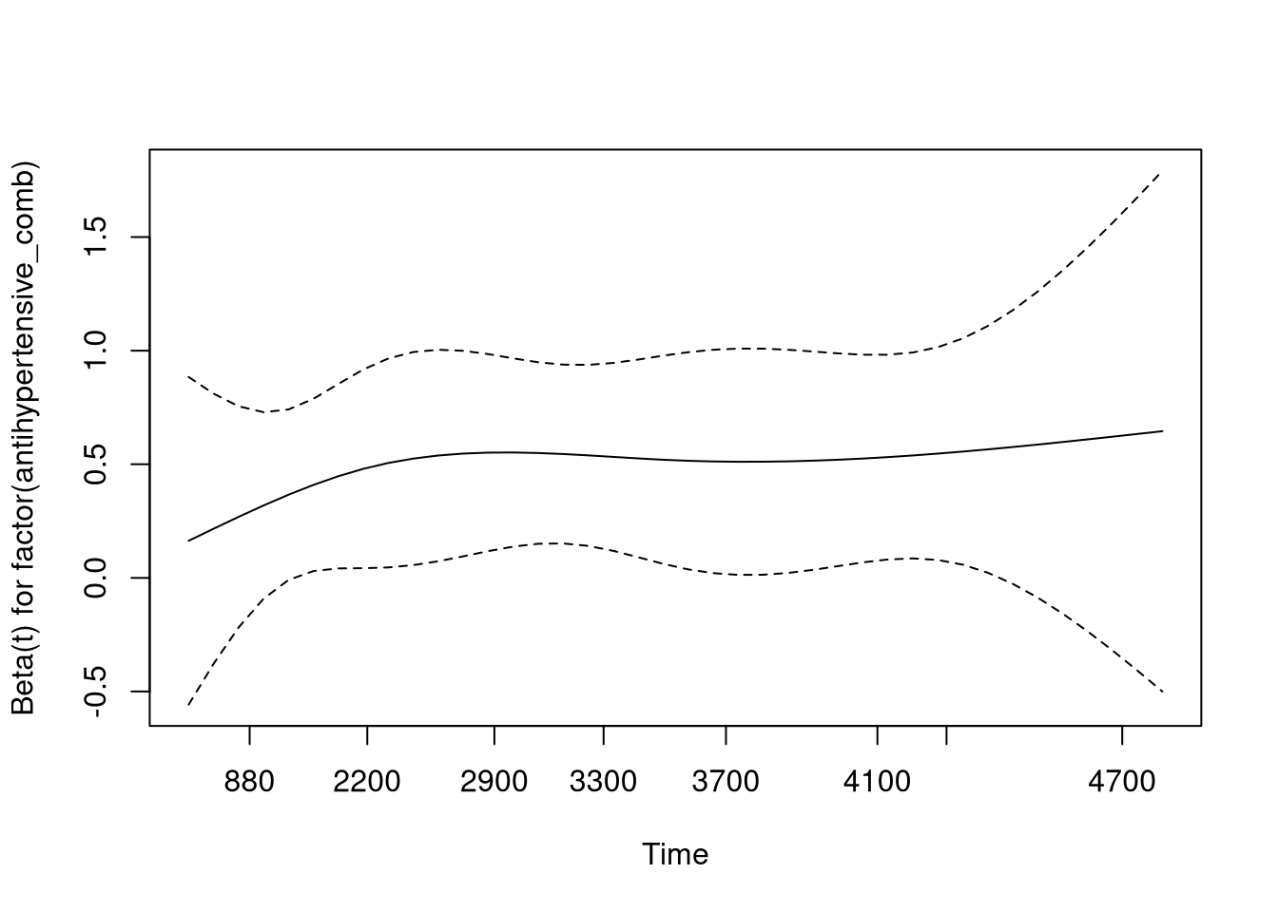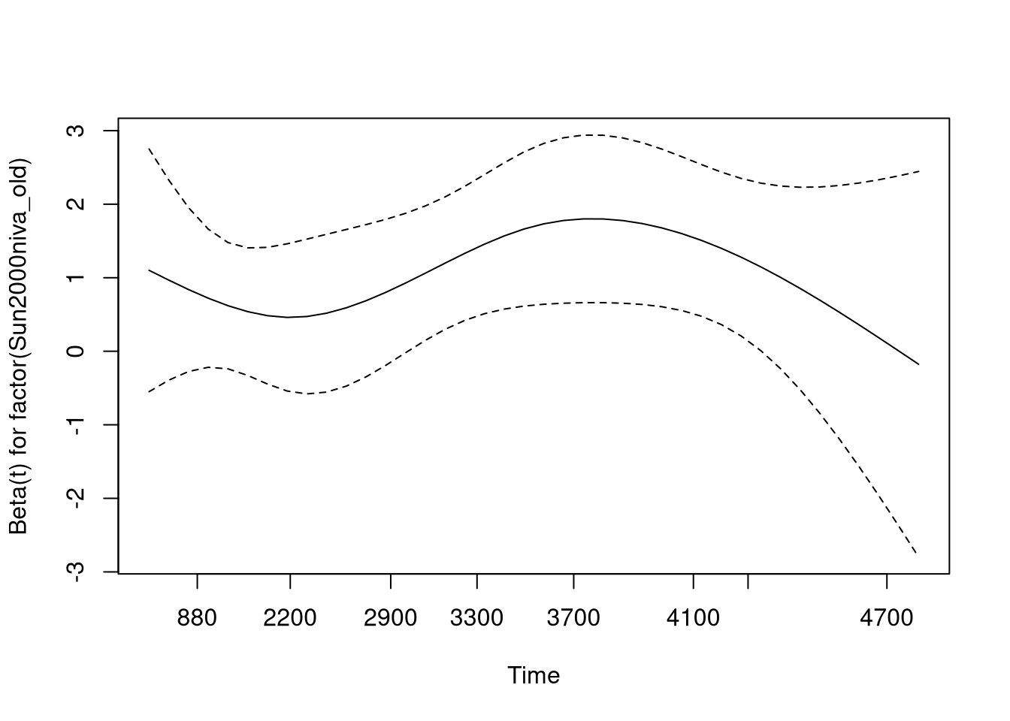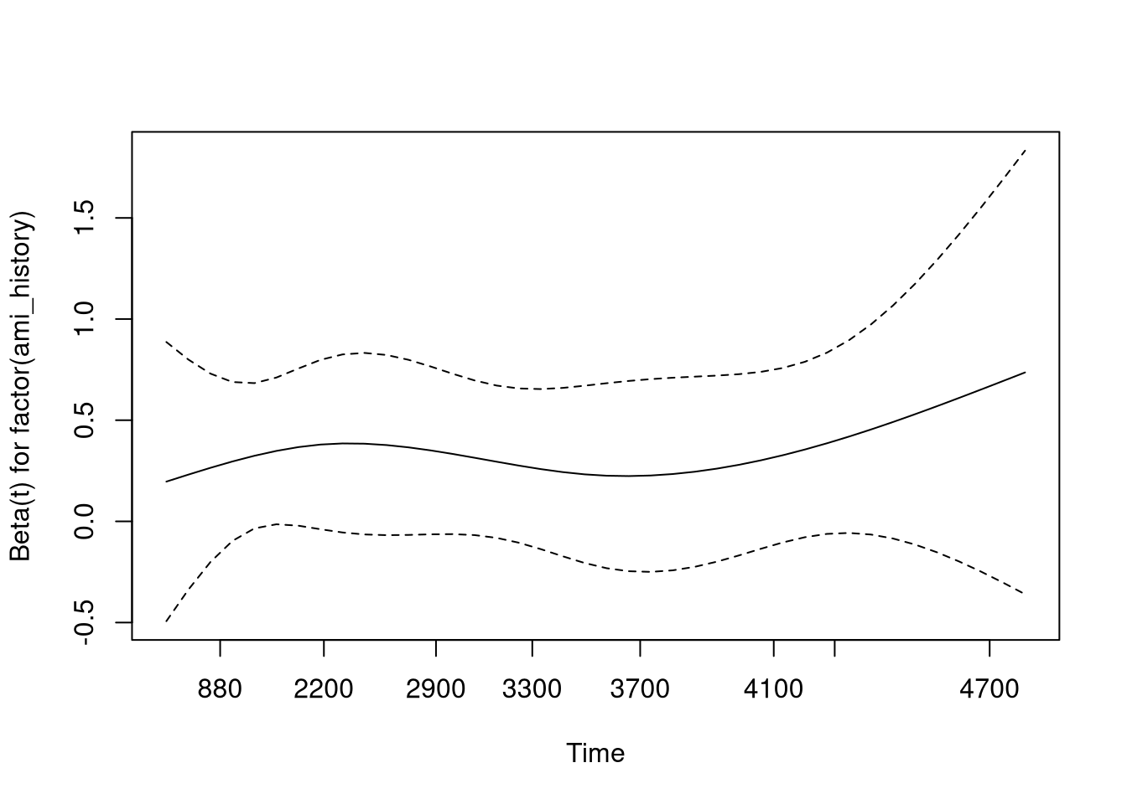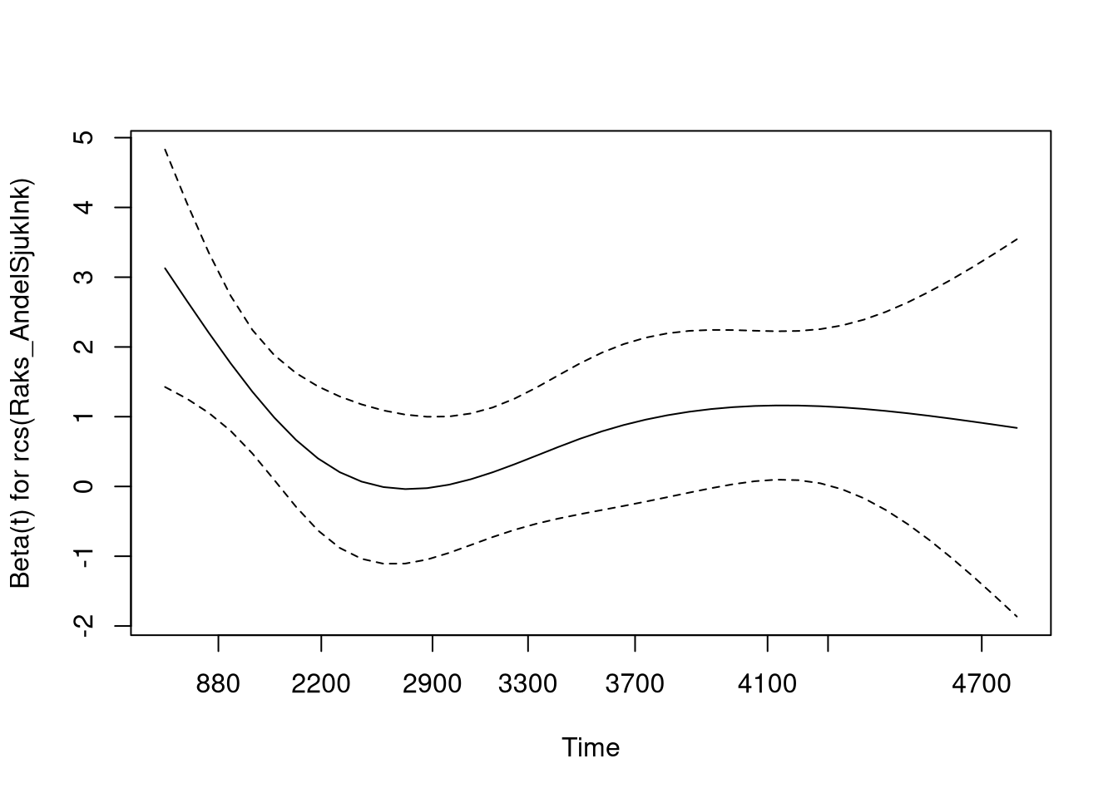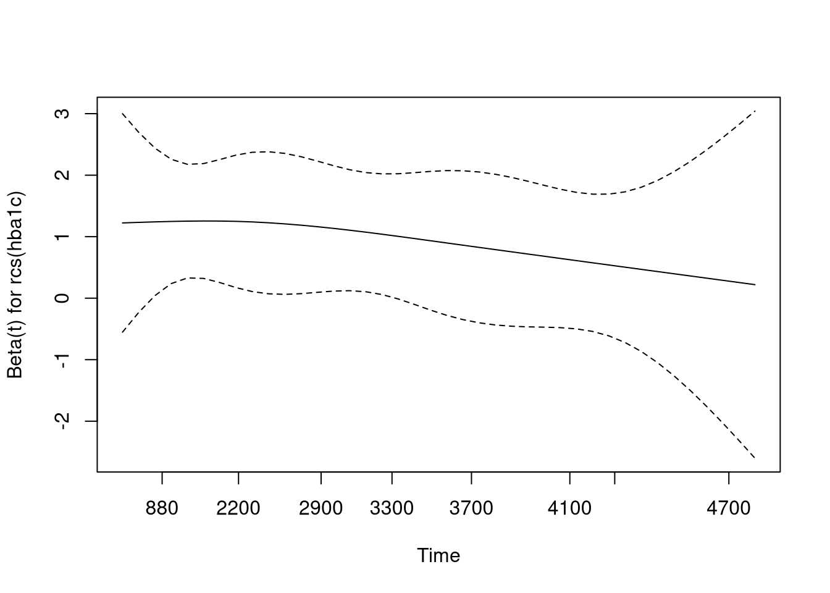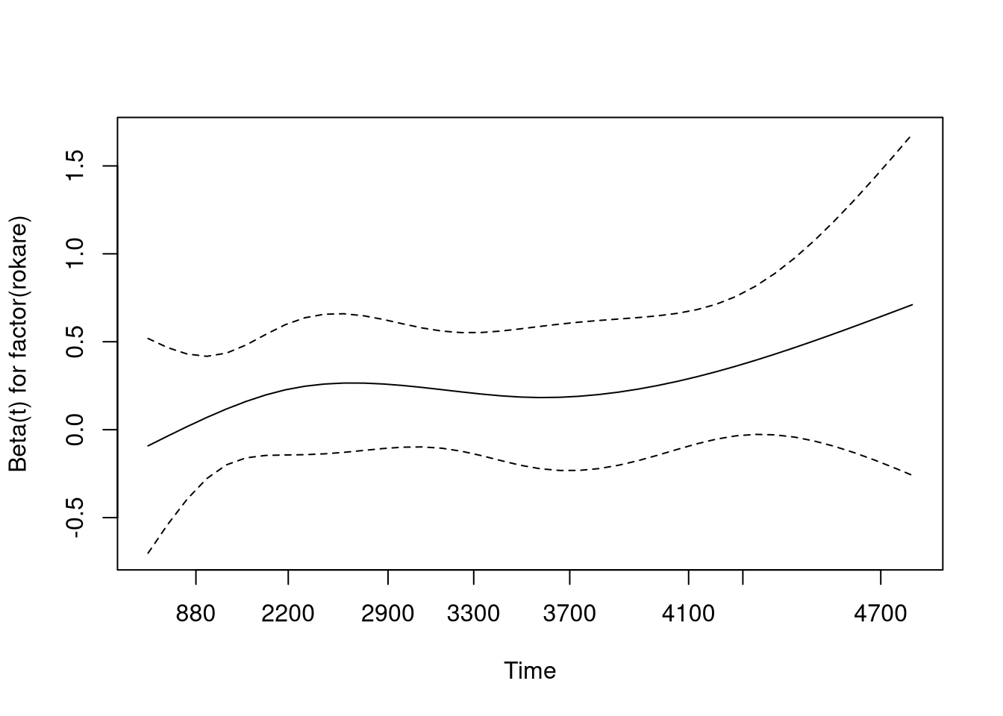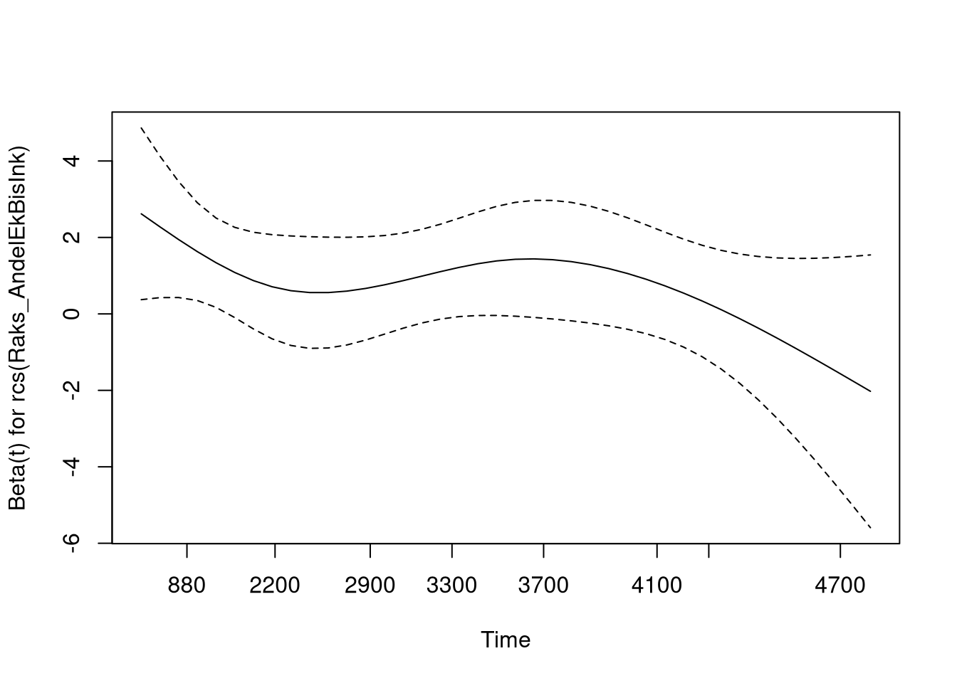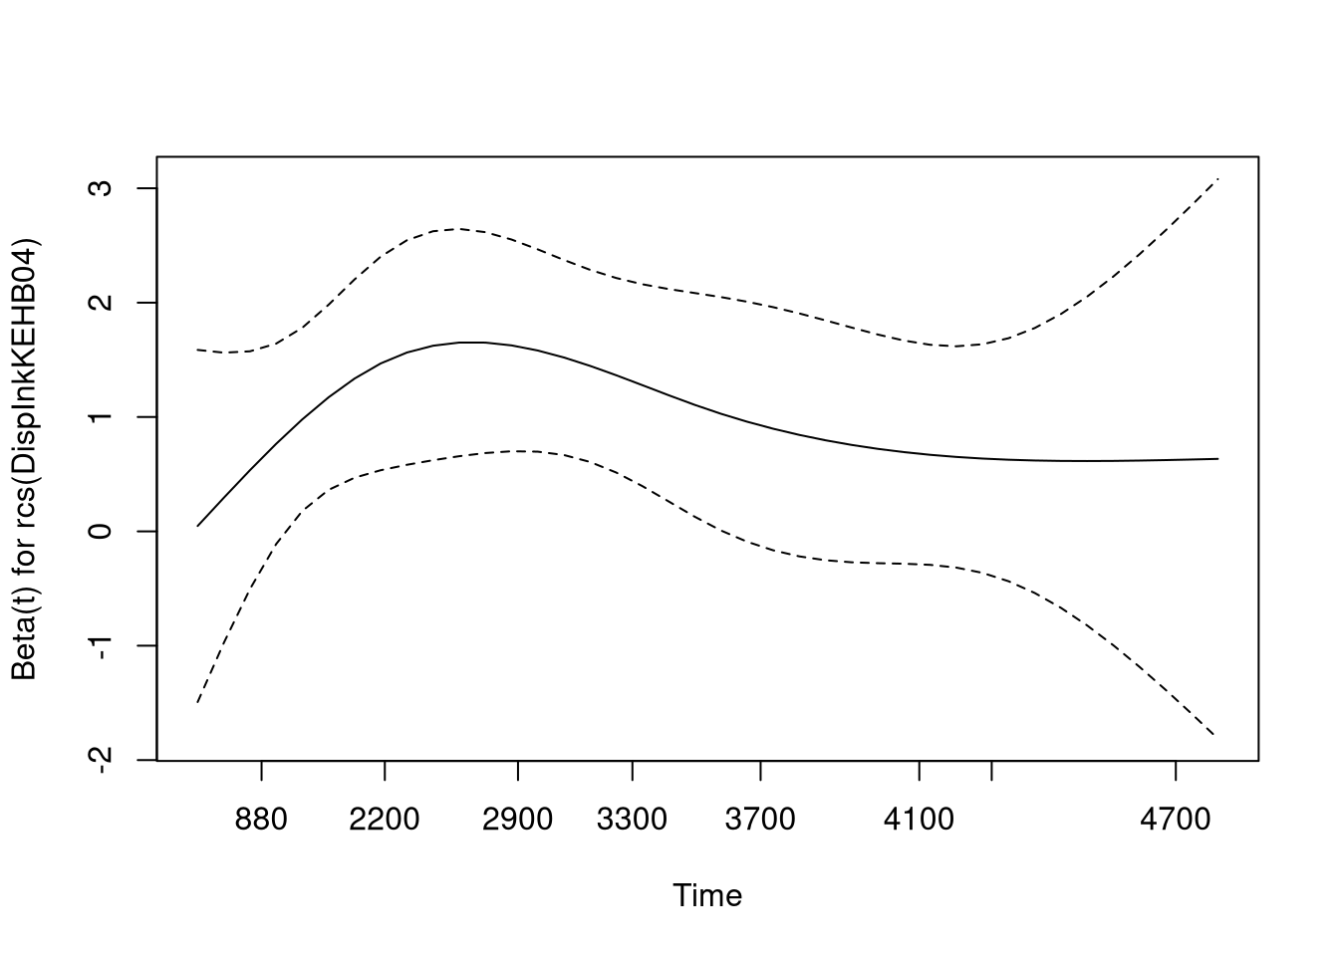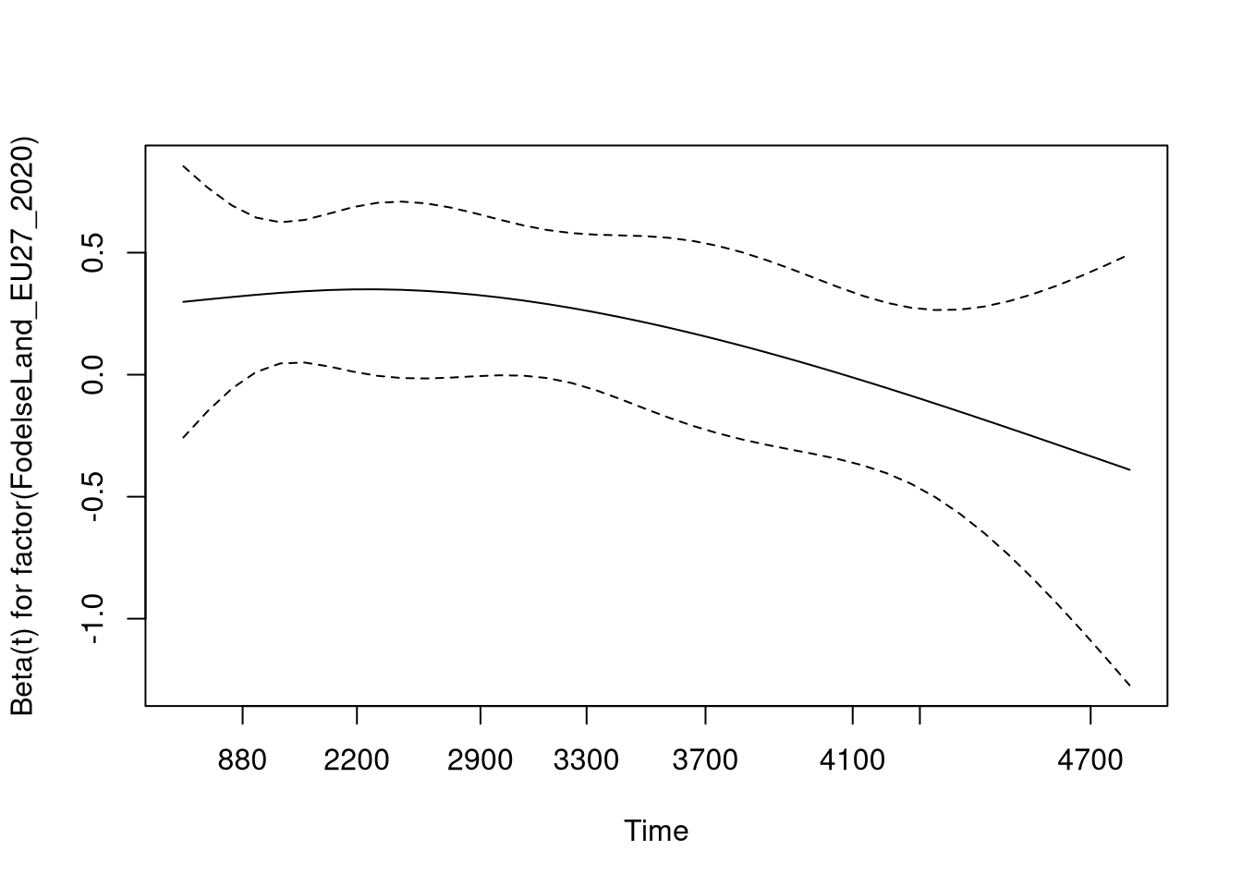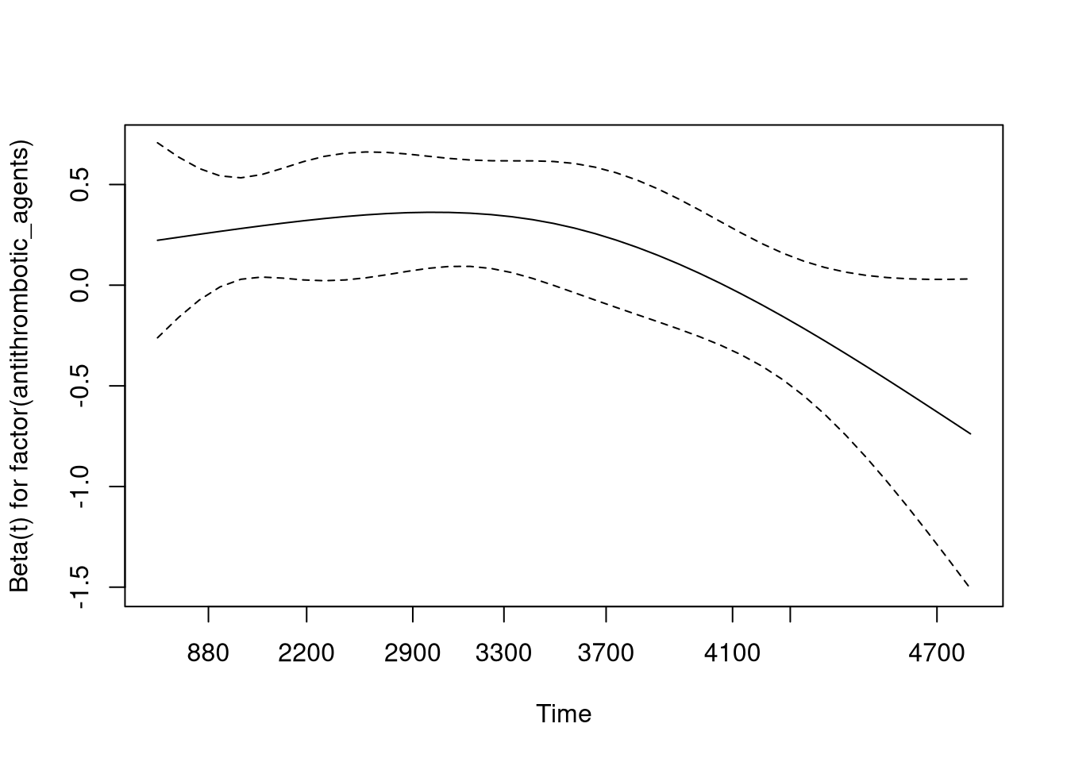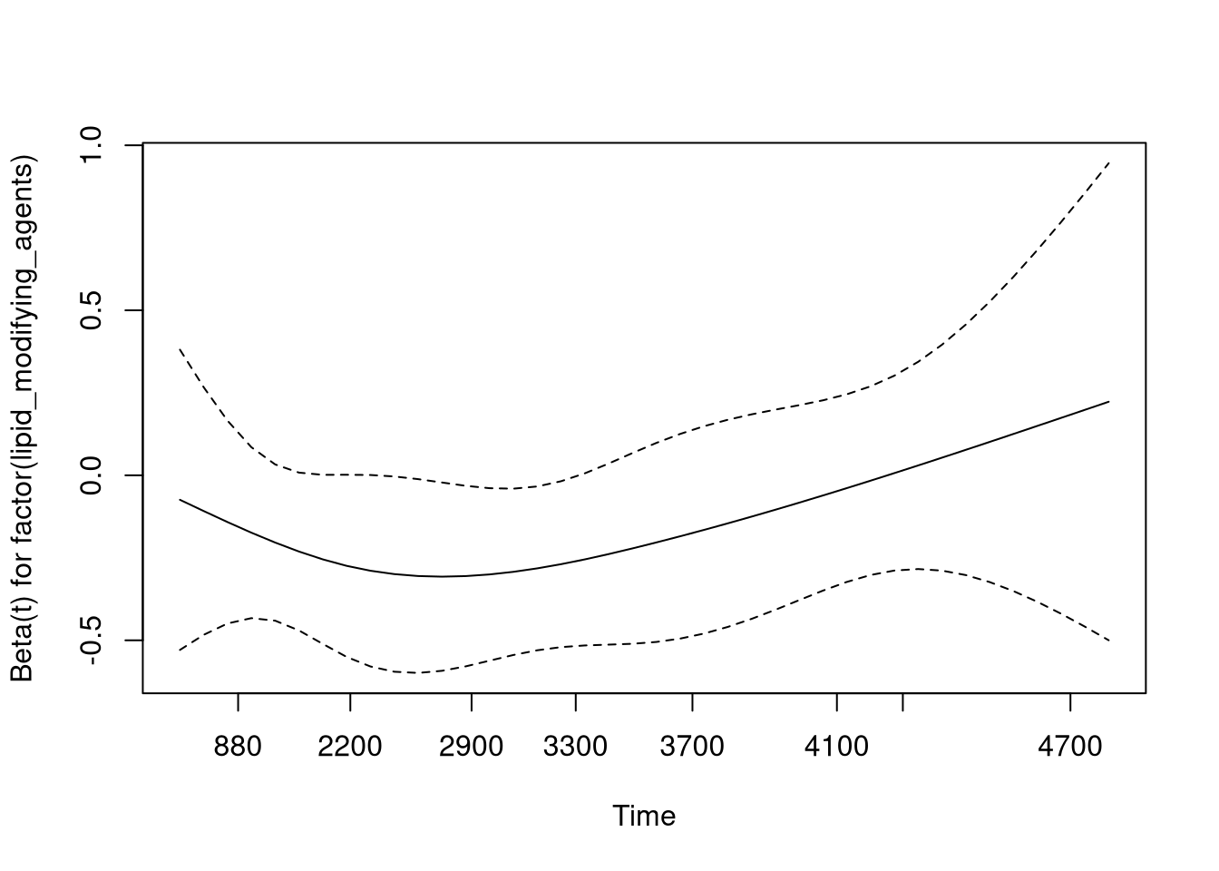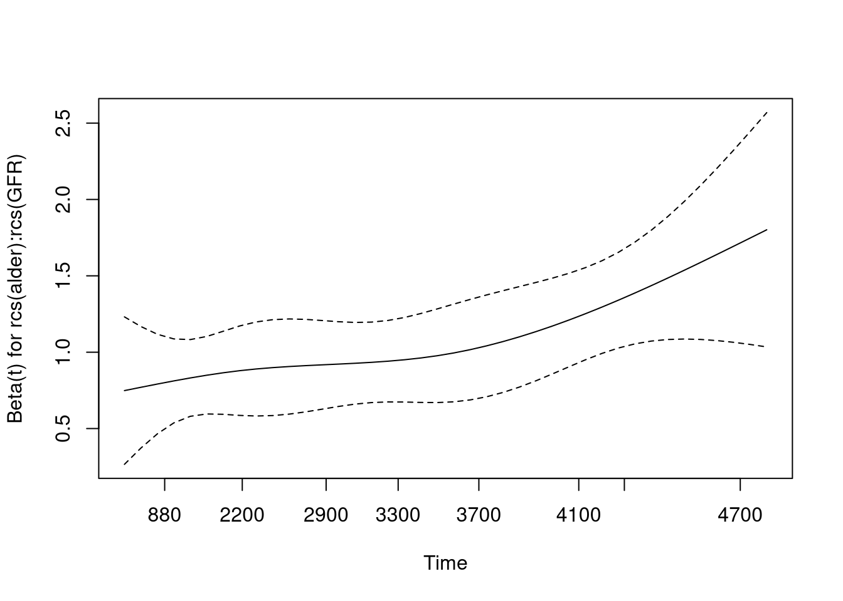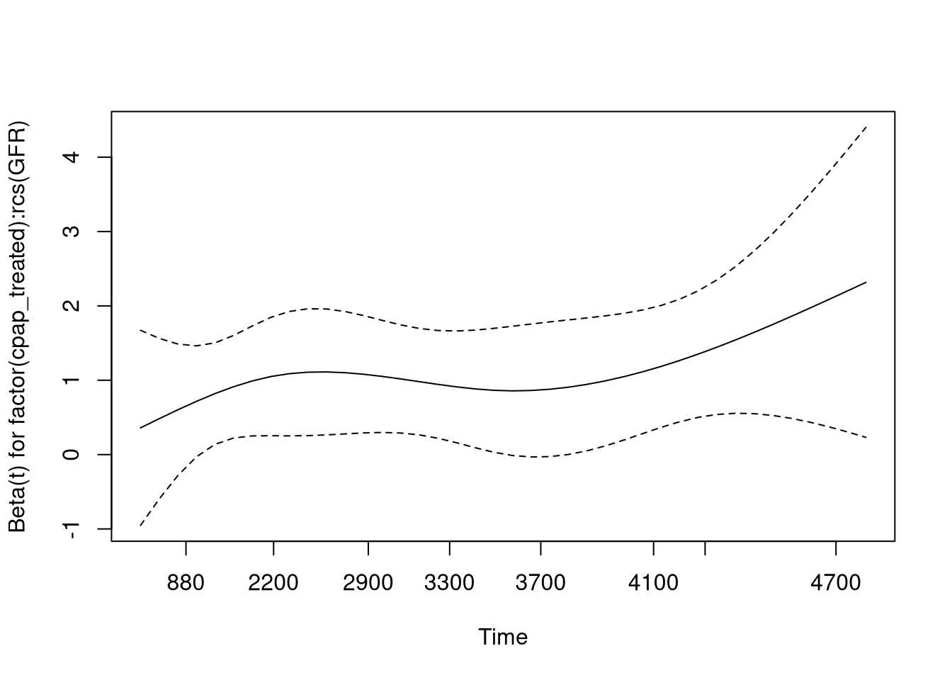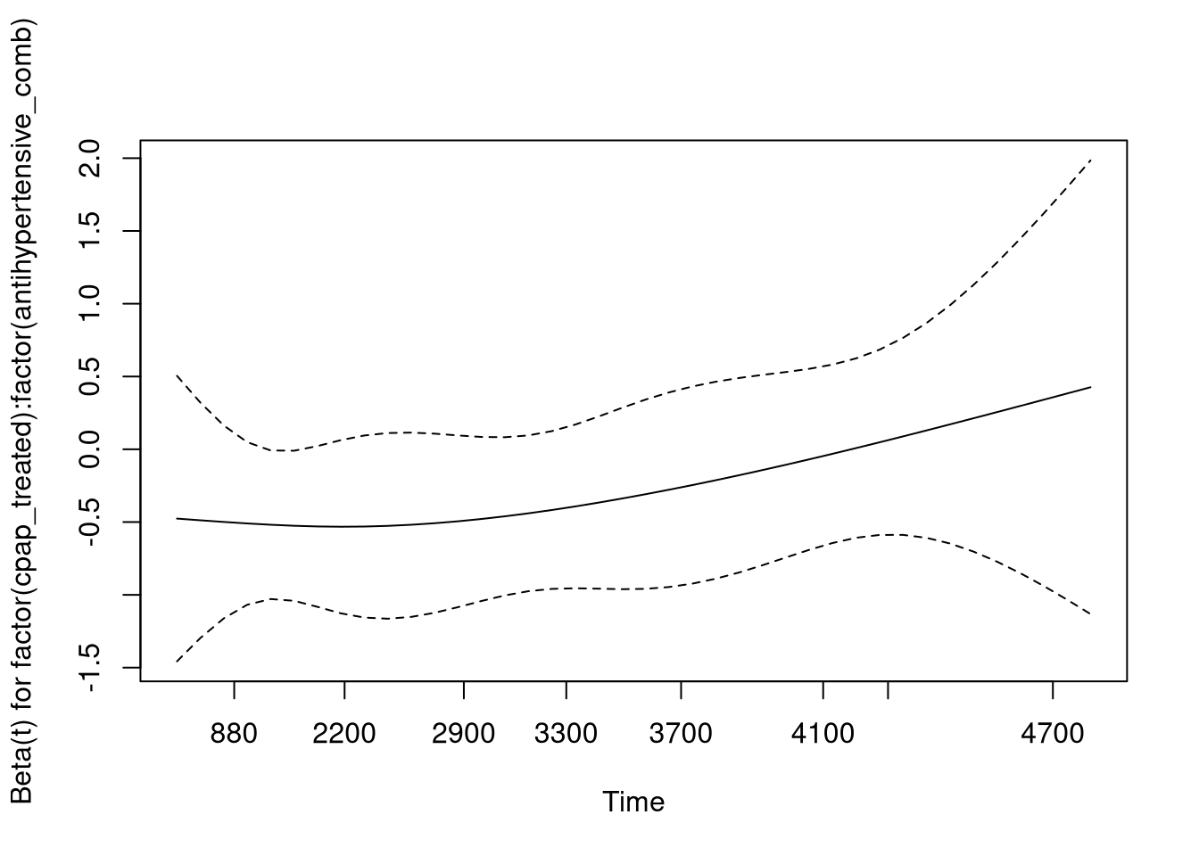

## Warning in termplot(cph): 'model' appears to involve interactions: see the help

## page

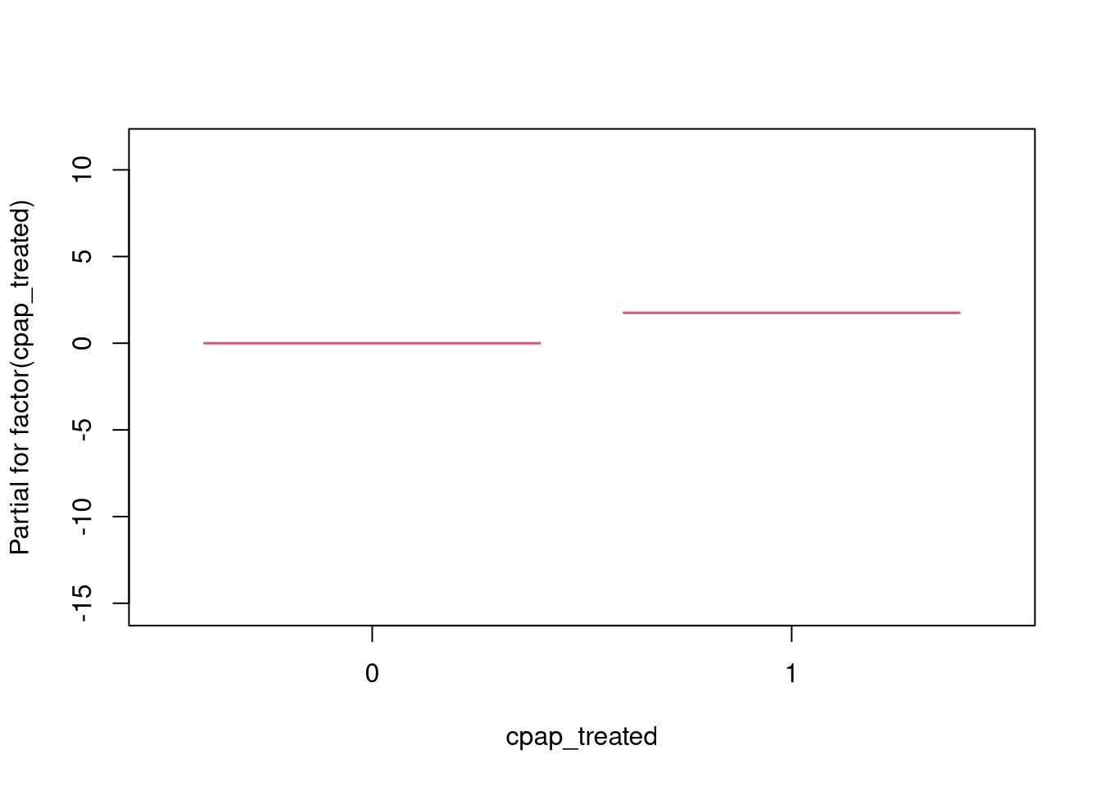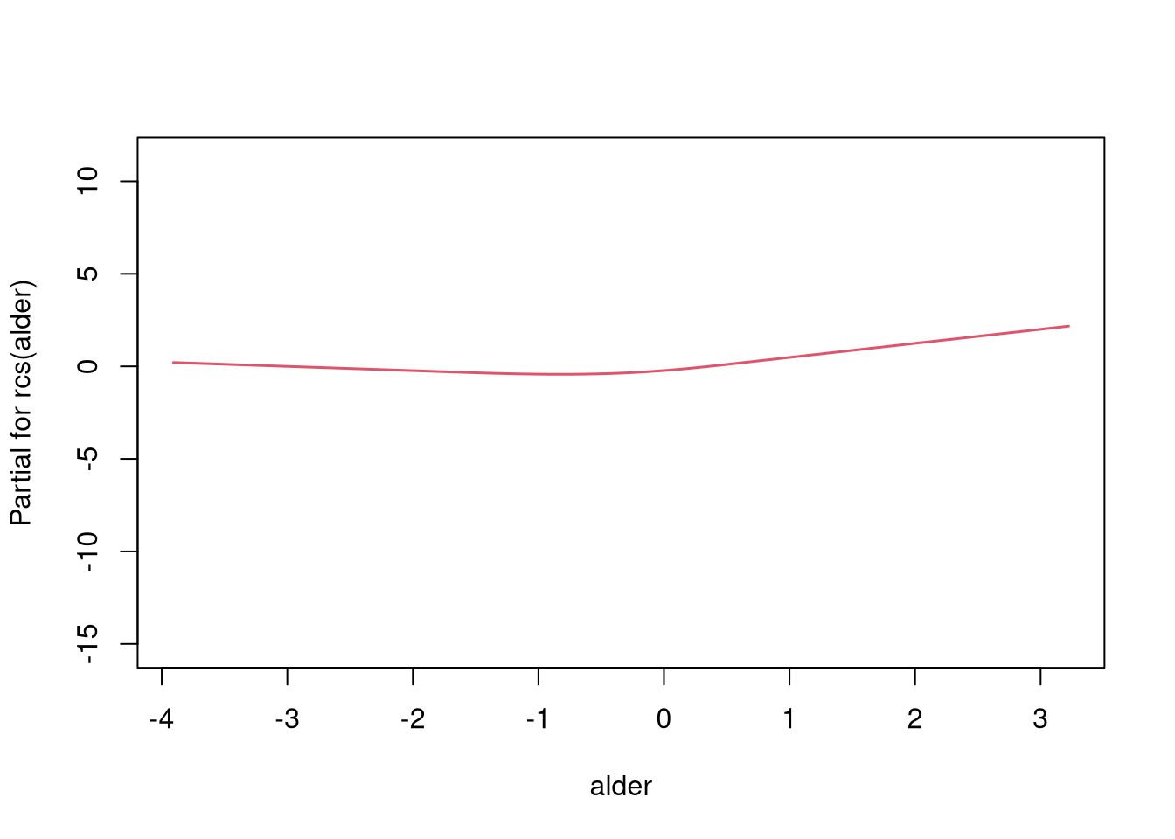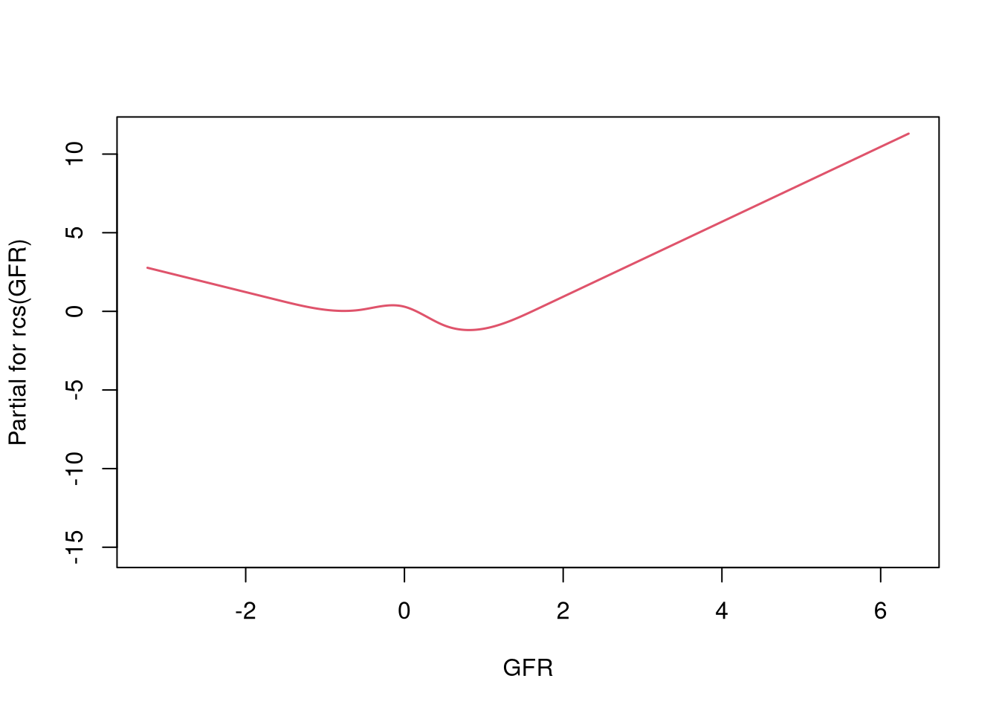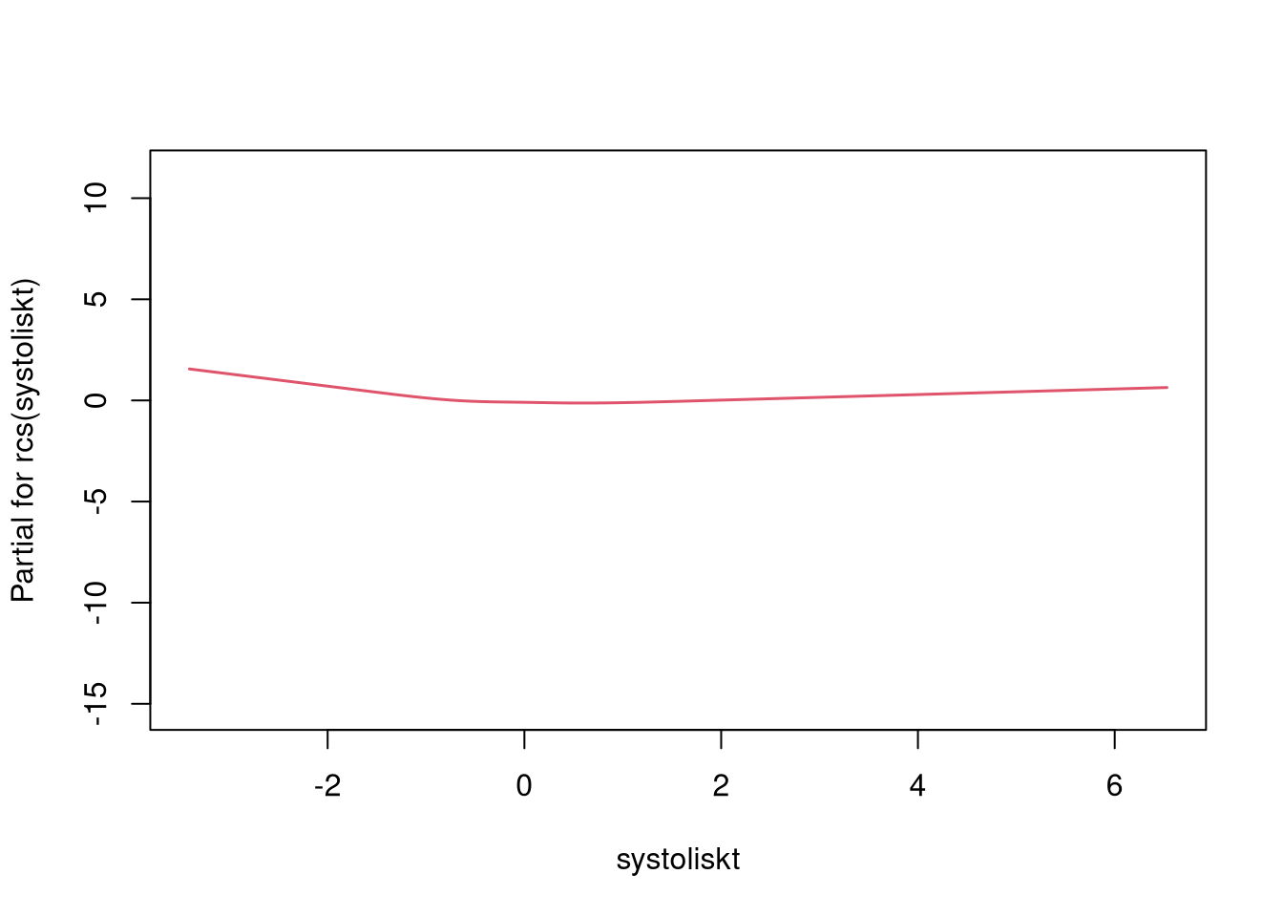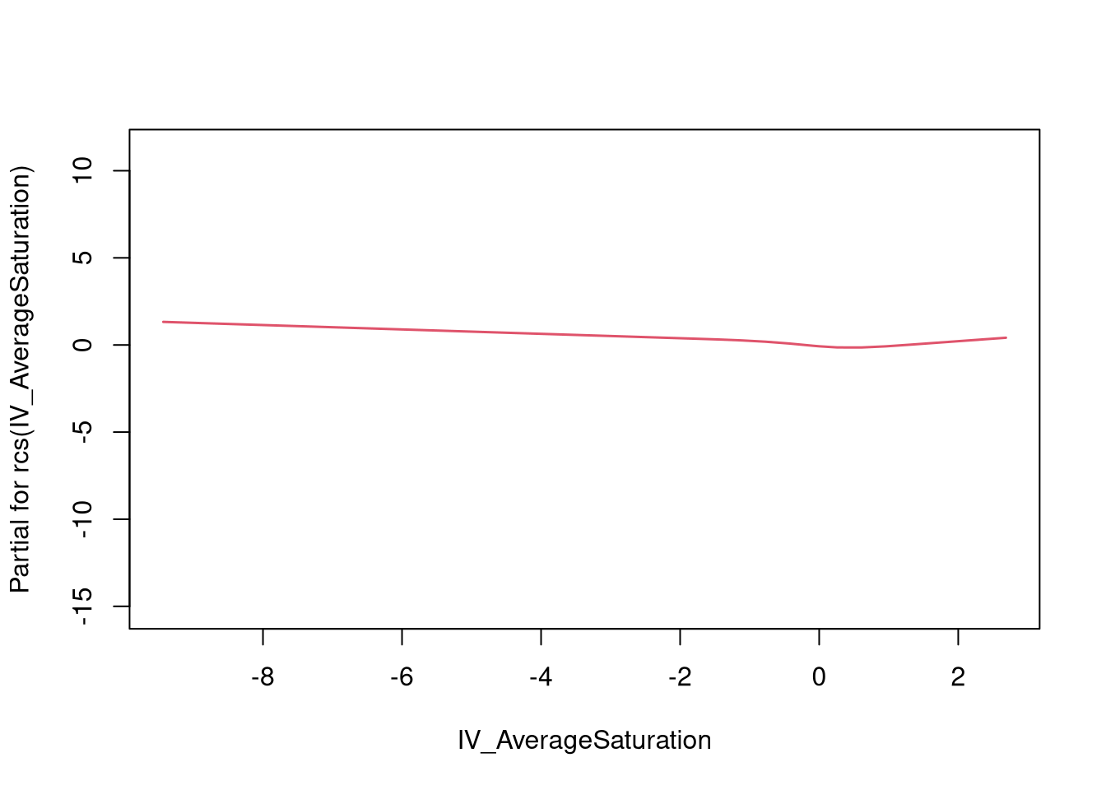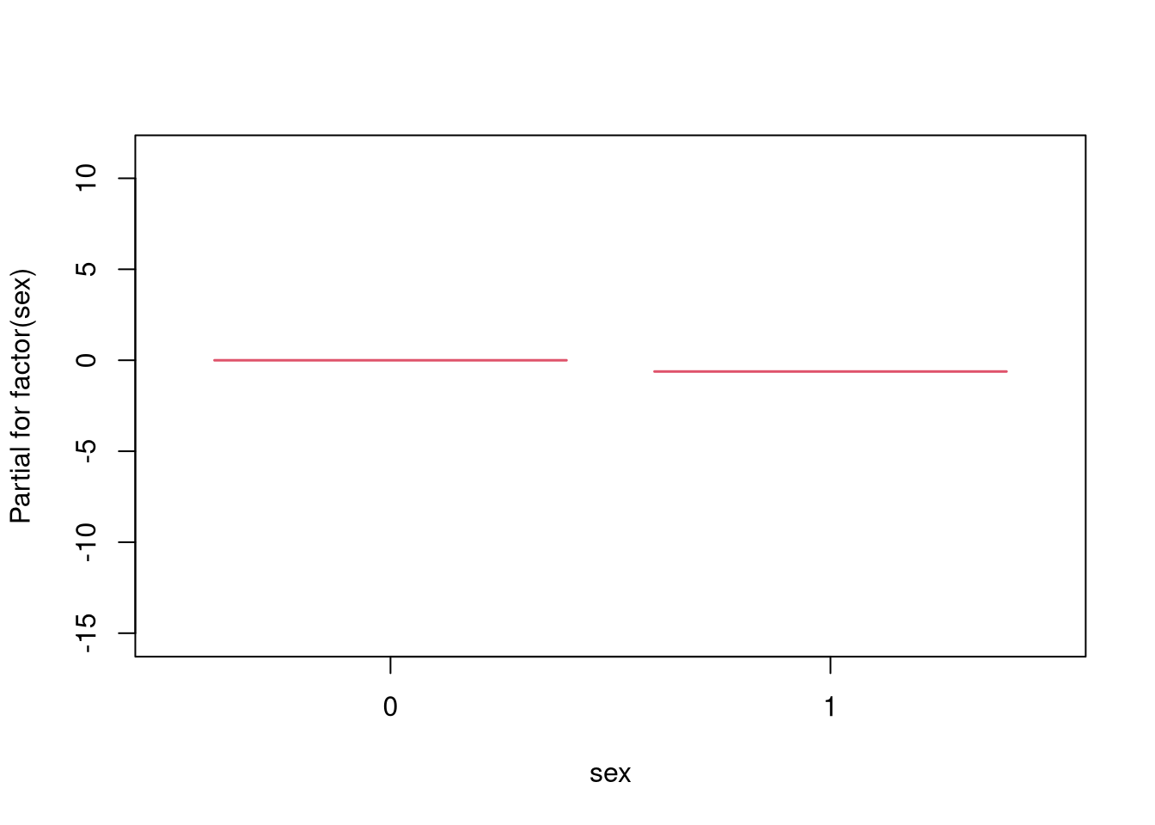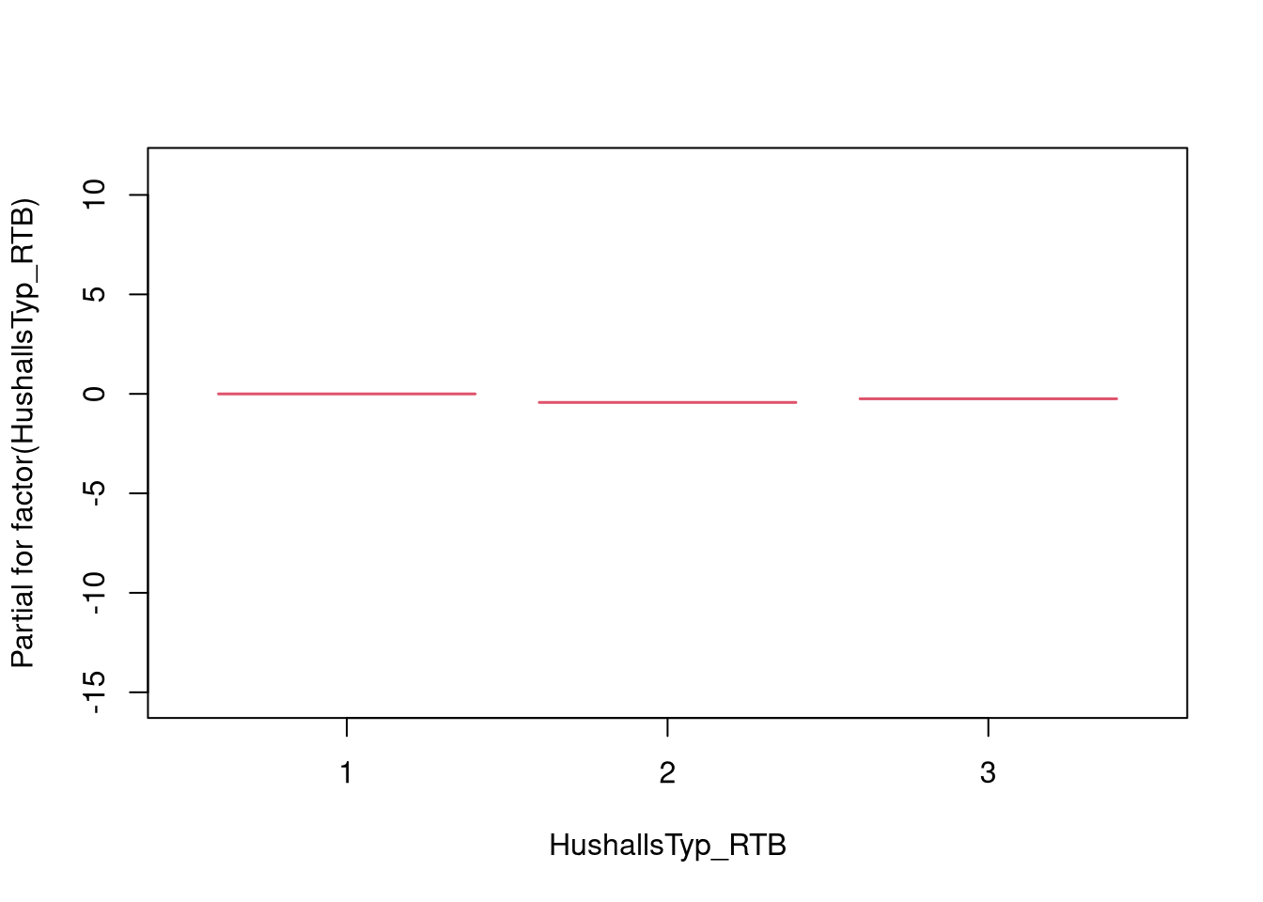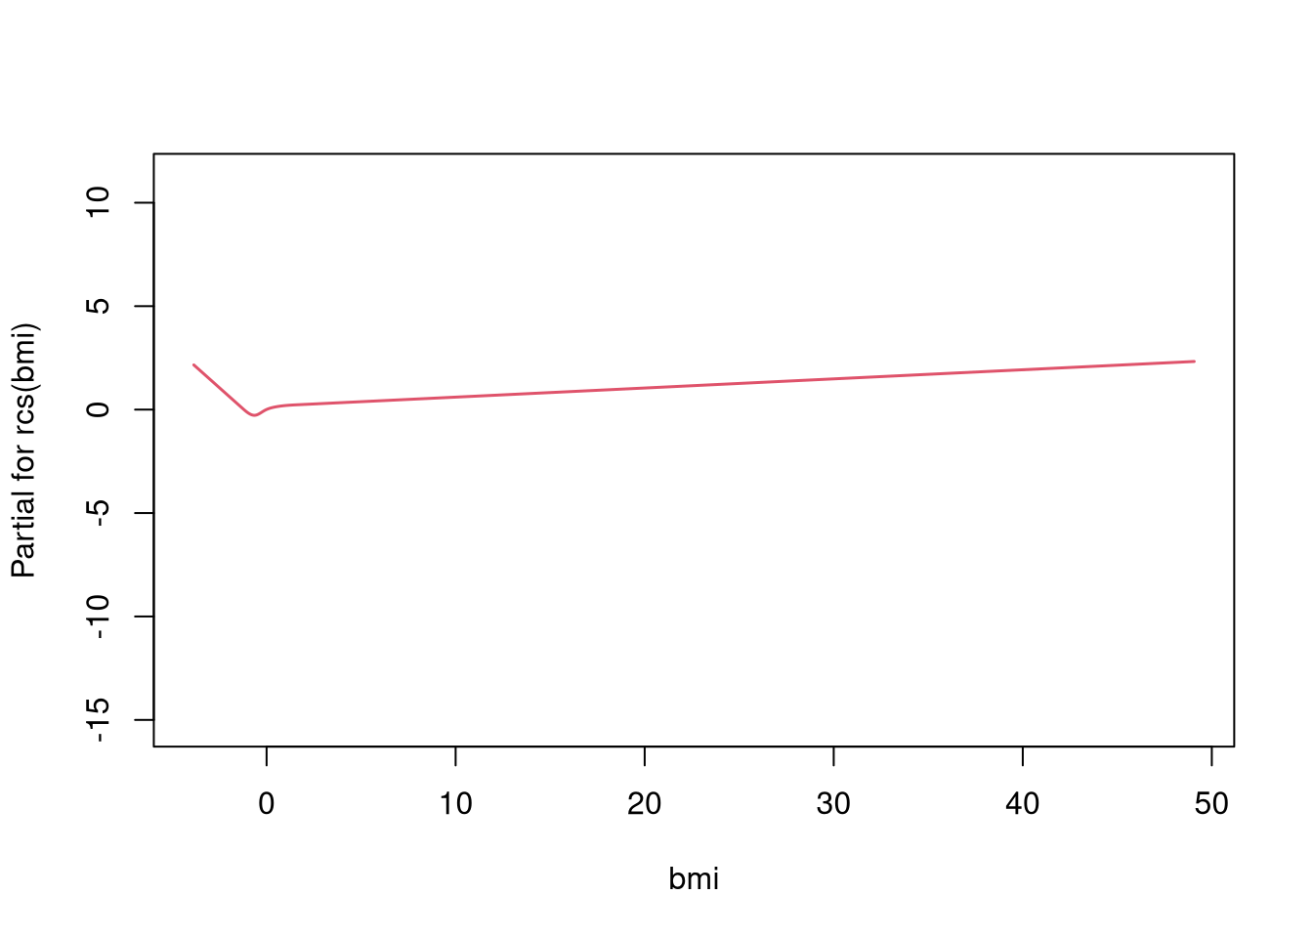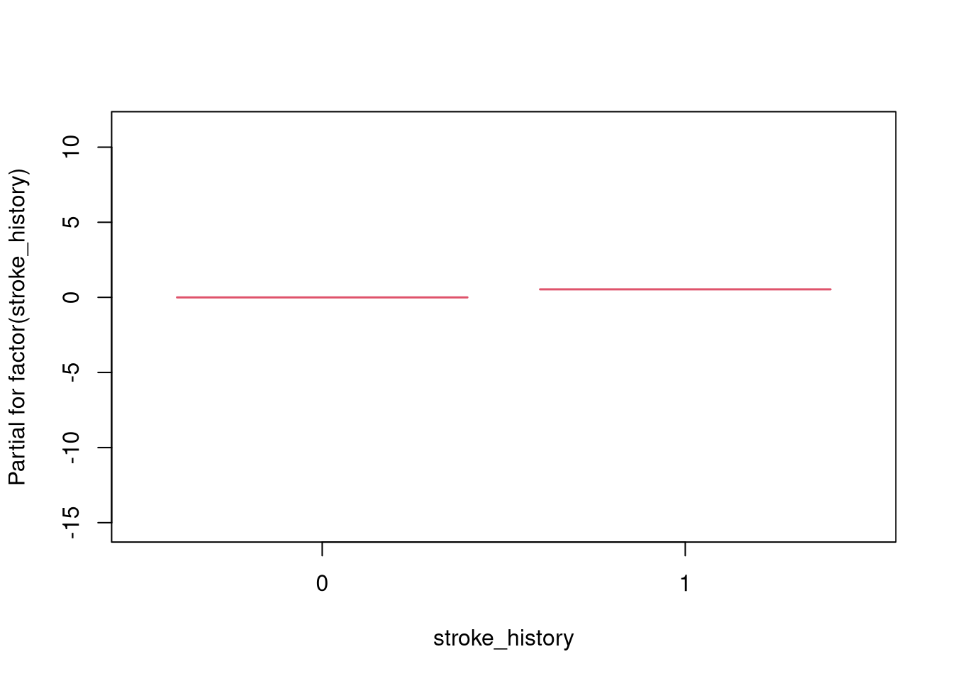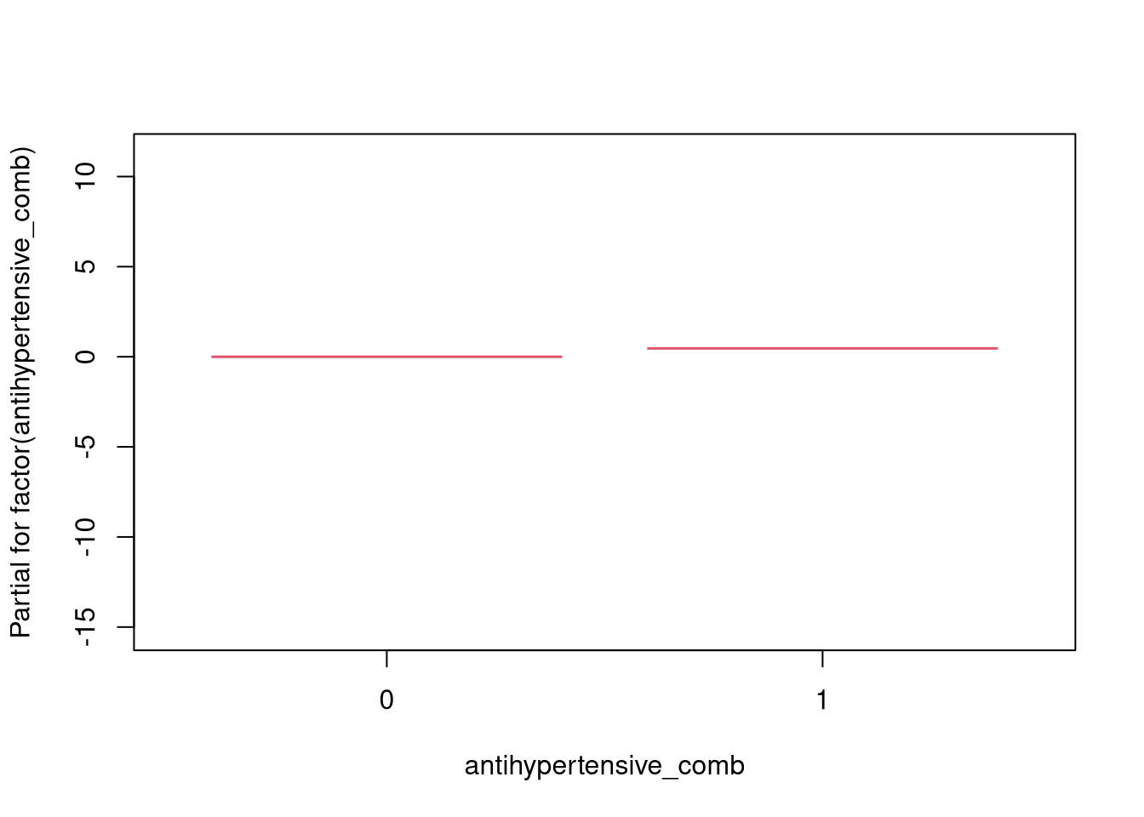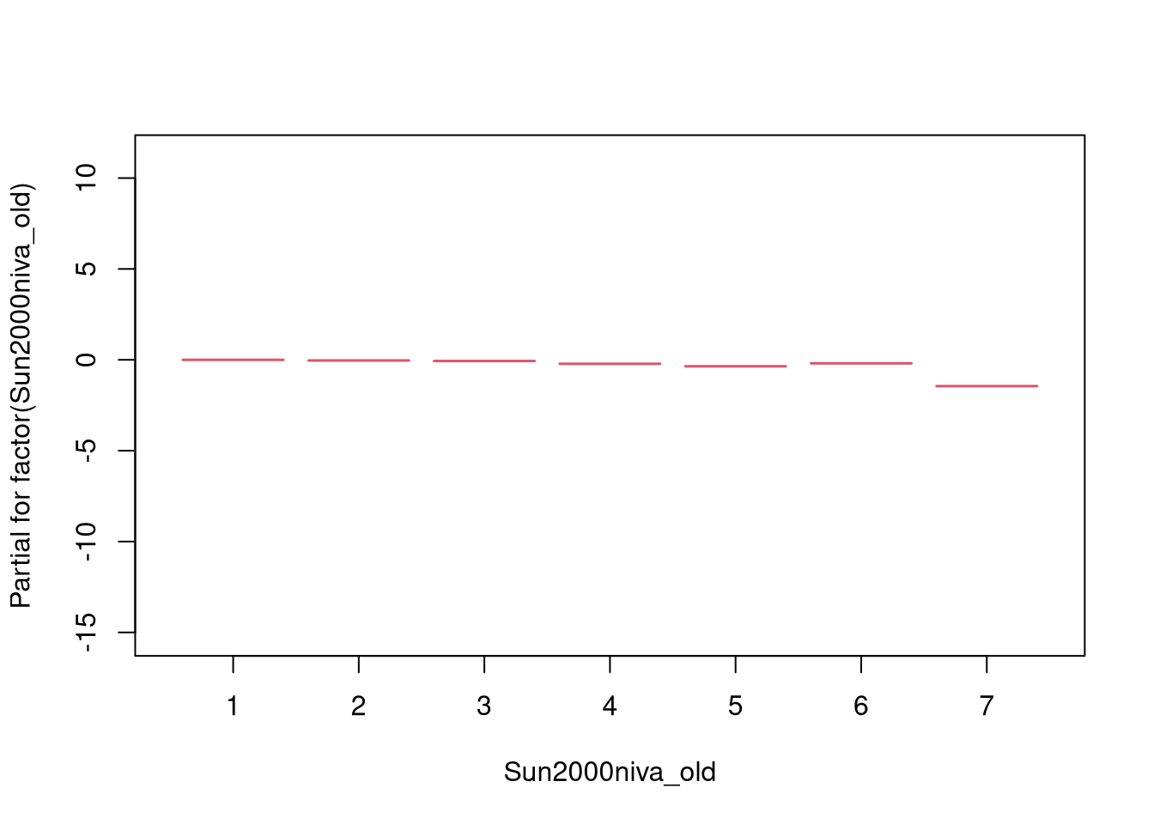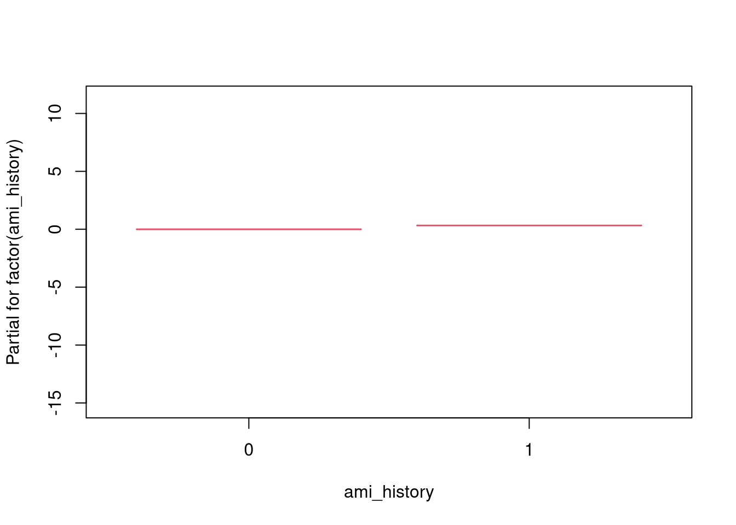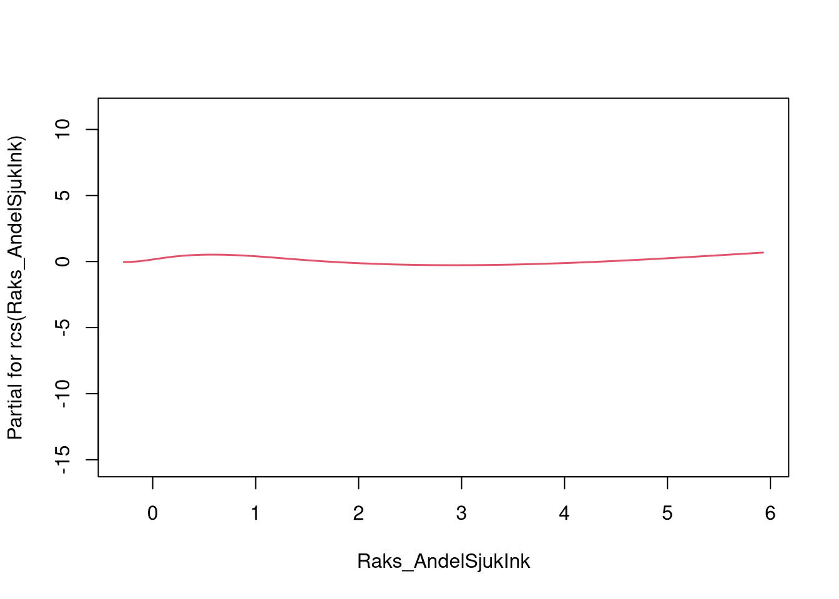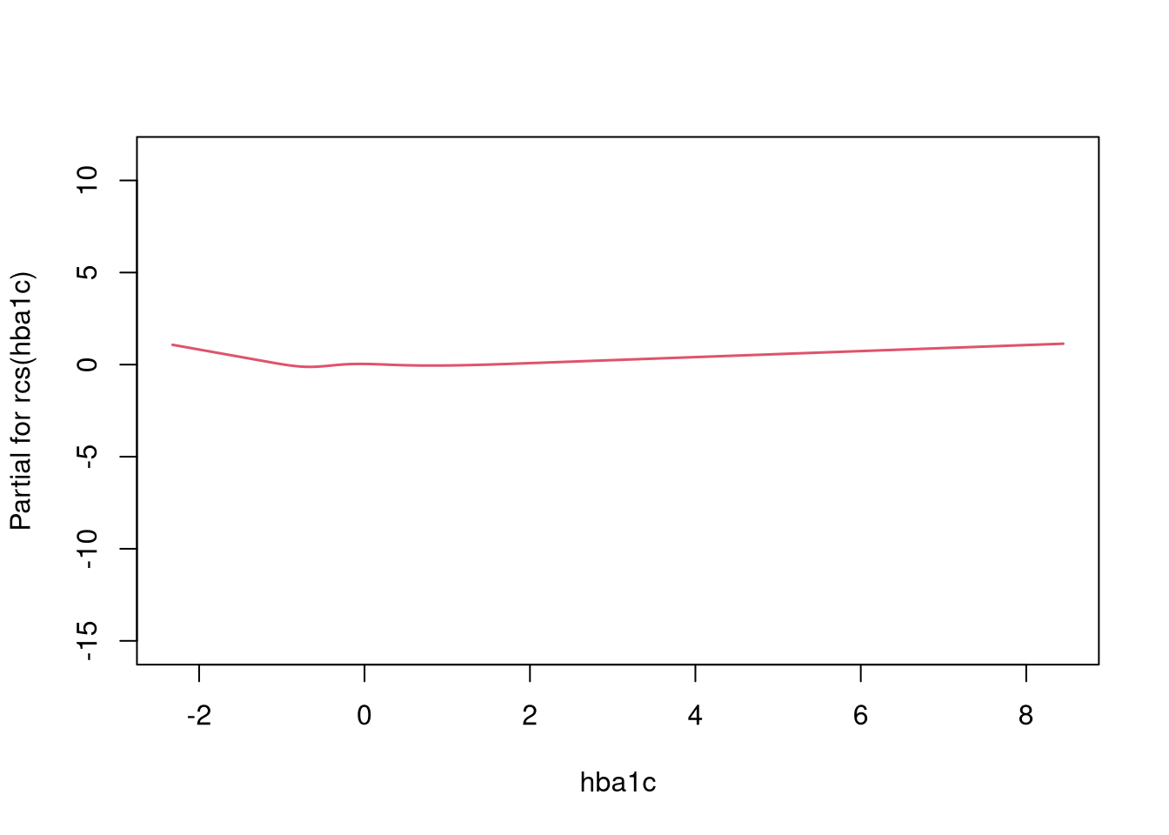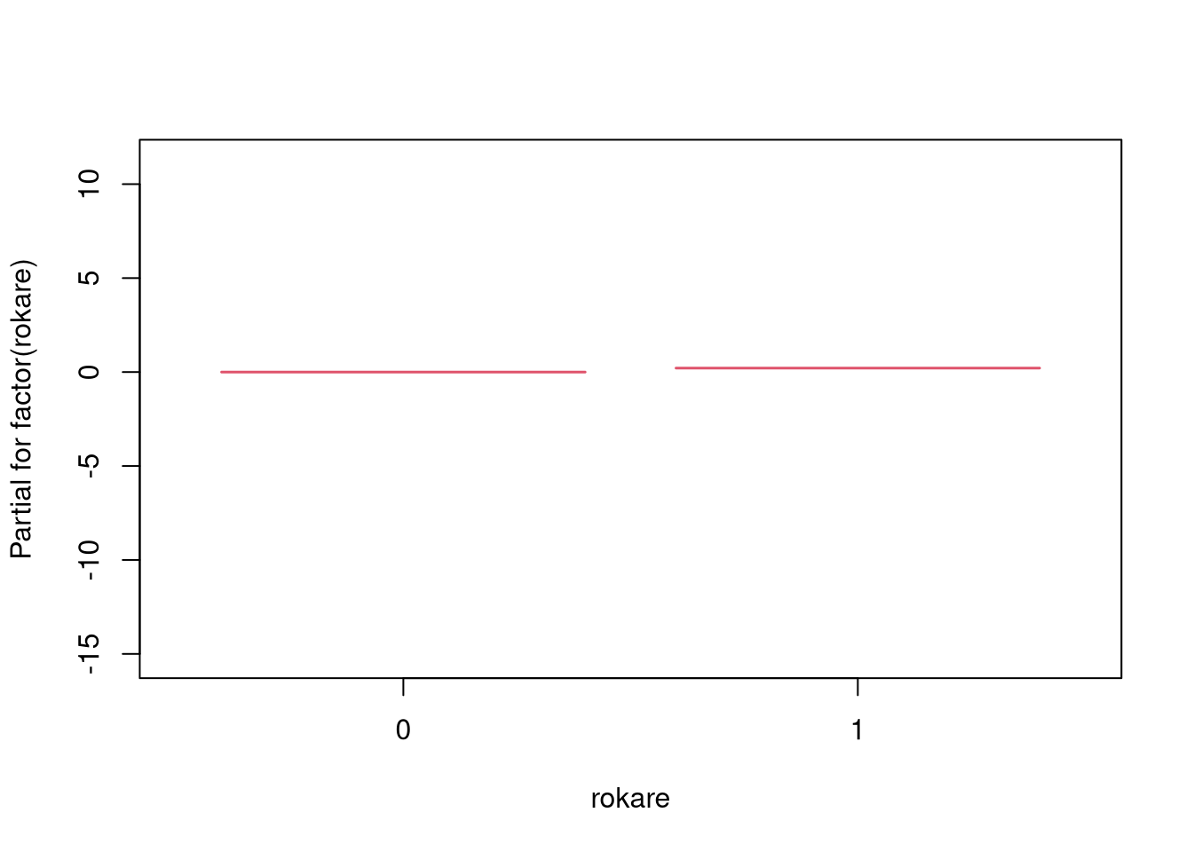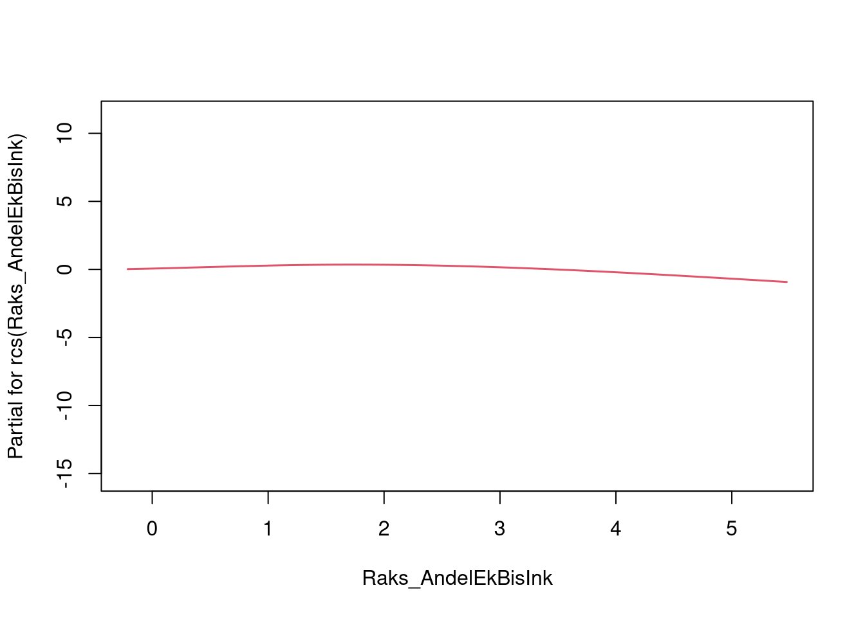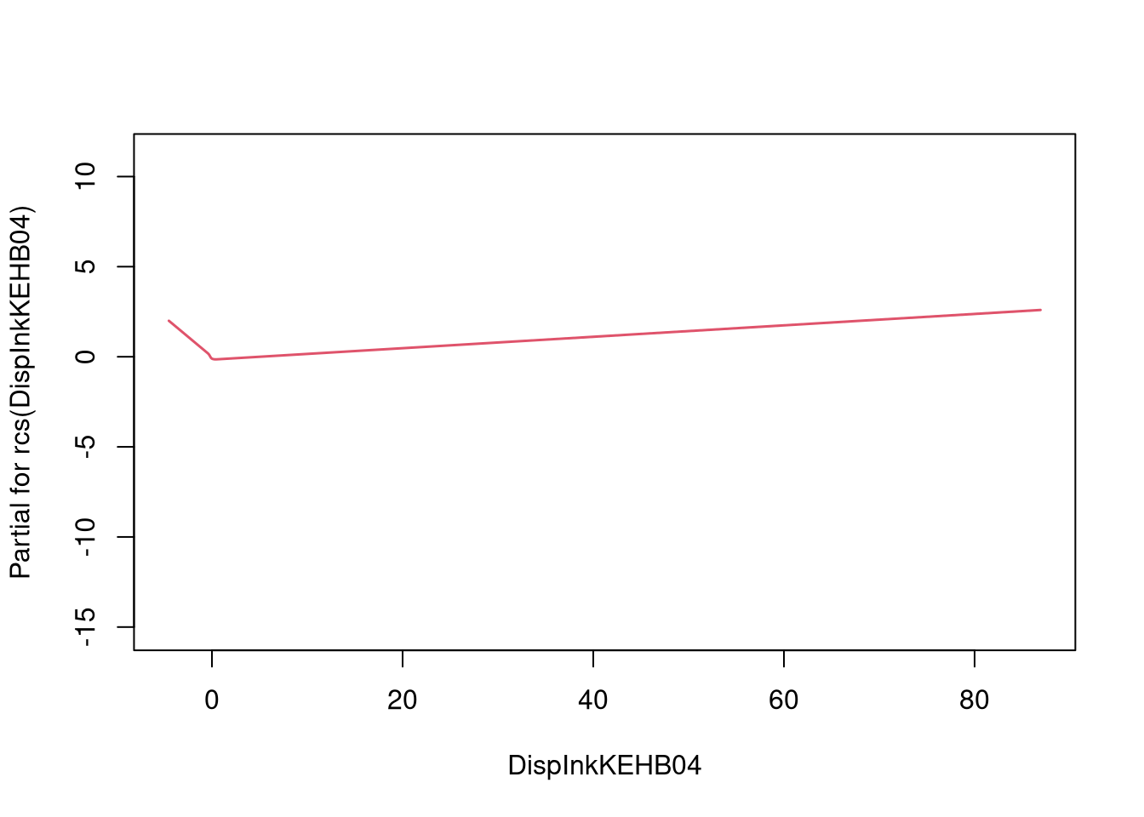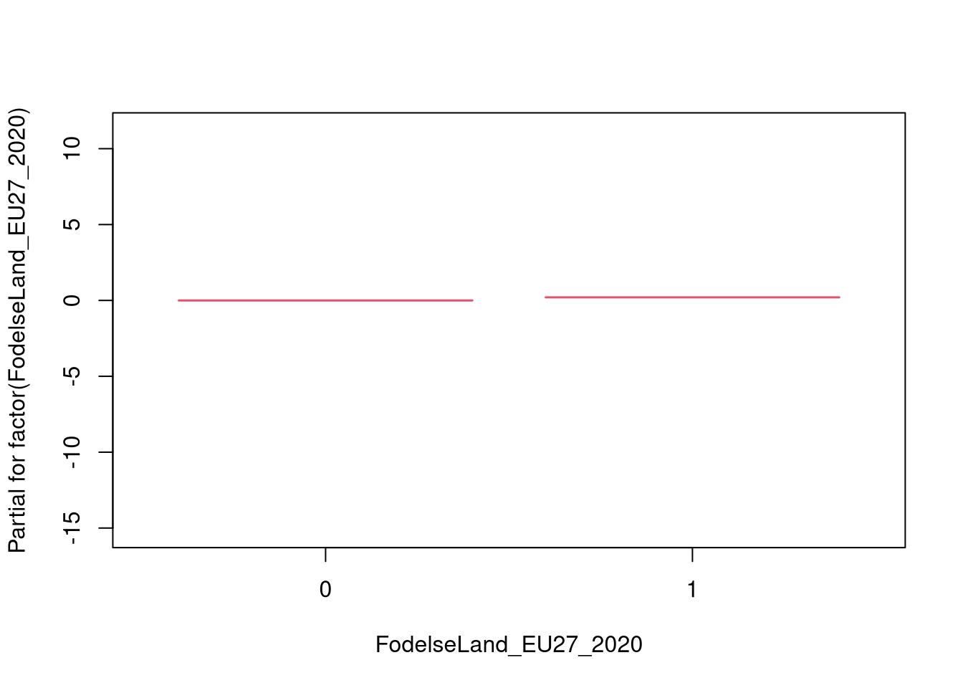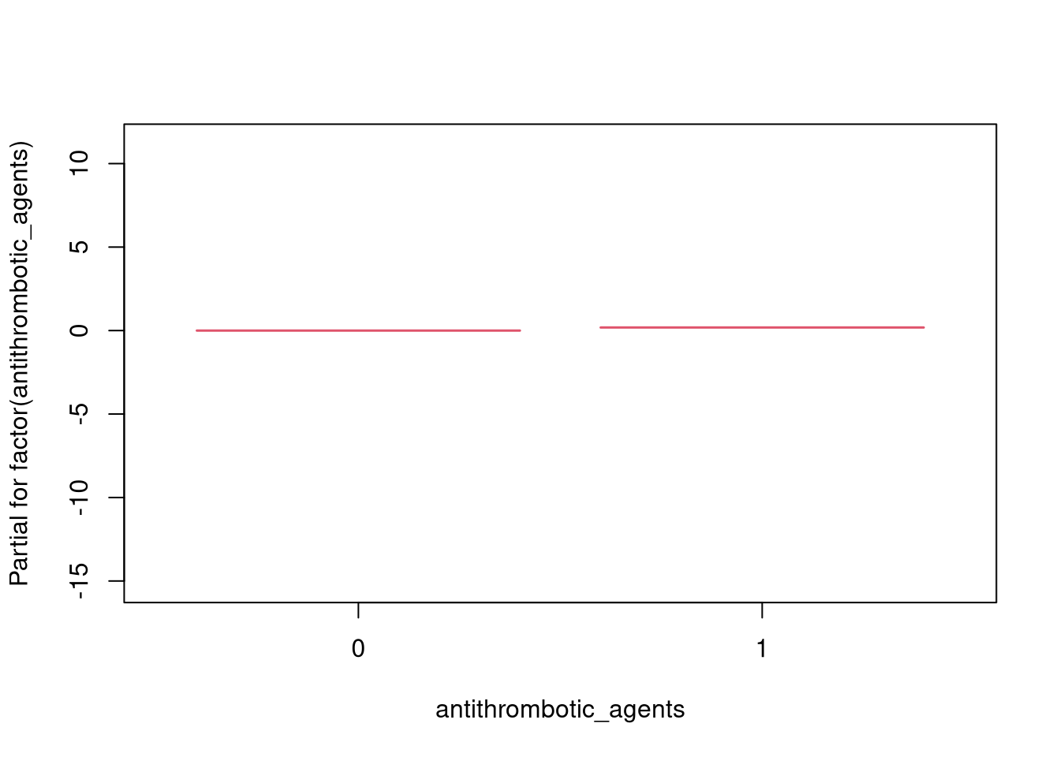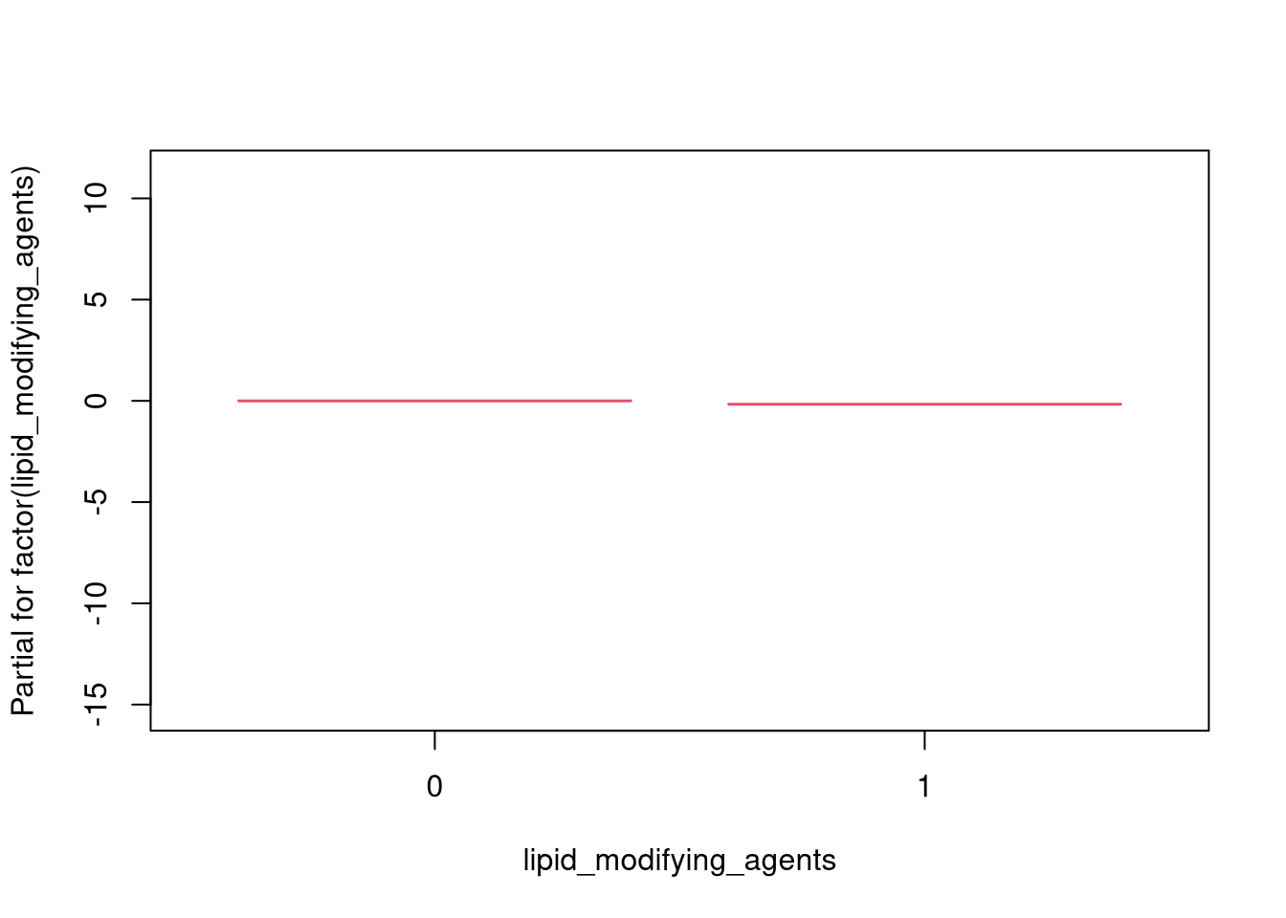

## [1] "--- CONCORDANCE RESULTS ---"

## C-index train: 0.8129236

## C-index test: 0.8206258

**AMI**

**Time-dependent**

**Group 1**

**Group 2**

run_models(c(list_forms_sleep[["form_tdep_spl"]], list_forms_sleep[["form_tdep_cat"]]), df_ami_sub_tv_train, df_ami_sub_tv_test, "stop", "event", cont_var, "prof_ami_dep_g2.html", bigd=F)

## [1] "### FORMULA 1 ###"

## Start: AIC=10600.63

## Surv(start, stop, event) ~ factor(cpap_treated)

## number of knots in rcs defaulting to 5

## number of knots in rcs defaulting to 5

## Warning in agreg.fit(X, Y, istrat, offset, init, control, weights = weights, :

## Loglik converged before variable 2 ; beta may be infinite.

## number of knots in rcs defaulting to 5

## number of knots in rcs defaulting to 5

## number of knots in rcs defaulting to 5

## number of knots in rcs defaulting to 5

## number of knots in rcs defaulting to 5

## number of knots in rcs defaulting to 5

## number of knots in rcs defaulting to 5

## number of knots in rcs defaulting to 5

## number of knots in rcs defaulting to 5

## number of knots in rcs defaulting to 5

## number of knots in rcs defaulting to 5

## Df AIC

## + factor(antithrombotic_agents) 1 10481

## + rcs(alder) 4 10505

## + factor(ami_history) 1 10531

## + rcs(GFR) 4 10552

## + factor(lipid_modifying_agents) 1 10563

## + factor(sex) 1 10565

## + factor(antihypertensive_comb) 1 10566

## + rcs(hba1c) 4 10568

## + rcs(systoliskt) 4 10574

## + factor(Sun2000niva_old) 6 10585

## + rcs(IV_ODI) 4 10594

## + rcs(IV_AHI) 4 10595

## + rcs(bmi) 4 10595

## + factor(stroke_history) 1 10598

## + factor(rokare) 1 10599

## + rcs(kolesterol) 4 10599

## + rcs(Raks_AndelSjukInk) 4 10600

## <none> 10601

## + factor(HushallsTyp_RTB) 2 10601

## + factor(FodelseLand_EU27_2020) 1 10601

## + factor(Civil) 1 10602

## + rcs(DispInkKEHB04) 4 10603

## + rcs(Raks_AndelEkBisInk) 3 10604

## + rcs(Raks_AndelArblosInk) 4 10605

## + rcs(IV_AverageSaturation) 4 10606

##

## Step: AIC=10481.41

## Surv(start, stop, event) ~ factor(cpap_treated) + factor(antithrombotic_agents)

## number of knots in rcs defaulting to 5

## number of knots in rcs defaulting to 5

## Warning in agreg.fit(X, Y, istrat, offset, init, control, weights = weights, :

## Loglik converged before variable 3 ; beta may be infinite.

## number of knots in rcs defaulting to 5

## number of knots in rcs defaulting to 5

## number of knots in rcs defaulting to 5

## number of knots in rcs defaulting to 5

## number of knots in rcs defaulting to 5

## number of knots in rcs defaulting to 5

## number of knots in rcs defaulting to 5

## number of knots in rcs defaulting to 5

## number of knots in rcs defaulting to 5

## number of knots in rcs defaulting to 5

## number of knots in rcs defaulting to 5

## Df AIC

## + factor(ami_history) 1 10359

## + rcs(alder) 4 10437

## + rcs(systoliskt) 4 10453

## + rcs(hba1c) 4 10455

## + rcs(GFR) 4 10456

## + factor(sex) 1 10456

## + factor(antihypertensive_comb) 1 10470

## + factor(Sun2000niva_old) 6 10476

## + factor(lipid_modifying_agents) 1 10476

## + factor(rokare) 1 10478

## + rcs(bmi) 4 10479

## + rcs(IV_ODI) 4 10480

## + rcs(IV_AHI) 4 10480

## + factor(cpap_treated):factor(antithrombotic_agents) 1 10481

## <none> 10481

## + rcs(Raks_AndelSjukInk) 4 10482

## + rcs(kolesterol) 4 10482

## + factor(FodelseLand_EU27_2020) 1 10483

## + factor(Civil) 1 10483

## + factor(HushallsTyp_RTB) 2 10483

## + factor(stroke_history) 1 10483

## + rcs(IV_AverageSaturation) 4 10484

## + rcs(DispInkKEHB04) 4 10485

## + rcs(Raks_AndelEkBisInk) 3 10486

## + rcs(Raks_AndelArblosInk) 4 10486

## - factor(antithrombotic_agents) 1 10601

## Warning in agreg.fit(X, Y, istrat, offset, init, control, weights = weights, :

## Loglik converged before variable 3 ; beta may be infinite.

##

## Step: AIC=10359.13

## Surv(start, stop, event) ~ factor(cpap_treated) + factor(antithrombotic_agents) +

## factor(ami_history)

## Warning in agreg.fit(X, Y, istrat, offset, init, control, weights = weights, :

## Loglik converged before variable 2 ; beta may be infinite.

## number of knots in rcs defaulting to 5

## Warning in agreg.fit(X, Y, istrat, offset, init, control, weights = weights, :

## Loglik converged before variable 3 ; beta may be infinite.

## Warning in agreg.fit(X, Y, istrat, offset, init, control, weights = weights, :

## Loglik converged before variable 3 ; beta may be infinite.

## number of knots in rcs defaulting to 5

## Warning in agreg.fit(X, Y, istrat, offset, init, control, weights = weights, :

## Loglik converged before variable 3 ; beta may be infinite.

## Warning in agreg.fit(X, Y, istrat, offset, init, control, weights = weights, :

## Loglik converged before variable 3 ; beta may be infinite.

## Warning in agreg.fit(X, Y, istrat, offset, init, control, weights = weights, :

## Loglik converged before variable 3 ; beta may be infinite.

## Warning in agreg.fit(X, Y, istrat, offset, init, control, weights = weights, :

## Loglik converged before variable 3 ; beta may be infinite.

## Warning in agreg.fit(X, Y, istrat, offset, init, control, weights = weights, :

## Loglik converged before variable 3 ; beta may be infinite.

## Warning in agreg.fit(X, Y, istrat, offset, init, control, weights = weights, :

## Loglik converged before variable 3 ; beta may be infinite.

## number of knots in rcs defaulting to 5

## Warning in agreg.fit(X, Y, istrat, offset, init, control, weights = weights, :

## Loglik converged before variable 3 ; beta may be infinite.

## number of knots in rcs defaulting to 5

## Warning in agreg.fit(X, Y, istrat, offset, init, control, weights = weights, :

## Loglik converged before variable 3 ; beta may be infinite.

## number of knots in rcs defaulting to 5

## Warning in agreg.fit(X, Y, istrat, offset, init, control, weights = weights, :

## Loglik converged before variable 3 ; beta may be infinite.

## number of knots in rcs defaulting to 5

## Warning in agreg.fit(X, Y, istrat, offset, init, control, weights = weights, :

## Loglik converged before variable 3 ; beta may be infinite.

## Warning in agreg.fit(X, Y, istrat, offset, init, control, weights = weights, :

## Loglik converged before variable 3 ; beta may be infinite.

## Warning in agreg.fit(X, Y, istrat, offset, init, control, weights = weights, :

## Loglik converged before variable 3 ; beta may be infinite.

## Warning in agreg.fit(X, Y, istrat, offset, init, control, weights = weights, :

## Loglik converged before variable 3 ; beta may be infinite.

## number of knots in rcs defaulting to 5

## Warning in agreg.fit(X, Y, istrat, offset, init, control, weights = weights, :

## Loglik converged before variable 3 ; beta may be infinite.

## number of knots in rcs defaulting to 5

## Warning in agreg.fit(X, Y, istrat, offset, init, control, weights = weights, :

## Loglik converged before variable 3 ; beta may be infinite.

## number of knots in rcs defaulting to 5

## Warning in agreg.fit(X, Y, istrat, offset, init, control, weights = weights, :

## Loglik converged before variable 3 ; beta may be infinite.

## number of knots in rcs defaulting to 5

## Warning in agreg.fit(X, Y, istrat, offset, init, control, weights = weights, :

## Loglik converged before variable 3 ; beta may be infinite.

## number of knots in rcs defaulting to 5

## Warning in agreg.fit(X, Y, istrat, offset, init, control, weights = weights, :

## Loglik converged before variable 3 ; beta may be infinite.

## number of knots in rcs defaulting to 5

## Warning in agreg.fit(X, Y, istrat, offset, init, control, weights = weights, :

## Loglik converged before variable 3 ; beta may be infinite.

## number of knots in rcs defaulting to 5

## Warning in agreg.fit(X, Y, istrat, offset, init, control, weights = weights, :

## Loglik converged before variable 3 ; beta may be infinite.

## Warning in agreg.fit(X, Y, istrat, offset, init, control, weights = weights, :

## Loglik converged before variable 3 ; beta may be infinite.

## Df AIC

## + rcs(alder) 4 10315

## + factor(sex) 1 10329

## + rcs(GFR) 4 10333

## + rcs(hba1c) 4 10334

## + rcs(systoliskt) 4 10334

## + factor(antihypertensive_comb) 1 10346

## + factor(lipid_modifying_agents) 1 10346

## + factor(Sun2000niva_old) 6 10354

## + factor(rokare) 1 10356

## + rcs(bmi) 4 10356

## + factor(cpap_treated):factor(antithrombotic_agents) 1 10357

## + rcs(IV_ODI) 4 10358

## + rcs(IV_AHI) 4 10358

## + rcs(kolesterol) 4 10358

## <none> 10359

## + rcs(Raks_AndelSjukInk) 4 10360

## + factor(stroke_history) 1 10361

## + factor(FodelseLand_EU27_2020) 1 10361

## + factor(HushallsTyp_RTB) 2 10361

## + factor(Civil) 1 10361

## + rcs(IV_AverageSaturation) 4 10361

## + rcs(DispInkKEHB04) 4 10362

## + rcs(Raks_AndelArblosInk) 4 10363

## + rcs(Raks_AndelEkBisInk) 3 10364

## - factor(ami_history) 1 10481

## - factor(antithrombotic_agents) 1 10531

## number of knots in rcs defaulting to 5

## Warning in agreg.fit(X, Y, istrat, offset, init, control, weights = weights, :

## Loglik converged before variable 3 ; beta may be infinite.

##

## Step: AIC=10315.41

## Surv(start, stop, event) ~ factor(cpap_treated) + factor(antithrombotic_agents) +

## factor(ami_history) + rcs(alder)

## number of knots in rcs defaulting to 5

## Warning in agreg.fit(X, Y, istrat, offset, init, control, weights = weights, :

## Loglik converged before variable 2 ; beta may be infinite.

## number of knots in rcs defaulting to 5

## Warning in agreg.fit(X, Y, istrat, offset, init, control, weights = weights, :

## Loglik converged before variable 3 ; beta may be infinite.

## number of knots in rcs defaulting to 5

## Warning in agreg.fit(X, Y, istrat, offset, init, control, weights = weights, :

## Loglik converged before variable 3 ; beta may be infinite.

## number of knots in rcs defaulting to 5

## number of knots in rcs defaulting to 5

## Warning in agreg.fit(X, Y, istrat, offset, init, control, weights = weights, :

## Loglik converged before variable 3 ; beta may be infinite.

## number of knots in rcs defaulting to 5

## Warning in agreg.fit(X, Y, istrat, offset, init, control, weights = weights, :

## Loglik converged before variable 3 ; beta may be infinite.

## number of knots in rcs defaulting to 5

## Warning in agreg.fit(X, Y, istrat, offset, init, control, weights = weights, :

## Loglik converged before variable 3 ; beta may be infinite.

## number of knots in rcs defaulting to 5

## Warning in agreg.fit(X, Y, istrat, offset, init, control, weights = weights, :

## Loglik converged before variable 3 ; beta may be infinite.

## number of knots in rcs defaulting to 5

## Warning in agreg.fit(X, Y, istrat, offset, init, control, weights = weights, :

## Loglik converged before variable 3 ; beta may be infinite.

## number of knots in rcs defaulting to 5

## Warning in agreg.fit(X, Y, istrat, offset, init, control, weights = weights, :

## Loglik converged before variable 3 ; beta may be infinite.

## number of knots in rcs defaulting to 5

## number of knots in rcs defaulting to 5

## Warning in agreg.fit(X, Y, istrat, offset, init, control, weights = weights, :

## Loglik converged before variable 3 ; beta may be infinite.

## number of knots in rcs defaulting to 5

## number of knots in rcs defaulting to 5

## Warning in agreg.fit(X, Y, istrat, offset, init, control, weights = weights, :

## Loglik converged before variable 3 ; beta may be infinite.

## number of knots in rcs defaulting to 5

## number of knots in rcs defaulting to 5

## Warning in agreg.fit(X, Y, istrat, offset, init, control, weights = weights, :

## Loglik converged before variable 3 ; beta may be infinite.

## number of knots in rcs defaulting to 5

## number of knots in rcs defaulting to 5

## Warning in agreg.fit(X, Y, istrat, offset, init, control, weights = weights, :

## Loglik converged before variable 3 ; beta may be infinite.

## number of knots in rcs defaulting to 5

## Warning in agreg.fit(X, Y, istrat, offset, init, control, weights = weights, :

## Loglik converged before variable 3 ; beta may be infinite.

## number of knots in rcs defaulting to 5

## Warning in agreg.fit(X, Y, istrat, offset, init, control, weights = weights, :

## Loglik converged before variable 3 ; beta may be infinite.

## number of knots in rcs defaulting to 5

## Warning in agreg.fit(X, Y, istrat, offset, init, control, weights = weights, :

## Loglik converged before variable 3 ; beta may be infinite.

## number of knots in rcs defaulting to 5

## number of knots in rcs defaulting to 5

## Warning in agreg.fit(X, Y, istrat, offset, init, control, weights = weights, :

## Loglik converged before variable 3 ; beta may be infinite.

## number of knots in rcs defaulting to 5

## number of knots in rcs defaulting to 5

## Warning in agreg.fit(X, Y, istrat, offset, init, control, weights = weights, :

## Loglik converged before variable 3 ; beta may be infinite.

## number of knots in rcs defaulting to 5

## number of knots in rcs defaulting to 5

## Warning in agreg.fit(X, Y, istrat, offset, init, control, weights = weights, :

## Loglik converged before variable 3 ; beta may be infinite.

## number of knots in rcs defaulting to 5

## number of knots in rcs defaulting to 5

## Warning in agreg.fit(X, Y, istrat, offset, init, control, weights = weights, :

## Loglik converged before variable 3 ; beta may be infinite.

## number of knots in rcs defaulting to 5

## number of knots in rcs defaulting to 5

## Warning in agreg.fit(X, Y, istrat, offset, init, control, weights = weights, :

## Loglik converged before variable 3 ; beta may be infinite.

## number of knots in rcs defaulting to 5

## number of knots in rcs defaulting to 5

## Warning in agreg.fit(X, Y, istrat, offset, init, control, weights = weights, :

## Loglik converged before variable 3 ; beta may be infinite.

## number of knots in rcs defaulting to 5

## number of knots in rcs defaulting to 5

## Warning in agreg.fit(X, Y, istrat, offset, init, control, weights = weights, :

## Loglik converged before variable 3 ; beta may be infinite.

## number of knots in rcs defaulting to 5

## Warning in agreg.fit(X, Y, istrat, offset, init, control, weights = weights, :

## Loglik converged before variable 3 ; beta may be infinite.

## Df AIC

## + factor(sex) 1 10282

## + rcs(hba1c) 4 10287

## + rcs(systoliskt) 4 10296

## + rcs(GFR) 4 10300

## + factor(rokare) 1 10307

## + factor(lipid_modifying_agents) 1 10308

## + factor(antihypertensive_comb) 1 10310

## + factor(cpap_treated):factor(antithrombotic_agents) 1 10314

## + rcs(IV_AverageSaturation) 4 10314

## + rcs(DispInkKEHB04) 4 10315

## + rcs(kolesterol) 4 10315

## <none> 10315

## + factor(Sun2000niva_old) 6 10316

## + factor(Civil) 1 10316

## + rcs(Raks_AndelSjukInk) 4 10317

## + factor(stroke_history) 1 10317

## + factor(FodelseLand_EU27_2020) 1 10317

## + rcs(IV_ODI) 4 10318

## + factor(HushallsTyp_RTB) 2 10318

## + rcs(Raks_AndelEkBisInk) 3 10318

## + rcs(IV_AHI) 4 10318

## + rcs(bmi) 4 10319

## + rcs(Raks_AndelArblosInk) 4 10320

## - rcs(alder) 4 10359

## - factor(antithrombotic_agents) 1 10423

## - factor(ami_history) 1 10437

## number of knots in rcs defaulting to 5

## Warning in agreg.fit(X, Y, istrat, offset, init, control, weights = weights, :

## Loglik converged before variable 3 ; beta may be infinite.

##

## Step: AIC=10281.98

## Surv(start, stop, event) ~ factor(cpap_treated) + factor(antithrombotic_agents) +

## factor(ami_history) + rcs(alder) + factor(sex)

## number of knots in rcs defaulting to 5

## Warning in agreg.fit(X, Y, istrat, offset, init, control, weights = weights, :

## Loglik converged before variable 2 ; beta may be infinite.

## number of knots in rcs defaulting to 5

## Warning in agreg.fit(X, Y, istrat, offset, init, control, weights = weights, :

## Loglik converged before variable 3 ; beta may be infinite.

## number of knots in rcs defaulting to 5

## Warning in agreg.fit(X, Y, istrat, offset, init, control, weights = weights, :

## Loglik converged before variable 3 ; beta may be infinite.

## number of knots in rcs defaulting to 5

## number of knots in rcs defaulting to 5

## Warning in agreg.fit(X, Y, istrat, offset, init, control, weights = weights, :

## Loglik converged before variable 3 ; beta may be infinite.

## number of knots in rcs defaulting to 5

## Warning in agreg.fit(X, Y, istrat, offset, init, control, weights = weights, :

## Loglik converged before variable 3 ; beta may be infinite.

## number of knots in rcs defaulting to 5

## Warning in agreg.fit(X, Y, istrat, offset, init, control, weights = weights, :

## Loglik converged before variable 3 ; beta may be infinite.

## number of knots in rcs defaulting to 5

## Warning in agreg.fit(X, Y, istrat, offset, init, control, weights = weights, :

## Loglik converged before variable 3 ; beta may be infinite.

## number of knots in rcs defaulting to 5

## Warning in agreg.fit(X, Y, istrat, offset, init, control, weights = weights, :

## Loglik converged before variable 3 ; beta may be infinite.

## number of knots in rcs defaulting to 5

## Warning in agreg.fit(X, Y, istrat, offset, init, control, weights = weights, :

## Loglik converged before variable 3 ; beta may be infinite.

## number of knots in rcs defaulting to 5

## number of knots in rcs defaulting to 5

## Warning in agreg.fit(X, Y, istrat, offset, init, control, weights = weights, :

## Loglik converged before variable 3 ; beta may be infinite.

## number of knots in rcs defaulting to 5

## number of knots in rcs defaulting to 5

## Warning in agreg.fit(X, Y, istrat, offset, init, control, weights = weights, :

## Loglik converged before variable 3 ; beta may be infinite.

## number of knots in rcs defaulting to 5

## number of knots in rcs defaulting to 5

## Warning in agreg.fit(X, Y, istrat, offset, init, control, weights = weights, :

## Loglik converged before variable 3 ; beta may be infinite.

## number of knots in rcs defaulting to 5

## number of knots in rcs defaulting to 5

## Warning in agreg.fit(X, Y, istrat, offset, init, control, weights = weights, :

## Loglik converged before variable 3 ; beta may be infinite.

## number of knots in rcs defaulting to 5

## Warning in agreg.fit(X, Y, istrat, offset, init, control, weights = weights, :

## Loglik converged before variable 3 ; beta may be infinite.

## number of knots in rcs defaulting to 5

## Warning in agreg.fit(X, Y, istrat, offset, init, control, weights = weights, :

## Loglik converged before variable 3 ; beta may be infinite.

## number of knots in rcs defaulting to 5

## Warning in agreg.fit(X, Y, istrat, offset, init, control, weights = weights, :

## Loglik converged before variable 3 ; beta may be infinite.

## number of knots in rcs defaulting to 5

## number of knots in rcs defaulting to 5

## Warning in agreg.fit(X, Y, istrat, offset, init, control, weights = weights, :

## Loglik converged before variable 3 ; beta may be infinite.

## number of knots in rcs defaulting to 5

## number of knots in rcs defaulting to 5

## Warning in agreg.fit(X, Y, istrat, offset, init, control, weights = weights, :

## Loglik converged before variable 3 ; beta may be infinite.

## number of knots in rcs defaulting to 5

## number of knots in rcs defaulting to 5

## Warning in agreg.fit(X, Y, istrat, offset, init, control, weights = weights, :

## Loglik converged before variable 3 ; beta may be infinite.

## number of knots in rcs defaulting to 5

## number of knots in rcs defaulting to 5

## Warning in agreg.fit(X, Y, istrat, offset, init, control, weights = weights, :

## Loglik converged before variable 3 ; beta may be infinite.

## number of knots in rcs defaulting to 5

## number of knots in rcs defaulting to 5

## Warning in agreg.fit(X, Y, istrat, offset, init, control, weights = weights, :

## Loglik converged before variable 3 ; beta may be infinite.

## number of knots in rcs defaulting to 5

## number of knots in rcs defaulting to 5

## Warning in agreg.fit(X, Y, istrat, offset, init, control, weights = weights, :

## Loglik converged before variable 3 ; beta may be infinite.

## number of knots in rcs defaulting to 5

## number of knots in rcs defaulting to 5

## Warning in agreg.fit(X, Y, istrat, offset, init, control, weights = weights, :

## Loglik converged before variable 3 ; beta may be infinite.

## number of knots in rcs defaulting to 5

## Warning in agreg.fit(X, Y, istrat, offset, init, control, weights = weights, :

## Loglik converged before variable 3 ; beta may be infinite.

## Df AIC

## + rcs(hba1c) 4 10255

## + rcs(systoliskt) 4 10263

## + rcs(GFR) 4 10263

## + factor(rokare) 1 10272

## + rcs(DispInkKEHB04) 4 10276

## + factor(lipid_modifying_agents) 1 10276

## + factor(antihypertensive_comb) 1 10278

## + rcs(kolesterol) 4 10280

## + factor(cpap_treated):factor(antithrombotic_agents) 1 10280

## + rcs(IV_AverageSaturation) 4 10281

## + factor(Sun2000niva_old) 6 10281

## <none> 10282

## + rcs(Raks_AndelSjukInk) 4 10283

## + factor(FodelseLand_EU27_2020) 1 10284

## + factor(stroke_history) 1 10284

## + rcs(Raks_AndelEkBisInk) 3 10284

## + factor(Civil) 1 10284

## + factor(HushallsTyp_RTB) 2 10286

## + rcs(IV_ODI) 4 10286

## + rcs(Raks_AndelArblosInk) 4 10286

## + rcs(IV_AHI) 4 10286

## + rcs(bmi) 4 10288

## - factor(sex) 1 10315

## - rcs(alder) 4 10329

## - factor(antithrombotic_agents) 1 10378

## - factor(ami_history) 1 10409

## number of knots in rcs defaulting to 5

## number of knots in rcs defaulting to 5

## Warning in agreg.fit(X, Y, istrat, offset, init, control, weights = weights, :

## Loglik converged before variable 3 ; beta may be infinite.

##

## Step: AIC=10255

## Surv(start, stop, event) ~ factor(cpap_treated) + factor(antithrombotic_agents) +

## factor(ami_history) + rcs(alder) + factor(sex) + rcs(hba1c)

## number of knots in rcs defaulting to 5

## number of knots in rcs defaulting to 5

## Warning in agreg.fit(X, Y, istrat, offset, init, control, weights = weights, :

## Loglik converged before variable 2 ; beta may be infinite.

## number of knots in rcs defaulting to 5

## number of knots in rcs defaulting to 5

## number of knots in rcs defaulting to 5

## Warning in agreg.fit(X, Y, istrat, offset, init, control, weights = weights, :

## Loglik converged before variable 3 ; beta may be infinite.

## number of knots in rcs defaulting to 5

## number of knots in rcs defaulting to 5

## Warning in agreg.fit(X, Y, istrat, offset, init, control, weights = weights, :

## Loglik converged before variable 3 ; beta may be infinite.

## number of knots in rcs defaulting to 5

## Warning in agreg.fit(X, Y, istrat, offset, init, control, weights = weights, :

## Loglik converged before variable 3 ; beta may be infinite.

## number of knots in rcs defaulting to 5

## number of knots in rcs defaulting to 5

## number of knots in rcs defaulting to 5

## Warning in agreg.fit(X, Y, istrat, offset, init, control, weights = weights, :

## Loglik converged before variable 3 ; beta may be infinite.

## number of knots in rcs defaulting to 5

## number of knots in rcs defaulting to 5

## Warning in agreg.fit(X, Y, istrat, offset, init, control, weights = weights, :

## Loglik converged before variable 3 ; beta may be infinite.

## number of knots in rcs defaulting to 5

## number of knots in rcs defaulting to 5

## Warning in agreg.fit(X, Y, istrat, offset, init, control, weights = weights, :

## Loglik converged before variable 3 ; beta may be infinite.

## number of knots in rcs defaulting to 5

## number of knots in rcs defaulting to 5

## Warning in agreg.fit(X, Y, istrat, offset, init, control, weights = weights, :

## Loglik converged before variable 3 ; beta may be infinite.

## number of knots in rcs defaulting to 5

## number of knots in rcs defaulting to 5

## Warning in agreg.fit(X, Y, istrat, offset, init, control, weights = weights, :

## Loglik converged before variable 3 ; beta may be infinite.

## number of knots in rcs defaulting to 5

## number of knots in rcs defaulting to 5

## Warning in agreg.fit(X, Y, istrat, offset, init, control, weights = weights, :

## Loglik converged before variable 3 ; beta may be infinite.

## number of knots in rcs defaulting to 5

## number of knots in rcs defaulting to 5

## number of knots in rcs defaulting to 5

## Warning in agreg.fit(X, Y, istrat, offset, init, control, weights = weights, :

## Loglik converged before variable 3 ; beta may be infinite.

## number of knots in rcs defaulting to 5

## number of knots in rcs defaulting to 5

## number of knots in rcs defaulting to 5

## Warning in agreg.fit(X, Y, istrat, offset, init, control, weights = weights, :

## Loglik converged before variable 3 ; beta may be infinite.

## number of knots in rcs defaulting to 5

## number of knots in rcs defaulting to 5

## number of knots in rcs defaulting to 5

## Warning in agreg.fit(X, Y, istrat, offset, init, control, weights = weights, :

## Loglik converged before variable 3 ; beta may be infinite.

## number of knots in rcs defaulting to 5

## number of knots in rcs defaulting to 5

## number of knots in rcs defaulting to 5

## Warning in agreg.fit(X, Y, istrat, offset, init, control, weights = weights, :

## Loglik converged before variable 3 ; beta may be infinite.

## number of knots in rcs defaulting to 5

## number of knots in rcs defaulting to 5

## Warning in agreg.fit(X, Y, istrat, offset, init, control, weights = weights, :

## Loglik converged before variable 3 ; beta may be infinite.

## number of knots in rcs defaulting to 5

## number of knots in rcs defaulting to 5

## Warning in agreg.fit(X, Y, istrat, offset, init, control, weights = weights, :

## Loglik converged before variable 3 ; beta may be infinite.

## number of knots in rcs defaulting to 5

## number of knots in rcs defaulting to 5

## Warning in agreg.fit(X, Y, istrat, offset, init, control, weights = weights, :

## Loglik converged before variable 3 ; beta may be infinite.

## number of knots in rcs defaulting to 5

## number of knots in rcs defaulting to 5

## number of knots in rcs defaulting to 5

## Warning in agreg.fit(X, Y, istrat, offset, init, control, weights = weights, :

## Loglik converged before variable 3 ; beta may be infinite.

## number of knots in rcs defaulting to 5

## number of knots in rcs defaulting to 5

## number of knots in rcs defaulting to 5

## Warning in agreg.fit(X, Y, istrat, offset, init, control, weights = weights, :

## Loglik converged before variable 3 ; beta may be infinite.

## number of knots in rcs defaulting to 5

## number of knots in rcs defaulting to 5

## number of knots in rcs defaulting to 5

## Warning in agreg.fit(X, Y, istrat, offset, init, control, weights = weights, :

## Loglik converged before variable 3 ; beta may be infinite.

## number of knots in rcs defaulting to 5

## number of knots in rcs defaulting to 5

## number of knots in rcs defaulting to 5

## Warning in agreg.fit(X, Y, istrat, offset, init, control, weights = weights, :

## Loglik converged before variable 3 ; beta may be infinite.

## number of knots in rcs defaulting to 5

## number of knots in rcs defaulting to 5

## number of knots in rcs defaulting to 5

## Warning in agreg.fit(X, Y, istrat, offset, init, control, weights = weights, :

## Loglik converged before variable 3 ; beta may be infinite.

## number of knots in rcs defaulting to 5

## number of knots in rcs defaulting to 5

## number of knots in rcs defaulting to 5

## Warning in agreg.fit(X, Y, istrat, offset, init, control, weights = weights, :

## Loglik converged before variable 3 ; beta may be infinite.

## number of knots in rcs defaulting to 5

## number of knots in rcs defaulting to 5

## Warning in agreg.fit(X, Y, istrat, offset, init, control, weights = weights, :

## Loglik converged before variable 3 ; beta may be infinite.

## Df AIC

## + rcs(systoliskt) 4 10239

## + rcs(GFR) 4 10239

## + factor(rokare) 1 10247

## + factor(lipid_modifying_agents) 1 10250

## + factor(antihypertensive_comb) 1 10252

## + rcs(kolesterol) 4 10253

## + rcs(DispInkKEHB04) 4 10253

## + factor(cpap_treated):factor(antithrombotic_agents) 1 10253

## + rcs(IV_AverageSaturation) 4 10253

## <none> 10255

## + rcs(Raks_AndelSjukInk) 4 10256

## + factor(FodelseLand_EU27_2020) 1 10256

## + factor(stroke_history) 1 10257

## + factor(Civil) 1 10257

## + factor(Sun2000niva_old) 6 10257

## + rcs(Raks_AndelEkBisInk) 3 10258

## + factor(HushallsTyp_RTB) 2 10258

## + rcs(Raks_AndelArblosInk) 4 10259

## + rcs(IV_ODI) 4 10260

## + rcs(IV_AHI) 4 10260

## + rcs(bmi) 4 10261

## - rcs(hba1c) 4 10282

## - factor(sex) 1 10287

## - rcs(alder) 4 10305

## - factor(antithrombotic_agents) 1 10344

## - factor(ami_history) 1 10380

## number of knots in rcs defaulting to 5

## number of knots in rcs defaulting to 5

## number of knots in rcs defaulting to 5

## Warning in agreg.fit(X, Y, istrat, offset, init, control, weights = weights, :

## Loglik converged before variable 3 ; beta may be infinite.

##

## Step: AIC=10238.63

## Surv(start, stop, event) ~ factor(cpap_treated) + factor(antithrombotic_agents) +

## factor(ami_history) + rcs(alder) + factor(sex) + rcs(hba1c) +

## rcs(systoliskt)

## number of knots in rcs defaulting to 5

## number of knots in rcs defaulting to 5

## number of knots in rcs defaulting to 5

## Warning in agreg.fit(X, Y, istrat, offset, init, control, weights = weights, :

## Loglik converged before variable 2 ; beta may be infinite.

## number of knots in rcs defaulting to 5

## number of knots in rcs defaulting to 5

## number of knots in rcs defaulting to 5

## number of knots in rcs defaulting to 5

## number of knots in rcs defaulting to 5

## Warning in agreg.fit(X, Y, istrat, offset, init, control, weights = weights, :

## Loglik converged before variable 3 ; beta may be infinite.

## number of knots in rcs defaulting to 5

## number of knots in rcs defaulting to 5

## number of knots in rcs defaulting to 5

## Warning in agreg.fit(X, Y, istrat, offset, init, control, weights = weights, :

## Loglik converged before variable 3 ; beta may be infinite.

## number of knots in rcs defaulting to 5

## number of knots in rcs defaulting to 5

## Warning in agreg.fit(X, Y, istrat, offset, init, control, weights = weights, :

## Loglik converged before variable 3 ; beta may be infinite.

## number of knots in rcs defaulting to 5

## number of knots in rcs defaulting to 5

## Warning in agreg.fit(X, Y, istrat, offset, init, control, weights = weights, :

## Loglik converged before variable 3 ; beta may be infinite.

## number of knots in rcs defaulting to 5

## number of knots in rcs defaulting to 5

## number of knots in rcs defaulting to 5

## number of knots in rcs defaulting to 5

## Warning in agreg.fit(X, Y, istrat, offset, init, control, weights = weights, :

## Loglik converged before variable 3 ; beta may be infinite.

## number of knots in rcs defaulting to 5

## number of knots in rcs defaulting to 5

## number of knots in rcs defaulting to 5

## Warning in agreg.fit(X, Y, istrat, offset, init, control, weights = weights, :

## Loglik converged before variable 3 ; beta may be infinite.

## number of knots in rcs defaulting to 5

## number of knots in rcs defaulting to 5

## number of knots in rcs defaulting to 5

## Warning in agreg.fit(X, Y, istrat, offset, init, control, weights = weights, :

## Loglik converged before variable 3 ; beta may be infinite.

## number of knots in rcs defaulting to 5

## number of knots in rcs defaulting to 5

## number of knots in rcs defaulting to 5

## Warning in agreg.fit(X, Y, istrat, offset, init, control, weights = weights, :

## Loglik converged before variable 3 ; beta may be infinite.

## number of knots in rcs defaulting to 5

## number of knots in rcs defaulting to 5

## number of knots in rcs defaulting to 5

## Warning in agreg.fit(X, Y, istrat, offset, init, control, weights = weights, :

## Loglik converged before variable 3 ; beta may be infinite.

## number of knots in rcs defaulting to 5

## number of knots in rcs defaulting to 5

## number of knots in rcs defaulting to 5

## Warning in agreg.fit(X, Y, istrat, offset, init, control, weights = weights, :

## Loglik converged before variable 3 ; beta may be infinite.

## number of knots in rcs defaulting to 5

## number of knots in rcs defaulting to 5

## number of knots in rcs defaulting to 5

## number of knots in rcs defaulting to 5

## Warning in agreg.fit(X, Y, istrat, offset, init, control, weights = weights, :

## Loglik converged before variable 3 ; beta may be infinite.

## number of knots in rcs defaulting to 5

## number of knots in rcs defaulting to 5

## number of knots in rcs defaulting to 5

## number of knots in rcs defaulting to 5

## Warning in agreg.fit(X, Y, istrat, offset, init, control, weights = weights, :

## Loglik converged before variable 3 ; beta may be infinite.

## number of knots in rcs defaulting to 5

## number of knots in rcs defaulting to 5

## number of knots in rcs defaulting to 5

## number of knots in rcs defaulting to 5

## Warning in agreg.fit(X, Y, istrat, offset, init, control, weights = weights, :

## Loglik converged before variable 3 ; beta may be infinite.

## number of knots in rcs defaulting to 5

## number of knots in rcs defaulting to 5

## number of knots in rcs defaulting to 5

## number of knots in rcs defaulting to 5

## Warning in agreg.fit(X, Y, istrat, offset, init, control, weights = weights, :

## Loglik converged before variable 3 ; beta may be infinite.

## number of knots in rcs defaulting to 5

## number of knots in rcs defaulting to 5

## number of knots in rcs defaulting to 5

## Warning in agreg.fit(X, Y, istrat, offset, init, control, weights = weights, :

## Loglik converged before variable 3 ; beta may be infinite.

## number of knots in rcs defaulting to 5

## number of knots in rcs defaulting to 5

## number of knots in rcs defaulting to 5

## Warning in agreg.fit(X, Y, istrat, offset, init, control, weights = weights, :

## Loglik converged before variable 3 ; beta may be infinite.

## number of knots in rcs defaulting to 5

## number of knots in rcs defaulting to 5

## number of knots in rcs defaulting to 5

## Warning in agreg.fit(X, Y, istrat, offset, init, control, weights = weights, :

## Loglik converged before variable 3 ; beta may be infinite.

## number of knots in rcs defaulting to 5

## number of knots in rcs defaulting to 5

## number of knots in rcs defaulting to 5

## number of knots in rcs defaulting to 5

## Warning in agreg.fit(X, Y, istrat, offset, init, control, weights = weights, :

## Loglik converged before variable 3 ; beta may be infinite.

## number of knots in rcs defaulting to 5

## number of knots in rcs defaulting to 5

## number of knots in rcs defaulting to 5

## number of knots in rcs defaulting to 5

## Warning in agreg.fit(X, Y, istrat, offset, init, control, weights = weights, :

## Loglik converged before variable 3 ; beta may be infinite.

## number of knots in rcs defaulting to 5

## number of knots in rcs defaulting to 5

## number of knots in rcs defaulting to 5

## number of knots in rcs defaulting to 5

## Warning in agreg.fit(X, Y, istrat, offset, init, control, weights = weights, :

## Loglik converged before variable 3 ; beta may be infinite.

## number of knots in rcs defaulting to 5

## number of knots in rcs defaulting to 5

## number of knots in rcs defaulting to 5

## number of knots in rcs defaulting to 5

## Warning in agreg.fit(X, Y, istrat, offset, init, control, weights = weights, :

## Loglik converged before variable 3 ; beta may be infinite.

## number of knots in rcs defaulting to 5

## number of knots in rcs defaulting to 5

## number of knots in rcs defaulting to 5

## number of knots in rcs defaulting to 5

## Warning in agreg.fit(X, Y, istrat, offset, init, control, weights = weights, :

## Loglik converged before variable 3 ; beta may be infinite.

## number of knots in rcs defaulting to 5

## number of knots in rcs defaulting to 5

## number of knots in rcs defaulting to 5

## Warning in agreg.fit(X, Y, istrat, offset, init, control, weights = weights, :

## Loglik converged before variable 3 ; beta may be infinite.

## Df AIC

## + rcs(GFR) 4 10224

## + factor(rokare) 1 10230

## + factor(lipid_modifying_agents) 1 10233

## + rcs(DispInkKEHB04) 4 10237

## + rcs(IV_AverageSaturation) 4 10237

## + factor(cpap_treated):factor(antithrombotic_agents) 1 10237

## + rcs(kolesterol) 4 10237

## + factor(antihypertensive_comb) 1 10237

## <none> 10239

## + rcs(Raks_AndelSjukInk) 4 10240

## + factor(FodelseLand_EU27_2020) 1 10240

## + factor(Sun2000niva_old) 6 10240

## + factor(stroke_history) 1 10240

## + factor(Civil) 1 10241

## + rcs(Raks_AndelEkBisInk) 3 10241

## + factor(HushallsTyp_RTB) 2 10242

## + rcs(Raks_AndelArblosInk) 4 10243

## + rcs(IV_ODI) 4 10244

## + rcs(bmi) 4 10244

## + rcs(IV_AHI) 4 10244

## - rcs(systoliskt) 4 10255

## - rcs(hba1c) 4 10263

## - factor(sex) 1 10270

## - rcs(alder) 4 10284

## - factor(antithrombotic_agents) 1 10330

## - factor(ami_history) 1 10361

## number of knots in rcs defaulting to 5

## number of knots in rcs defaulting to 5

## number of knots in rcs defaulting to 5

## number of knots in rcs defaulting to 5

## Warning in agreg.fit(X, Y, istrat, offset, init, control, weights = weights, :

## Loglik converged before variable 3 ; beta may be infinite.

##

## Step: AIC=10223.67

## Surv(start, stop, event) ~ factor(cpap_treated) + factor(antithrombotic_agents) +

## factor(ami_history) + rcs(alder) + factor(sex) + rcs(hba1c) +

## rcs(systoliskt) + rcs(GFR)

## number of knots in rcs defaulting to 5

## number of knots in rcs defaulting to 5

## number of knots in rcs defaulting to 5

## number of knots in rcs defaulting to 5

## Warning in agreg.fit(X, Y, istrat, offset, init, control, weights = weights, :

## Loglik converged before variable 2 ; beta may be infinite.

## number of knots in rcs defaulting to 5

## number of knots in rcs defaulting to 5

## number of knots in rcs defaulting to 5

## number of knots in rcs defaulting to 5

## number of knots in rcs defaulting to 5

## number of knots in rcs defaulting to 5

## number of knots in rcs defaulting to 5

## Warning in agreg.fit(X, Y, istrat, offset, init, control, weights = weights, :

## Loglik converged before variable 3 ; beta may be infinite.

## number of knots in rcs defaulting to 5

## number of knots in rcs defaulting to 5

## number of knots in rcs defaulting to 5

## number of knots in rcs defaulting to 5

## Warning in agreg.fit(X, Y, istrat, offset, init, control, weights = weights, :

## Loglik converged before variable 3 ; beta may be infinite.

## number of knots in rcs defaulting to 5

## number of knots in rcs defaulting to 5

## number of knots in rcs defaulting to 5

## Warning in agreg.fit(X, Y, istrat, offset, init, control, weights = weights, :

## Loglik converged before variable 3 ; beta may be infinite.

## number of knots in rcs defaulting to 5

## number of knots in rcs defaulting to 5

## number of knots in rcs defaulting to 5

## Warning in agreg.fit(X, Y, istrat, offset, init, control, weights = weights, :

## Loglik converged before variable 3 ; beta may be infinite.

## number of knots in rcs defaulting to 5

## number of knots in rcs defaulting to 5

## number of knots in rcs defaulting to 5

## Warning in agreg.fit(X, Y, istrat, offset, init, control, weights = weights, :

## Loglik converged before variable 3 ; beta may be infinite.

## number of knots in rcs defaulting to 5

## number of knots in rcs defaulting to 5

## number of knots in rcs defaulting to 5

## number of knots in rcs defaulting to 5

## number of knots in rcs defaulting to 5

## Warning in agreg.fit(X, Y, istrat, offset, init, control, weights = weights, :

## Loglik converged before variable 3 ; beta may be infinite.

## number of knots in rcs defaulting to 5

## number of knots in rcs defaulting to 5

## number of knots in rcs defaulting to 5

## number of knots in rcs defaulting to 5

## Warning in agreg.fit(X, Y, istrat, offset, init, control, weights = weights, :

## Loglik converged before variable 3 ; beta may be infinite.

## number of knots in rcs defaulting to 5

## number of knots in rcs defaulting to 5

## number of knots in rcs defaulting to 5

## number of knots in rcs defaulting to 5

## Warning in agreg.fit(X, Y, istrat, offset, init, control, weights = weights, :

## Loglik converged before variable 3 ; beta may be infinite.

## number of knots in rcs defaulting to 5

## number of knots in rcs defaulting to 5

## number of knots in rcs defaulting to 5

## number of knots in rcs defaulting to 5

## Warning in agreg.fit(X, Y, istrat, offset, init, control, weights = weights, :

## Loglik converged before variable 3 ; beta may be infinite.

## number of knots in rcs defaulting to 5

## number of knots in rcs defaulting to 5

## number of knots in rcs defaulting to 5

## number of knots in rcs defaulting to 5

## Warning in agreg.fit(X, Y, istrat, offset, init, control, weights = weights, :

## Loglik converged before variable 3 ; beta may be infinite.

## number of knots in rcs defaulting to 5

## number of knots in rcs defaulting to 5

## number of knots in rcs defaulting to 5

## number of knots in rcs defaulting to 5

## Warning in agreg.fit(X, Y, istrat, offset, init, control, weights = weights, :

## Loglik converged before variable 3 ; beta may be infinite.

## number of knots in rcs defaulting to 5

## number of knots in rcs defaulting to 5

## number of knots in rcs defaulting to 5

## number of knots in rcs defaulting to 5

## number of knots in rcs defaulting to 5

## Warning in agreg.fit(X, Y, istrat, offset, init, control, weights = weights, :

## Loglik converged before variable 3 ; beta may be infinite.

## number of knots in rcs defaulting to 5

## number of knots in rcs defaulting to 5

## number of knots in rcs defaulting to 5

## number of knots in rcs defaulting to 5

## number of knots in rcs defaulting to 5

## Warning in agreg.fit(X, Y, istrat, offset, init, control, weights = weights, :

## Loglik converged before variable 3 ; beta may be infinite.

## number of knots in rcs defaulting to 5

## number of knots in rcs defaulting to 5

## number of knots in rcs defaulting to 5

## number of knots in rcs defaulting to 5

## number of knots in rcs defaulting to 5

## Warning in agreg.fit(X, Y, istrat, offset, init, control, weights = weights, :

## Loglik converged before variable 3 ; beta may be infinite.

## number of knots in rcs defaulting to 5

## number of knots in rcs defaulting to 5

## number of knots in rcs defaulting to 5

## number of knots in rcs defaulting to 5

## number of knots in rcs defaulting to 5

## Warning in agreg.fit(X, Y, istrat, offset, init, control, weights = weights, :

## Loglik converged before variable 3 ; beta may be infinite.

## number of knots in rcs defaulting to 5

## number of knots in rcs defaulting to 5

## number of knots in rcs defaulting to 5

## number of knots in rcs defaulting to 5

## Warning in agreg.fit(X, Y, istrat, offset, init, control, weights = weights, :

## Loglik converged before variable 3 ; beta may be infinite.

## number of knots in rcs defaulting to 5

## number of knots in rcs defaulting to 5

## number of knots in rcs defaulting to 5

## number of knots in rcs defaulting to 5

## Warning in agreg.fit(X, Y, istrat, offset, init, control, weights = weights, :

## Loglik converged before variable 3 ; beta may be infinite.

## number of knots in rcs defaulting to 5

## number of knots in rcs defaulting to 5

## number of knots in rcs defaulting to 5

## number of knots in rcs defaulting to 5

## Warning in agreg.fit(X, Y, istrat, offset, init, control, weights = weights, :

## Loglik converged before variable 3 ; beta may be infinite.

## number of knots in rcs defaulting to 5

## number of knots in rcs defaulting to 5

## number of knots in rcs defaulting to 5

## number of knots in rcs defaulting to 5

## number of knots in rcs defaulting to 5

## Warning in agreg.fit(X, Y, istrat, offset, init, control, weights = weights, :

## Loglik converged before variable 3 ; beta may be infinite.

## number of knots in rcs defaulting to 5

## number of knots in rcs defaulting to 5

## number of knots in rcs defaulting to 5

## number of knots in rcs defaulting to 5

## number of knots in rcs defaulting to 5

## Warning in agreg.fit(X, Y, istrat, offset, init, control, weights = weights, :

## Loglik converged before variable 3 ; beta may be infinite.

## number of knots in rcs defaulting to 5

## number of knots in rcs defaulting to 5

## number of knots in rcs defaulting to 5

## number of knots in rcs defaulting to 5

## number of knots in rcs defaulting to 5

## Warning in agreg.fit(X, Y, istrat, offset, init, control, weights = weights, :

## Loglik converged before variable 3 ; beta may be infinite.

## number of knots in rcs defaulting to 5

## number of knots in rcs defaulting to 5

## number of knots in rcs defaulting to 5

## number of knots in rcs defaulting to 5

## number of knots in rcs defaulting to 5

## Warning in agreg.fit(X, Y, istrat, offset, init, control, weights = weights, :

## Loglik converged before variable 3 ; beta may be infinite.

## number of knots in rcs defaulting to 5

## number of knots in rcs defaulting to 5

## number of knots in rcs defaulting to 5

## number of knots in rcs defaulting to 5

## Warning in agreg.fit(X, Y, istrat, offset, init, control, weights = weights, :

## Loglik converged before variable 3 ; beta may be infinite.

## number of knots in rcs defaulting to 5

## number of knots in rcs defaulting to 5

## number of knots in rcs defaulting to 5

## number of knots in rcs defaulting to 5

## Warning in agreg.fit(X, Y, istrat, offset, init, control, weights = weights, :

## Loglik converged before variable 3 ; beta may be infinite.

## number of knots in rcs defaulting to 5

## number of knots in rcs defaulting to 5

## number of knots in rcs defaulting to 5

## number of knots in rcs defaulting to 5

## Warning in agreg.fit(X, Y, istrat, offset, init, control, weights = weights, :

## Loglik converged before variable 3 ; beta may be infinite.

## Df AIC

## + factor(rokare) 1 10215

## + factor(lipid_modifying_agents) 1 10218

## + rcs(IV_AverageSaturation) 4 10221

## + factor(cpap_treated):factor(antithrombotic_agents) 1 10222

## + rcs(DispInkKEHB04) 4 10222

## + rcs(kolesterol) 4 10223

## + factor(antihypertensive_comb) 1 10223

## <none> 10224

## + rcs(Raks_AndelSjukInk) 4 10225

## + factor(FodelseLand_EU27_2020) 1 10225

## + factor(Sun2000niva_old) 6 10225

## + factor(stroke_history) 1 10226

## + factor(cpap_treated):rcs(GFR) 4 10226

## + factor(Civil) 1 10226

## + rcs(Raks_AndelEkBisInk) 3 10226

## + factor(HushallsTyp_RTB) 2 10227

## + rcs(Raks_AndelArblosInk) 4 10228

## + rcs(IV_ODI) 4 10229

## + rcs(bmi) 4 10229

## + rcs(IV_AHI) 4 10230

## - rcs(GFR) 4 10239

## - rcs(systoliskt) 4 10239

## + rcs(alder):rcs(GFR) 16 10241

## - rcs(hba1c) 4 10246

## - rcs(alder) 4 10255

## - factor(sex) 1 10258

## - factor(antithrombotic_agents) 1 10309

## - factor(ami_history) 1 10347

## number of knots in rcs defaulting to 5

## number of knots in rcs defaulting to 5

## number of knots in rcs defaulting to 5

## number of knots in rcs defaulting to 5

## Warning in agreg.fit(X, Y, istrat, offset, init, control, weights = weights, :

## Loglik converged before variable 3 ; beta may be infinite.

##

## Step: AIC=10215.23

## Surv(start, stop, event) ~ factor(cpap_treated) + factor(antithrombotic_agents) +

## factor(ami_history) + rcs(alder) + factor(sex) + rcs(hba1c) +

## rcs(systoliskt) + rcs(GFR) + factor(rokare)

## number of knots in rcs defaulting to 5

## number of knots in rcs defaulting to 5

## number of knots in rcs defaulting to 5

## number of knots in rcs defaulting to 5

## Warning in agreg.fit(X, Y, istrat, offset, init, control, weights = weights, :

## Loglik converged before variable 2 ; beta may be infinite.

## number of knots in rcs defaulting to 5

## number of knots in rcs defaulting to 5

## number of knots in rcs defaulting to 5

## number of knots in rcs defaulting to 5

## number of knots in rcs defaulting to 5

## number of knots in rcs defaulting to 5

## number of knots in rcs defaulting to 5

## Warning in agreg.fit(X, Y, istrat, offset, init, control, weights = weights, :

## Loglik converged before variable 3 ; beta may be infinite.

## number of knots in rcs defaulting to 5

## number of knots in rcs defaulting to 5

## number of knots in rcs defaulting to 5

## number of knots in rcs defaulting to 5

## Warning in agreg.fit(X, Y, istrat, offset, init, control, weights = weights, :

## Loglik converged before variable 3 ; beta may be infinite.

## number of knots in rcs defaulting to 5

## number of knots in rcs defaulting to 5

## number of knots in rcs defaulting to 5

## Warning in agreg.fit(X, Y, istrat, offset, init, control, weights = weights, :

## Loglik converged before variable 3 ; beta may be infinite.

## number of knots in rcs defaulting to 5

## number of knots in rcs defaulting to 5

## number of knots in rcs defaulting to 5

## Warning in agreg.fit(X, Y, istrat, offset, init, control, weights = weights, :

## Loglik converged before variable 3 ; beta may be infinite.

## number of knots in rcs defaulting to 5

## number of knots in rcs defaulting to 5

## number of knots in rcs defaulting to 5

## Warning in agreg.fit(X, Y, istrat, offset, init, control, weights = weights, :

## Loglik converged before variable 3 ; beta may be infinite.

## number of knots in rcs defaulting to 5

## number of knots in rcs defaulting to 5

## number of knots in rcs defaulting to 5

## number of knots in rcs defaulting to 5

## Warning in agreg.fit(X, Y, istrat, offset, init, control, weights = weights, :

## Loglik converged before variable 3 ; beta may be infinite.

## number of knots in rcs defaulting to 5

## number of knots in rcs defaulting to 5

## number of knots in rcs defaulting to 5

## number of knots in rcs defaulting to 5

## number of knots in rcs defaulting to 5

## Warning in agreg.fit(X, Y, istrat, offset, init, control, weights = weights, :

## Loglik converged before variable 3 ; beta may be infinite.

## number of knots in rcs defaulting to 5

## number of knots in rcs defaulting to 5

## number of knots in rcs defaulting to 5

## number of knots in rcs defaulting to 5

## Warning in agreg.fit(X, Y, istrat, offset, init, control, weights = weights, :

## Loglik converged before variable 3 ; beta may be infinite.

## number of knots in rcs defaulting to 5

## number of knots in rcs defaulting to 5

## number of knots in rcs defaulting to 5

## number of knots in rcs defaulting to 5

## Warning in agreg.fit(X, Y, istrat, offset, init, control, weights = weights, :

## Loglik converged before variable 3 ; beta may be infinite.

## number of knots in rcs defaulting to 5

## number of knots in rcs defaulting to 5

## number of knots in rcs defaulting to 5

## number of knots in rcs defaulting to 5

## Warning in agreg.fit(X, Y, istrat, offset, init, control, weights = weights, :

## Loglik converged before variable 3 ; beta may be infinite.

## number of knots in rcs defaulting to 5

## number of knots in rcs defaulting to 5

## number of knots in rcs defaulting to 5

## number of knots in rcs defaulting to 5

## Warning in agreg.fit(X, Y, istrat, offset, init, control, weights = weights, :

## Loglik converged before variable 3 ; beta may be infinite.

## number of knots in rcs defaulting to 5

## number of knots in rcs defaulting to 5

## number of knots in rcs defaulting to 5

## number of knots in rcs defaulting to 5

## number of knots in rcs defaulting to 5

## Warning in agreg.fit(X, Y, istrat, offset, init, control, weights = weights, :

## Loglik converged before variable 3 ; beta may be infinite.

## number of knots in rcs defaulting to 5

## number of knots in rcs defaulting to 5

## number of knots in rcs defaulting to 5

## number of knots in rcs defaulting to 5

## number of knots in rcs defaulting to 5

## Warning in agreg.fit(X, Y, istrat, offset, init, control, weights = weights, :

## Loglik converged before variable 3 ; beta may be infinite.

## number of knots in rcs defaulting to 5

## number of knots in rcs defaulting to 5

## number of knots in rcs defaulting to 5

## number of knots in rcs defaulting to 5

## number of knots in rcs defaulting to 5

## Warning in agreg.fit(X, Y, istrat, offset, init, control, weights = weights, :

## Loglik converged before variable 3 ; beta may be infinite.

## number of knots in rcs defaulting to 5

## number of knots in rcs defaulting to 5

## number of knots in rcs defaulting to 5

## number of knots in rcs defaulting to 5

## number of knots in rcs defaulting to 5

## Warning in agreg.fit(X, Y, istrat, offset, init, control, weights = weights, :

## Loglik converged before variable 3 ; beta may be infinite.

## number of knots in rcs defaulting to 5

## number of knots in rcs defaulting to 5

## number of knots in rcs defaulting to 5

## number of knots in rcs defaulting to 5

## Warning in agreg.fit(X, Y, istrat, offset, init, control, weights = weights, :

## Loglik converged before variable 3 ; beta may be infinite.

## number of knots in rcs defaulting to 5

## number of knots in rcs defaulting to 5

## number of knots in rcs defaulting to 5

## number of knots in rcs defaulting to 5

## Warning in agreg.fit(X, Y, istrat, offset, init, control, weights = weights, :

## Loglik converged before variable 3 ; beta may be infinite.

## number of knots in rcs defaulting to 5

## number of knots in rcs defaulting to 5

## number of knots in rcs defaulting to 5

## number of knots in rcs defaulting to 5

## Warning in agreg.fit(X, Y, istrat, offset, init, control, weights = weights, :

## Loglik converged before variable 3 ; beta may be infinite.

## number of knots in rcs defaulting to 5

## number of knots in rcs defaulting to 5

## number of knots in rcs defaulting to 5

## number of knots in rcs defaulting to 5

## number of knots in rcs defaulting to 5

## Warning in agreg.fit(X, Y, istrat, offset, init, control, weights = weights, :

## Loglik converged before variable 3 ; beta may be infinite.

## number of knots in rcs defaulting to 5

## number of knots in rcs defaulting to 5

## number of knots in rcs defaulting to 5

## number of knots in rcs defaulting to 5

## number of knots in rcs defaulting to 5

## Warning in agreg.fit(X, Y, istrat, offset, init, control, weights = weights, :

## Loglik converged before variable 3 ; beta may be infinite.

## number of knots in rcs defaulting to 5

## number of knots in rcs defaulting to 5

## number of knots in rcs defaulting to 5

## number of knots in rcs defaulting to 5

## number of knots in rcs defaulting to 5

## Warning in agreg.fit(X, Y, istrat, offset, init, control, weights = weights, :

## Loglik converged before variable 3 ; beta may be infinite.

## number of knots in rcs defaulting to 5

## number of knots in rcs defaulting to 5

## number of knots in rcs defaulting to 5

## number of knots in rcs defaulting to 5

## number of knots in rcs defaulting to 5

## Warning in agreg.fit(X, Y, istrat, offset, init, control, weights = weights, :

## Loglik converged before variable 3 ; beta may be infinite.

## number of knots in rcs defaulting to 5

## number of knots in rcs defaulting to 5

## number of knots in rcs defaulting to 5

## number of knots in rcs defaulting to 5

## Warning in agreg.fit(X, Y, istrat, offset, init, control, weights = weights, :

## Loglik converged before variable 3 ; beta may be infinite.

## number of knots in rcs defaulting to 5

## number of knots in rcs defaulting to 5

## number of knots in rcs defaulting to 5

## number of knots in rcs defaulting to 5

## Warning in agreg.fit(X, Y, istrat, offset, init, control, weights = weights, :

## Loglik converged before variable 3 ; beta may be infinite.

## number of knots in rcs defaulting to 5

## number of knots in rcs defaulting to 5

## number of knots in rcs defaulting to 5

## number of knots in rcs defaulting to 5

## Warning in agreg.fit(X, Y, istrat, offset, init, control, weights = weights, :

## Loglik converged before variable 3 ; beta may be infinite.

## Df AIC

## + factor(lipid_modifying_agents) 1 10210

## + rcs(IV_AverageSaturation) 4 10212

## + factor(cpap_treated):factor(antithrombotic_agents) 1 10214

## + factor(antihypertensive_comb) 1 10214

## + rcs(kolesterol) 4 10215

## + rcs(DispInkKEHB04) 4 10215

## <none> 10215

## + rcs(Raks_AndelSjukInk) 4 10217

## + factor(FodelseLand_EU27_2020) 1 10217

## + factor(stroke_history) 1 10217

## + factor(cpap_treated):rcs(GFR) 4 10217

## + factor(Civil) 1 10217

## + factor(Sun2000niva_old) 6 10218

## + factor(HushallsTyp_RTB) 2 10218

## + rcs(Raks_AndelEkBisInk) 3 10218

## + rcs(Raks_AndelArblosInk) 4 10220

## + rcs(IV_ODI) 4 10220

## + rcs(bmi) 4 10221

## + rcs(IV_AHI) 4 10221

## - factor(rokare) 1 10224

## - rcs(GFR) 4 10230

## - rcs(systoliskt) 4 10231

## + rcs(alder):rcs(GFR) 16 10232

## - rcs(hba1c) 4 10236

## - rcs(alder) 4 10250

## - factor(sex) 1 10251

## - factor(antithrombotic_agents) 1 10298

## - factor(ami_history) 1 10339

## number of knots in rcs defaulting to 5

## number of knots in rcs defaulting to 5

## number of knots in rcs defaulting to 5

## number of knots in rcs defaulting to 5

## Warning in agreg.fit(X, Y, istrat, offset, init, control, weights = weights, :

## Loglik converged before variable 3 ; beta may be infinite.

##

## Step: AIC=10210.16

## Surv(start, stop, event) ~ factor(cpap_treated) + factor(antithrombotic_agents) +

## factor(ami_history) + rcs(alder) + factor(sex) + rcs(hba1c) +

## rcs(systoliskt) + rcs(GFR) + factor(rokare) + factor(lipid_modifying_agents)

## number of knots in rcs defaulting to 5

## number of knots in rcs defaulting to 5

## number of knots in rcs defaulting to 5

## number of knots in rcs defaulting to 5

## Warning in agreg.fit(X, Y, istrat, offset, init, control, weights = weights, :

## Loglik converged before variable 2 ; beta may be infinite.

## number of knots in rcs defaulting to 5

## number of knots in rcs defaulting to 5

## number of knots in rcs defaulting to 5

## number of knots in rcs defaulting to 5

## number of knots in rcs defaulting to 5

## number of knots in rcs defaulting to 5

## number of knots in rcs defaulting to 5

## Warning in agreg.fit(X, Y, istrat, offset, init, control, weights = weights, :

## Loglik converged before variable 3 ; beta may be infinite.

## number of knots in rcs defaulting to 5

## number of knots in rcs defaulting to 5

## number of knots in rcs defaulting to 5

## number of knots in rcs defaulting to 5

## Warning in agreg.fit(X, Y, istrat, offset, init, control, weights = weights, :

## Loglik converged before variable 3 ; beta may be infinite.

## number of knots in rcs defaulting to 5

## number of knots in rcs defaulting to 5

## number of knots in rcs defaulting to 5

## Warning in agreg.fit(X, Y, istrat, offset, init, control, weights = weights, :

## Loglik converged before variable 3 ; beta may be infinite.

## number of knots in rcs defaulting to 5

## number of knots in rcs defaulting to 5

## number of knots in rcs defaulting to 5

## Warning in agreg.fit(X, Y, istrat, offset, init, control, weights = weights, :

## Loglik converged before variable 3 ; beta may be infinite.

## number of knots in rcs defaulting to 5

## number of knots in rcs defaulting to 5

## number of knots in rcs defaulting to 5

## Warning in agreg.fit(X, Y, istrat, offset, init, control, weights = weights, :

## Loglik converged before variable 3 ; beta may be infinite.

## number of knots in rcs defaulting to 5

## number of knots in rcs defaulting to 5

## number of knots in rcs defaulting to 5

## number of knots in rcs defaulting to 5

## Warning in agreg.fit(X, Y, istrat, offset, init, control, weights = weights, :

## Loglik converged before variable 3 ; beta may be infinite.

## number of knots in rcs defaulting to 5

## number of knots in rcs defaulting to 5

## number of knots in rcs defaulting to 5

## number of knots in rcs defaulting to 5

## Warning in agreg.fit(X, Y, istrat, offset, init, control, weights = weights, :

## Loglik converged before variable 3 ; beta may be infinite.

## number of knots in rcs defaulting to 5

## number of knots in rcs defaulting to 5

## number of knots in rcs defaulting to 5

## number of knots in rcs defaulting to 5

## number of knots in rcs defaulting to 5

## Warning in agreg.fit(X, Y, istrat, offset, init, control, weights = weights, :

## Loglik converged before variable 3 ; beta may be infinite.

## number of knots in rcs defaulting to 5

## number of knots in rcs defaulting to 5

## number of knots in rcs defaulting to 5

## number of knots in rcs defaulting to 5

## Warning in agreg.fit(X, Y, istrat, offset, init, control, weights = weights, :

## Loglik converged before variable 3 ; beta may be infinite.

## number of knots in rcs defaulting to 5

## number of knots in rcs defaulting to 5

## number of knots in rcs defaulting to 5

## number of knots in rcs defaulting to 5

## Warning in agreg.fit(X, Y, istrat, offset, init, control, weights = weights, :

## Loglik converged before variable 3 ; beta may be infinite.

## number of knots in rcs defaulting to 5

## number of knots in rcs defaulting to 5

## number of knots in rcs defaulting to 5

## number of knots in rcs defaulting to 5

## Warning in agreg.fit(X, Y, istrat, offset, init, control, weights = weights, :

## Loglik converged before variable 3 ; beta may be infinite.

## number of knots in rcs defaulting to 5

## number of knots in rcs defaulting to 5

## number of knots in rcs defaulting to 5

## number of knots in rcs defaulting to 5

## Warning in agreg.fit(X, Y, istrat, offset, init, control, weights = weights, :

## Loglik converged before variable 3 ; beta may be infinite.

## number of knots in rcs defaulting to 5

## number of knots in rcs defaulting to 5

## number of knots in rcs defaulting to 5

## number of knots in rcs defaulting to 5

## number of knots in rcs defaulting to 5

## Warning in agreg.fit(X, Y, istrat, offset, init, control, weights = weights, :

## Loglik converged before variable 3 ; beta may be infinite.

## number of knots in rcs defaulting to 5

## number of knots in rcs defaulting to 5

## number of knots in rcs defaulting to 5

## number of knots in rcs defaulting to 5

## number of knots in rcs defaulting to 5

## Warning in agreg.fit(X, Y, istrat, offset, init, control, weights = weights, :

## Loglik converged before variable 3 ; beta may be infinite.

## number of knots in rcs defaulting to 5

## number of knots in rcs defaulting to 5

## number of knots in rcs defaulting to 5

## number of knots in rcs defaulting to 5

## number of knots in rcs defaulting to 5

## Warning in agreg.fit(X, Y, istrat, offset, init, control, weights = weights, :

## Loglik converged before variable 3 ; beta may be infinite.

## number of knots in rcs defaulting to 5

## number of knots in rcs defaulting to 5

## number of knots in rcs defaulting to 5

## number of knots in rcs defaulting to 5

## number of knots in rcs defaulting to 5

## Warning in agreg.fit(X, Y, istrat, offset, init, control, weights = weights, :

## Loglik converged before variable 3 ; beta may be infinite.

## number of knots in rcs defaulting to 5

## number of knots in rcs defaulting to 5

## number of knots in rcs defaulting to 5

## number of knots in rcs defaulting to 5

## Warning in agreg.fit(X, Y, istrat, offset, init, control, weights = weights, :

## Loglik converged before variable 3 ; beta may be infinite.

## number of knots in rcs defaulting to 5

## number of knots in rcs defaulting to 5

## number of knots in rcs defaulting to 5

## number of knots in rcs defaulting to 5

## Warning in agreg.fit(X, Y, istrat, offset, init, control, weights = weights, :

## Loglik converged before variable 3 ; beta may be infinite.

## number of knots in rcs defaulting to 5

## number of knots in rcs defaulting to 5

## number of knots in rcs defaulting to 5

## number of knots in rcs defaulting to 5

## number of knots in rcs defaulting to 5

## Warning in agreg.fit(X, Y, istrat, offset, init, control, weights = weights, :

## Loglik converged before variable 3 ; beta may be infinite.

## number of knots in rcs defaulting to 5

## number of knots in rcs defaulting to 5

## number of knots in rcs defaulting to 5

## number of knots in rcs defaulting to 5

## number of knots in rcs defaulting to 5

## Warning in agreg.fit(X, Y, istrat, offset, init, control, weights = weights, :

## Loglik converged before variable 3 ; beta may be infinite.

## number of knots in rcs defaulting to 5

## number of knots in rcs defaulting to 5

## number of knots in rcs defaulting to 5

## number of knots in rcs defaulting to 5

## number of knots in rcs defaulting to 5

## Warning in agreg.fit(X, Y, istrat, offset, init, control, weights = weights, :

## Loglik converged before variable 3 ; beta may be infinite.

## number of knots in rcs defaulting to 5

## number of knots in rcs defaulting to 5

## number of knots in rcs defaulting to 5

## number of knots in rcs defaulting to 5

## number of knots in rcs defaulting to 5

## Warning in agreg.fit(X, Y, istrat, offset, init, control, weights = weights, :

## Loglik converged before variable 3 ; beta may be infinite.

## number of knots in rcs defaulting to 5

## number of knots in rcs defaulting to 5

## number of knots in rcs defaulting to 5

## number of knots in rcs defaulting to 5

## Warning in agreg.fit(X, Y, istrat, offset, init, control, weights = weights, :

## Loglik converged before variable 3 ; beta may be infinite.

## number of knots in rcs defaulting to 5

## number of knots in rcs defaulting to 5

## number of knots in rcs defaulting to 5

## number of knots in rcs defaulting to 5

## Warning in agreg.fit(X, Y, istrat, offset, init, control, weights = weights, :

## Loglik converged before variable 3 ; beta may be infinite.

## number of knots in rcs defaulting to 5

## number of knots in rcs defaulting to 5

## number of knots in rcs defaulting to 5

## number of knots in rcs defaulting to 5

## Warning in agreg.fit(X, Y, istrat, offset, init, control, weights = weights, :

## Loglik converged before variable 3 ; beta may be infinite.

## number of knots in rcs defaulting to 5

## number of knots in rcs defaulting to 5

## number of knots in rcs defaulting to 5

## number of knots in rcs defaulting to 5

## Warning in agreg.fit(X, Y, istrat, offset, init, control, weights = weights, :

## Loglik converged before variable 3 ; beta may be infinite.

## Df AIC

## + rcs(IV_AverageSaturation) 4 10206

## + factor(cpap_treated):factor(antithrombotic_agents) 1 10208

## + rcs(kolesterol) 4 10209

## + factor(cpap_treated):factor(lipid_modifying_agents) 1 10210

## <none> 10210

## + rcs(DispInkKEHB04) 4 10210

## + factor(antihypertensive_comb) 1 10210

## + rcs(Raks_AndelSjukInk) 4 10211

## + factor(stroke_history) 1 10212

## + factor(FodelseLand_EU27_2020) 1 10212

## + factor(cpap_treated):rcs(GFR) 4 10212

## + factor(Civil) 1 10212

## + factor(Sun2000niva_old) 6 10213

## + factor(HushallsTyp_RTB) 2 10213

## + rcs(Raks_AndelEkBisInk) 3 10214

## + rcs(Raks_AndelArblosInk) 4 10215

## - factor(lipid_modifying_agents) 1 10215

## + rcs(IV_ODI) 4 10215

## + rcs(bmi) 4 10216

## + rcs(IV_AHI) 4 10216

## - factor(rokare) 1 10218

## - rcs(GFR) 4 10224

## - rcs(systoliskt) 4 10226

## + rcs(alder):rcs(GFR) 16 10227

## - rcs(hba1c) 4 10231

## - rcs(alder) 4 10242

## - factor(sex) 1 10244

## - factor(antithrombotic_agents) 1 10277

## - factor(ami_history) 1 10338

## number of knots in rcs defaulting to 5

## number of knots in rcs defaulting to 5

## number of knots in rcs defaulting to 5

## number of knots in rcs defaulting to 5

## number of knots in rcs defaulting to 5

## Warning in agreg.fit(X, Y, istrat, offset, init, control, weights = weights, :

## Loglik converged before variable 3 ; beta may be infinite.

##

## Step: AIC=10205.69

## Surv(start, stop, event) ~ factor(cpap_treated) + factor(antithrombotic_agents) +

## factor(ami_history) + rcs(alder) + factor(sex) + rcs(hba1c) +

## rcs(systoliskt) + rcs(GFR) + factor(rokare) + factor(lipid_modifying_agents) +

## rcs(IV_AverageSaturation)

## number of knots in rcs defaulting to 5

## number of knots in rcs defaulting to 5

## number of knots in rcs defaulting to 5

## number of knots in rcs defaulting to 5

## number of knots in rcs defaulting to 5

## Warning in agreg.fit(X, Y, istrat, offset, init, control, weights = weights, :

## Loglik converged before variable 2 ; beta may be infinite.

## number of knots in rcs defaulting to 5

## number of knots in rcs defaulting to 5

## number of knots in rcs defaulting to 5

## number of knots in rcs defaulting to 5

## number of knots in rcs defaulting to 5

## number of knots in rcs defaulting to 5

## number of knots in rcs defaulting to 5

## number of knots in rcs defaulting to 5

## number of knots in rcs defaulting to 5

## Warning in agreg.fit(X, Y, istrat, offset, init, control, weights = weights, :

## Loglik converged before variable 3 ; beta may be infinite.

## number of knots in rcs defaulting to 5

## number of knots in rcs defaulting to 5

## number of knots in rcs defaulting to 5

## number of knots in rcs defaulting to 5

## number of knots in rcs defaulting to 5

## Warning in agreg.fit(X, Y, istrat, offset, init, control, weights = weights, :

## Loglik converged before variable 3 ; beta may be infinite.

## number of knots in rcs defaulting to 5

## number of knots in rcs defaulting to 5

## number of knots in rcs defaulting to 5

## number of knots in rcs defaulting to 5

## Warning in agreg.fit(X, Y, istrat, offset, init, control, weights = weights, :

## Loglik converged before variable 3 ; beta may be infinite.

## number of knots in rcs defaulting to 5

## number of knots in rcs defaulting to 5

## number of knots in rcs defaulting to 5

## number of knots in rcs defaulting to 5

## Warning in agreg.fit(X, Y, istrat, offset, init, control, weights = weights, :

## Loglik converged before variable 3 ; beta may be infinite.

## number of knots in rcs defaulting to 5

## number of knots in rcs defaulting to 5

## number of knots in rcs defaulting to 5

## number of knots in rcs defaulting to 5

## Warning in agreg.fit(X, Y, istrat, offset, init, control, weights = weights, :

## Loglik converged before variable 3 ; beta may be infinite.

## number of knots in rcs defaulting to 5

## number of knots in rcs defaulting to 5

## number of knots in rcs defaulting to 5

## number of knots in rcs defaulting to 5

## number of knots in rcs defaulting to 5

## Warning in agreg.fit(X, Y, istrat, offset, init, control, weights = weights, :

## Loglik converged before variable 3 ; beta may be infinite.

## number of knots in rcs defaulting to 5

## number of knots in rcs defaulting to 5

## number of knots in rcs defaulting to 5

## number of knots in rcs defaulting to 5

## number of knots in rcs defaulting to 5

## Warning in agreg.fit(X, Y, istrat, offset, init, control, weights = weights, :

## Loglik converged before variable 3 ; beta may be infinite.

## number of knots in rcs defaulting to 5

## number of knots in rcs defaulting to 5

## number of knots in rcs defaulting to 5

## number of knots in rcs defaulting to 5

## Warning in agreg.fit(X, Y, istrat, offset, init, control, weights = weights, :

## Loglik converged before variable 3 ; beta may be infinite.

## number of knots in rcs defaulting to 5

## number of knots in rcs defaulting to 5

## number of knots in rcs defaulting to 5

## number of knots in rcs defaulting to 5

## number of knots in rcs defaulting to 5

## number of knots in rcs defaulting to 5

## Warning in agreg.fit(X, Y, istrat, offset, init, control, weights = weights, :

## Loglik converged before variable 3 ; beta may be infinite.

## number of knots in rcs defaulting to 5

## number of knots in rcs defaulting to 5

## number of knots in rcs defaulting to 5

## number of knots in rcs defaulting to 5

## number of knots in rcs defaulting to 5

## Warning in agreg.fit(X, Y, istrat, offset, init, control, weights = weights, :

## Loglik converged before variable 3 ; beta may be infinite.

## number of knots in rcs defaulting to 5

## number of knots in rcs defaulting to 5

## number of knots in rcs defaulting to 5

## number of knots in rcs defaulting to 5

## number of knots in rcs defaulting to 5

## Warning in agreg.fit(X, Y, istrat, offset, init, control, weights = weights, :

## Loglik converged before variable 3 ; beta may be infinite.

## number of knots in rcs defaulting to 5

## number of knots in rcs defaulting to 5

## number of knots in rcs defaulting to 5

## number of knots in rcs defaulting to 5

## number of knots in rcs defaulting to 5

## Warning in agreg.fit(X, Y, istrat, offset, init, control, weights = weights, :

## Loglik converged before variable 3 ; beta may be infinite.

## number of knots in rcs defaulting to 5

## number of knots in rcs defaulting to 5

## number of knots in rcs defaulting to 5

## number of knots in rcs defaulting to 5

## number of knots in rcs defaulting to 5

## Warning in agreg.fit(X, Y, istrat, offset, init, control, weights = weights, :

## Loglik converged before variable 3 ; beta may be infinite.

## number of knots in rcs defaulting to 5

## number of knots in rcs defaulting to 5

## number of knots in rcs defaulting to 5

## number of knots in rcs defaulting to 5

## number of knots in rcs defaulting to 5

## number of knots in rcs defaulting to 5

## Warning in agreg.fit(X, Y, istrat, offset, init, control, weights = weights, :

## Loglik converged before variable 3 ; beta may be infinite.

## number of knots in rcs defaulting to 5

## number of knots in rcs defaulting to 5

## number of knots in rcs defaulting to 5

## number of knots in rcs defaulting to 5

## number of knots in rcs defaulting to 5

## number of knots in rcs defaulting to 5

## Warning in agreg.fit(X, Y, istrat, offset, init, control, weights = weights, :

## Loglik converged before variable 3 ; beta may be infinite.

## number of knots in rcs defaulting to 5

## number of knots in rcs defaulting to 5

## number of knots in rcs defaulting to 5

## number of knots in rcs defaulting to 5

## number of knots in rcs defaulting to 5

## number of knots in rcs defaulting to 5

## Warning in agreg.fit(X, Y, istrat, offset, init, control, weights = weights, :

## Loglik converged before variable 3 ; beta may be infinite.

## number of knots in rcs defaulting to 5

## number of knots in rcs defaulting to 5

## number of knots in rcs defaulting to 5

## number of knots in rcs defaulting to 5

## number of knots in rcs defaulting to 5

## number of knots in rcs defaulting to 5

## Warning in agreg.fit(X, Y, istrat, offset, init, control, weights = weights, :

## Loglik converged before variable 3 ; beta may be infinite.

## number of knots in rcs defaulting to 5

## number of knots in rcs defaulting to 5

## number of knots in rcs defaulting to 5

## number of knots in rcs defaulting to 5

## number of knots in rcs defaulting to 5

## Warning in agreg.fit(X, Y, istrat, offset, init, control, weights = weights, :

## Loglik converged before variable 3 ; beta may be infinite.

## number of knots in rcs defaulting to 5

## number of knots in rcs defaulting to 5

## number of knots in rcs defaulting to 5

## number of knots in rcs defaulting to 5

## number of knots in rcs defaulting to 5

## Warning in agreg.fit(X, Y, istrat, offset, init, control, weights = weights, :

## Loglik converged before variable 3 ; beta may be infinite.

## number of knots in rcs defaulting to 5

## number of knots in rcs defaulting to 5

## number of knots in rcs defaulting to 5

## number of knots in rcs defaulting to 5

## number of knots in rcs defaulting to 5

## number of knots in rcs defaulting to 5

## Warning in agreg.fit(X, Y, istrat, offset, init, control, weights = weights, :

## Loglik converged before variable 3 ; beta may be infinite.

## number of knots in rcs defaulting to 5

## number of knots in rcs defaulting to 5

## number of knots in rcs defaulting to 5

## number of knots in rcs defaulting to 5

## number of knots in rcs defaulting to 5

## number of knots in rcs defaulting to 5

## Warning in agreg.fit(X, Y, istrat, offset, init, control, weights = weights, :

## Loglik converged before variable 3 ; beta may be infinite.

## number of knots in rcs defaulting to 5

## number of knots in rcs defaulting to 5

## number of knots in rcs defaulting to 5

## number of knots in rcs defaulting to 5

## number of knots in rcs defaulting to 5

## number of knots in rcs defaulting to 5

## Warning in agreg.fit(X, Y, istrat, offset, init, control, weights = weights, :

## Loglik converged before variable 3 ; beta may be infinite.

## number of knots in rcs defaulting to 5

## number of knots in rcs defaulting to 5

## number of knots in rcs defaulting to 5

## number of knots in rcs defaulting to 5

## number of knots in rcs defaulting to 5

## Warning in agreg.fit(X, Y, istrat, offset, init, control, weights = weights, :

## Loglik converged before variable 3 ; beta may be infinite.

## number of knots in rcs defaulting to 5

## number of knots in rcs defaulting to 5

## number of knots in rcs defaulting to 5

## number of knots in rcs defaulting to 5

## number of knots in rcs defaulting to 5

## Warning in agreg.fit(X, Y, istrat, offset, init, control, weights = weights, :

## Loglik converged before variable 3 ; beta may be infinite.

## number of knots in rcs defaulting to 5

## number of knots in rcs defaulting to 5

## number of knots in rcs defaulting to 5

## number of knots in rcs defaulting to 5

## number of knots in rcs defaulting to 5

## Warning in agreg.fit(X, Y, istrat, offset, init, control, weights = weights, :

## Loglik converged before variable 3 ; beta may be infinite.

## number of knots in rcs defaulting to 5

## number of knots in rcs defaulting to 5

## number of knots in rcs defaulting to 5

## number of knots in rcs defaulting to 5

## number of knots in rcs defaulting to 5

## Warning in agreg.fit(X, Y, istrat, offset, init, control, weights = weights, :

## Loglik converged before variable 3 ; beta may be infinite.

## Df AIC

## + factor(cpap_treated):factor(antithrombotic_agents) 1 10204

## + rcs(kolesterol) 4 10205

## + factor(antihypertensive_comb) 1 10205

## + factor(cpap_treated):factor(lipid_modifying_agents) 1 10205

## + rcs(DispInkKEHB04) 4 10206

## <none> 10206

## + rcs(Raks_AndelSjukInk) 4 10207

## + factor(cpap_treated):rcs(GFR) 4 10207

## + factor(stroke_history) 1 10207

## + factor(FodelseLand_EU27_2020) 1 10208

## + factor(Civil) 1 10208

## + rcs(IV_ODI) 4 10208

## + factor(Sun2000niva_old) 6 10208

## + factor(HushallsTyp_RTB) 2 10209

## + rcs(IV_AHI) 4 10209

## + rcs(Raks_AndelEkBisInk) 3 10210

## - rcs(IV_AverageSaturation) 4 10210

## + rcs(Raks_AndelArblosInk) 4 10210

## + rcs(bmi) 4 10211

## - factor(lipid_modifying_agents) 1 10212

## - factor(rokare) 1 10215

## - rcs(GFR) 4 10220

## - rcs(systoliskt) 4 10222

## + rcs(alder):rcs(GFR) 16 10222

## - rcs(hba1c) 4 10227

## - factor(sex) 1 10240

## - rcs(alder) 4 10240

## - factor(antithrombotic_agents) 1 10274

## - factor(ami_history) 1 10335

## number of knots in rcs defaulting to 5

## number of knots in rcs defaulting to 5

## number of knots in rcs defaulting to 5

## number of knots in rcs defaulting to 5

## number of knots in rcs defaulting to 5

## Warning in agreg.fit(X, Y, istrat, offset, init, control, weights = weights, :

## Loglik converged before variable 3 ; beta may be infinite.

##

## Step: AIC=10204.01

## Surv(start, stop, event) ~ factor(cpap_treated) + factor(antithrombotic_agents) +

## factor(ami_history) + rcs(alder) + factor(sex) + rcs(hba1c) +

## rcs(systoliskt) + rcs(GFR) + factor(rokare) + factor(lipid_modifying_agents) +

## rcs(IV_AverageSaturation) + factor(cpap_treated):factor(antithrombotic_agents)

## number of knots in rcs defaulting to 5

## number of knots in rcs defaulting to 5

## number of knots in rcs defaulting to 5

## number of knots in rcs defaulting to 5

## number of knots in rcs defaulting to 5

## number of knots in rcs defaulting to 5

## number of knots in rcs defaulting to 5

## number of knots in rcs defaulting to 5

## number of knots in rcs defaulting to 5

## Warning in agreg.fit(X, Y, istrat, offset, init, control, weights = weights, :

## Loglik converged before variable 3 ; beta may be infinite.

## number of knots in rcs defaulting to 5

## number of knots in rcs defaulting to 5

## number of knots in rcs defaulting to 5

## number of knots in rcs defaulting to 5

## number of knots in rcs defaulting to 5

## Warning in agreg.fit(X, Y, istrat, offset, init, control, weights = weights, :

## Loglik converged before variable 3 ; beta may be infinite.

## number of knots in rcs defaulting to 5

## number of knots in rcs defaulting to 5

## number of knots in rcs defaulting to 5

## number of knots in rcs defaulting to 5

## Warning in agreg.fit(X, Y, istrat, offset, init, control, weights = weights, :

## Loglik converged before variable 3 ; beta may be infinite.

## number of knots in rcs defaulting to 5

## number of knots in rcs defaulting to 5

## number of knots in rcs defaulting to 5

## number of knots in rcs defaulting to 5

## Warning in agreg.fit(X, Y, istrat, offset, init, control, weights = weights, :

## Loglik converged before variable 3 ; beta may be infinite.

## number of knots in rcs defaulting to 5

## number of knots in rcs defaulting to 5

## number of knots in rcs defaulting to 5

## number of knots in rcs defaulting to 5

## Warning in agreg.fit(X, Y, istrat, offset, init, control, weights = weights, :

## Loglik converged before variable 3 ; beta may be infinite.

## number of knots in rcs defaulting to 5

## number of knots in rcs defaulting to 5

## number of knots in rcs defaulting to 5

## number of knots in rcs defaulting to 5

## number of knots in rcs defaulting to 5

## Warning in agreg.fit(X, Y, istrat, offset, init, control, weights = weights, :

## Loglik converged before variable 3 ; beta may be infinite.

## number of knots in rcs defaulting to 5

## number of knots in rcs defaulting to 5

## number of knots in rcs defaulting to 5

## number of knots in rcs defaulting to 5

## number of knots in rcs defaulting to 5

## Warning in agreg.fit(X, Y, istrat, offset, init, control, weights = weights, :

## Loglik converged before variable 3 ; beta may be infinite.

## number of knots in rcs defaulting to 5

## number of knots in rcs defaulting to 5

## number of knots in rcs defaulting to 5

## number of knots in rcs defaulting to 5

## Warning in agreg.fit(X, Y, istrat, offset, init, control, weights = weights, :

## Loglik converged before variable 3 ; beta may be infinite.

## number of knots in rcs defaulting to 5

## number of knots in rcs defaulting to 5

## number of knots in rcs defaulting to 5

## number of knots in rcs defaulting to 5

## number of knots in rcs defaulting to 5

## Warning in agreg.fit(X, Y, istrat, offset, init, control, weights = weights, :

## Loglik converged before variable 3 ; beta may be infinite.

## number of knots in rcs defaulting to 5

## number of knots in rcs defaulting to 5

## number of knots in rcs defaulting to 5

## number of knots in rcs defaulting to 5

## number of knots in rcs defaulting to 5

## number of knots in rcs defaulting to 5

## Warning in agreg.fit(X, Y, istrat, offset, init, control, weights = weights, :

## Loglik converged before variable 3 ; beta may be infinite.

## number of knots in rcs defaulting to 5

## number of knots in rcs defaulting to 5

## number of knots in rcs defaulting to 5

## number of knots in rcs defaulting to 5

## number of knots in rcs defaulting to 5

## Warning in agreg.fit(X, Y, istrat, offset, init, control, weights = weights, :

## Loglik converged before variable 3 ; beta may be infinite.

## number of knots in rcs defaulting to 5

## number of knots in rcs defaulting to 5

## number of knots in rcs defaulting to 5

## number of knots in rcs defaulting to 5

## number of knots in rcs defaulting to 5

## Warning in agreg.fit(X, Y, istrat, offset, init, control, weights = weights, :

## Loglik converged before variable 3 ; beta may be infinite.

## number of knots in rcs defaulting to 5

## number of knots in rcs defaulting to 5

## number of knots in rcs defaulting to 5

## number of knots in rcs defaulting to 5

## number of knots in rcs defaulting to 5

## Warning in agreg.fit(X, Y, istrat, offset, init, control, weights = weights, :

## Loglik converged before variable 3 ; beta may be infinite.

## number of knots in rcs defaulting to 5

## number of knots in rcs defaulting to 5

## number of knots in rcs defaulting to 5

## number of knots in rcs defaulting to 5

## number of knots in rcs defaulting to 5

## Warning in agreg.fit(X, Y, istrat, offset, init, control, weights = weights, :

## Loglik converged before variable 3 ; beta may be infinite.

## number of knots in rcs defaulting to 5

## number of knots in rcs defaulting to 5

## number of knots in rcs defaulting to 5

## number of knots in rcs defaulting to 5

## number of knots in rcs defaulting to 5

## number of knots in rcs defaulting to 5

## Warning in agreg.fit(X, Y, istrat, offset, init, control, weights = weights, :

## Loglik converged before variable 3 ; beta may be infinite.

## number of knots in rcs defaulting to 5

## number of knots in rcs defaulting to 5

## number of knots in rcs defaulting to 5

## number of knots in rcs defaulting to 5

## number of knots in rcs defaulting to 5

## number of knots in rcs defaulting to 5

## Warning in agreg.fit(X, Y, istrat, offset, init, control, weights = weights, :

## Loglik converged before variable 3 ; beta may be infinite.

## number of knots in rcs defaulting to 5

## number of knots in rcs defaulting to 5

## number of knots in rcs defaulting to 5

## number of knots in rcs defaulting to 5

## number of knots in rcs defaulting to 5

## number of knots in rcs defaulting to 5

## Warning in agreg.fit(X, Y, istrat, offset, init, control, weights = weights, :

## Loglik converged before variable 3 ; beta may be infinite.

## number of knots in rcs defaulting to 5

## number of knots in rcs defaulting to 5

## number of knots in rcs defaulting to 5

## number of knots in rcs defaulting to 5

## number of knots in rcs defaulting to 5

## number of knots in rcs defaulting to 5

## Warning in agreg.fit(X, Y, istrat, offset, init, control, weights = weights, :

## Loglik converged before variable 3 ; beta may be infinite.

## number of knots in rcs defaulting to 5

## number of knots in rcs defaulting to 5

## number of knots in rcs defaulting to 5

## number of knots in rcs defaulting to 5

## number of knots in rcs defaulting to 5

## Warning in agreg.fit(X, Y, istrat, offset, init, control, weights = weights, :

## Loglik converged before variable 3 ; beta may be infinite.

## number of knots in rcs defaulting to 5

## number of knots in rcs defaulting to 5

## number of knots in rcs defaulting to 5

## number of knots in rcs defaulting to 5

## number of knots in rcs defaulting to 5

## Warning in agreg.fit(X, Y, istrat, offset, init, control, weights = weights, :

## Loglik converged before variable 3 ; beta may be infinite.

## number of knots in rcs defaulting to 5

## number of knots in rcs defaulting to 5

## number of knots in rcs defaulting to 5

## number of knots in rcs defaulting to 5

## number of knots in rcs defaulting to 5

## number of knots in rcs defaulting to 5

## Warning in agreg.fit(X, Y, istrat, offset, init, control, weights = weights, :

## Loglik converged before variable 3 ; beta may be infinite.

## number of knots in rcs defaulting to 5

## number of knots in rcs defaulting to 5

## number of knots in rcs defaulting to 5

## number of knots in rcs defaulting to 5

## number of knots in rcs defaulting to 5

## number of knots in rcs defaulting to 5

## Warning in agreg.fit(X, Y, istrat, offset, init, control, weights = weights, :

## Loglik converged before variable 3 ; beta may be infinite.

## number of knots in rcs defaulting to 5

## number of knots in rcs defaulting to 5

## number of knots in rcs defaulting to 5

## number of knots in rcs defaulting to 5

## number of knots in rcs defaulting to 5

## number of knots in rcs defaulting to 5

## Warning in agreg.fit(X, Y, istrat, offset, init, control, weights = weights, :

## Loglik converged before variable 3 ; beta may be infinite.

## number of knots in rcs defaulting to 5

## number of knots in rcs defaulting to 5

## number of knots in rcs defaulting to 5

## number of knots in rcs defaulting to 5

## number of knots in rcs defaulting to 5

## Warning in agreg.fit(X, Y, istrat, offset, init, control, weights = weights, :

## Loglik converged before variable 3 ; beta may be infinite.

## number of knots in rcs defaulting to 5

## number of knots in rcs defaulting to 5

## number of knots in rcs defaulting to 5

## number of knots in rcs defaulting to 5

## number of knots in rcs defaulting to 5

## Warning in agreg.fit(X, Y, istrat, offset, init, control, weights = weights, :

## Loglik converged before variable 3 ; beta may be infinite.

## number of knots in rcs defaulting to 5

## number of knots in rcs defaulting to 5

## number of knots in rcs defaulting to 5

## number of knots in rcs defaulting to 5

## number of knots in rcs defaulting to 5

## Warning in agreg.fit(X, Y, istrat, offset, init, control, weights = weights, :

## Loglik converged before variable 3 ; beta may be infinite.

## Df AIC

## + rcs(kolesterol) 4 10203

## + factor(antihypertensive_comb) 1 10204

## <none> 10204

## + rcs(DispInkKEHB04) 4 10204

## + rcs(Raks_AndelSjukInk) 4 10205

## + factor(cpap_treated):factor(lipid_modifying_agents) 1 10205

## + factor(stroke_history) 1 10206

## + factor(cpap_treated):rcs(GFR) 4 10206

## - factor(cpap_treated):factor(antithrombotic_agents) 1 10206

## + factor(FodelseLand_EU27_2020) 1 10206

## + factor(Civil) 1 10206

## + rcs(IV_ODI) 4 10206

## + factor(Sun2000niva_old) 6 10207

## + rcs(IV_AHI) 4 10207

## + factor(HushallsTyp_RTB) 2 10207

## + rcs(Raks_AndelEkBisInk) 3 10208

## - rcs(IV_AverageSaturation) 4 10208

## + rcs(Raks_AndelArblosInk) 4 10209

## + rcs(bmi) 4 10209

## - factor(lipid_modifying_agents) 1 10210

## - factor(rokare) 1 10213

## - rcs(GFR) 4 10219

## - rcs(systoliskt) 4 10220

## + rcs(alder):rcs(GFR) 16 10221

## - rcs(hba1c) 4 10226

## - rcs(alder) 4 10238

## - factor(sex) 1 10238

## - factor(ami_history) 1 10335

## number of knots in rcs defaulting to 5

## number of knots in rcs defaulting to 5

## number of knots in rcs defaulting to 5

## number of knots in rcs defaulting to 5

## number of knots in rcs defaulting to 5

## number of knots in rcs defaulting to 5

## Warning in agreg.fit(X, Y, istrat, offset, init, control, weights = weights, :

## Loglik converged before variable 3 ; beta may be infinite.

##

## Step: AIC=10202.98

## Surv(start, stop, event) ~ factor(cpap_treated) + factor(antithrombotic_agents) +

## factor(ami_history) + rcs(alder) + factor(sex) + rcs(hba1c) +

## rcs(systoliskt) + rcs(GFR) + factor(rokare) + factor(lipid_modifying_agents) +

## rcs(IV_AverageSaturation) + rcs(kolesterol) + factor(cpap_treated):factor(antithrombotic_agents)

## number of knots in rcs defaulting to 5

## number of knots in rcs defaulting to 5

## number of knots in rcs defaulting to 5

## number of knots in rcs defaulting to 5

## number of knots in rcs defaulting to 5

## number of knots in rcs defaulting to 5

## number of knots in rcs defaulting to 5

## number of knots in rcs defaulting to 5

## number of knots in rcs defaulting to 5

## number of knots in rcs defaulting to 5

## number of knots in rcs defaulting to 5

## Warning in agreg.fit(X, Y, istrat, offset, init, control, weights = weights, :

## Loglik converged before variable 3 ; beta may be infinite.

## number of knots in rcs defaulting to 5

## number of knots in rcs defaulting to 5

## number of knots in rcs defaulting to 5

## number of knots in rcs defaulting to 5

## number of knots in rcs defaulting to 5

## number of knots in rcs defaulting to 5

## Warning in agreg.fit(X, Y, istrat, offset, init, control, weights = weights, :

## Loglik converged before variable 3 ; beta may be infinite.

## number of knots in rcs defaulting to 5

## number of knots in rcs defaulting to 5

## number of knots in rcs defaulting to 5

## number of knots in rcs defaulting to 5

## number of knots in rcs defaulting to 5

## Warning in agreg.fit(X, Y, istrat, offset, init, control, weights = weights, :

## Loglik converged before variable 3 ; beta may be infinite.

## number of knots in rcs defaulting to 5

## number of knots in rcs defaulting to 5

## number of knots in rcs defaulting to 5

## number of knots in rcs defaulting to 5

## number of knots in rcs defaulting to 5

## Warning in agreg.fit(X, Y, istrat, offset, init, control, weights = weights, :

## Loglik converged before variable 3 ; beta may be infinite.

## number of knots in rcs defaulting to 5

## number of knots in rcs defaulting to 5

## number of knots in rcs defaulting to 5

## number of knots in rcs defaulting to 5

## number of knots in rcs defaulting to 5

## Warning in agreg.fit(X, Y, istrat, offset, init, control, weights = weights, :

## Loglik converged before variable 3 ; beta may be infinite.

## number of knots in rcs defaulting to 5

## number of knots in rcs defaulting to 5

## number of knots in rcs defaulting to 5

## number of knots in rcs defaulting to 5

## number of knots in rcs defaulting to 5

## number of knots in rcs defaulting to 5

## Warning in agreg.fit(X, Y, istrat, offset, init, control, weights = weights, :

## Loglik converged before variable 3 ; beta may be infinite.

## number of knots in rcs defaulting to 5

## number of knots in rcs defaulting to 5

## number of knots in rcs defaulting to 5

## number of knots in rcs defaulting to 5

## number of knots in rcs defaulting to 5

## number of knots in rcs defaulting to 5

## Warning in agreg.fit(X, Y, istrat, offset, init, control, weights = weights, :

## Loglik converged before variable 3 ; beta may be infinite.

## number of knots in rcs defaulting to 5

## number of knots in rcs defaulting to 5

## number of knots in rcs defaulting to 5

## number of knots in rcs defaulting to 5

## number of knots in rcs defaulting to 5

## Warning in agreg.fit(X, Y, istrat, offset, init, control, weights = weights, :

## Loglik converged before variable 3 ; beta may be infinite.

## number of knots in rcs defaulting to 5

## number of knots in rcs defaulting to 5

## number of knots in rcs defaulting to 5

## number of knots in rcs defaulting to 5

## number of knots in rcs defaulting to 5

## Warning in agreg.fit(X, Y, istrat, offset, init, control, weights = weights, :

## Loglik converged before variable 3 ; beta may be infinite.

## number of knots in rcs defaulting to 5

## number of knots in rcs defaulting to 5

## number of knots in rcs defaulting to 5

## number of knots in rcs defaulting to 5

## number of knots in rcs defaulting to 5

## number of knots in rcs defaulting to 5

## Warning in agreg.fit(X, Y, istrat, offset, init, control, weights = weights, :

## Loglik converged before variable 3 ; beta may be infinite.

## number of knots in rcs defaulting to 5

## number of knots in rcs defaulting to 5

## number of knots in rcs defaulting to 5

## number of knots in rcs defaulting to 5

## number of knots in rcs defaulting to 5

## number of knots in rcs defaulting to 5

## number of knots in rcs defaulting to 5

## Warning in agreg.fit(X, Y, istrat, offset, init, control, weights = weights, :

## Loglik converged before variable 3 ; beta may be infinite.

## number of knots in rcs defaulting to 5

## number of knots in rcs defaulting to 5

## number of knots in rcs defaulting to 5

## number of knots in rcs defaulting to 5

## number of knots in rcs defaulting to 5

## number of knots in rcs defaulting to 5

## Warning in agreg.fit(X, Y, istrat, offset, init, control, weights = weights, :

## Loglik converged before variable 3 ; beta may be infinite.

## number of knots in rcs defaulting to 5

## number of knots in rcs defaulting to 5

## number of knots in rcs defaulting to 5

## number of knots in rcs defaulting to 5

## number of knots in rcs defaulting to 5

## number of knots in rcs defaulting to 5

## Warning in agreg.fit(X, Y, istrat, offset, init, control, weights = weights, :

## Loglik converged before variable 3 ; beta may be infinite.

## number of knots in rcs defaulting to 5

## number of knots in rcs defaulting to 5

## number of knots in rcs defaulting to 5

## number of knots in rcs defaulting to 5

## number of knots in rcs defaulting to 5

## number of knots in rcs defaulting to 5

## Warning in agreg.fit(X, Y, istrat, offset, init, control, weights = weights, :

## Loglik converged before variable 3 ; beta may be infinite.

## number of knots in rcs defaulting to 5

## number of knots in rcs defaulting to 5

## number of knots in rcs defaulting to 5

## number of knots in rcs defaulting to 5

## number of knots in rcs defaulting to 5

## number of knots in rcs defaulting to 5

## Warning in agreg.fit(X, Y, istrat, offset, init, control, weights = weights, :

## Loglik converged before variable 3 ; beta may be infinite.

## number of knots in rcs defaulting to 5

## number of knots in rcs defaulting to 5

## number of knots in rcs defaulting to 5

## number of knots in rcs defaulting to 5

## number of knots in rcs defaulting to 5

## number of knots in rcs defaulting to 5

## number of knots in rcs defaulting to 5

## Warning in agreg.fit(X, Y, istrat, offset, init, control, weights = weights, :

## Loglik converged before variable 3 ; beta may be infinite.

## number of knots in rcs defaulting to 5

## number of knots in rcs defaulting to 5

## number of knots in rcs defaulting to 5

## number of knots in rcs defaulting to 5

## number of knots in rcs defaulting to 5

## number of knots in rcs defaulting to 5

## number of knots in rcs defaulting to 5

## Warning in agreg.fit(X, Y, istrat, offset, init, control, weights = weights, :

## Loglik converged before variable 3 ; beta may be infinite.

## number of knots in rcs defaulting to 5

## number of knots in rcs defaulting to 5

## number of knots in rcs defaulting to 5

## number of knots in rcs defaulting to 5

## number of knots in rcs defaulting to 5

## number of knots in rcs defaulting to 5

## number of knots in rcs defaulting to 5

## Warning in agreg.fit(X, Y, istrat, offset, init, control, weights = weights, :

## Loglik converged before variable 3 ; beta may be infinite.

## number of knots in rcs defaulting to 5

## number of knots in rcs defaulting to 5

## number of knots in rcs defaulting to 5

## number of knots in rcs defaulting to 5

## number of knots in rcs defaulting to 5

## number of knots in rcs defaulting to 5

## number of knots in rcs defaulting to 5

## Warning in agreg.fit(X, Y, istrat, offset, init, control, weights = weights, :

## Loglik converged before variable 3 ; beta may be infinite.

## number of knots in rcs defaulting to 5

## number of knots in rcs defaulting to 5

## number of knots in rcs defaulting to 5

## number of knots in rcs defaulting to 5

## number of knots in rcs defaulting to 5

## number of knots in rcs defaulting to 5

## Warning in agreg.fit(X, Y, istrat, offset, init, control, weights = weights, :

## Loglik converged before variable 3 ; beta may be infinite.

## number of knots in rcs defaulting to 5

## number of knots in rcs defaulting to 5

## number of knots in rcs defaulting to 5

## number of knots in rcs defaulting to 5

## number of knots in rcs defaulting to 5

## number of knots in rcs defaulting to 5

## Warning in agreg.fit(X, Y, istrat, offset, init, control, weights = weights, :

## Loglik converged before variable 3 ; beta may be infinite.

## number of knots in rcs defaulting to 5

## number of knots in rcs defaulting to 5

## number of knots in rcs defaulting to 5

## number of knots in rcs defaulting to 5

## number of knots in rcs defaulting to 5

## number of knots in rcs defaulting to 5

## number of knots in rcs defaulting to 5

## Warning in agreg.fit(X, Y, istrat, offset, init, control, weights = weights, :

## Loglik converged before variable 3 ; beta may be infinite.

## number of knots in rcs defaulting to 5

## number of knots in rcs defaulting to 5

## number of knots in rcs defaulting to 5

## number of knots in rcs defaulting to 5

## number of knots in rcs defaulting to 5

## number of knots in rcs defaulting to 5

## number of knots in rcs defaulting to 5

## Warning in agreg.fit(X, Y, istrat, offset, init, control, weights = weights, :

## Loglik converged before variable 3 ; beta may be infinite.

## number of knots in rcs defaulting to 5

## number of knots in rcs defaulting to 5

## number of knots in rcs defaulting to 5

## number of knots in rcs defaulting to 5

## number of knots in rcs defaulting to 5

## number of knots in rcs defaulting to 5

## Warning in agreg.fit(X, Y, istrat, offset, init, control, weights = weights, :

## Loglik converged before variable 3 ; beta may be infinite.

## number of knots in rcs defaulting to 5

## number of knots in rcs defaulting to 5

## number of knots in rcs defaulting to 5

## number of knots in rcs defaulting to 5

## number of knots in rcs defaulting to 5

## number of knots in rcs defaulting to 5

## Warning in agreg.fit(X, Y, istrat, offset, init, control, weights = weights, :

## Loglik converged before variable 3 ; beta may be infinite.

## number of knots in rcs defaulting to 5

## number of knots in rcs defaulting to 5

## number of knots in rcs defaulting to 5

## number of knots in rcs defaulting to 5

## number of knots in rcs defaulting to 5

## number of knots in rcs defaulting to 5

## Warning in agreg.fit(X, Y, istrat, offset, init, control, weights = weights, :

## Loglik converged before variable 3 ; beta may be infinite.

## Df AIC

## + factor(antihypertensive_comb) 1 10202

## + rcs(DispInkKEHB04) 4 10203

## <none> 10203

## + rcs(Raks_AndelSjukInk) 4 10204

## + factor(cpap_treated):factor(lipid_modifying_agents) 1 10204

## - rcs(kolesterol) 4 10204

## + factor(stroke_history) 1 10204

## + factor(cpap_treated):rcs(GFR) 4 10205

## - factor(cpap_treated):factor(antithrombotic_agents) 1 10205

## + factor(FodelseLand_EU27_2020) 1 10205

## + factor(Civil) 1 10205

## + rcs(IV_ODI) 4 10205

## + factor(Sun2000niva_old) 6 10205

## + rcs(IV_AHI) 4 10206

## + factor(HushallsTyp_RTB) 2 10206

## + rcs(Raks_AndelEkBisInk) 3 10207

## - rcs(IV_AverageSaturation) 4 10207

## + rcs(Raks_AndelArblosInk) 4 10208

## + rcs(bmi) 4 10208

## - factor(lipid_modifying_agents) 1 10210

## - factor(rokare) 1 10212

## - rcs(GFR) 4 10217

## - rcs(systoliskt) 4 10218

## + rcs(alder):rcs(GFR) 16 10220

## - rcs(hba1c) 4 10225

## - rcs(alder) 4 10238

## - factor(sex) 1 10238

## - factor(ami_history) 1 10333

## number of knots in rcs defaulting to 5

## number of knots in rcs defaulting to 5

## number of knots in rcs defaulting to 5

## number of knots in rcs defaulting to 5

## number of knots in rcs defaulting to 5

## number of knots in rcs defaulting to 5

## Warning in agreg.fit(X, Y, istrat, offset, init, control, weights = weights, :

## Loglik converged before variable 3 ; beta may be infinite.

##

## Step: AIC=10202.28

## Surv(start, stop, event) ~ factor(cpap_treated) + factor(antithrombotic_agents) +

## factor(ami_history) + rcs(alder) + factor(sex) + rcs(hba1c) +

## rcs(systoliskt) + rcs(GFR) + factor(rokare) + factor(lipid_modifying_agents) +

## rcs(IV_AverageSaturation) + rcs(kolesterol) + factor(antihypertensive_comb) +

## factor(cpap_treated):factor(antithrombotic_agents)

## number of knots in rcs defaulting to 5

## number of knots in rcs defaulting to 5

## number of knots in rcs defaulting to 5

## number of knots in rcs defaulting to 5

## number of knots in rcs defaulting to 5

## number of knots in rcs defaulting to 5

## number of knots in rcs defaulting to 5

## number of knots in rcs defaulting to 5

## number of knots in rcs defaulting to 5

## number of knots in rcs defaulting to 5

## number of knots in rcs defaulting to 5

## Warning in agreg.fit(X, Y, istrat, offset, init, control, weights = weights, :

## Loglik converged before variable 3 ; beta may be infinite.

## number of knots in rcs defaulting to 5

## number of knots in rcs defaulting to 5

## number of knots in rcs defaulting to 5

## number of knots in rcs defaulting to 5

## number of knots in rcs defaulting to 5

## number of knots in rcs defaulting to 5

## Warning in agreg.fit(X, Y, istrat, offset, init, control, weights = weights, :

## Loglik converged before variable 3 ; beta may be infinite.

## number of knots in rcs defaulting to 5

## number of knots in rcs defaulting to 5

## number of knots in rcs defaulting to 5

## number of knots in rcs defaulting to 5

## number of knots in rcs defaulting to 5

## Warning in agreg.fit(X, Y, istrat, offset, init, control, weights = weights, :

## Loglik converged before variable 3 ; beta may be infinite.

## number of knots in rcs defaulting to 5

## number of knots in rcs defaulting to 5

## number of knots in rcs defaulting to 5

## number of knots in rcs defaulting to 5

## number of knots in rcs defaulting to 5

## Warning in agreg.fit(X, Y, istrat, offset, init, control, weights = weights, :

## Loglik converged before variable 3 ; beta may be infinite.

## number of knots in rcs defaulting to 5

## number of knots in rcs defaulting to 5

## number of knots in rcs defaulting to 5

## number of knots in rcs defaulting to 5

## number of knots in rcs defaulting to 5

## Warning in agreg.fit(X, Y, istrat, offset, init, control, weights = weights, :

## Loglik converged before variable 3 ; beta may be infinite.

## number of knots in rcs defaulting to 5

## number of knots in rcs defaulting to 5

## number of knots in rcs defaulting to 5

## number of knots in rcs defaulting to 5

## number of knots in rcs defaulting to 5

## number of knots in rcs defaulting to 5

## Warning in agreg.fit(X, Y, istrat, offset, init, control, weights = weights, :

## Loglik converged before variable 3 ; beta may be infinite.

## number of knots in rcs defaulting to 5

## number of knots in rcs defaulting to 5

## number of knots in rcs defaulting to 5

## number of knots in rcs defaulting to 5

## number of knots in rcs defaulting to 5

## number of knots in rcs defaulting to 5

## Warning in agreg.fit(X, Y, istrat, offset, init, control, weights = weights, :

## Loglik converged before variable 3 ; beta may be infinite.

## number of knots in rcs defaulting to 5

## number of knots in rcs defaulting to 5

## number of knots in rcs defaulting to 5

## number of knots in rcs defaulting to 5

## number of knots in rcs defaulting to 5

## Warning in agreg.fit(X, Y, istrat, offset, init, control, weights = weights, :

## Loglik converged before variable 3 ; beta may be infinite.

## number of knots in rcs defaulting to 5

## number of knots in rcs defaulting to 5

## number of knots in rcs defaulting to 5

## number of knots in rcs defaulting to 5

## number of knots in rcs defaulting to 5

## Warning in agreg.fit(X, Y, istrat, offset, init, control, weights = weights, :

## Loglik converged before variable 3 ; beta may be infinite.

## number of knots in rcs defaulting to 5

## number of knots in rcs defaulting to 5

## number of knots in rcs defaulting to 5

## number of knots in rcs defaulting to 5

## number of knots in rcs defaulting to 5

## number of knots in rcs defaulting to 5

## Warning in agreg.fit(X, Y, istrat, offset, init, control, weights = weights, :

## Loglik converged before variable 3 ; beta may be infinite.

## number of knots in rcs defaulting to 5

## number of knots in rcs defaulting to 5

## number of knots in rcs defaulting to 5

## number of knots in rcs defaulting to 5

## number of knots in rcs defaulting to 5

## number of knots in rcs defaulting to 5

## Warning in agreg.fit(X, Y, istrat, offset, init, control, weights = weights, :

## Loglik converged before variable 3 ; beta may be infinite.

## number of knots in rcs defaulting to 5

## number of knots in rcs defaulting to 5

## number of knots in rcs defaulting to 5

## number of knots in rcs defaulting to 5

## number of knots in rcs defaulting to 5

## number of knots in rcs defaulting to 5

## number of knots in rcs defaulting to 5

## Warning in agreg.fit(X, Y, istrat, offset, init, control, weights = weights, :

## Loglik converged before variable 3 ; beta may be infinite.

## number of knots in rcs defaulting to 5

## number of knots in rcs defaulting to 5

## number of knots in rcs defaulting to 5

## number of knots in rcs defaulting to 5

## number of knots in rcs defaulting to 5

## number of knots in rcs defaulting to 5

## Warning in agreg.fit(X, Y, istrat, offset, init, control, weights = weights, :

## Loglik converged before variable 3 ; beta may be infinite.

## number of knots in rcs defaulting to 5

## number of knots in rcs defaulting to 5

## number of knots in rcs defaulting to 5

## number of knots in rcs defaulting to 5

## number of knots in rcs defaulting to 5

## number of knots in rcs defaulting to 5

## Warning in agreg.fit(X, Y, istrat, offset, init, control, weights = weights, :

## Loglik converged before variable 3 ; beta may be infinite.

## number of knots in rcs defaulting to 5

## number of knots in rcs defaulting to 5

## number of knots in rcs defaulting to 5

## number of knots in rcs defaulting to 5

## number of knots in rcs defaulting to 5

## number of knots in rcs defaulting to 5

## Warning in agreg.fit(X, Y, istrat, offset, init, control, weights = weights, :

## Loglik converged before variable 3 ; beta may be infinite.

## number of knots in rcs defaulting to 5

## number of knots in rcs defaulting to 5

## number of knots in rcs defaulting to 5

## number of knots in rcs defaulting to 5

## number of knots in rcs defaulting to 5

## number of knots in rcs defaulting to 5

## Warning in agreg.fit(X, Y, istrat, offset, init, control, weights = weights, :

## Loglik converged before variable 3 ; beta may be infinite.

## number of knots in rcs defaulting to 5

## number of knots in rcs defaulting to 5

## number of knots in rcs defaulting to 5

## number of knots in rcs defaulting to 5

## number of knots in rcs defaulting to 5

## number of knots in rcs defaulting to 5

## number of knots in rcs defaulting to 5

## Warning in agreg.fit(X, Y, istrat, offset, init, control, weights = weights, :

## Loglik converged before variable 3 ; beta may be infinite.

## number of knots in rcs defaulting to 5

## number of knots in rcs defaulting to 5

## number of knots in rcs defaulting to 5

## number of knots in rcs defaulting to 5

## number of knots in rcs defaulting to 5

## number of knots in rcs defaulting to 5

## number of knots in rcs defaulting to 5

## Warning in agreg.fit(X, Y, istrat, offset, init, control, weights = weights, :

## Loglik converged before variable 3 ; beta may be infinite.

## number of knots in rcs defaulting to 5

## number of knots in rcs defaulting to 5

## number of knots in rcs defaulting to 5

## number of knots in rcs defaulting to 5

## number of knots in rcs defaulting to 5

## number of knots in rcs defaulting to 5

## number of knots in rcs defaulting to 5

## Warning in agreg.fit(X, Y, istrat, offset, init, control, weights = weights, :

## Loglik converged before variable 3 ; beta may be infinite.

## number of knots in rcs defaulting to 5

## number of knots in rcs defaulting to 5

## number of knots in rcs defaulting to 5

## number of knots in rcs defaulting to 5

## number of knots in rcs defaulting to 5

## number of knots in rcs defaulting to 5

## number of knots in rcs defaulting to 5

## Warning in agreg.fit(X, Y, istrat, offset, init, control, weights = weights, :

## Loglik converged before variable 3 ; beta may be infinite.

## number of knots in rcs defaulting to 5

## number of knots in rcs defaulting to 5

## number of knots in rcs defaulting to 5

## number of knots in rcs defaulting to 5

## number of knots in rcs defaulting to 5

## number of knots in rcs defaulting to 5

## Warning in agreg.fit(X, Y, istrat, offset, init, control, weights = weights, :

## Loglik converged before variable 3 ; beta may be infinite.

## number of knots in rcs defaulting to 5

## number of knots in rcs defaulting to 5

## number of knots in rcs defaulting to 5

## number of knots in rcs defaulting to 5

## number of knots in rcs defaulting to 5

## number of knots in rcs defaulting to 5

## number of knots in rcs defaulting to 5

## Warning in agreg.fit(X, Y, istrat, offset, init, control, weights = weights, :

## Loglik converged before variable 3 ; beta may be infinite.

## number of knots in rcs defaulting to 5

## number of knots in rcs defaulting to 5

## number of knots in rcs defaulting to 5

## number of knots in rcs defaulting to 5

## number of knots in rcs defaulting to 5

## number of knots in rcs defaulting to 5

## number of knots in rcs defaulting to 5

## Warning in agreg.fit(X, Y, istrat, offset, init, control, weights = weights, :

## Loglik converged before variable 3 ; beta may be infinite.

## number of knots in rcs defaulting to 5

## number of knots in rcs defaulting to 5

## number of knots in rcs defaulting to 5

## number of knots in rcs defaulting to 5

## number of knots in rcs defaulting to 5

## number of knots in rcs defaulting to 5

## Warning in agreg.fit(X, Y, istrat, offset, init, control, weights = weights, :

## Loglik converged before variable 3 ; beta may be infinite.

## number of knots in rcs defaulting to 5

## number of knots in rcs defaulting to 5

## number of knots in rcs defaulting to 5

## number of knots in rcs defaulting to 5

## number of knots in rcs defaulting to 5

## number of knots in rcs defaulting to 5

## Warning in agreg.fit(X, Y, istrat, offset, init, control, weights = weights, :

## Loglik converged before variable 3 ; beta may be infinite.

## number of knots in rcs defaulting to 5

## number of knots in rcs defaulting to 5

## number of knots in rcs defaulting to 5

## number of knots in rcs defaulting to 5

## number of knots in rcs defaulting to 5

## number of knots in rcs defaulting to 5

## Warning in agreg.fit(X, Y, istrat, offset, init, control, weights = weights, :

## Loglik converged before variable 3 ; beta may be infinite.

## number of knots in rcs defaulting to 5

## number of knots in rcs defaulting to 5

## number of knots in rcs defaulting to 5

## number of knots in rcs defaulting to 5

## number of knots in rcs defaulting to 5

## number of knots in rcs defaulting to 5

## Warning in agreg.fit(X, Y, istrat, offset, init, control, weights = weights, :

## Loglik converged before variable 3 ; beta may be infinite.

## Df AIC

## + rcs(DispInkKEHB04) 4 10202

## + factor(cpap_treated):factor(antihypertensive_comb) 1 10202

## <none> 10202

## - factor(antihypertensive_comb) 1 10203

## + rcs(Raks_AndelSjukInk) 4 10203

## + factor(cpap_treated):factor(lipid_modifying_agents) 1 10203

## - rcs(kolesterol) 4 10204

## + factor(cpap_treated):rcs(GFR) 4 10204

## + factor(stroke_history) 1 10204

## - factor(cpap_treated):factor(antithrombotic_agents) 1 10204

## + factor(FodelseLand_EU27_2020) 1 10204

## + factor(Civil) 1 10204

## + rcs(IV_ODI) 4 10205

## + factor(Sun2000niva_old) 6 10205

## + factor(HushallsTyp_RTB) 2 10206

## + rcs(IV_AHI) 4 10206

## + rcs(Raks_AndelEkBisInk) 3 10206

## + rcs(Raks_AndelArblosInk) 4 10207

## - rcs(IV_AverageSaturation) 4 10208

## - factor(lipid_modifying_agents) 1 10208

## + rcs(bmi) 4 10208

## - factor(rokare) 1 10212

## - rcs(systoliskt) 4 10215

## - rcs(GFR) 4 10216

## + rcs(alder):rcs(GFR) 16 10219

## - rcs(hba1c) 4 10225

## - rcs(alder) 4 10235

## - factor(sex) 1 10237

## - factor(ami_history) 1 10333

## number of knots in rcs defaulting to 5

## number of knots in rcs defaulting to 5

## number of knots in rcs defaulting to 5

## number of knots in rcs defaulting to 5

## number of knots in rcs defaulting to 5

## number of knots in rcs defaulting to 5

## number of knots in rcs defaulting to 5

## Warning in agreg.fit(X, Y, istrat, offset, init, control, weights = weights, :

## Loglik converged before variable 3 ; beta may be infinite.

##

## Step: AIC=10201.76

## Surv(start, stop, event) ~ factor(cpap_treated) + factor(antithrombotic_agents) +

## factor(ami_history) + rcs(alder) + factor(sex) + rcs(hba1c) +

## rcs(systoliskt) + rcs(GFR) + factor(rokare) + factor(lipid_modifying_agents) +

## rcs(IV_AverageSaturation) + rcs(kolesterol) + factor(antihypertensive_comb) +

## rcs(DispInkKEHB04) + factor(cpap_treated):factor(antithrombotic_agents)

## number of knots in rcs defaulting to 5

## number of knots in rcs defaulting to 5

## number of knots in rcs defaulting to 5

## number of knots in rcs defaulting to 5

## number of knots in rcs defaulting to 5

## number of knots in rcs defaulting to 5

## number of knots in rcs defaulting to 5

## number of knots in rcs defaulting to 5

## number of knots in rcs defaulting to 5

## number of knots in rcs defaulting to 5

## number of knots in rcs defaulting to 5

## number of knots in rcs defaulting to 5

## number of knots in rcs defaulting to 5

## Warning in agreg.fit(X, Y, istrat, offset, init, control, weights = weights, :

## Loglik converged before variable 3 ; beta may be infinite.

## number of knots in rcs defaulting to 5

## number of knots in rcs defaulting to 5

## number of knots in rcs defaulting to 5

## number of knots in rcs defaulting to 5

## number of knots in rcs defaulting to 5

## number of knots in rcs defaulting to 5

## number of knots in rcs defaulting to 5

## Warning in agreg.fit(X, Y, istrat, offset, init, control, weights = weights, :

## Loglik converged before variable 3 ; beta may be infinite.

## number of knots in rcs defaulting to 5

## number of knots in rcs defaulting to 5

## number of knots in rcs defaulting to 5

## number of knots in rcs defaulting to 5

## number of knots in rcs defaulting to 5

## number of knots in rcs defaulting to 5

## Warning in agreg.fit(X, Y, istrat, offset, init, control, weights = weights, :

## Loglik converged before variable 3 ; beta may be infinite.

## number of knots in rcs defaulting to 5

## number of knots in rcs defaulting to 5

## number of knots in rcs defaulting to 5

## number of knots in rcs defaulting to 5

## number of knots in rcs defaulting to 5

## number of knots in rcs defaulting to 5

## Warning in agreg.fit(X, Y, istrat, offset, init, control, weights = weights, :

## Loglik converged before variable 3 ; beta may be infinite.

## number of knots in rcs defaulting to 5

## number of knots in rcs defaulting to 5

## number of knots in rcs defaulting to 5

## number of knots in rcs defaulting to 5

## number of knots in rcs defaulting to 5

## number of knots in rcs defaulting to 5

## Warning in agreg.fit(X, Y, istrat, offset, init, control, weights = weights, :

## Loglik converged before variable 3 ; beta may be infinite.

## number of knots in rcs defaulting to 5

## number of knots in rcs defaulting to 5

## number of knots in rcs defaulting to 5

## number of knots in rcs defaulting to 5

## number of knots in rcs defaulting to 5

## number of knots in rcs defaulting to 5

## number of knots in rcs defaulting to 5

## Warning in agreg.fit(X, Y, istrat, offset, init, control, weights = weights, :

## Loglik converged before variable 3 ; beta may be infinite.

## number of knots in rcs defaulting to 5

## number of knots in rcs defaulting to 5

## number of knots in rcs defaulting to 5

## number of knots in rcs defaulting to 5

## number of knots in rcs defaulting to 5

## number of knots in rcs defaulting to 5

## number of knots in rcs defaulting to 5

## Warning in agreg.fit(X, Y, istrat, offset, init, control, weights = weights, :

## Loglik converged before variable 3 ; beta may be infinite.

## number of knots in rcs defaulting to 5

## number of knots in rcs defaulting to 5

## number of knots in rcs defaulting to 5

## number of knots in rcs defaulting to 5

## number of knots in rcs defaulting to 5

## number of knots in rcs defaulting to 5

## Warning in agreg.fit(X, Y, istrat, offset, init, control, weights = weights, :

## Loglik converged before variable 3 ; beta may be infinite.

## number of knots in rcs defaulting to 5

## number of knots in rcs defaulting to 5

## number of knots in rcs defaulting to 5

## number of knots in rcs defaulting to 5

## number of knots in rcs defaulting to 5

## number of knots in rcs defaulting to 5

## Warning in agreg.fit(X, Y, istrat, offset, init, control, weights = weights, :

## Loglik converged before variable 3 ; beta may be infinite.

## number of knots in rcs defaulting to 5

## number of knots in rcs defaulting to 5

## number of knots in rcs defaulting to 5

## number of knots in rcs defaulting to 5

## number of knots in rcs defaulting to 5

## number of knots in rcs defaulting to 5

## number of knots in rcs defaulting to 5

## Warning in agreg.fit(X, Y, istrat, offset, init, control, weights = weights, :

## Loglik converged before variable 3 ; beta may be infinite.

## number of knots in rcs defaulting to 5

## number of knots in rcs defaulting to 5

## number of knots in rcs defaulting to 5

## number of knots in rcs defaulting to 5

## number of knots in rcs defaulting to 5

## number of knots in rcs defaulting to 5

## Warning in agreg.fit(X, Y, istrat, offset, init, control, weights = weights, :

## Loglik converged before variable 3 ; beta may be infinite.

## number of knots in rcs defaulting to 5

## number of knots in rcs defaulting to 5

## number of knots in rcs defaulting to 5

## number of knots in rcs defaulting to 5

## number of knots in rcs defaulting to 5

## number of knots in rcs defaulting to 5

## number of knots in rcs defaulting to 5

## Warning in agreg.fit(X, Y, istrat, offset, init, control, weights = weights, :

## Loglik converged before variable 3 ; beta may be infinite.

## number of knots in rcs defaulting to 5

## number of knots in rcs defaulting to 5

## number of knots in rcs defaulting to 5

## number of knots in rcs defaulting to 5

## number of knots in rcs defaulting to 5

## number of knots in rcs defaulting to 5

## number of knots in rcs defaulting to 5

## number of knots in rcs defaulting to 5

## Warning in agreg.fit(X, Y, istrat, offset, init, control, weights = weights, :

## Loglik converged before variable 3 ; beta may be infinite.

## number of knots in rcs defaulting to 5

## number of knots in rcs defaulting to 5

## number of knots in rcs defaulting to 5

## number of knots in rcs defaulting to 5

## number of knots in rcs defaulting to 5

## number of knots in rcs defaulting to 5

## number of knots in rcs defaulting to 5

## Warning in agreg.fit(X, Y, istrat, offset, init, control, weights = weights, :

## Loglik converged before variable 3 ; beta may be infinite.

## number of knots in rcs defaulting to 5

## number of knots in rcs defaulting to 5

## number of knots in rcs defaulting to 5

## number of knots in rcs defaulting to 5

## number of knots in rcs defaulting to 5

## number of knots in rcs defaulting to 5

## number of knots in rcs defaulting to 5

## Warning in agreg.fit(X, Y, istrat, offset, init, control, weights = weights, :

## Loglik converged before variable 3 ; beta may be infinite.

## number of knots in rcs defaulting to 5

## number of knots in rcs defaulting to 5

## number of knots in rcs defaulting to 5

## number of knots in rcs defaulting to 5

## number of knots in rcs defaulting to 5

## number of knots in rcs defaulting to 5

## number of knots in rcs defaulting to 5

## Warning in agreg.fit(X, Y, istrat, offset, init, control, weights = weights, :

## Loglik converged before variable 3 ; beta may be infinite.

## number of knots in rcs defaulting to 5

## number of knots in rcs defaulting to 5

## number of knots in rcs defaulting to 5

## number of knots in rcs defaulting to 5

## number of knots in rcs defaulting to 5

## number of knots in rcs defaulting to 5

## number of knots in rcs defaulting to 5

## Warning in agreg.fit(X, Y, istrat, offset, init, control, weights = weights, :

## Loglik converged before variable 3 ; beta may be infinite.

## number of knots in rcs defaulting to 5

## number of knots in rcs defaulting to 5

## number of knots in rcs defaulting to 5

## number of knots in rcs defaulting to 5

## number of knots in rcs defaulting to 5

## number of knots in rcs defaulting to 5

## number of knots in rcs defaulting to 5

## number of knots in rcs defaulting to 5

## Warning in agreg.fit(X, Y, istrat, offset, init, control, weights = weights, :

## Loglik converged before variable 3 ; beta may be infinite.

## number of knots in rcs defaulting to 5

## number of knots in rcs defaulting to 5

## number of knots in rcs defaulting to 5

## number of knots in rcs defaulting to 5

## number of knots in rcs defaulting to 5

## number of knots in rcs defaulting to 5

## number of knots in rcs defaulting to 5

## number of knots in rcs defaulting to 5

## Warning in agreg.fit(X, Y, istrat, offset, init, control, weights = weights, :

## Loglik converged before variable 3 ; beta may be infinite.

## number of knots in rcs defaulting to 5

## number of knots in rcs defaulting to 5

## number of knots in rcs defaulting to 5

## number of knots in rcs defaulting to 5

## number of knots in rcs defaulting to 5

## number of knots in rcs defaulting to 5

## number of knots in rcs defaulting to 5

## number of knots in rcs defaulting to 5

## Warning in agreg.fit(X, Y, istrat, offset, init, control, weights = weights, :

## Loglik converged before variable 3 ; beta may be infinite.

## number of knots in rcs defaulting to 5

## number of knots in rcs defaulting to 5

## number of knots in rcs defaulting to 5

## number of knots in rcs defaulting to 5

## number of knots in rcs defaulting to 5

## number of knots in rcs defaulting to 5

## number of knots in rcs defaulting to 5

## Warning in agreg.fit(X, Y, istrat, offset, init, control, weights = weights, :

## Loglik converged before variable 3 ; beta may be infinite.

## number of knots in rcs defaulting to 5

## number of knots in rcs defaulting to 5

## number of knots in rcs defaulting to 5

## number of knots in rcs defaulting to 5

## number of knots in rcs defaulting to 5

## number of knots in rcs defaulting to 5

## number of knots in rcs defaulting to 5

## number of knots in rcs defaulting to 5

## Warning in agreg.fit(X, Y, istrat, offset, init, control, weights = weights, :

## Loglik converged before variable 3 ; beta may be infinite.

## number of knots in rcs defaulting to 5

## number of knots in rcs defaulting to 5

## number of knots in rcs defaulting to 5

## number of knots in rcs defaulting to 5

## number of knots in rcs defaulting to 5

## number of knots in rcs defaulting to 5

## number of knots in rcs defaulting to 5

## number of knots in rcs defaulting to 5

## Warning in agreg.fit(X, Y, istrat, offset, init, control, weights = weights, :

## Loglik converged before variable 3 ; beta may be infinite.

## number of knots in rcs defaulting to 5

## number of knots in rcs defaulting to 5

## number of knots in rcs defaulting to 5

## number of knots in rcs defaulting to 5

## number of knots in rcs defaulting to 5

## number of knots in rcs defaulting to 5

## number of knots in rcs defaulting to 5

## Warning in agreg.fit(X, Y, istrat, offset, init, control, weights = weights, :

## Loglik converged before variable 3 ; beta may be infinite.

## number of knots in rcs defaulting to 5

## number of knots in rcs defaulting to 5

## number of knots in rcs defaulting to 5

## number of knots in rcs defaulting to 5

## number of knots in rcs defaulting to 5

## number of knots in rcs defaulting to 5

## number of knots in rcs defaulting to 5

## Warning in agreg.fit(X, Y, istrat, offset, init, control, weights = weights, :

## Loglik converged before variable 3 ; beta may be infinite.

## number of knots in rcs defaulting to 5

## number of knots in rcs defaulting to 5

## number of knots in rcs defaulting to 5

## number of knots in rcs defaulting to 5

## number of knots in rcs defaulting to 5

## number of knots in rcs defaulting to 5

## number of knots in rcs defaulting to 5

## Warning in agreg.fit(X, Y, istrat, offset, init, control, weights = weights, :

## Loglik converged before variable 3 ; beta may be infinite.

## number of knots in rcs defaulting to 5

## number of knots in rcs defaulting to 5

## number of knots in rcs defaulting to 5

## number of knots in rcs defaulting to 5

## number of knots in rcs defaulting to 5

## number of knots in rcs defaulting to 5

## number of knots in rcs defaulting to 5

## Warning in agreg.fit(X, Y, istrat, offset, init, control, weights = weights, :

## Loglik converged before variable 3 ; beta may be infinite.

## Df AIC

## + factor(cpap_treated):factor(antihypertensive_comb) 1 10202

## <none> 10202

## + rcs(Raks_AndelSjukInk) 4 10202

## - rcs(DispInkKEHB04) 4 10202

## + factor(cpap_treated):factor(lipid_modifying_agents) 1 10203

## - factor(antihypertensive_comb) 1 10203

## - rcs(kolesterol) 4 10203

## + factor(stroke_history) 1 10203

## - factor(cpap_treated):factor(antithrombotic_agents) 1 10203

## + factor(cpap_treated):rcs(GFR) 4 10203

## + factor(Civil) 1 10204

## + factor(FodelseLand_EU27_2020) 1 10204

## + rcs(IV_ODI) 4 10204

## + factor(HushallsTyp_RTB) 2 10204

## + rcs(IV_AHI) 4 10205

## + rcs(Raks_AndelArblosInk) 4 10207

## - factor(lipid_modifying_agents) 1 10207

## + rcs(Raks_AndelEkBisInk) 3 10207

## + factor(Sun2000niva_old) 6 10207

## - rcs(IV_AverageSaturation) 4 10207

## + rcs(bmi) 4 10207

## - factor(rokare) 1 10210

## - rcs(systoliskt) 4 10214

## - rcs(GFR) 4 10214

## + rcs(alder):rcs(GFR) 16 10219

## - rcs(hba1c) 4 10221

## - rcs(alder) 4 10236

## - factor(sex) 1 10240

## - factor(ami_history) 1 10333

## number of knots in rcs defaulting to 5

## number of knots in rcs defaulting to 5

## number of knots in rcs defaulting to 5

## number of knots in rcs defaulting to 5

## number of knots in rcs defaulting to 5

## number of knots in rcs defaulting to 5

## number of knots in rcs defaulting to 5

## Warning in agreg.fit(X, Y, istrat, offset, init, control, weights = weights, :

## Loglik converged before variable 3 ; beta may be infinite.

##

## Step: AIC=10201.47

## Surv(start, stop, event) ~ factor(cpap_treated) + factor(antithrombotic_agents) +

## factor(ami_history) + rcs(alder) + factor(sex) + rcs(hba1c) +

## rcs(systoliskt) + rcs(GFR) + factor(rokare) + factor(lipid_modifying_agents) +

## rcs(IV_AverageSaturation) + rcs(kolesterol) + factor(antihypertensive_comb) +

## rcs(DispInkKEHB04) + factor(cpap_treated):factor(antithrombotic_agents) +

## factor(cpap_treated):factor(antihypertensive_comb)

## number of knots in rcs defaulting to 5

## number of knots in rcs defaulting to 5

## number of knots in rcs defaulting to 5

## number of knots in rcs defaulting to 5

## number of knots in rcs defaulting to 5

## number of knots in rcs defaulting to 5

## number of knots in rcs defaulting to 5

## number of knots in rcs defaulting to 5

## number of knots in rcs defaulting to 5

## number of knots in rcs defaulting to 5

## number of knots in rcs defaulting to 5

## number of knots in rcs defaulting to 5

## number of knots in rcs defaulting to 5

## Warning in agreg.fit(X, Y, istrat, offset, init, control, weights = weights, :

## Loglik converged before variable 3 ; beta may be infinite.

## number of knots in rcs defaulting to 5

## number of knots in rcs defaulting to 5

## number of knots in rcs defaulting to 5

## number of knots in rcs defaulting to 5

## number of knots in rcs defaulting to 5

## number of knots in rcs defaulting to 5

## number of knots in rcs defaulting to 5

## Warning in agreg.fit(X, Y, istrat, offset, init, control, weights = weights, :

## Loglik converged before variable 3 ; beta may be infinite.

## number of knots in rcs defaulting to 5

## number of knots in rcs defaulting to 5

## number of knots in rcs defaulting to 5

## number of knots in rcs defaulting to 5

## number of knots in rcs defaulting to 5

## number of knots in rcs defaulting to 5

## Warning in agreg.fit(X, Y, istrat, offset, init, control, weights = weights, :

## Loglik converged before variable 3 ; beta may be infinite.

## number of knots in rcs defaulting to 5

## number of knots in rcs defaulting to 5

## number of knots in rcs defaulting to 5

## number of knots in rcs defaulting to 5

## number of knots in rcs defaulting to 5

## number of knots in rcs defaulting to 5

## Warning in agreg.fit(X, Y, istrat, offset, init, control, weights = weights, :

## Loglik converged before variable 3 ; beta may be infinite.

## number of knots in rcs defaulting to 5

## number of knots in rcs defaulting to 5

## number of knots in rcs defaulting to 5

## number of knots in rcs defaulting to 5

## number of knots in rcs defaulting to 5

## number of knots in rcs defaulting to 5

## Warning in agreg.fit(X, Y, istrat, offset, init, control, weights = weights, :

## Loglik converged before variable 3 ; beta may be infinite.

## number of knots in rcs defaulting to 5

## number of knots in rcs defaulting to 5

## number of knots in rcs defaulting to 5

## number of knots in rcs defaulting to 5

## number of knots in rcs defaulting to 5

## number of knots in rcs defaulting to 5

## number of knots in rcs defaulting to 5

## Warning in agreg.fit(X, Y, istrat, offset, init, control, weights = weights, :

## Loglik converged before variable 3 ; beta may be infinite.

## number of knots in rcs defaulting to 5

## number of knots in rcs defaulting to 5

## number of knots in rcs defaulting to 5

## number of knots in rcs defaulting to 5

## number of knots in rcs defaulting to 5

## number of knots in rcs defaulting to 5

## number of knots in rcs defaulting to 5

## Warning in agreg.fit(X, Y, istrat, offset, init, control, weights = weights, :

## Loglik converged before variable 3 ; beta may be infinite.

## number of knots in rcs defaulting to 5

## number of knots in rcs defaulting to 5

## number of knots in rcs defaulting to 5

## number of knots in rcs defaulting to 5

## number of knots in rcs defaulting to 5

## number of knots in rcs defaulting to 5

## Warning in agreg.fit(X, Y, istrat, offset, init, control, weights = weights, :

## Loglik converged before variable 3 ; beta may be infinite.

## number of knots in rcs defaulting to 5

## number of knots in rcs defaulting to 5

## number of knots in rcs defaulting to 5

## number of knots in rcs defaulting to 5

## number of knots in rcs defaulting to 5

## number of knots in rcs defaulting to 5

## Warning in agreg.fit(X, Y, istrat, offset, init, control, weights = weights, :

## Loglik converged before variable 3 ; beta may be infinite.

## number of knots in rcs defaulting to 5

## number of knots in rcs defaulting to 5

## number of knots in rcs defaulting to 5

## number of knots in rcs defaulting to 5

## number of knots in rcs defaulting to 5

## number of knots in rcs defaulting to 5

## Warning in agreg.fit(X, Y, istrat, offset, init, control, weights = weights, :

## Loglik converged before variable 3 ; beta may be infinite.

## number of knots in rcs defaulting to 5

## number of knots in rcs defaulting to 5

## number of knots in rcs defaulting to 5

## number of knots in rcs defaulting to 5

## number of knots in rcs defaulting to 5

## number of knots in rcs defaulting to 5

## number of knots in rcs defaulting to 5

## Warning in agreg.fit(X, Y, istrat, offset, init, control, weights = weights, :

## Loglik converged before variable 3 ; beta may be infinite.

## number of knots in rcs defaulting to 5

## number of knots in rcs defaulting to 5

## number of knots in rcs defaulting to 5

## number of knots in rcs defaulting to 5

## number of knots in rcs defaulting to 5

## number of knots in rcs defaulting to 5

## number of knots in rcs defaulting to 5

## Warning in agreg.fit(X, Y, istrat, offset, init, control, weights = weights, :

## Loglik converged before variable 3 ; beta may be infinite.

## number of knots in rcs defaulting to 5

## number of knots in rcs defaulting to 5

## number of knots in rcs defaulting to 5

## number of knots in rcs defaulting to 5

## number of knots in rcs defaulting to 5

## number of knots in rcs defaulting to 5

## number of knots in rcs defaulting to 5

## number of knots in rcs defaulting to 5

## Warning in agreg.fit(X, Y, istrat, offset, init, control, weights = weights, :

## Loglik converged before variable 3 ; beta may be infinite.

## number of knots in rcs defaulting to 5

## number of knots in rcs defaulting to 5

## number of knots in rcs defaulting to 5

## number of knots in rcs defaulting to 5

## number of knots in rcs defaulting to 5

## number of knots in rcs defaulting to 5

## number of knots in rcs defaulting to 5

## Warning in agreg.fit(X, Y, istrat, offset, init, control, weights = weights, :

## Loglik converged before variable 3 ; beta may be infinite.

## number of knots in rcs defaulting to 5

## number of knots in rcs defaulting to 5

## number of knots in rcs defaulting to 5

## number of knots in rcs defaulting to 5

## number of knots in rcs defaulting to 5

## number of knots in rcs defaulting to 5

## number of knots in rcs defaulting to 5

## Warning in agreg.fit(X, Y, istrat, offset, init, control, weights = weights, :

## Loglik converged before variable 3 ; beta may be infinite.

## number of knots in rcs defaulting to 5

## number of knots in rcs defaulting to 5

## number of knots in rcs defaulting to 5

## number of knots in rcs defaulting to 5

## number of knots in rcs defaulting to 5

## number of knots in rcs defaulting to 5

## number of knots in rcs defaulting to 5

## Warning in agreg.fit(X, Y, istrat, offset, init, control, weights = weights, :

## Loglik converged before variable 3 ; beta may be infinite.

## number of knots in rcs defaulting to 5

## number of knots in rcs defaulting to 5

## number of knots in rcs defaulting to 5

## number of knots in rcs defaulting to 5

## number of knots in rcs defaulting to 5

## number of knots in rcs defaulting to 5

## number of knots in rcs defaulting to 5

## Warning in agreg.fit(X, Y, istrat, offset, init, control, weights = weights, :

## Loglik converged before variable 3 ; beta may be infinite.

## number of knots in rcs defaulting to 5

## number of knots in rcs defaulting to 5

## number of knots in rcs defaulting to 5

## number of knots in rcs defaulting to 5

## number of knots in rcs defaulting to 5

## number of knots in rcs defaulting to 5

## number of knots in rcs defaulting to 5

## number of knots in rcs defaulting to 5

## Warning in agreg.fit(X, Y, istrat, offset, init, control, weights = weights, :

## Loglik converged before variable 3 ; beta may be infinite.

## number of knots in rcs defaulting to 5

## number of knots in rcs defaulting to 5

## number of knots in rcs defaulting to 5

## number of knots in rcs defaulting to 5

## number of knots in rcs defaulting to 5

## number of knots in rcs defaulting to 5

## number of knots in rcs defaulting to 5

## number of knots in rcs defaulting to 5

## Warning in agreg.fit(X, Y, istrat, offset, init, control, weights = weights, :

## Loglik converged before variable 3 ; beta may be infinite.

## number of knots in rcs defaulting to 5

## number of knots in rcs defaulting to 5

## number of knots in rcs defaulting to 5

## number of knots in rcs defaulting to 5

## number of knots in rcs defaulting to 5

## number of knots in rcs defaulting to 5

## number of knots in rcs defaulting to 5

## number of knots in rcs defaulting to 5

## Warning in agreg.fit(X, Y, istrat, offset, init, control, weights = weights, :

## Loglik converged before variable 3 ; beta may be infinite.

## number of knots in rcs defaulting to 5

## number of knots in rcs defaulting to 5

## number of knots in rcs defaulting to 5

## number of knots in rcs defaulting to 5

## number of knots in rcs defaulting to 5

## number of knots in rcs defaulting to 5

## number of knots in rcs defaulting to 5

## Warning in agreg.fit(X, Y, istrat, offset, init, control, weights = weights, :

## Loglik converged before variable 3 ; beta may be infinite.

## number of knots in rcs defaulting to 5

## number of knots in rcs defaulting to 5

## number of knots in rcs defaulting to 5

## number of knots in rcs defaulting to 5

## number of knots in rcs defaulting to 5

## number of knots in rcs defaulting to 5

## number of knots in rcs defaulting to 5

## number of knots in rcs defaulting to 5

## Warning in agreg.fit(X, Y, istrat, offset, init, control, weights = weights, :

## Loglik converged before variable 3 ; beta may be infinite.

## number of knots in rcs defaulting to 5

## number of knots in rcs defaulting to 5

## number of knots in rcs defaulting to 5

## number of knots in rcs defaulting to 5

## number of knots in rcs defaulting to 5

## number of knots in rcs defaulting to 5

## number of knots in rcs defaulting to 5

## number of knots in rcs defaulting to 5

## Warning in agreg.fit(X, Y, istrat, offset, init, control, weights = weights, :

## Loglik converged before variable 3 ; beta may be infinite.

## number of knots in rcs defaulting to 5

## number of knots in rcs defaulting to 5

## number of knots in rcs defaulting to 5

## number of knots in rcs defaulting to 5

## number of knots in rcs defaulting to 5

## number of knots in rcs defaulting to 5

## number of knots in rcs defaulting to 5

## Warning in agreg.fit(X, Y, istrat, offset, init, control, weights = weights, :

## Loglik converged before variable 3 ; beta may be infinite.

## number of knots in rcs defaulting to 5

## number of knots in rcs defaulting to 5

## number of knots in rcs defaulting to 5

## number of knots in rcs defaulting to 5

## number of knots in rcs defaulting to 5

## number of knots in rcs defaulting to 5

## number of knots in rcs defaulting to 5

## Warning in agreg.fit(X, Y, istrat, offset, init, control, weights = weights, :

## Loglik converged before variable 3 ; beta may be infinite.

## number of knots in rcs defaulting to 5

## number of knots in rcs defaulting to 5

## number of knots in rcs defaulting to 5

## number of knots in rcs defaulting to 5

## number of knots in rcs defaulting to 5

## number of knots in rcs defaulting to 5

## number of knots in rcs defaulting to 5

## Warning in agreg.fit(X, Y, istrat, offset, init, control, weights = weights, :

## Loglik converged before variable 3 ; beta may be infinite.

## Df AIC

## <none> 10202

## + rcs(Raks_AndelSjukInk) 4 10202

## - factor(cpap_treated):factor(antihypertensive_comb) 1 10202

## - factor(cpap_treated):factor(antithrombotic_agents) 1 10202

## - rcs(DispInkKEHB04) 4 10202

## + factor(cpap_treated):rcs(GFR) 4 10203

## - rcs(kolesterol) 4 10203

## + factor(cpap_treated):factor(lipid_modifying_agents) 1 10203

## + factor(stroke_history) 1 10203

## + factor(FodelseLand_EU27_2020) 1 10203

## + factor(Civil) 1 10203

## + rcs(IV_ODI) 4 10204

## + factor(HushallsTyp_RTB) 2 10204

## + rcs(IV_AHI) 4 10205

## + rcs(Raks_AndelArblosInk) 4 10206

## - factor(lipid_modifying_agents) 1 10206

## + rcs(Raks_AndelEkBisInk) 3 10206

## + factor(Sun2000niva_old) 6 10207

## - rcs(IV_AverageSaturation) 4 10207

## + rcs(bmi) 4 10207

## - factor(rokare) 1 10210

## - rcs(GFR) 4 10214

## - rcs(systoliskt) 4 10214

## + rcs(alder):rcs(GFR) 16 10218

## - rcs(hba1c) 4 10220

## - rcs(alder) 4 10236

## - factor(sex) 1 10240

## - factor(ami_history) 1 10333

## [1] "--- SURVIVAL RESULTS ---"

## Call:

## coxph(formula = Surv(start, stop, event) ~ factor(cpap_treated) +

## factor(antithrombotic_agents) + factor(ami_history) + rcs(alder) +

## factor(sex) + rcs(hba1c) + rcs(systoliskt) + rcs(GFR) + factor(rokare) +

## factor(lipid_modifying_agents) + rcs(IV_AverageSaturation) +

## rcs(kolesterol) + factor(antihypertensive_comb) + rcs(DispInkKEHB04) +

## factor(cpap_treated):factor(antithrombotic_agents) + factor(cpap_treated):factor(antihypertensive_comb),

## data = df_train)

##

## n= 149203, number of events= 608

##

## coef exp(coef)

## factor(cpap_treated)1 -8.580e-01 4.240e-01

## factor(antithrombotic_agents)1 6.684e-01 1.951e+00

## factor(ami_history)1 -1.800e+01 1.527e-08

## rcs(alder)alder 8.898e-01 2.435e+00

## rcs(alder)alder' -1.461e+00 2.320e-01

## rcs(alder)alder'' 6.245e+00 5.152e+02

## rcs(alder)alder''' -1.015e+01 3.919e-05

## factor(sex)1 -6.079e-01 5.445e-01

## rcs(hba1c)hba1c 9.687e-01 2.634e+00

## rcs(hba1c)hba1c' -6.722e+00 1.204e-03

## rcs(hba1c)hba1c'' 1.625e+01 1.138e+07

## rcs(hba1c)hba1c''' -1.136e+01 1.164e-05

## rcs(systoliskt)systoliskt -1.613e-01 8.510e-01

## rcs(systoliskt)systoliskt' 6.285e-01 1.875e+00

## rcs(systoliskt)systoliskt'' 1.070e+00 2.915e+00

## rcs(systoliskt)systoliskt''' -9.046e+00 1.179e-04

## rcs(GFR)GFR -3.496e-01 7.050e-01

## rcs(GFR)GFR' 1.463e+00 4.320e+00

## rcs(GFR)GFR'' -1.169e+01 8.377e-06

## rcs(GFR)GFR''' 2.283e+01 8.220e+09

## factor(rokare)1 3.600e-01 1.433e+00

## factor(lipid_modifying_agents)1 2.345e-01 1.264e+00

## rcs(IV_AverageSaturation)IV_AverageSaturation -1.961e-01 8.219e-01

## rcs(IV_AverageSaturation)IV_AverageSaturation' 7.393e-01 2.094e+00

## rcs(IV_AverageSaturation)IV_AverageSaturation'' -4.249e+00 1.427e-02

## rcs(IV_AverageSaturation)IV_AverageSaturation''' 1.070e+01 4.427e+04

## rcs(kolesterol)kolesterol -1.346e-01 8.741e-01

## rcs(kolesterol)kolesterol' -6.052e-01 5.460e-01

## rcs(kolesterol)kolesterol'' 5.759e+00 3.170e+02

## rcs(kolesterol)kolesterol''' -1.213e+01 5.410e-06

## factor(antihypertensive_comb)1 1.088e-01 1.115e+00

## rcs(DispInkKEHB04)DispInkKEHB04 -2.456e-02 9.757e-01

## rcs(DispInkKEHB04)DispInkKEHB04' -2.872e+00 5.656e-02

## rcs(DispInkKEHB04)DispInkKEHB04'' 4.823e+00 1.243e+02

## rcs(DispInkKEHB04)DispInkKEHB04''' 1.518e+00 4.564e+00

## factor(cpap_treated)1:factor(antithrombotic_agents)1 3.386e-01 1.403e+00

## factor(cpap_treated)1:factor(antihypertensive_comb)1 3.922e-01 1.480e+00

## se(coef) z Pr(>|z|)

## factor(cpap_treated)1 2.512e-01 -3.416 0.000635

## factor(antithrombotic_agents)1 9.959e-02 6.712 1.93e-11

## factor(ami_history)1 9.291e+02 -0.019 0.984546

## rcs(alder)alder 3.119e-01 2.853 0.004330

## rcs(alder)alder' 1.035e+00 -1.411 0.158145

## rcs(alder)alder'' 5.261e+00 1.187 0.235276

## rcs(alder)alder''' 9.036e+00 -1.123 0.261479

## factor(sex)1 9.983e-02 -6.089 1.14e-09

## rcs(hba1c)hba1c 4.462e-01 2.171 0.029922

## rcs(hba1c)hba1c' 6.125e+00 -1.098 0.272378

## rcs(hba1c)hba1c'' 1.797e+01 0.904 0.365800

## rcs(hba1c)hba1c''' 1.638e+01 -0.694 0.487978

## rcs(systoliskt)systoliskt 1.980e-01 -0.815 0.415106

## rcs(systoliskt)systoliskt' 1.212e+00 0.519 0.603965

## rcs(systoliskt)systoliskt'' 6.056e+00 0.177 0.859782

## rcs(systoliskt)systoliskt''' 1.187e+01 -0.762 0.445892

## rcs(GFR)GFR 1.470e-01 -2.378 0.017390

## rcs(GFR)GFR' 8.938e-01 1.637 0.101592

## rcs(GFR)GFR'' 5.853e+00 -1.997 0.045783

## rcs(GFR)GFR''' 9.783e+00 2.334 0.019614

## factor(rokare)1 1.094e-01 3.290 0.001003

## factor(lipid_modifying_agents)1 9.005e-02 2.604 0.009226

## rcs(IV_AverageSaturation)IV_AverageSaturation 7.574e-02 -2.589 0.009625

## rcs(IV_AverageSaturation)IV_AverageSaturation' 3.412e-01 2.167 0.030262

## rcs(IV_AverageSaturation)IV_AverageSaturation'' 3.431e+00 -1.238 0.215542

## rcs(IV_AverageSaturation)IV_AverageSaturation''' 1.289e+01 0.830 0.406579

## rcs(kolesterol)kolesterol 2.291e-01 -0.587 0.557042

## rcs(kolesterol)kolesterol' 1.718e+00 -0.352 0.724626

## rcs(kolesterol)kolesterol'' 6.682e+00 0.862 0.388769

## rcs(kolesterol)kolesterol''' 9.580e+00 -1.266 0.205556

## factor(antihypertensive_comb)1 1.075e-01 1.012 0.311572

## rcs(DispInkKEHB04)DispInkKEHB04 4.707e-01 -0.052 0.958386

## rcs(DispInkKEHB04)DispInkKEHB04' 6.345e+00 -0.453 0.650747

## rcs(DispInkKEHB04)DispInkKEHB04'' 2.135e+01 0.226 0.821277

## rcs(DispInkKEHB04)DispInkKEHB04''' 2.414e+01 0.063 0.949848

## factor(cpap_treated)1:factor(antithrombotic_agents)1 2.146e-01 1.578 0.114539

## factor(cpap_treated)1:factor(antihypertensive_comb)1 2.661e-01 1.474 0.140489

##

## factor(cpap_treated)1 ***

## factor(antithrombotic_agents)1 ***

## factor(ami_history)1

## rcs(alder)alder **

## rcs(alder)alder'

## rcs(alder)alder''

## rcs(alder)alder'''

## factor(sex)1 ***

## rcs(hba1c)hba1c *

## rcs(hba1c)hba1c'

## rcs(hba1c)hba1c''

## rcs(hba1c)hba1c'''

## rcs(systoliskt)systoliskt

## rcs(systoliskt)systoliskt'

## rcs(systoliskt)systoliskt''

## rcs(systoliskt)systoliskt'''

## rcs(GFR)GFR *

## rcs(GFR)GFR'

## rcs(GFR)GFR'' *

## rcs(GFR)GFR''' *

## factor(rokare)1 **

## factor(lipid_modifying_agents)1 **

## rcs(IV_AverageSaturation)IV_AverageSaturation **

## rcs(IV_AverageSaturation)IV_AverageSaturation' *

## rcs(IV_AverageSaturation)IV_AverageSaturation''

## rcs(IV_AverageSaturation)IV_AverageSaturation'''

## rcs(kolesterol)kolesterol

## rcs(kolesterol)kolesterol'

## rcs(kolesterol)kolesterol''

## rcs(kolesterol)kolesterol'''

## factor(antihypertensive_comb)1

## rcs(DispInkKEHB04)DispInkKEHB04

## rcs(DispInkKEHB04)DispInkKEHB04'

## rcs(DispInkKEHB04)DispInkKEHB04''

## rcs(DispInkKEHB04)DispInkKEHB04'''

## factor(cpap_treated)1:factor(antithrombotic_agents)1

## factor(cpap_treated)1:factor(antihypertensive_comb)1

## ---

## Signif. codes: 0 '***' 0.001 '**' 0.01 '*' 0.05 '.' 0.1 ' ' 1

##

## exp(coef) exp(-coef)

## factor(cpap_treated)1 4.240e-01 2.359e+00

## factor(antithrombotic_agents)1 1.951e+00 5.125e-01

## factor(ami_history)1 1.527e-08 6.547e+07

## rcs(alder)alder 2.435e+00 4.107e-01

## rcs(alder)alder' 2.320e-01 4.311e+00

## rcs(alder)alder'' 5.152e+02 1.941e-03

## rcs(alder)alder''' 3.919e-05 2.552e+04

## factor(sex)1 5.445e-01 1.837e+00

## rcs(hba1c)hba1c 2.634e+00 3.796e-01

## rcs(hba1c)hba1c' 1.204e-03 8.307e+02

## rcs(hba1c)hba1c'' 1.138e+07 8.784e-08

## rcs(hba1c)hba1c''' 1.164e-05 8.588e+04

## rcs(systoliskt)systoliskt 8.510e-01 1.175e+00

## rcs(systoliskt)systoliskt' 1.875e+00 5.334e-01

## rcs(systoliskt)systoliskt'' 2.915e+00 3.431e-01

## rcs(systoliskt)systoliskt''' 1.179e-04 8.483e+03

## rcs(GFR)GFR 7.050e-01 1.418e+00

## rcs(GFR)GFR' 4.320e+00 2.315e-01

## rcs(GFR)GFR'' 8.377e-06 1.194e+05

## rcs(GFR)GFR''' 8.220e+09 1.217e-10

## factor(rokare)1 1.433e+00 6.977e-01

## factor(lipid_modifying_agents)1 1.264e+00 7.910e-01

## rcs(IV_AverageSaturation)IV_AverageSaturation 8.219e-01 1.217e+00

## rcs(IV_AverageSaturation)IV_AverageSaturation' 2.094e+00 4.774e-01

## rcs(IV_AverageSaturation)IV_AverageSaturation'' 1.427e-02 7.006e+01

## rcs(IV_AverageSaturation)IV_AverageSaturation''' 4.427e+04 2.259e-05

## rcs(kolesterol)kolesterol 8.741e-01 1.144e+00

## rcs(kolesterol)kolesterol' 5.460e-01 1.832e+00

## rcs(kolesterol)kolesterol'' 3.170e+02 3.154e-03

## rcs(kolesterol)kolesterol''' 5.410e-06 1.849e+05

## factor(antihypertensive_comb)1 1.115e+00 8.969e-01

## rcs(DispInkKEHB04)DispInkKEHB04 9.757e-01 1.025e+00

## rcs(DispInkKEHB04)DispInkKEHB04' 5.656e-02 1.768e+01

## rcs(DispInkKEHB04)DispInkKEHB04'' 1.243e+02 8.044e-03

## rcs(DispInkKEHB04)DispInkKEHB04''' 4.564e+00 2.191e-01

## factor(cpap_treated)1:factor(antithrombotic_agents)1 1.403e+00 7.128e-01

## factor(cpap_treated)1:factor(antihypertensive_comb)1 1.480e+00 6.756e-01

## lower .95 upper .95

## factor(cpap_treated)1 2.592e-01 6.937e-01

## factor(antithrombotic_agents)1 1.605e+00 2.372e+00

## factor(ami_history)1 0.000e+00 Inf

## rcs(alder)alder 1.321e+00 4.486e+00

## rcs(alder)alder' 3.050e-02 1.765e+00

## rcs(alder)alder'' 1.712e-02 1.551e+07

## rcs(alder)alder''' 7.968e-13 1.928e+03

## factor(sex)1 4.477e-01 6.622e-01

## rcs(hba1c)hba1c 1.099e+00 6.316e+00

## rcs(hba1c)hba1c' 7.368e-09 1.967e+02

## rcs(hba1c)hba1c'' 5.804e-09 2.233e+22

## rcs(hba1c)hba1c''' 1.326e-19 1.022e+09

## rcs(systoliskt)systoliskt 5.774e-01 1.254e+00

## rcs(systoliskt)systoliskt' 1.744e-01 2.015e+01

## rcs(systoliskt)systoliskt'' 2.041e-05 4.161e+05

## rcs(systoliskt)systoliskt''' 9.340e-15 1.488e+06

## rcs(GFR)GFR 5.285e-01 9.404e-01

## rcs(GFR)GFR' 7.494e-01 2.491e+01

## rcs(GFR)GFR'' 8.736e-11 8.033e-01

## rcs(GFR)GFR''' 3.870e+01 1.746e+18

## factor(rokare)1 1.157e+00 1.776e+00

## factor(lipid_modifying_agents)1 1.060e+00 1.508e+00

## rcs(IV_AverageSaturation)IV_AverageSaturation 7.085e-01 9.535e-01

## rcs(IV_AverageSaturation)IV_AverageSaturation' 1.073e+00 4.088e+00

## rcs(IV_AverageSaturation)IV_AverageSaturation'' 1.714e-05 1.189e+01

## rcs(IV_AverageSaturation)IV_AverageSaturation''' 4.718e-07 4.154e+15

## rcs(kolesterol)kolesterol 5.578e-01 1.370e+00

## rcs(kolesterol)kolesterol' 1.884e-02 1.583e+01

## rcs(kolesterol)kolesterol'' 6.505e-04 1.545e+08

## rcs(kolesterol)kolesterol''' 3.789e-14 7.724e+02

## factor(antihypertensive_comb)1 9.031e-01 1.376e+00

## rcs(DispInkKEHB04)DispInkKEHB04 3.878e-01 2.455e+00

## rcs(DispInkKEHB04)DispInkKEHB04' 2.248e-07 1.423e+04

## rcs(DispInkKEHB04)DispInkKEHB04'' 8.361e-17 1.848e+20

## rcs(DispInkKEHB04)DispInkKEHB04''' 1.302e-20 1.600e+21

## factor(cpap_treated)1:factor(antithrombotic_agents)1 9.213e-01 2.136e+00

## factor(cpap_treated)1:factor(antihypertensive_comb)1 8.787e-01 2.494e+00

##

## Concordance= 0.745 (se = 0.01 )

## Likelihood ratio test= 489.4 on 37 df, p=<2e-16

## Wald test = 376.5 on 37 df, p=<2e-16

## Score (logrank) test = 465.7 on 37 df, p=<2e-16

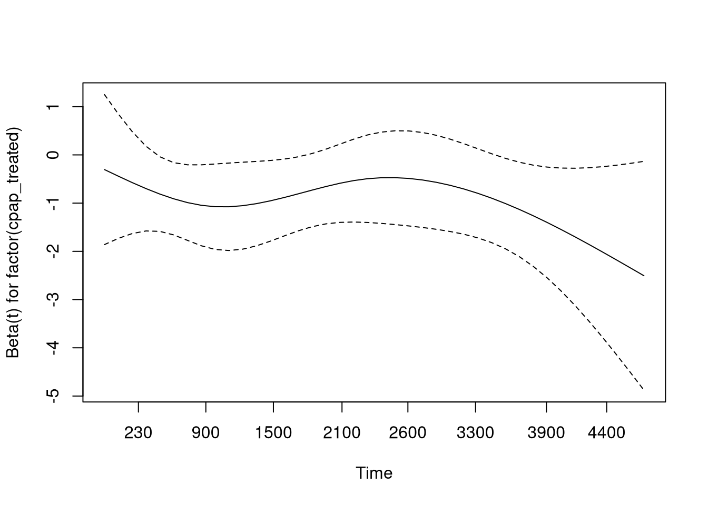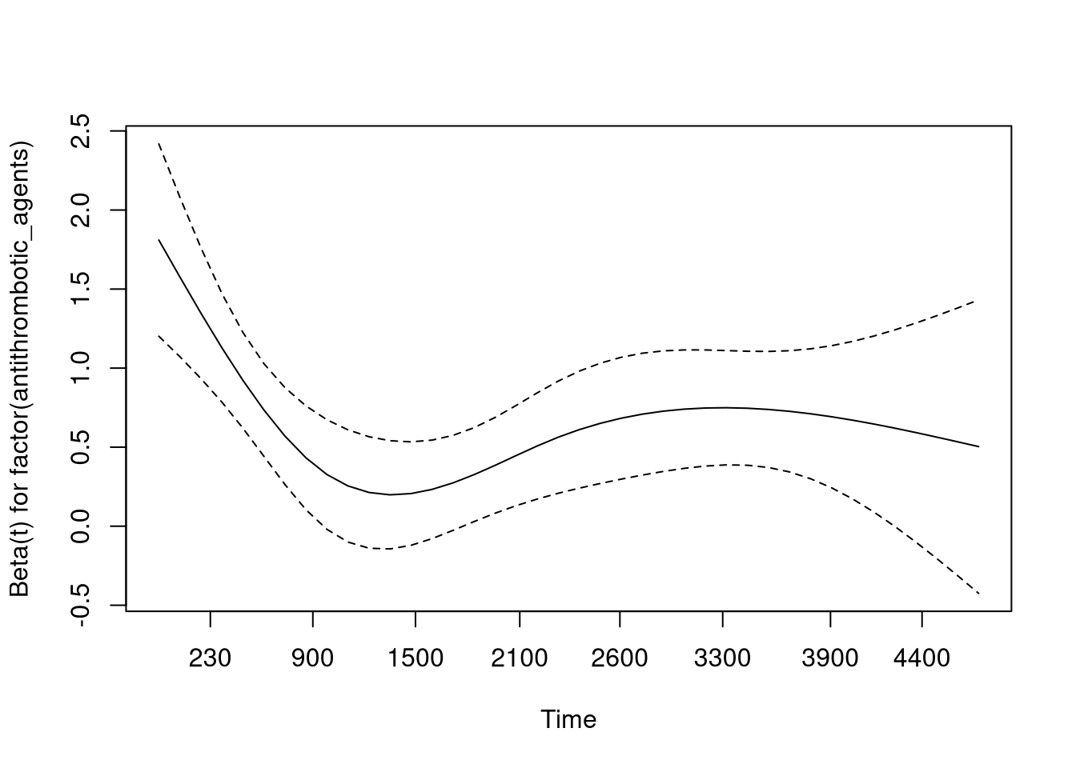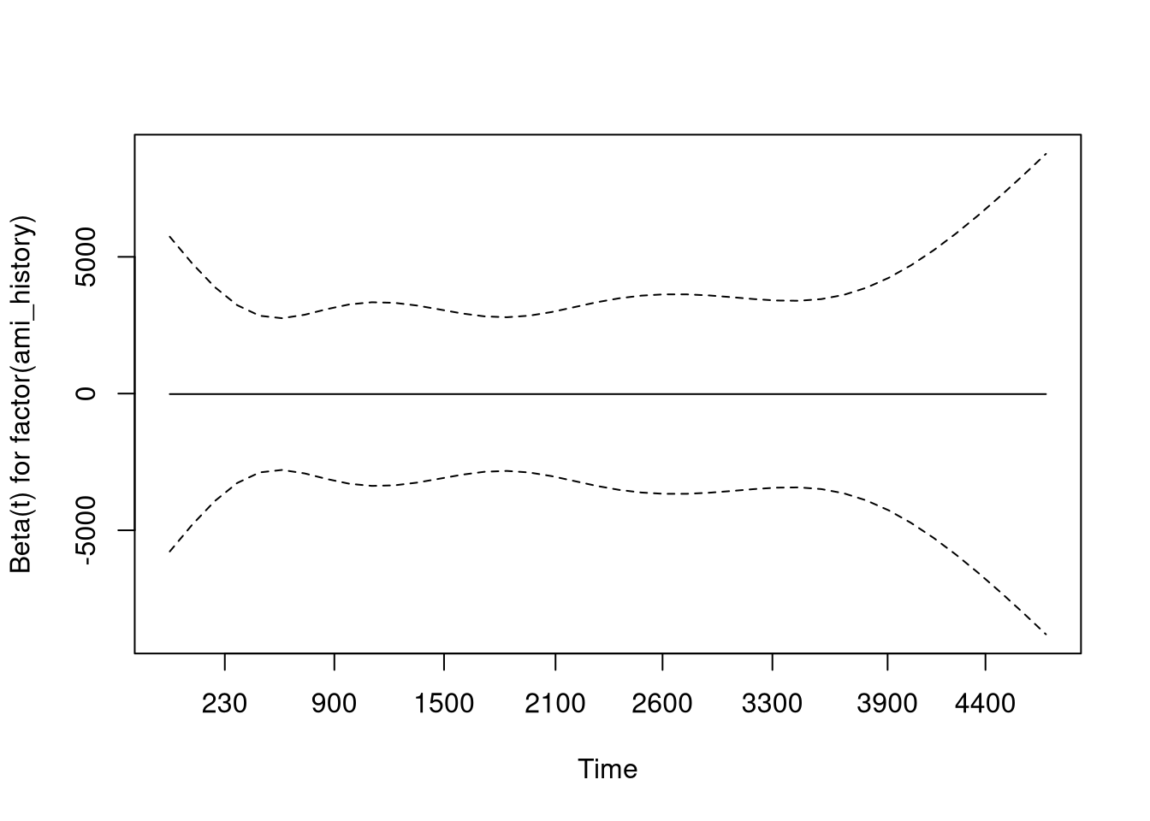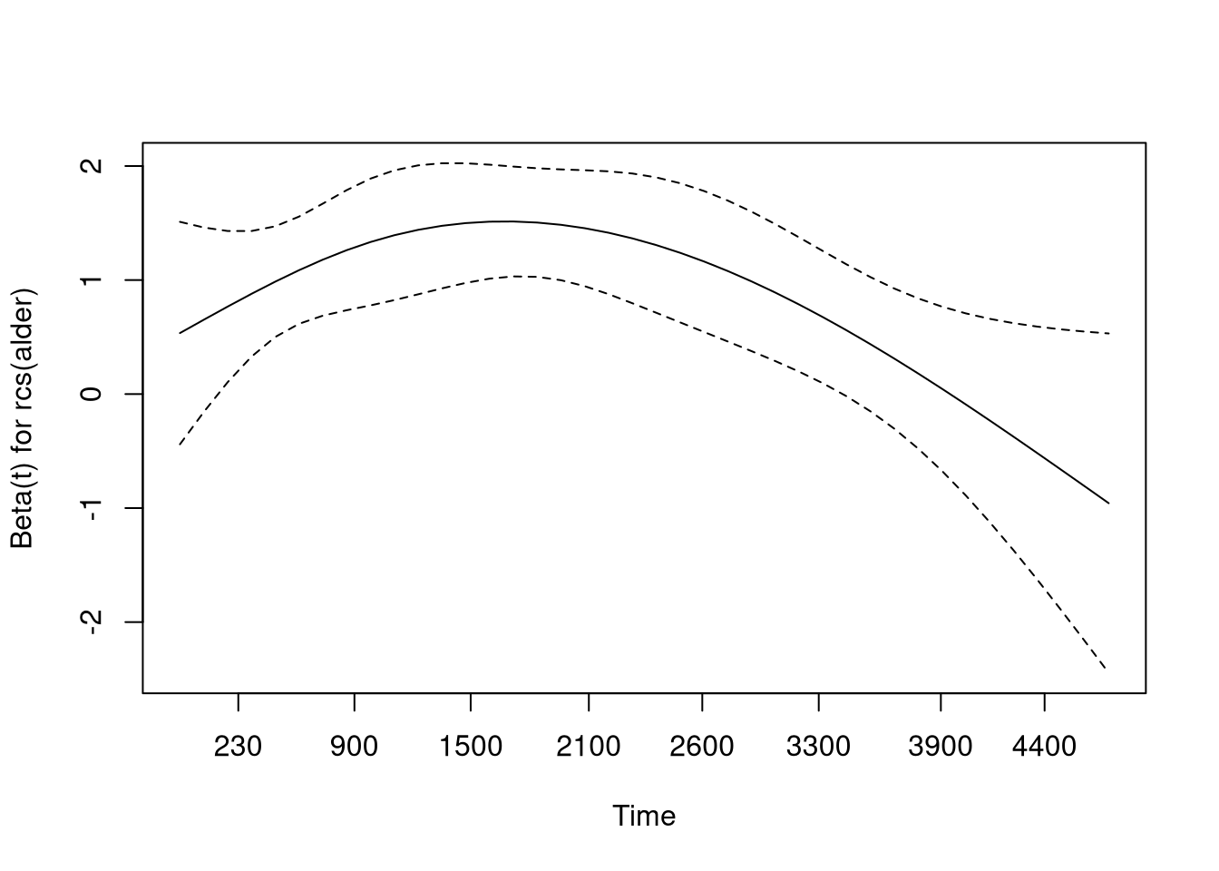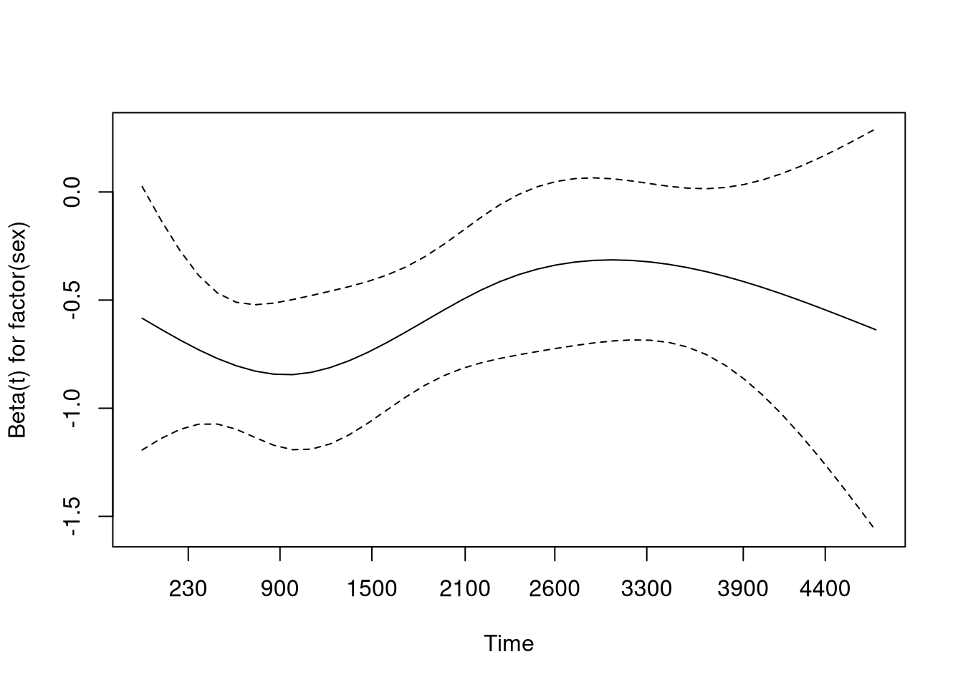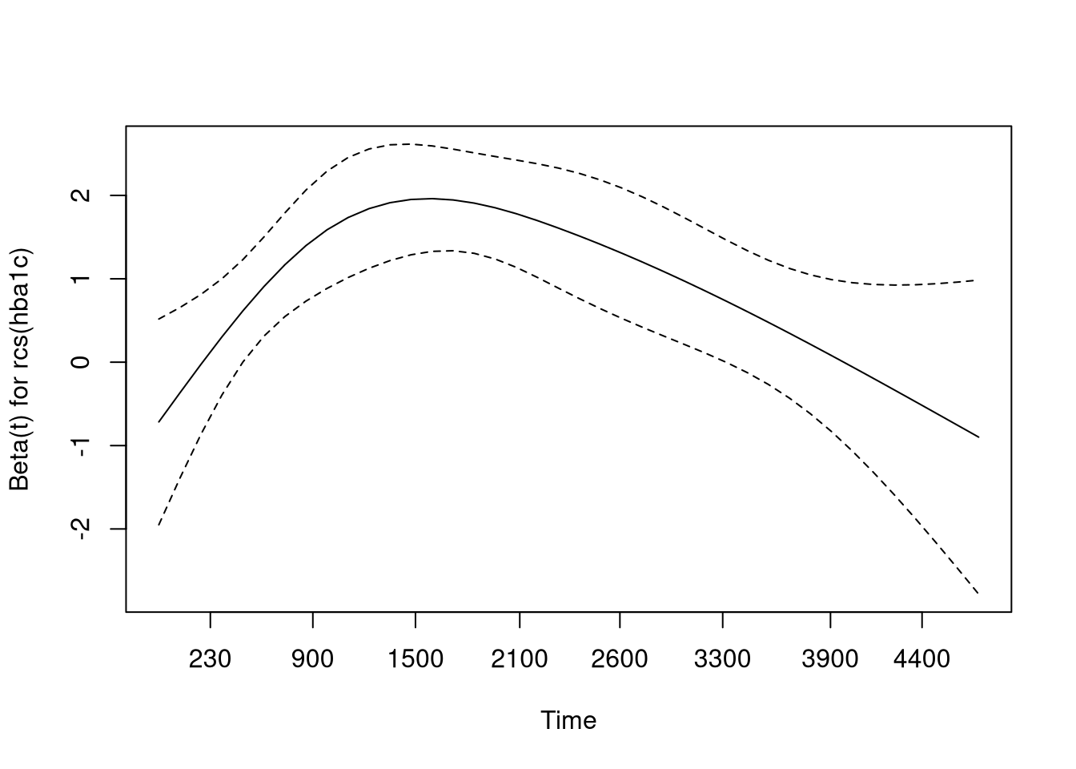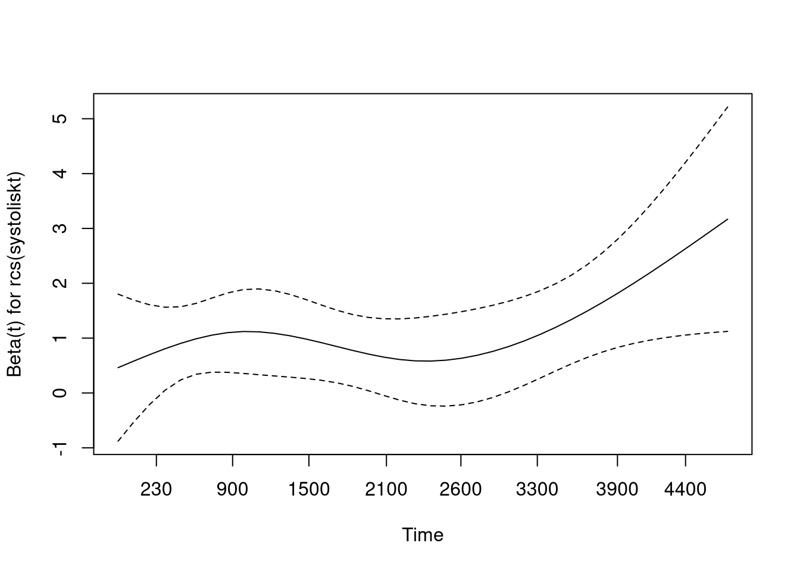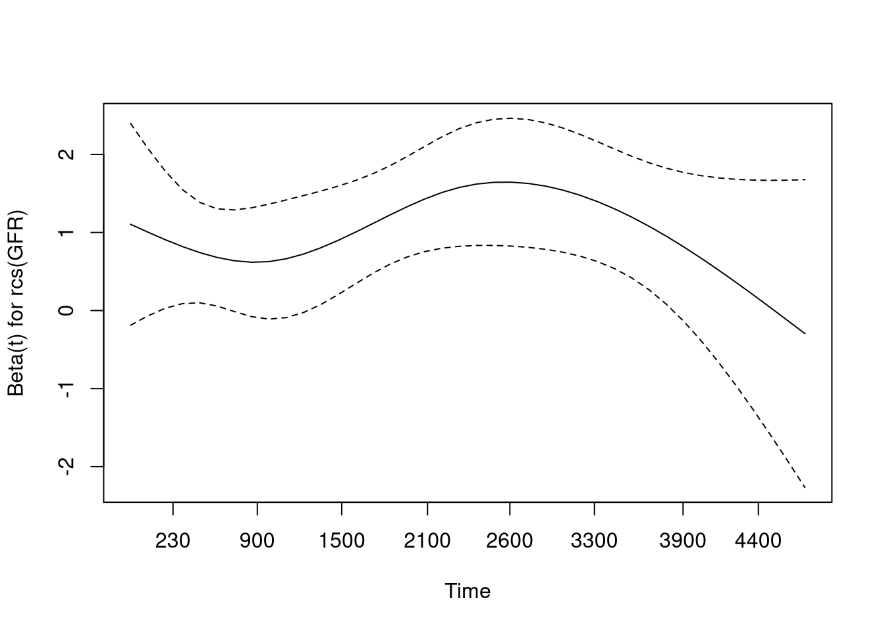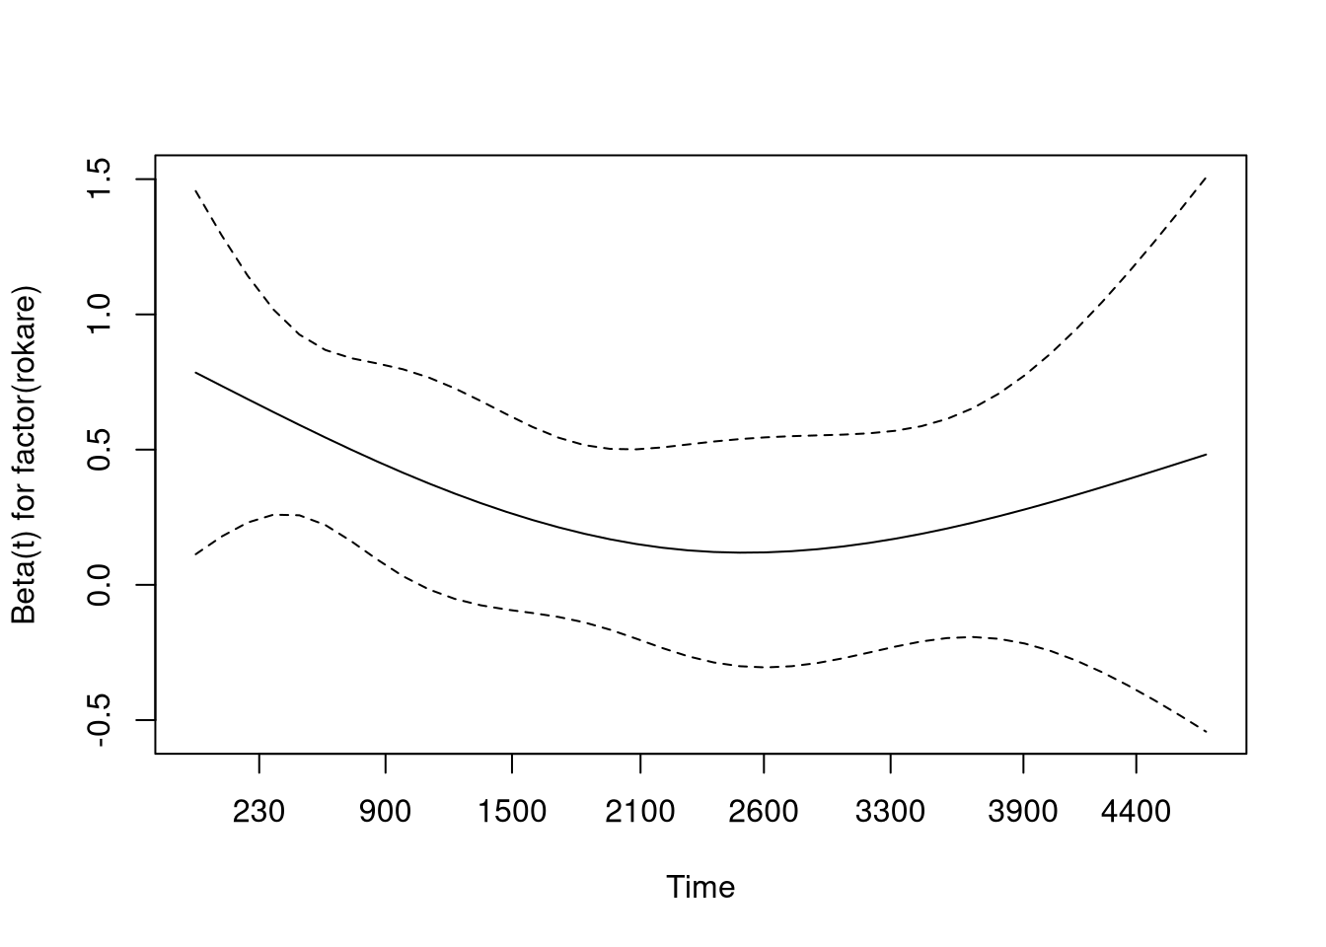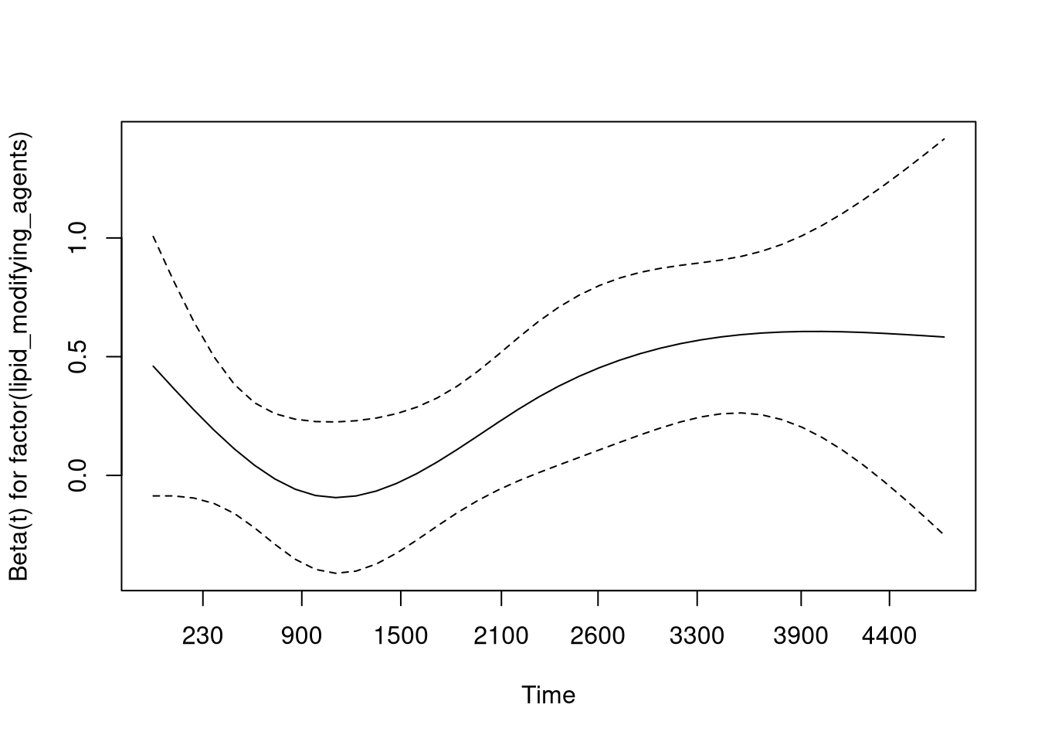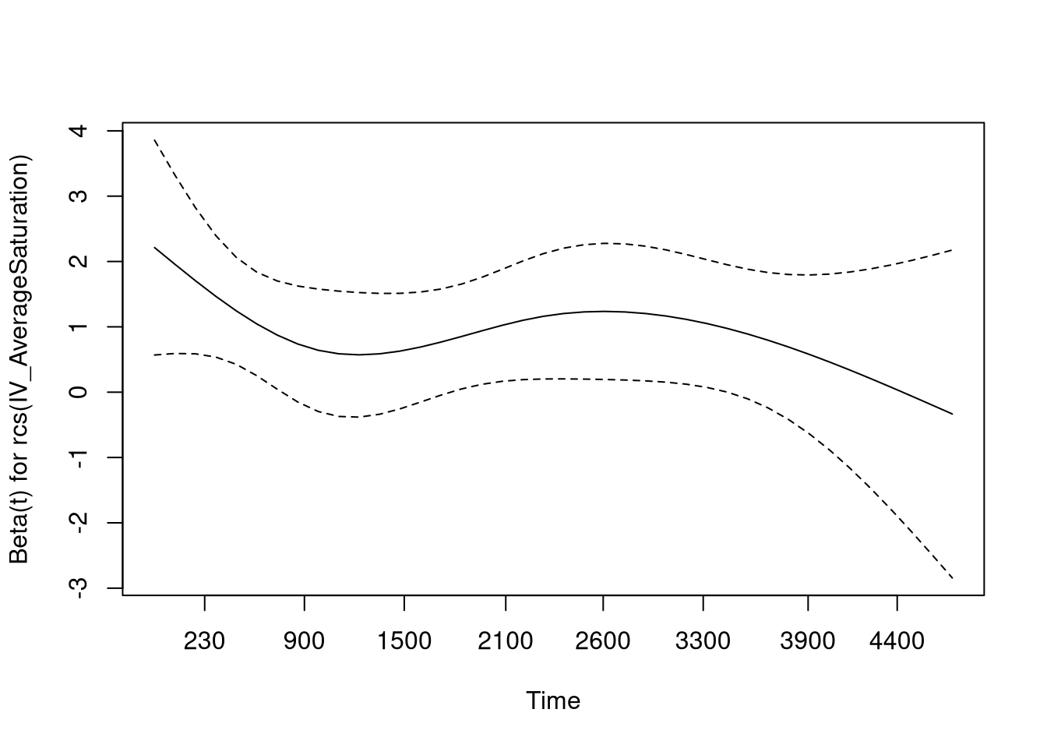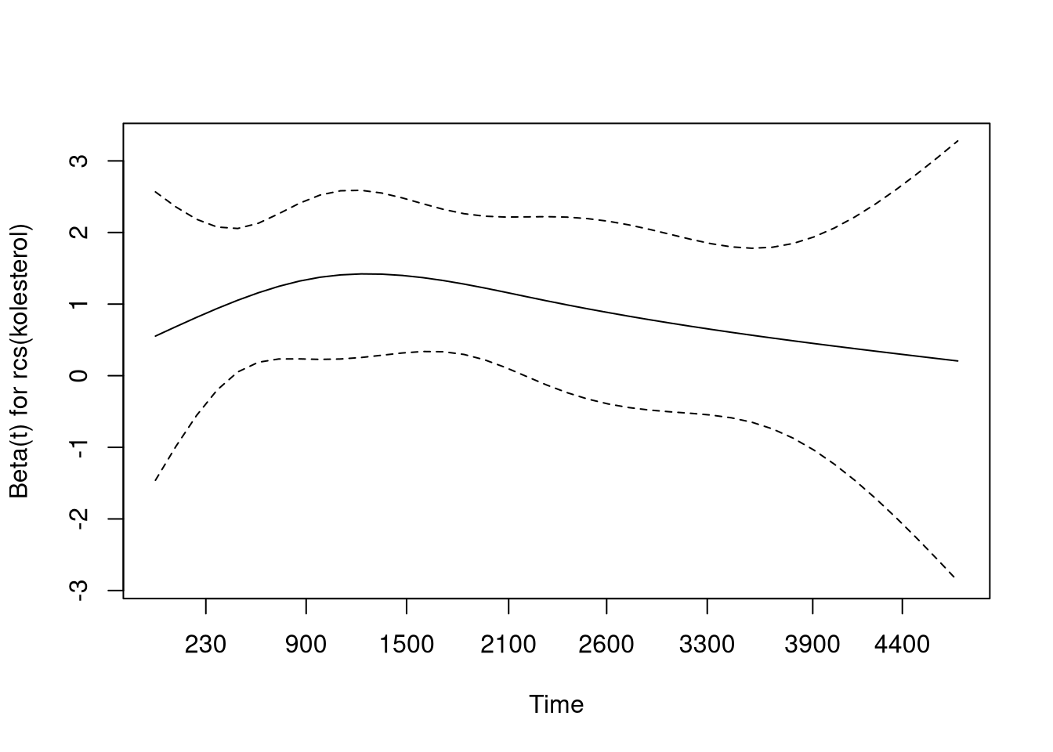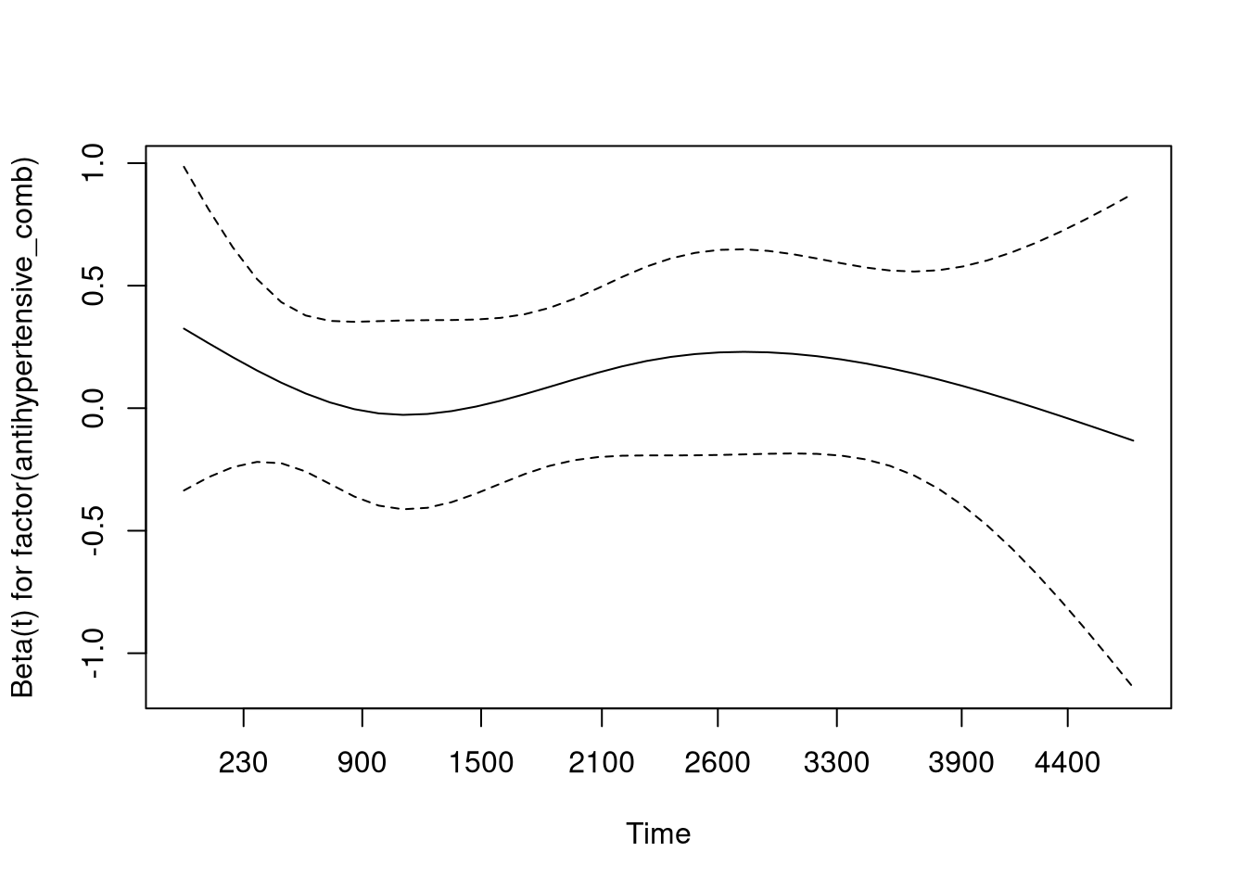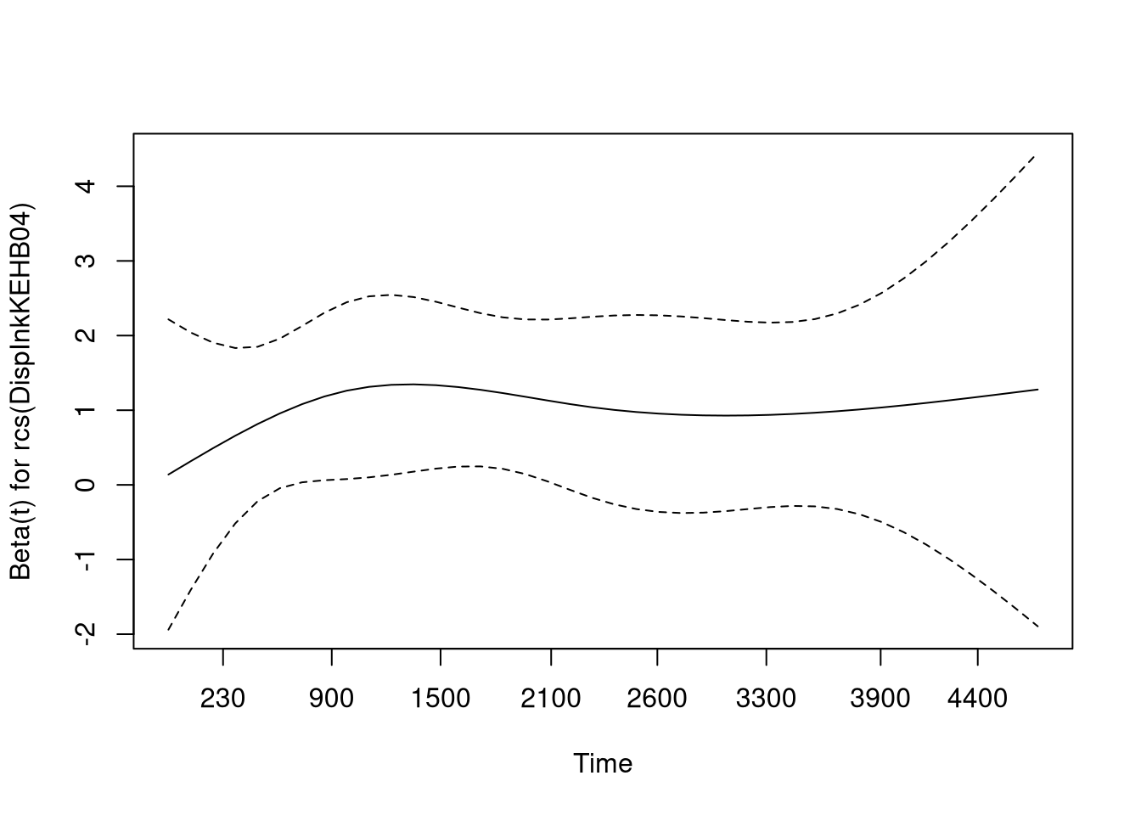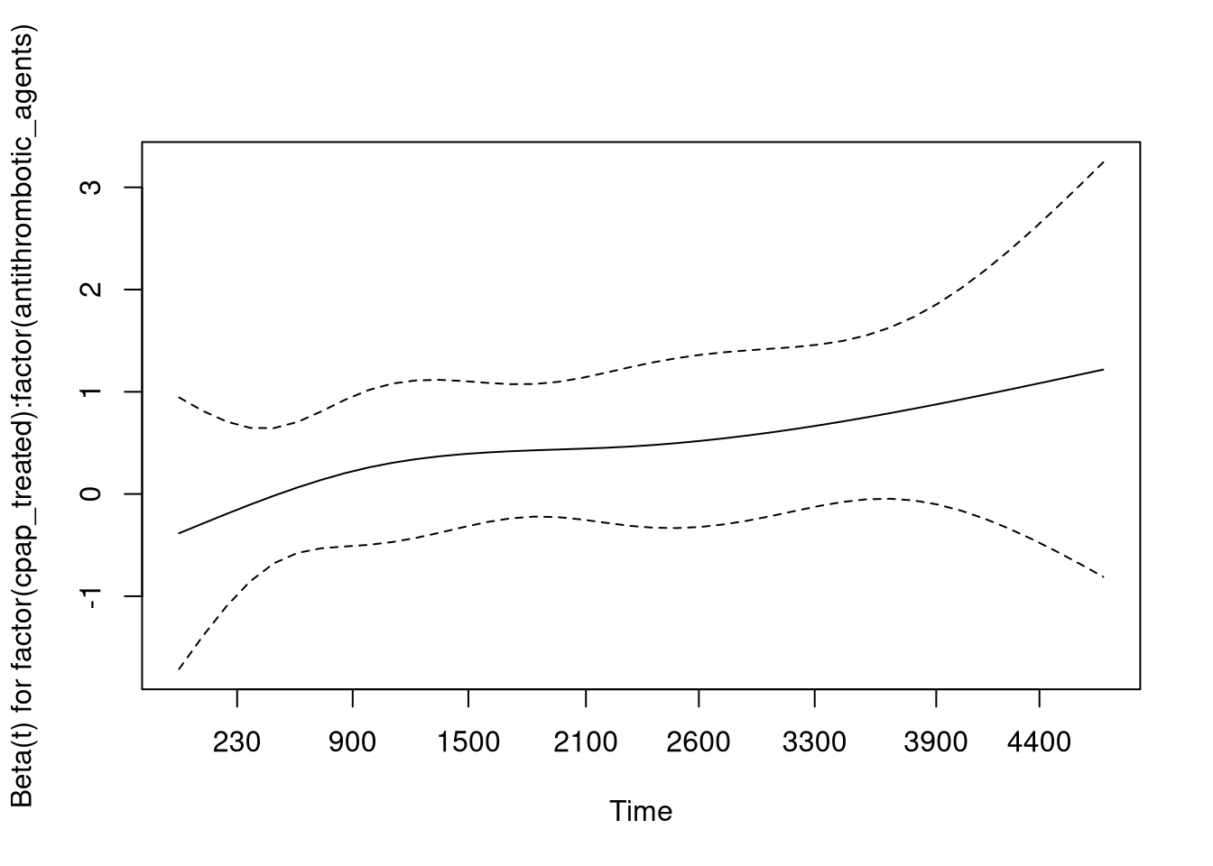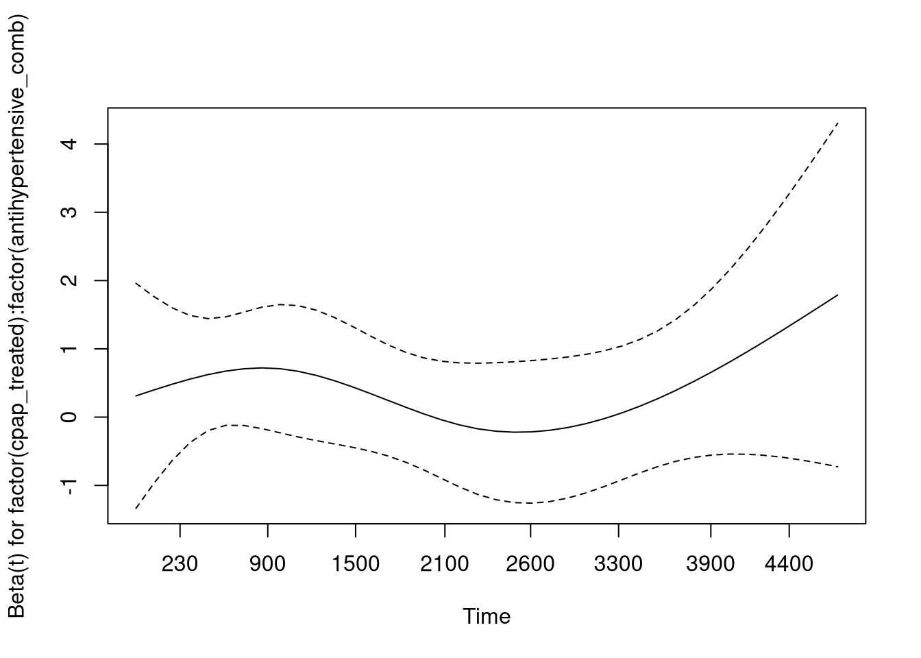

## Warning in termplot(cph): 'model' appears to involve interactions: see the help

## page

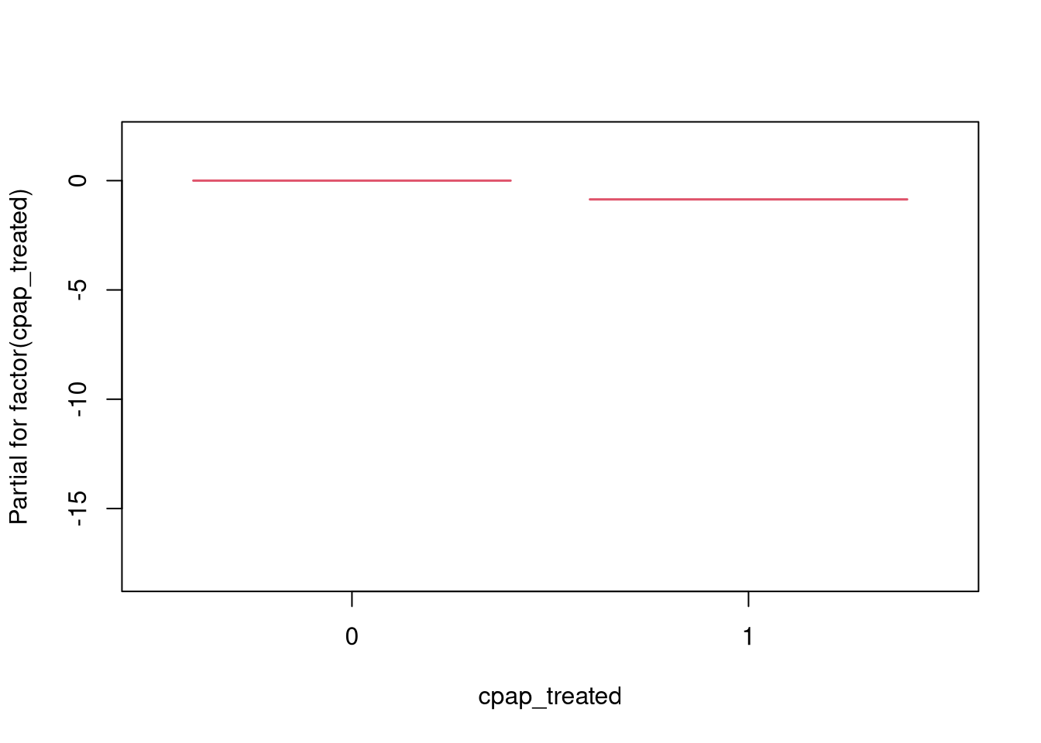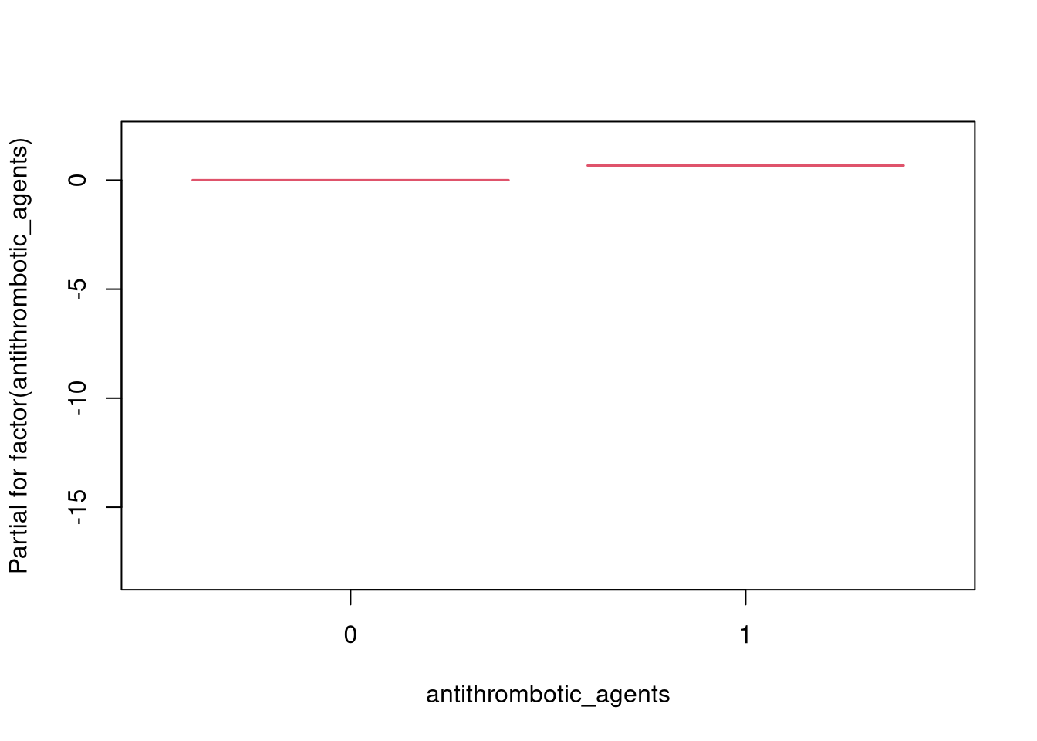

## [1] "--- CONCORDANCE RESULTS ---"

## C-index train: 0.7453331

## C-index test: 0.7453331

**Stroke**

**Time-dependent**

**Group 1**

run_models(c(list_forms[["form_tdep_spl"]], list_forms[["form_tdep_cat"]]), df_stroke_tv_train, df_stroke_tv_test, "stop", "event", cont_var, "prof_stroke_dep_g1.html")

## [1] "### FORMULA 1 ###"

## number of knots in rcs defaulting to 5

## number of knots in rcs defaulting to 5

## number of knots in rcs defaulting to 5

## number of knots in rcs defaulting to 5

## number of knots in rcs defaulting to 5

## number of knots in rcs defaulting to 5

## number of knots in rcs defaulting to 5

## number of knots in rcs defaulting to 5

## number of knots in rcs defaulting to 5

## number of knots in rcs defaulting to 5

## Warning in agreg.fit(X, Y, istrat, offset, init, control, weights = weights, :

## Loglik converged before variable 13 ; beta may be infinite.

## number of knots in rcs defaulting to 5

## number of knots in rcs defaulting to 5

## number of knots in rcs defaulting to 5

## number of knots in rcs defaulting to 5

## number of knots in rcs defaulting to 5

## number of knots in rcs defaulting to 5

## number of knots in rcs defaulting to 5

## number of knots in rcs defaulting to 5

## number of knots in rcs defaulting to 5

## number of knots in rcs defaulting to 5

## Warning in agreg.fit(x = X[idx, ], y = Y[idx, ], strata = strata[idx], offset =

## offset[idx], : Loglik converged before variable 13 ; beta may be infinite.

## [1] "--- SURVIVAL RESULTS ---"

## Call:

## coxph(formula = form, data = df_train, x = T)

##

## n= 7086751, number of events= 36051

##

## coef exp(coef)

## factor(cpap_treated)1 6.724e-02 1.070e+00

## rcs(alder)alder 1.151e+00 3.162e+00

## rcs(alder)alder' -1.701e+00 1.825e-01

## rcs(alder)alder'' 1.057e+01 3.893e+04

## rcs(alder)alder''' -2.084e+01 8.866e-10

## factor(sex)1 -2.809e-01 7.551e-01

## rcs(bmi)bmi 1.075e-01 1.113e+00

## rcs(bmi)bmi' -3.822e+00 2.189e-02

## rcs(bmi)bmi'' 1.620e+01 1.084e+07

## rcs(bmi)bmi''' -1.771e+01 2.033e-08

## factor(rokare)1 3.180e-01 1.374e+00

## factor(ami_history)1 2.997e-03 1.003e+00

## factor(stroke_history)1 -1.675e+01 5.312e-08

## factor(Civil)1 -3.443e-02 9.662e-01

## factor(HushallsTyp_RTB)2 -1.073e-01 8.982e-01

## factor(HushallsTyp_RTB)3 -1.920e-02 9.810e-01

## factor(Sun2000niva_old)2 4.780e-02 1.049e+00

## factor(Sun2000niva_old)3 1.536e-02 1.015e+00

## factor(Sun2000niva_old)4 1.491e-02 1.015e+00

## factor(Sun2000niva_old)5 2.736e-02 1.028e+00

## factor(Sun2000niva_old)6 -1.280e-02 9.873e-01

## factor(Sun2000niva_old)7 4.471e-02 1.046e+00

## rcs(DispInkKEHB04)DispInkKEHB04 8.096e-02 1.084e+00

## rcs(DispInkKEHB04)DispInkKEHB04' -7.254e+00 7.070e-04

## rcs(DispInkKEHB04)DispInkKEHB04'' 1.332e+01 6.115e+05

## rcs(DispInkKEHB04)DispInkKEHB04''' -2.152e+00 1.163e-01

## rcs(Raks_AndelArblosInk)Raks_AndelArblosInk 1.042e+00 2.833e+00

## rcs(Raks_AndelArblosInk)Raks_AndelArblosInk' -3.985e+02 9.018e-174

## rcs(Raks_AndelArblosInk)Raks_AndelArblosInk'' 4.288e+02 1.628e+186

## rcs(Raks_AndelArblosInk)Raks_AndelArblosInk''' -3.223e+01 1.004e-14

## rcs(Raks_AndelSjukInk)Raks_AndelSjukInk 2.803e+00 1.650e+01

## rcs(Raks_AndelSjukInk)Raks_AndelSjukInk' -3.498e+03 0.000e+00

## rcs(Raks_AndelSjukInk)Raks_AndelSjukInk'' 4.028e+03 Inf

## rcs(Raks_AndelSjukInk)Raks_AndelSjukInk''' -5.379e+02 2.590e-234

## rcs(Raks_AndelEkBisInk)Raks_AndelEkBisInk 1.084e+00 2.957e+00

## rcs(Raks_AndelEkBisInk)Raks_AndelEkBisInk' -1.855e+02 2.861e-81

## rcs(Raks_AndelEkBisInk)Raks_AndelEkBisInk'' 1.941e+02 2.033e+84

## factor(FodelseLand_EU27_2020)1 5.298e-02 1.054e+00

## factor(antithrombotic_agents)1 5.071e-01 1.661e+00

## factor(antihypertensive_comb)1 4.178e-02 1.043e+00

## factor(lipid_modifying_agents)1 -4.068e-03 9.959e-01

## rcs(hba1c)hba1c 4.347e-03 1.004e+00

## rcs(hba1c)hba1c' 2.181e+00 8.858e+00

## rcs(hba1c)hba1c'' -5.008e+00 6.686e-03

## rcs(hba1c)hba1c''' 2.160e+00 8.672e+00

## rcs(GFR)GFR -3.599e-01 6.977e-01

## rcs(GFR)GFR' -1.146e+00 3.180e-01

## rcs(GFR)GFR'' 1.286e+01 3.830e+05

## rcs(GFR)GFR''' -2.463e+01 2.013e-11

## rcs(kolesterol)kolesterol -9.338e-02 9.109e-01

## rcs(kolesterol)kolesterol' 1.068e+00 2.910e+00

## rcs(kolesterol)kolesterol'' -4.281e+00 1.384e-02

## rcs(kolesterol)kolesterol''' 4.813e+00 1.231e+02

## rcs(systoliskt)systoliskt -1.558e-01 8.557e-01

## rcs(systoliskt)systoliskt' 5.906e-01 1.805e+00

## rcs(systoliskt)systoliskt'' -8.857e-01 4.124e-01

## rcs(systoliskt)systoliskt''' -6.675e-01 5.130e-01

## factor(cpap_treated)1:factor(antithrombotic_agents)1 -1.335e-01 8.751e-01

## factor(cpap_treated)1:factor(antihypertensive_comb)1 -2.426e-02 9.760e-01

## factor(cpap_treated)1:factor(lipid_modifying_agents)1 -1.286e-01 8.793e-01

## rcs(alder)alder:rcs(bmi)bmi 2.464e-01 1.279e+00

## rcs(alder)alder':rcs(bmi)bmi -8.995e-01 4.068e-01

## rcs(alder)alder'':rcs(bmi)bmi 5.449e+00 2.324e+02

## rcs(alder)alder''':rcs(bmi)bmi -1.066e+01 2.342e-05

## rcs(alder)alder:rcs(bmi)bmi' -3.217e+00 4.006e-02

## rcs(alder)alder':rcs(bmi)bmi' 1.463e+01 2.269e+06

## rcs(alder)alder'':rcs(bmi)bmi' -8.473e+01 1.601e-37

## rcs(alder)alder''':rcs(bmi)bmi' 1.553e+02 2.907e+67

## rcs(alder)alder:rcs(bmi)bmi'' 1.252e+01 2.741e+05

## rcs(alder)alder':rcs(bmi)bmi'' -6.239e+01 7.995e-28

## rcs(alder)alder'':rcs(bmi)bmi'' 3.609e+02 5.503e+156

## rcs(alder)alder''':rcs(bmi)bmi'' -6.580e+02 1.717e-286

## rcs(alder)alder:rcs(bmi)bmi''' -1.285e+01 2.629e-06

## rcs(alder)alder':rcs(bmi)bmi''' 7.020e+01 3.069e+30

## rcs(alder)alder'':rcs(bmi)bmi''' -4.061e+02 4.115e-177

## rcs(alder)alder''':rcs(bmi)bmi''' 7.384e+02 Inf

## rcs(alder)alder:rcs(GFR)GFR 1.816e-01 1.199e+00

## rcs(alder)alder':rcs(GFR)GFR -2.897e-01 7.485e-01

## rcs(alder)alder'':rcs(GFR)GFR 2.139e+00 8.495e+00

## rcs(alder)alder''':rcs(GFR)GFR -4.522e+00 1.087e-02

## rcs(alder)alder:rcs(GFR)GFR' -1.128e+00 3.238e-01

## rcs(alder)alder':rcs(GFR)GFR' 4.096e+00 6.011e+01

## rcs(alder)alder'':rcs(GFR)GFR' -1.756e+01 2.364e-08

## rcs(alder)alder''':rcs(GFR)GFR' 2.020e+01 5.917e+08

## rcs(alder)alder:rcs(GFR)GFR'' 9.713e+00 1.653e+04

## rcs(alder)alder':rcs(GFR)GFR'' -3.102e+01 3.382e-14

## rcs(alder)alder'':rcs(GFR)GFR'' 1.204e+02 1.960e+52

## rcs(alder)alder''':rcs(GFR)GFR'' -1.268e+02 8.777e-56

## rcs(alder)alder:rcs(GFR)GFR''' -1.900e+01 5.582e-09

## rcs(alder)alder':rcs(GFR)GFR''' 5.410e+01 3.132e+23

## rcs(alder)alder'':rcs(GFR)GFR''' -1.954e+02 1.433e-85

## rcs(alder)alder''':rcs(GFR)GFR''' 1.899e+02 2.896e+82

## factor(cpap_treated)1:rcs(GFR)GFR 6.030e-02 1.062e+00

## factor(cpap_treated)1:rcs(GFR)GFR' 1.697e+00 5.455e+00

## factor(cpap_treated)1:rcs(GFR)GFR'' -1.760e+01 2.279e-08

## factor(cpap_treated)1:rcs(GFR)GFR''' 3.763e+01 2.206e+16

## se(coef) z

## factor(cpap_treated)1 4.713e-01 0.143

## rcs(alder)alder 5.212e-01 2.209

## rcs(alder)alder' 1.561e+00 -1.090

## rcs(alder)alder'' 7.548e+00 1.400

## rcs(alder)alder''' 1.256e+01 -1.660

## factor(sex)1 1.191e-02 -23.582

## rcs(bmi)bmi 4.706e-01 0.228

## rcs(bmi)bmi' 3.722e+00 -1.027

## rcs(bmi)bmi'' 1.571e+01 1.031

## rcs(bmi)bmi''' 1.904e+01 -0.930

## factor(rokare)1 1.527e-02 20.826

## factor(ami_history)1 1.922e-02 0.156

## factor(stroke_history)1 8.574e+01 -0.195

## factor(Civil)1 1.709e-02 -2.015

## factor(HushallsTyp_RTB)2 1.377e-02 -7.793

## factor(HushallsTyp_RTB)3 2.111e-02 -0.909

## factor(Sun2000niva_old)2 1.983e-02 2.410

## factor(Sun2000niva_old)3 1.385e-02 1.109

## factor(Sun2000niva_old)4 1.921e-02 0.776

## factor(Sun2000niva_old)5 2.164e-02 1.264

## factor(Sun2000niva_old)6 2.177e-02 -0.588

## factor(Sun2000niva_old)7 6.916e-02 0.646

## rcs(DispInkKEHB04)DispInkKEHB04 1.458e-01 0.555

## rcs(DispInkKEHB04)DispInkKEHB04' 2.757e+00 -2.631

## rcs(DispInkKEHB04)DispInkKEHB04'' 8.391e+00 1.588

## rcs(DispInkKEHB04)DispInkKEHB04''' 7.966e+00 -0.270

## rcs(Raks_AndelArblosInk)Raks_AndelArblosInk 2.204e-01 4.726

## rcs(Raks_AndelArblosInk)Raks_AndelArblosInk' 9.576e+01 -4.161

## rcs(Raks_AndelArblosInk)Raks_AndelArblosInk'' 1.036e+02 4.137

## rcs(Raks_AndelArblosInk)Raks_AndelArblosInk''' 8.913e+00 -3.616

## rcs(Raks_AndelSjukInk)Raks_AndelSjukInk 3.793e-01 7.391

## rcs(Raks_AndelSjukInk)Raks_AndelSjukInk' 5.499e+02 -6.361

## rcs(Raks_AndelSjukInk)Raks_AndelSjukInk'' 6.351e+02 6.341

## rcs(Raks_AndelSjukInk)Raks_AndelSjukInk''' 8.715e+01 -6.172

## rcs(Raks_AndelEkBisInk)Raks_AndelEkBisInk 1.560e-01 6.951

## rcs(Raks_AndelEkBisInk)Raks_AndelEkBisInk' 2.791e+01 -6.644

## rcs(Raks_AndelEkBisInk)Raks_AndelEkBisInk'' 2.924e+01 6.639

## factor(FodelseLand_EU27_2020)1 1.503e-02 3.524

## factor(antithrombotic_agents)1 1.197e-02 42.362

## factor(antihypertensive_comb)1 1.231e-02 3.393

## factor(lipid_modifying_agents)1 1.176e-02 -0.346

## rcs(hba1c)hba1c 4.730e-02 0.092

## rcs(hba1c)hba1c' 5.965e-01 3.657

## rcs(hba1c)hba1c'' 2.015e+00 -2.485

## rcs(hba1c)hba1c''' 2.018e+00 1.071

## rcs(GFR)GFR 2.760e-01 -1.304

## rcs(GFR)GFR' 1.744e+00 -0.657

## rcs(GFR)GFR'' 9.562e+00 1.344

## rcs(GFR)GFR''' 1.472e+01 -1.673

## rcs(kolesterol)kolesterol 3.012e-02 -3.100

## rcs(kolesterol)kolesterol' 1.954e-01 5.467

## rcs(kolesterol)kolesterol'' 9.492e-01 -4.509

## rcs(kolesterol)kolesterol''' 1.357e+00 3.548

## rcs(systoliskt)systoliskt 2.566e-02 -6.074

## rcs(systoliskt)systoliskt' 1.700e-01 3.475

## rcs(systoliskt)systoliskt'' 8.418e-01 -1.052

## rcs(systoliskt)systoliskt''' 1.616e+00 -0.413

## factor(cpap_treated)1:factor(antithrombotic_agents)1 1.675e-01 -0.797

## factor(cpap_treated)1:factor(antihypertensive_comb)1 1.802e-01 -0.135

## factor(cpap_treated)1:factor(lipid_modifying_agents)1 1.663e-01 -0.773

## rcs(alder)alder:rcs(bmi)bmi 3.779e-01 0.652

## rcs(alder)alder':rcs(bmi)bmi 1.178e+00 -0.764

## rcs(alder)alder'':rcs(bmi)bmi 5.805e+00 0.939

## rcs(alder)alder''':rcs(bmi)bmi 9.737e+00 -1.095

## rcs(alder)alder:rcs(bmi)bmi' 3.012e+00 -1.068

## rcs(alder)alder':rcs(bmi)bmi' 9.350e+00 1.565

## rcs(alder)alder'':rcs(bmi)bmi' 4.628e+01 -1.831

## rcs(alder)alder''':rcs(bmi)bmi' 7.867e+01 1.975

## rcs(alder)alder:rcs(bmi)bmi'' 1.271e+01 0.985

## rcs(alder)alder':rcs(bmi)bmi'' 3.959e+01 -1.576

## rcs(alder)alder'':rcs(bmi)bmi'' 1.971e+02 1.831

## rcs(alder)alder''':rcs(bmi)bmi'' 3.381e+02 -1.946

## rcs(alder)alder:rcs(bmi)bmi''' 1.538e+01 -0.835

## rcs(alder)alder':rcs(bmi)bmi''' 4.816e+01 1.458

## rcs(alder)alder'':rcs(bmi)bmi''' 2.413e+02 -1.683

## rcs(alder)alder''':rcs(bmi)bmi''' 4.180e+02 1.767

## rcs(alder)alder:rcs(GFR)GFR 2.243e-01 0.810

## rcs(alder)alder':rcs(GFR)GFR 6.911e-01 -0.419

## rcs(alder)alder'':rcs(GFR)GFR 3.396e+00 0.630

## rcs(alder)alder''':rcs(GFR)GFR 5.729e+00 -0.789

## rcs(alder)alder:rcs(GFR)GFR' 1.463e+00 -0.771

## rcs(alder)alder':rcs(GFR)GFR' 4.337e+00 0.944

## rcs(alder)alder'':rcs(GFR)GFR' 2.097e+01 -0.837

## rcs(alder)alder''':rcs(GFR)GFR' 3.520e+01 0.574

## rcs(alder)alder:rcs(GFR)GFR'' 7.936e+00 1.224

## rcs(alder)alder':rcs(GFR)GFR'' 2.399e+01 -1.293

## rcs(alder)alder'':rcs(GFR)GFR'' 1.185e+02 1.016

## rcs(alder)alder''':rcs(GFR)GFR'' 2.047e+02 -0.619

## rcs(alder)alder:rcs(GFR)GFR''' 1.201e+01 -1.583

## rcs(alder)alder':rcs(GFR)GFR''' 3.740e+01 1.446

## rcs(alder)alder'':rcs(GFR)GFR''' 1.903e+02 -1.027

## rcs(alder)alder''':rcs(GFR)GFR''' 3.402e+02 0.558

## factor(cpap_treated)1:rcs(GFR)GFR 3.166e-01 0.190

## factor(cpap_treated)1:rcs(GFR)GFR' 1.890e+00 0.898

## factor(cpap_treated)1:rcs(GFR)GFR'' 1.095e+01 -1.607

## factor(cpap_treated)1:rcs(GFR)GFR''' 1.806e+01 2.084

## Pr(>|z|)

## factor(cpap_treated)1 0.886547

## rcs(alder)alder 0.027191 *

## rcs(alder)alder' 0.275854

## rcs(alder)alder'' 0.161418

## rcs(alder)alder''' 0.096931 .

## factor(sex)1 < 2e-16 ***

## rcs(bmi)bmi 0.819342

## rcs(bmi)bmi' 0.304544

## rcs(bmi)bmi'' 0.302588

## rcs(bmi)bmi''' 0.352254

## factor(rokare)1 < 2e-16 ***

## factor(ami_history)1 0.876121

## factor(stroke_history)1 0.845108

## factor(Civil)1 0.043866 *

## factor(HushallsTyp_RTB)2 6.52e-15 ***

## factor(HushallsTyp_RTB)3 0.363113

## factor(Sun2000niva_old)2 0.015936 *

## factor(Sun2000niva_old)3 0.267607

## factor(Sun2000niva_old)4 0.437853

## factor(Sun2000niva_old)5 0.206191

## factor(Sun2000niva_old)6 0.556476

## factor(Sun2000niva_old)7 0.518005

## rcs(DispInkKEHB04)DispInkKEHB04 0.578562

## rcs(DispInkKEHB04)DispInkKEHB04' 0.008514 **

## rcs(DispInkKEHB04)DispInkKEHB04'' 0.112317

## rcs(DispInkKEHB04)DispInkKEHB04''' 0.787100

## rcs(Raks_AndelArblosInk)Raks_AndelArblosInk 2.29e-06 ***

## rcs(Raks_AndelArblosInk)Raks_AndelArblosInk' 3.17e-05 ***

## rcs(Raks_AndelArblosInk)Raks_AndelArblosInk'' 3.52e-05 ***

## rcs(Raks_AndelArblosInk)Raks_AndelArblosInk''' 0.000299 ***

## rcs(Raks_AndelSjukInk)Raks_AndelSjukInk 1.46e-13 ***

## rcs(Raks_AndelSjukInk)Raks_AndelSjukInk' 2.00e-10 ***

## rcs(Raks_AndelSjukInk)Raks_AndelSjukInk'' 2.28e-10 ***

## rcs(Raks_AndelSjukInk)Raks_AndelSjukInk''' 6.75e-10 ***

## rcs(Raks_AndelEkBisInk)Raks_AndelEkBisInk 3.64e-12 ***

## rcs(Raks_AndelEkBisInk)Raks_AndelEkBisInk' 3.06e-11 ***

## rcs(Raks_AndelEkBisInk)Raks_AndelEkBisInk'' 3.17e-11 ***

## factor(FodelseLand_EU27_2020)1 0.000425 ***

## factor(antithrombotic_agents)1 < 2e-16 ***

## factor(antihypertensive_comb)1 0.000691 ***

## factor(lipid_modifying_agents)1 0.729352

## rcs(hba1c)hba1c 0.926772

## rcs(hba1c)hba1c' 0.000256 ***

## rcs(hba1c)hba1c'' 0.012949 *

## rcs(hba1c)hba1c''' 0.284338

## rcs(GFR)GFR 0.192277

## rcs(GFR)GFR' 0.511167

## rcs(GFR)GFR'' 0.178818

## rcs(GFR)GFR''' 0.094388 .

## rcs(kolesterol)kolesterol 0.001935 **

## rcs(kolesterol)kolesterol' 4.57e-08 ***

## rcs(kolesterol)kolesterol'' 6.50e-06 ***

## rcs(kolesterol)kolesterol''' 0.000389 ***

## rcs(systoliskt)systoliskt 1.25e-09 ***

## rcs(systoliskt)systoliskt' 0.000511 ***

## rcs(systoliskt)systoliskt'' 0.292761

## rcs(systoliskt)systoliskt''' 0.679580

## factor(cpap_treated)1:factor(antithrombotic_agents)1 0.425640

## factor(cpap_treated)1:factor(antihypertensive_comb)1 0.892873

## factor(cpap_treated)1:factor(lipid_modifying_agents)1 0.439377

## rcs(alder)alder:rcs(bmi)bmi 0.514437

## rcs(alder)alder':rcs(bmi)bmi 0.445117

## rcs(alder)alder'':rcs(bmi)bmi 0.347949

## rcs(alder)alder''':rcs(bmi)bmi 0.273531

## rcs(alder)alder:rcs(bmi)bmi' 0.285401

## rcs(alder)alder':rcs(bmi)bmi' 0.117524

## rcs(alder)alder'':rcs(bmi)bmi' 0.067121 .

## rcs(alder)alder''':rcs(bmi)bmi' 0.048311 *

## rcs(alder)alder:rcs(bmi)bmi'' 0.324537

## rcs(alder)alder':rcs(bmi)bmi'' 0.115049

## rcs(alder)alder'':rcs(bmi)bmi'' 0.067027 .

## rcs(alder)alder''':rcs(bmi)bmi'' 0.051634 .

## rcs(alder)alder:rcs(bmi)bmi''' 0.403522

## rcs(alder)alder':rcs(bmi)bmi''' 0.144944

## rcs(alder)alder'':rcs(bmi)bmi''' 0.092353 .

## rcs(alder)alder''':rcs(bmi)bmi''' 0.077310 .

## rcs(alder)alder:rcs(GFR)GFR 0.418125

## rcs(alder)alder':rcs(GFR)GFR 0.675024

## rcs(alder)alder'':rcs(GFR)GFR 0.528690

## rcs(alder)alder''':rcs(GFR)GFR 0.429904

## rcs(alder)alder:rcs(GFR)GFR' 0.440718

## rcs(alder)alder':rcs(GFR)GFR' 0.344934

## rcs(alder)alder'':rcs(GFR)GFR' 0.402376

## rcs(alder)alder''':rcs(GFR)GFR' 0.566092

## rcs(alder)alder:rcs(GFR)GFR'' 0.220959

## rcs(alder)alder':rcs(GFR)GFR'' 0.196010

## rcs(alder)alder'':rcs(GFR)GFR'' 0.309575

## rcs(alder)alder''':rcs(GFR)GFR'' 0.535626

## rcs(alder)alder:rcs(GFR)GFR''' 0.113493

## rcs(alder)alder':rcs(GFR)GFR''' 0.148042

## rcs(alder)alder'':rcs(GFR)GFR''' 0.304521

## rcs(alder)alder''':rcs(GFR)GFR''' 0.576758

## factor(cpap_treated)1:rcs(GFR)GFR 0.848954

## factor(cpap_treated)1:rcs(GFR)GFR' 0.369319

## factor(cpap_treated)1:rcs(GFR)GFR'' 0.108019

## factor(cpap_treated)1:rcs(GFR)GFR''' 0.037162 *

## ---

## Signif. codes: 0 '***' 0.001 '**' 0.01 '*' 0.05 '.' 0.1 ' ' 1

##

## exp(coef) exp(-coef)

## factor(cpap_treated)1 1.070e+00 9.350e-01

## rcs(alder)alder 3.162e+00 3.162e-01

## rcs(alder)alder' 1.825e-01 5.479e+00

## rcs(alder)alder'' 3.893e+04 2.569e-05

## rcs(alder)alder''' 8.866e-10 1.128e+09

## factor(sex)1 7.551e-01 1.324e+00

## rcs(bmi)bmi 1.113e+00 8.981e-01

## rcs(bmi)bmi' 2.189e-02 4.568e+01

## rcs(bmi)bmi'' 1.084e+07 9.225e-08

## rcs(bmi)bmi''' 2.033e-08 4.918e+07

## factor(rokare)1 1.374e+00 7.276e-01

## factor(ami_history)1 1.003e+00 9.970e-01

## factor(stroke_history)1 5.312e-08 1.883e+07

## factor(Civil)1 9.662e-01 1.035e+00

## factor(HushallsTyp_RTB)2 8.982e-01 1.113e+00

## factor(HushallsTyp_RTB)3 9.810e-01 1.019e+00

## factor(Sun2000niva_old)2 1.049e+00 9.533e-01

## factor(Sun2000niva_old)3 1.015e+00 9.848e-01

## factor(Sun2000niva_old)4 1.015e+00 9.852e-01

## factor(Sun2000niva_old)5 1.028e+00 9.730e-01

## factor(Sun2000niva_old)6 9.873e-01 1.013e+00

## factor(Sun2000niva_old)7 1.046e+00 9.563e-01

## rcs(DispInkKEHB04)DispInkKEHB04 1.084e+00 9.222e-01

## rcs(DispInkKEHB04)DispInkKEHB04' 7.070e-04 1.414e+03

## rcs(DispInkKEHB04)DispInkKEHB04'' 6.115e+05 1.635e-06

## rcs(DispInkKEHB04)DispInkKEHB04''' 1.163e-01 8.598e+00

## rcs(Raks_AndelArblosInk)Raks_AndelArblosInk 2.833e+00 3.529e-01

## rcs(Raks_AndelArblosInk)Raks_AndelArblosInk' 9.018e-174 1.109e+173

## rcs(Raks_AndelArblosInk)Raks_AndelArblosInk'' 1.628e+186 6.142e-187

## rcs(Raks_AndelArblosInk)Raks_AndelArblosInk''' 1.004e-14 9.956e+13

## rcs(Raks_AndelSjukInk)Raks_AndelSjukInk 1.650e+01 6.061e-02

## rcs(Raks_AndelSjukInk)Raks_AndelSjukInk' 0.000e+00 Inf

## rcs(Raks_AndelSjukInk)Raks_AndelSjukInk'' Inf 0.000e+00

## rcs(Raks_AndelSjukInk)Raks_AndelSjukInk''' 2.590e-234 3.862e+233

## rcs(Raks_AndelEkBisInk)Raks_AndelEkBisInk 2.957e+00 3.382e-01

## rcs(Raks_AndelEkBisInk)Raks_AndelEkBisInk' 2.861e-81 3.496e+80

## rcs(Raks_AndelEkBisInk)Raks_AndelEkBisInk'' 2.033e+84 4.920e-85

## factor(FodelseLand_EU27_2020)1 1.054e+00 9.484e-01

## factor(antithrombotic_agents)1 1.661e+00 6.022e-01

## factor(antihypertensive_comb)1 1.043e+00 9.591e-01

## factor(lipid_modifying_agents)1 9.959e-01 1.004e+00

## rcs(hba1c)hba1c 1.004e+00 9.957e-01

## rcs(hba1c)hba1c' 8.858e+00 1.129e-01

## rcs(hba1c)hba1c'' 6.686e-03 1.496e+02

## rcs(hba1c)hba1c''' 8.672e+00 1.153e-01

## rcs(GFR)GFR 6.977e-01 1.433e+00

## rcs(GFR)GFR' 3.180e-01 3.144e+00

## rcs(GFR)GFR'' 3.830e+05 2.611e-06

## rcs(GFR)GFR''' 2.013e-11 4.967e+10

## rcs(kolesterol)kolesterol 9.109e-01 1.098e+00

## rcs(kolesterol)kolesterol' 2.910e+00 3.436e-01

## rcs(kolesterol)kolesterol'' 1.384e-02 7.228e+01

## rcs(kolesterol)kolesterol''' 1.231e+02 8.120e-03

## rcs(systoliskt)systoliskt 8.557e-01 1.169e+00

## rcs(systoliskt)systoliskt' 1.805e+00 5.540e-01

## rcs(systoliskt)systoliskt'' 4.124e-01 2.425e+00

## rcs(systoliskt)systoliskt''' 5.130e-01 1.949e+00

## factor(cpap_treated)1:factor(antithrombotic_agents)1 8.751e-01 1.143e+00

## factor(cpap_treated)1:factor(antihypertensive_comb)1 9.760e-01 1.025e+00

## factor(cpap_treated)1:factor(lipid_modifying_agents)1 8.793e-01 1.137e+00

## rcs(alder)alder:rcs(bmi)bmi 1.279e+00 7.816e-01

## rcs(alder)alder':rcs(bmi)bmi 4.068e-01 2.458e+00

## rcs(alder)alder'':rcs(bmi)bmi 2.324e+02 4.303e-03

## rcs(alder)alder''':rcs(bmi)bmi 2.342e-05 4.270e+04

## rcs(alder)alder:rcs(bmi)bmi' 4.006e-02 2.496e+01

## rcs(alder)alder':rcs(bmi)bmi' 2.269e+06 4.407e-07

## rcs(alder)alder'':rcs(bmi)bmi' 1.601e-37 6.248e+36

## rcs(alder)alder''':rcs(bmi)bmi' 2.907e+67 3.440e-68

## rcs(alder)alder:rcs(bmi)bmi'' 2.741e+05 3.649e-06

## rcs(alder)alder':rcs(bmi)bmi'' 7.995e-28 1.251e+27

## rcs(alder)alder'':rcs(bmi)bmi'' 5.503e+156 1.817e-157

## rcs(alder)alder''':rcs(bmi)bmi'' 1.717e-286 5.824e+285

## rcs(alder)alder:rcs(bmi)bmi''' 2.629e-06 3.804e+05

## rcs(alder)alder':rcs(bmi)bmi''' 3.069e+30 3.258e-31

## rcs(alder)alder'':rcs(bmi)bmi''' 4.115e-177 2.430e+176

## rcs(alder)alder''':rcs(bmi)bmi''' Inf 2.055e-321

## rcs(alder)alder:rcs(GFR)GFR 1.199e+00 8.339e-01

## rcs(alder)alder':rcs(GFR)GFR 7.485e-01 1.336e+00

## rcs(alder)alder'':rcs(GFR)GFR 8.495e+00 1.177e-01

## rcs(alder)alder''':rcs(GFR)GFR 1.087e-02 9.203e+01

## rcs(alder)alder:rcs(GFR)GFR' 3.238e-01 3.089e+00

## rcs(alder)alder':rcs(GFR)GFR' 6.011e+01 1.664e-02

## rcs(alder)alder'':rcs(GFR)GFR' 2.364e-08 4.229e+07

## rcs(alder)alder''':rcs(GFR)GFR' 5.917e+08 1.690e-09

## rcs(alder)alder:rcs(GFR)GFR'' 1.653e+04 6.049e-05

## rcs(alder)alder':rcs(GFR)GFR'' 3.382e-14 2.956e+13

## rcs(alder)alder'':rcs(GFR)GFR'' 1.960e+52 5.101e-53

## rcs(alder)alder''':rcs(GFR)GFR'' 8.777e-56 1.139e+55

## rcs(alder)alder:rcs(GFR)GFR''' 5.582e-09 1.791e+08

## rcs(alder)alder':rcs(GFR)GFR''' 3.132e+23 3.193e-24

## rcs(alder)alder'':rcs(GFR)GFR''' 1.433e-85 6.980e+84

## rcs(alder)alder''':rcs(GFR)GFR''' 2.896e+82 3.453e-83

## factor(cpap_treated)1:rcs(GFR)GFR 1.062e+00 9.415e-01

## factor(cpap_treated)1:rcs(GFR)GFR' 5.455e+00 1.833e-01

## factor(cpap_treated)1:rcs(GFR)GFR'' 2.279e-08 4.388e+07

## factor(cpap_treated)1:rcs(GFR)GFR''' 2.206e+16 4.534e-17

## lower .95 upper .95

## factor(cpap_treated)1 4.247e-01 2.694e+00

## rcs(alder)alder 1.138e+00 8.784e+00

## rcs(alder)alder' 8.561e-03 3.890e+00

## rcs(alder)alder'' 1.464e-02 1.035e+11

## rcs(alder)alder''' 1.816e-20 4.328e+01

## factor(sex)1 7.377e-01 7.730e-01

## rcs(bmi)bmi 4.427e-01 2.801e+00

## rcs(bmi)bmi' 1.485e-05 3.226e+01

## rcs(bmi)bmi'' 4.570e-07 2.571e+20

## rcs(bmi)bmi''' 1.264e-24 3.270e+08

## factor(rokare)1 1.334e+00 1.416e+00

## factor(ami_history)1 9.659e-01 1.042e+00

## factor(stroke_history)1 5.525e-81 5.107e+65

## factor(Civil)1 9.343e-01 9.991e-01

## factor(HushallsTyp_RTB)2 8.743e-01 9.228e-01

## factor(HushallsTyp_RTB)3 9.412e-01 1.022e+00

## factor(Sun2000niva_old)2 1.009e+00 1.091e+00

## factor(Sun2000niva_old)3 9.883e-01 1.043e+00

## factor(Sun2000niva_old)4 9.775e-01 1.054e+00

## factor(Sun2000niva_old)5 9.851e-01 1.072e+00

## factor(Sun2000niva_old)6 9.460e-01 1.030e+00

## factor(Sun2000niva_old)7 9.132e-01 1.198e+00

## rcs(DispInkKEHB04)DispInkKEHB04 8.149e-01 1.443e+00

## rcs(DispInkKEHB04)DispInkKEHB04' 3.180e-06 1.572e-01

## rcs(DispInkKEHB04)DispInkKEHB04'' 4.406e-02 8.487e+12

## rcs(DispInkKEHB04)DispInkKEHB04''' 1.926e-08 7.023e+05

## rcs(Raks_AndelArblosInk)Raks_AndelArblosInk 1.840e+00 4.364e+00

## rcs(Raks_AndelArblosInk)Raks_AndelArblosInk' 2.805e-255 2.899e-92

## rcs(Raks_AndelArblosInk)Raks_AndelArblosInk'' 9.813e+97 2.701e+274

## rcs(Raks_AndelArblosInk)Raks_AndelArblosInk''' 2.601e-22 3.879e-07

## rcs(Raks_AndelSjukInk)Raks_AndelSjukInk 7.845e+00 3.470e+01

## rcs(Raks_AndelSjukInk)Raks_AndelSjukInk' 0.000e+00 0.000e+00

## rcs(Raks_AndelSjukInk)Raks_AndelSjukInk'' Inf Inf

## rcs(Raks_AndelSjukInk)Raks_AndelSjukInk''' 1.718e-308 3.904e-160

## rcs(Raks_AndelEkBisInk)Raks_AndelEkBisInk 2.178e+00 4.014e+00

## rcs(Raks_AndelEkBisInk)Raks_AndelEkBisInk' 4.962e-105 1.649e-57

## rcs(Raks_AndelEkBisInk)Raks_AndelEkBisInk'' 2.613e+59 1.581e+109

## factor(FodelseLand_EU27_2020)1 1.024e+00 1.086e+00

## factor(antithrombotic_agents)1 1.622e+00 1.700e+00

## factor(antihypertensive_comb)1 1.018e+00 1.068e+00

## factor(lipid_modifying_agents)1 9.733e-01 1.019e+00

## rcs(hba1c)hba1c 9.154e-01 1.102e+00

## rcs(hba1c)hba1c' 2.751e+00 2.852e+01

## rcs(hba1c)hba1c'' 1.288e-04 3.470e-01

## rcs(hba1c)hba1c''' 1.662e-01 4.523e+02

## rcs(GFR)GFR 4.062e-01 1.199e+00

## rcs(GFR)GFR' 1.043e-02 9.696e+00

## rcs(GFR)GFR'' 2.777e-03 5.281e+13

## rcs(GFR)GFR''' 5.899e-24 6.870e+01

## rcs(kolesterol)kolesterol 8.586e-01 9.662e-01

## rcs(kolesterol)kolesterol' 1.984e+00 4.268e+00

## rcs(kolesterol)kolesterol'' 2.153e-03 8.892e-02

## rcs(kolesterol)kolesterol''' 8.620e+00 1.759e+03

## rcs(systoliskt)systoliskt 8.137e-01 8.998e-01

## rcs(systoliskt)systoliskt' 1.294e+00 2.519e+00

## rcs(systoliskt)systoliskt'' 7.921e-02 2.147e+00

## rcs(systoliskt)systoliskt''' 2.161e-02 1.218e+01

## factor(cpap_treated)1:factor(antithrombotic_agents)1 6.301e-01 1.215e+00

## factor(cpap_treated)1:factor(antihypertensive_comb)1 6.857e-01 1.389e+00

## factor(cpap_treated)1:factor(lipid_modifying_agents)1 6.347e-01 1.218e+00

## rcs(alder)alder:rcs(bmi)bmi 6.100e-01 2.683e+00

## rcs(alder)alder':rcs(bmi)bmi 4.042e-02 4.094e+00

## rcs(alder)alder'':rcs(bmi)bmi 2.660e-03 2.030e+07

## rcs(alder)alder''':rcs(bmi)bmi 1.205e-13 4.549e+03

## rcs(alder)alder:rcs(bmi)bmi' 1.094e-04 1.467e+01

## rcs(alder)alder':rcs(bmi)bmi' 2.496e-02 2.063e+14

## rcs(alder)alder'':rcs(bmi)bmi' 6.515e-77 3.932e+02

## rcs(alder)alder''':rcs(bmi)bmi' 3.169e+00 2.666e+134

## rcs(alder)alder:rcs(bmi)bmi'' 4.164e-06 1.804e+16

## rcs(alder)alder':rcs(bmi)bmi'' 1.592e-61 4.016e+06

## rcs(alder)alder'':rcs(bmi)bmi'' 1.013e-11 Inf

## rcs(alder)alder''':rcs(bmi)bmi'' 0.000e+00 1.061e+02

## rcs(alder)alder:rcs(bmi)bmi''' 2.122e-19 3.256e+07

## rcs(alder)alder':rcs(bmi)bmi''' 3.114e-11 3.025e+71

## rcs(alder)alder'':rcs(bmi)bmi''' 0.000e+00 1.030e+29

## rcs(alder)alder''':rcs(bmi)bmi''' 7.615e-36 Inf

## rcs(alder)alder:rcs(GFR)GFR 7.726e-01 1.861e+00

## rcs(alder)alder':rcs(GFR)GFR 1.932e-01 2.900e+00

## rcs(alder)alder'':rcs(GFR)GFR 1.093e-02 6.603e+03

## rcs(alder)alder''':rcs(GFR)GFR 1.444e-07 8.174e+02

## rcs(alder)alder:rcs(GFR)GFR' 1.841e-02 5.693e+00

## rcs(alder)alder':rcs(GFR)GFR' 1.222e-02 2.956e+05

## rcs(alder)alder'':rcs(GFR)GFR' 3.341e-26 1.673e+10

## rcs(alder)alder''':rcs(GFR)GFR' 6.449e-22 5.429e+38

## rcs(alder)alder:rcs(GFR)GFR'' 2.907e-03 9.400e+10

## rcs(alder)alder':rcs(GFR)GFR'' 1.288e-34 8.882e+06

## rcs(alder)alder'':rcs(GFR)GFR'' 2.671e-49 1.439e+153

## rcs(alder)alder''':rcs(GFR)GFR'' 5.485e-230 1.405e+119

## rcs(alder)alder:rcs(GFR)GFR''' 3.359e-19 9.277e+01

## rcs(alder)alder':rcs(GFR)GFR''' 4.563e-09 2.149e+55

## rcs(alder)alder'':rcs(GFR)GFR''' 1.598e-247 1.285e+77

## rcs(alder)alder''':rcs(GFR)GFR''' 7.613e-208 Inf

## factor(cpap_treated)1:rcs(GFR)GFR 5.711e-01 1.975e+00

## factor(cpap_treated)1:rcs(GFR)GFR' 1.343e-01 2.215e+02

## factor(cpap_treated)1:rcs(GFR)GFR'' 1.091e-17 4.760e+01

## factor(cpap_treated)1:rcs(GFR)GFR''' 9.388e+00 5.182e+31

##

## Concordance= 0.758 (se = 0.001 )

## Likelihood ratio test= 29806 on 96 df, p=<2e-16

## Wald test = 23506 on 96 df, p=<2e-16

## Score (logrank) test = 30597 on 96 df, p=<2e-16

## Warning in termplot(cph): 'model' appears to involve interactions: see the help

## page

## [1] "--- CONCORDANCE RESULTS ---"

## C-index train: 0.7582911

## C-index test: 0.7581617

**Group 2**

run_models(c(list_forms_sleep[["form_tdep_spl"]], list_forms_sleep[["form_tdep_cat"]]), df_stroke_sub_tv_train, df_stroke_sub_tv_test, "stop", "event", cont_var, "prof_stroke_dep_g2.html", bigd=F)

## [1] "### FORMULA 1 ###"

## Start: AIC=7501.25

## Surv(start, stop, event) ~ factor(cpap_treated)

## number of knots in rcs defaulting to 5

## number of knots in rcs defaulting to 5

## Warning in agreg.fit(X, Y, istrat, offset, init, control, weights = weights, :

## Loglik converged before variable 2 ; beta may be infinite.

## number of knots in rcs defaulting to 5

## number of knots in rcs defaulting to 5

## number of knots in rcs defaulting to 5

## number of knots in rcs defaulting to 5

## number of knots in rcs defaulting to 5

## number of knots in rcs defaulting to 5

## number of knots in rcs defaulting to 5

## number of knots in rcs defaulting to 5

## number of knots in rcs defaulting to 5

## number of knots in rcs defaulting to 5

## number of knots in rcs defaulting to 5

## Df AIC

## + rcs(alder) 4 7401.1

## + factor(antithrombotic_agents) 1 7453.9

## + factor(stroke_history) 1 7479.0

## + rcs(systoliskt) 4 7481.0

## + rcs(GFR) 4 7481.0

## + rcs(DispInkKEHB04) 4 7484.2

## + rcs(hba1c) 4 7491.2

## + rcs(IV_AHI) 4 7492.2

## + rcs(IV_ODI) 4 7492.7

## + factor(antihypertensive_comb) 1 7494.8

## + factor(lipid_modifying_agents) 1 7494.9

## + factor(ami_history) 1 7499.6

## + factor(Civil) 1 7501.2

## <none> 7501.2

## + factor(sex) 1 7501.3

## + factor(FodelseLand_EU27_2020) 1 7501.6

## + rcs(Raks_AndelArblosInk) 4 7501.8

## + factor(HushallsTyp_RTB) 2 7502.6

## + rcs(bmi) 4 7502.6

## + factor(Sun2000niva_old) 6 7502.9

## + factor(rokare) 1 7503.1

## + rcs(Raks_AndelEkBisInk) 3 7505.6

## + rcs(Raks_AndelSjukInk) 4 7505.8

## + rcs(IV_AverageSaturation) 4 7505.8

## + rcs(kolesterol) 4 7506.7

## number of knots in rcs defaulting to 5

##

## Step: AIC=7401.05

## Surv(start, stop, event) ~ factor(cpap_treated) + rcs(alder)

## number of knots in rcs defaulting to 5

## number of knots in rcs defaulting to 5

## number of knots in rcs defaulting to 5

## number of knots in rcs defaulting to 5

## number of knots in rcs defaulting to 5

## number of knots in rcs defaulting to 5

## Warning in agreg.fit(X, Y, istrat, offset, init, control, weights = weights, :

## Loglik converged before variable 6 ; beta may be infinite.

## number of knots in rcs defaulting to 5

## number of knots in rcs defaulting to 5

## number of knots in rcs defaulting to 5

## number of knots in rcs defaulting to 5

## number of knots in rcs defaulting to 5

## number of knots in rcs defaulting to 5

## number of knots in rcs defaulting to 5

## number of knots in rcs defaulting to 5

## number of knots in rcs defaulting to 5

## number of knots in rcs defaulting to 5

## number of knots in rcs defaulting to 5

## number of knots in rcs defaulting to 5

## number of knots in rcs defaulting to 5

## number of knots in rcs defaulting to 5

## number of knots in rcs defaulting to 5

## number of knots in rcs defaulting to 5

## number of knots in rcs defaulting to 5

## number of knots in rcs defaulting to 5

## number of knots in rcs defaulting to 5

## number of knots in rcs defaulting to 5

## number of knots in rcs defaulting to 5

## number of knots in rcs defaulting to 5

## number of knots in rcs defaulting to 5

## number of knots in rcs defaulting to 5

## number of knots in rcs defaulting to 5

## number of knots in rcs defaulting to 5

## number of knots in rcs defaulting to 5

## number of knots in rcs defaulting to 5

## number of knots in rcs defaulting to 5

## Df AIC

## + factor(stroke_history) 1 7371.9

## + rcs(DispInkKEHB04) 4 7380.0

## + rcs(hba1c) 4 7384.9

## + factor(antithrombotic_agents) 1 7386.5

## + rcs(systoliskt) 4 7387.0

## + rcs(IV_ODI) 4 7397.2

## + factor(rokare) 1 7399.2

## + rcs(IV_AHI) 4 7400.0

## + factor(sex) 1 7400.3

## + rcs(Raks_AndelEkBisInk) 3 7400.9

## <none> 7401.1

## + factor(lipid_modifying_agents) 1 7401.9

## + factor(ami_history) 1 7402.1

## + rcs(Raks_AndelArblosInk) 4 7402.3

## + factor(antihypertensive_comb) 1 7402.5

## + factor(Civil) 1 7402.6

## + factor(FodelseLand_EU27_2020) 1 7402.9

## + rcs(GFR) 4 7403.8

## + factor(HushallsTyp_RTB) 2 7404.6

## + rcs(kolesterol) 4 7405.8

## + rcs(IV_AverageSaturation) 4 7406.9

## + rcs(Raks_AndelSjukInk) 4 7407.5

## + factor(Sun2000niva_old) 6 7408.7

## + rcs(bmi) 4 7408.9

## - rcs(alder) 4 7501.2

## number of knots in rcs defaulting to 5

## Warning in agreg.fit(X, Y, istrat, offset, init, control, weights = weights, :

## Loglik converged before variable 6 ; beta may be infinite.

##

## Step: AIC=7371.86

## Surv(start, stop, event) ~ factor(cpap_treated) + rcs(alder) +

## factor(stroke_history)

## Warning in agreg.fit(X, Y, istrat, offset, init, control, weights = weights, :

## Loglik converged before variable 2 ; beta may be infinite.

## number of knots in rcs defaulting to 5

## number of knots in rcs defaulting to 5

## Warning in agreg.fit(X, Y, istrat, offset, init, control, weights = weights, :

## Loglik converged before variable 6 ; beta may be infinite.

## number of knots in rcs defaulting to 5

## number of knots in rcs defaulting to 5

## Warning in agreg.fit(X, Y, istrat, offset, init, control, weights = weights, :

## Loglik converged before variable 6 ; beta may be infinite.

## number of knots in rcs defaulting to 5

## Warning in agreg.fit(X, Y, istrat, offset, init, control, weights = weights, :

## Loglik converged before variable 6 ; beta may be infinite.

## number of knots in rcs defaulting to 5

## Warning in agreg.fit(X, Y, istrat, offset, init, control, weights = weights, :

## Loglik converged before variable 6 ; beta may be infinite.

## number of knots in rcs defaulting to 5

## Warning in agreg.fit(X, Y, istrat, offset, init, control, weights = weights, :

## Loglik converged before variable 6 ; beta may be infinite.

## number of knots in rcs defaulting to 5

## Warning in agreg.fit(X, Y, istrat, offset, init, control, weights = weights, :

## Loglik converged before variable 6 ; beta may be infinite.

## number of knots in rcs defaulting to 5

## Warning in agreg.fit(X, Y, istrat, offset, init, control, weights = weights, :

## Loglik converged before variable 6 ; beta may be infinite.

## number of knots in rcs defaulting to 5

## number of knots in rcs defaulting to 5

## Warning in agreg.fit(X, Y, istrat, offset, init, control, weights = weights, :

## Loglik converged before variable 6 ; beta may be infinite.

## number of knots in rcs defaulting to 5

## number of knots in rcs defaulting to 5

## Warning in agreg.fit(X, Y, istrat, offset, init, control, weights = weights, :

## Loglik converged before variable 6 ; beta may be infinite.

## number of knots in rcs defaulting to 5

## number of knots in rcs defaulting to 5

## Warning in agreg.fit(X, Y, istrat, offset, init, control, weights = weights, :

## Loglik converged before variable 6 ; beta may be infinite.

## number of knots in rcs defaulting to 5

## number of knots in rcs defaulting to 5

## Warning in agreg.fit(X, Y, istrat, offset, init, control, weights = weights, :

## Loglik converged before variable 6 ; beta may be infinite.

## number of knots in rcs defaulting to 5

## Warning in agreg.fit(X, Y, istrat, offset, init, control, weights = weights, :

## Loglik converged before variable 6 ; beta may be infinite.

## number of knots in rcs defaulting to 5

## Warning in agreg.fit(X, Y, istrat, offset, init, control, weights = weights, :

## Loglik converged before variable 6 ; beta may be infinite.

## number of knots in rcs defaulting to 5

## Warning in agreg.fit(X, Y, istrat, offset, init, control, weights = weights, :

## Loglik converged before variable 6 ; beta may be infinite.

## number of knots in rcs defaulting to 5

## Warning in agreg.fit(X, Y, istrat, offset, init, control, weights = weights, :

## Loglik converged before variable 6 ; beta may be infinite.

## number of knots in rcs defaulting to 5

## number of knots in rcs defaulting to 5

## Warning in agreg.fit(X, Y, istrat, offset, init, control, weights = weights, :

## Loglik converged before variable 6 ; beta may be infinite.

## number of knots in rcs defaulting to 5

## number of knots in rcs defaulting to 5

## Warning in agreg.fit(X, Y, istrat, offset, init, control, weights = weights, :

## Loglik converged before variable 6 ; beta may be infinite.

## number of knots in rcs defaulting to 5

## number of knots in rcs defaulting to 5

## Warning in agreg.fit(X, Y, istrat, offset, init, control, weights = weights, :

## Loglik converged before variable 6 ; beta may be infinite.

## number of knots in rcs defaulting to 5

## number of knots in rcs defaulting to 5

## Warning in agreg.fit(X, Y, istrat, offset, init, control, weights = weights, :

## Loglik converged before variable 6 ; beta may be infinite.

## number of knots in rcs defaulting to 5

## number of knots in rcs defaulting to 5

## Warning in agreg.fit(X, Y, istrat, offset, init, control, weights = weights, :

## Loglik converged before variable 6 ; beta may be infinite.

## number of knots in rcs defaulting to 5

## number of knots in rcs defaulting to 5

## Warning in agreg.fit(X, Y, istrat, offset, init, control, weights = weights, :

## Loglik converged before variable 6 ; beta may be infinite.

## number of knots in rcs defaulting to 5

## number of knots in rcs defaulting to 5

## Warning in agreg.fit(X, Y, istrat, offset, init, control, weights = weights, :

## Loglik converged before variable 6 ; beta may be infinite.

## Df AIC

## + factor(antithrombotic_agents) 1 7350.8

## + rcs(DispInkKEHB04) 4 7351.1

## + rcs(hba1c) 4 7355.2

## + rcs(systoliskt) 4 7358.0

## + rcs(IV_ODI) 4 7367.7

## + factor(rokare) 1 7369.7

## + rcs(IV_AHI) 4 7370.1

## + factor(sex) 1 7370.8

## + rcs(Raks_AndelEkBisInk) 3 7371.7

## + factor(lipid_modifying_agents) 1 7371.7

## <none> 7371.9

## + factor(ami_history) 1 7372.8

## + factor(antihypertensive_comb) 1 7373.2

## + rcs(Raks_AndelArblosInk) 4 7373.2

## + factor(Civil) 1 7373.4

## + factor(FodelseLand_EU27_2020) 1 7373.8

## + rcs(GFR) 4 7374.2

## + factor(HushallsTyp_RTB) 2 7375.4

## + rcs(kolesterol) 4 7376.7

## + rcs(IV_AverageSaturation) 4 7377.7

## + rcs(Raks_AndelSjukInk) 4 7378.0

## + factor(Sun2000niva_old) 6 7379.3

## + rcs(bmi) 4 7379.7

## - factor(stroke_history) 1 7401.1

## - rcs(alder) 4 7479.0

## number of knots in rcs defaulting to 5

## Warning in agreg.fit(X, Y, istrat, offset, init, control, weights = weights, :

## Loglik converged before variable 6 ; beta may be infinite.

##

## Step: AIC=7350.85

## Surv(start, stop, event) ~ factor(cpap_treated) + rcs(alder) +

## factor(stroke_history) + factor(antithrombotic_agents)

## Warning in agreg.fit(X, Y, istrat, offset, init, control, weights = weights, :

## Loglik converged before variable 2 ; beta may be infinite.

## number of knots in rcs defaulting to 5

## number of knots in rcs defaulting to 5

## Warning in agreg.fit(X, Y, istrat, offset, init, control, weights = weights, :

## Loglik converged before variable 6 ; beta may be infinite.

## number of knots in rcs defaulting to 5

## Warning in agreg.fit(X, Y, istrat, offset, init, control, weights = weights, :

## Loglik converged before variable 6 ; beta may be infinite.

## number of knots in rcs defaulting to 5

## number of knots in rcs defaulting to 5

## Warning in agreg.fit(X, Y, istrat, offset, init, control, weights = weights, :

## Loglik converged before variable 6 ; beta may be infinite.

## number of knots in rcs defaulting to 5

## Warning in agreg.fit(X, Y, istrat, offset, init, control, weights = weights, :

## Loglik converged before variable 6 ; beta may be infinite.

## number of knots in rcs defaulting to 5

## Warning in agreg.fit(X, Y, istrat, offset, init, control, weights = weights, :

## Loglik converged before variable 6 ; beta may be infinite.

## number of knots in rcs defaulting to 5

## Warning in agreg.fit(X, Y, istrat, offset, init, control, weights = weights, :

## Loglik converged before variable 6 ; beta may be infinite.

## number of knots in rcs defaulting to 5

## Warning in agreg.fit(X, Y, istrat, offset, init, control, weights = weights, :

## Loglik converged before variable 6 ; beta may be infinite.

## number of knots in rcs defaulting to 5

## Warning in agreg.fit(X, Y, istrat, offset, init, control, weights = weights, :

## Loglik converged before variable 6 ; beta may be infinite.

## number of knots in rcs defaulting to 5

## number of knots in rcs defaulting to 5

## Warning in agreg.fit(X, Y, istrat, offset, init, control, weights = weights, :

## Loglik converged before variable 6 ; beta may be infinite.

## number of knots in rcs defaulting to 5

## number of knots in rcs defaulting to 5

## Warning in agreg.fit(X, Y, istrat, offset, init, control, weights = weights, :

## Loglik converged before variable 6 ; beta may be infinite.

## number of knots in rcs defaulting to 5

## number of knots in rcs defaulting to 5

## Warning in agreg.fit(X, Y, istrat, offset, init, control, weights = weights, :

## Loglik converged before variable 6 ; beta may be infinite.

## number of knots in rcs defaulting to 5

## number of knots in rcs defaulting to 5

## Warning in agreg.fit(X, Y, istrat, offset, init, control, weights = weights, :

## Loglik converged before variable 6 ; beta may be infinite.

## number of knots in rcs defaulting to 5

## Warning in agreg.fit(X, Y, istrat, offset, init, control, weights = weights, :

## Loglik converged before variable 6 ; beta may be infinite.

## number of knots in rcs defaulting to 5

## Warning in agreg.fit(X, Y, istrat, offset, init, control, weights = weights, :

## Loglik converged before variable 6 ; beta may be infinite.

## number of knots in rcs defaulting to 5

## Warning in agreg.fit(X, Y, istrat, offset, init, control, weights = weights, :

## Loglik converged before variable 6 ; beta may be infinite.

## number of knots in rcs defaulting to 5

## number of knots in rcs defaulting to 5

## Warning in agreg.fit(X, Y, istrat, offset, init, control, weights = weights, :

## Loglik converged before variable 6 ; beta may be infinite.

## number of knots in rcs defaulting to 5

## number of knots in rcs defaulting to 5

## Warning in agreg.fit(X, Y, istrat, offset, init, control, weights = weights, :

## Loglik converged before variable 6 ; beta may be infinite.

## number of knots in rcs defaulting to 5

## number of knots in rcs defaulting to 5

## Warning in agreg.fit(X, Y, istrat, offset, init, control, weights = weights, :

## Loglik converged before variable 6 ; beta may be infinite.

## number of knots in rcs defaulting to 5

## number of knots in rcs defaulting to 5

## Warning in agreg.fit(X, Y, istrat, offset, init, control, weights = weights, :

## Loglik converged before variable 6 ; beta may be infinite.

## number of knots in rcs defaulting to 5

## number of knots in rcs defaulting to 5

## Warning in agreg.fit(X, Y, istrat, offset, init, control, weights = weights, :

## Loglik converged before variable 6 ; beta may be infinite.

## number of knots in rcs defaulting to 5

## number of knots in rcs defaulting to 5

## Warning in agreg.fit(X, Y, istrat, offset, init, control, weights = weights, :

## Loglik converged before variable 6 ; beta may be infinite.

## number of knots in rcs defaulting to 5

## number of knots in rcs defaulting to 5

## Warning in agreg.fit(X, Y, istrat, offset, init, control, weights = weights, :

## Loglik converged before variable 6 ; beta may be infinite.

## number of knots in rcs defaulting to 5

## Warning in agreg.fit(X, Y, istrat, offset, init, control, weights = weights, :

## Loglik converged before variable 6 ; beta may be infinite.

## Df AIC

## + rcs(DispInkKEHB04) 4 7331.3

## + rcs(systoliskt) 4 7335.5

## + rcs(hba1c) 4 7336.4

## + rcs(IV_ODI) 4 7347.4

## + factor(rokare) 1 7349.2

## + rcs(IV_AHI) 4 7349.4

## + factor(cpap_treated):factor(antithrombotic_agents) 1 7349.5

## + rcs(Raks_AndelEkBisInk) 3 7350.8

## <none> 7350.8

## + factor(sex) 1 7351.4

## + rcs(Raks_AndelArblosInk) 4 7352.3

## + factor(Civil) 1 7352.5

## + factor(ami_history) 1 7352.7

## + factor(FodelseLand_EU27_2020) 1 7352.8

## + factor(lipid_modifying_agents) 1 7352.8

## + factor(antihypertensive_comb) 1 7352.8

## + factor(HushallsTyp_RTB) 2 7354.2

## + rcs(GFR) 4 7354.3

## + rcs(kolesterol) 4 7355.0

## + rcs(IV_AverageSaturation) 4 7356.8

## + rcs(Raks_AndelSjukInk) 4 7357.3

## + rcs(bmi) 4 7358.7

## + factor(Sun2000niva_old) 6 7359.0

## - factor(antithrombotic_agents) 1 7371.9

## - factor(stroke_history) 1 7386.5

## - rcs(alder) 4 7420.3

## number of knots in rcs defaulting to 5

## number of knots in rcs defaulting to 5

## Warning in agreg.fit(X, Y, istrat, offset, init, control, weights = weights, :

## Loglik converged before variable 6 ; beta may be infinite.

##

## Step: AIC=7331.29

## Surv(start, stop, event) ~ factor(cpap_treated) + rcs(alder) +

## factor(stroke_history) + factor(antithrombotic_agents) +

## rcs(DispInkKEHB04)

## number of knots in rcs defaulting to 5

## Warning in agreg.fit(X, Y, istrat, offset, init, control, weights = weights, :

## Loglik converged before variable 2 ; beta may be infinite.

## number of knots in rcs defaulting to 5

## number of knots in rcs defaulting to 5

## number of knots in rcs defaulting to 5

## number of knots in rcs defaulting to 5

## Warning in agreg.fit(X, Y, istrat, offset, init, control, weights = weights, :

## Loglik converged before variable 6 ; beta may be infinite.

## number of knots in rcs defaulting to 5

## Warning in agreg.fit(X, Y, istrat, offset, init, control, weights = weights, :

## Loglik converged before variable 6 ; beta may be infinite.

## number of knots in rcs defaulting to 5

## number of knots in rcs defaulting to 5

## Warning in agreg.fit(X, Y, istrat, offset, init, control, weights = weights, :

## Loglik converged before variable 6 ; beta may be infinite.

## number of knots in rcs defaulting to 5

## number of knots in rcs defaulting to 5

## number of knots in rcs defaulting to 5

## Warning in agreg.fit(X, Y, istrat, offset, init, control, weights = weights, :

## Loglik converged before variable 6 ; beta may be infinite.

## number of knots in rcs defaulting to 5

## number of knots in rcs defaulting to 5

## Warning in agreg.fit(X, Y, istrat, offset, init, control, weights = weights, :

## Loglik converged before variable 6 ; beta may be infinite.

## number of knots in rcs defaulting to 5

## number of knots in rcs defaulting to 5

## Warning in agreg.fit(X, Y, istrat, offset, init, control, weights = weights, :

## Loglik converged before variable 6 ; beta may be infinite.

## number of knots in rcs defaulting to 5

## number of knots in rcs defaulting to 5

## Warning in agreg.fit(X, Y, istrat, offset, init, control, weights = weights, :

## Loglik converged before variable 6 ; beta may be infinite.

## number of knots in rcs defaulting to 5

## number of knots in rcs defaulting to 5

## Warning in agreg.fit(X, Y, istrat, offset, init, control, weights = weights, :

## Loglik converged before variable 6 ; beta may be infinite.

## number of knots in rcs defaulting to 5

## number of knots in rcs defaulting to 5

## Warning in agreg.fit(X, Y, istrat, offset, init, control, weights = weights, :

## Loglik converged before variable 6 ; beta may be infinite.

## number of knots in rcs defaulting to 5

## number of knots in rcs defaulting to 5

## number of knots in rcs defaulting to 5

## Warning in agreg.fit(X, Y, istrat, offset, init, control, weights = weights, :

## Loglik converged before variable 6 ; beta may be infinite.

## number of knots in rcs defaulting to 5

## number of knots in rcs defaulting to 5

## number of knots in rcs defaulting to 5

## Warning in agreg.fit(X, Y, istrat, offset, init, control, weights = weights, :

## Loglik converged before variable 6 ; beta may be infinite.

## number of knots in rcs defaulting to 5

## number of knots in rcs defaulting to 5

## number of knots in rcs defaulting to 5

## Warning in agreg.fit(X, Y, istrat, offset, init, control, weights = weights, :

## Loglik converged before variable 6 ; beta may be infinite.

## number of knots in rcs defaulting to 5

## number of knots in rcs defaulting to 5

## Warning in agreg.fit(X, Y, istrat, offset, init, control, weights = weights, :

## Loglik converged before variable 6 ; beta may be infinite.

## number of knots in rcs defaulting to 5

## number of knots in rcs defaulting to 5

## Warning in agreg.fit(X, Y, istrat, offset, init, control, weights = weights, :

## Loglik converged before variable 6 ; beta may be infinite.

## number of knots in rcs defaulting to 5

## number of knots in rcs defaulting to 5

## Warning in agreg.fit(X, Y, istrat, offset, init, control, weights = weights, :

## Loglik converged before variable 6 ; beta may be infinite.

## number of knots in rcs defaulting to 5

## number of knots in rcs defaulting to 5

## number of knots in rcs defaulting to 5

## Warning in agreg.fit(X, Y, istrat, offset, init, control, weights = weights, :

## Loglik converged before variable 6 ; beta may be infinite.

## number of knots in rcs defaulting to 5

## number of knots in rcs defaulting to 5

## number of knots in rcs defaulting to 5

## Warning in agreg.fit(X, Y, istrat, offset, init, control, weights = weights, :

## Loglik converged before variable 6 ; beta may be infinite.

## number of knots in rcs defaulting to 5

## number of knots in rcs defaulting to 5

## number of knots in rcs defaulting to 5

## Warning in agreg.fit(X, Y, istrat, offset, init, control, weights = weights, :

## Loglik converged before variable 6 ; beta may be infinite.

## number of knots in rcs defaulting to 5

## number of knots in rcs defaulting to 5

## number of knots in rcs defaulting to 5

## Warning in agreg.fit(X, Y, istrat, offset, init, control, weights = weights, :

## Loglik converged before variable 6 ; beta may be infinite.

## number of knots in rcs defaulting to 5

## number of knots in rcs defaulting to 5

## number of knots in rcs defaulting to 5

## Warning in agreg.fit(X, Y, istrat, offset, init, control, weights = weights, :

## Loglik converged before variable 6 ; beta may be infinite.

## number of knots in rcs defaulting to 5

## number of knots in rcs defaulting to 5

## number of knots in rcs defaulting to 5

## Warning in agreg.fit(X, Y, istrat, offset, init, control, weights = weights, :

## Loglik converged before variable 6 ; beta may be infinite.

## number of knots in rcs defaulting to 5

## number of knots in rcs defaulting to 5

## number of knots in rcs defaulting to 5

## Warning in agreg.fit(X, Y, istrat, offset, init, control, weights = weights, :

## Loglik converged before variable 6 ; beta may be infinite.

## number of knots in rcs defaulting to 5

## number of knots in rcs defaulting to 5

## Warning in agreg.fit(X, Y, istrat, offset, init, control, weights = weights, :

## Loglik converged before variable 6 ; beta may be infinite.

## Df AIC

## + rcs(systoliskt) 4 7315.9

## + rcs(hba1c) 4 7319.7

## + rcs(IV_ODI) 4 7328.2

## + factor(cpap_treated):factor(antithrombotic_agents) 1 7329.7

## + rcs(IV_AHI) 4 7329.8

## + factor(rokare) 1 7330.3

## + factor(sex) 1 7330.3

## <none> 7331.3

## + factor(Civil) 1 7332.7

## + factor(FodelseLand_EU27_2020) 1 7332.8

## + factor(ami_history) 1 7333.2

## + rcs(Raks_AndelArblosInk) 4 7333.3

## + factor(antihypertensive_comb) 1 7333.3

## + factor(lipid_modifying_agents) 1 7333.3

## + rcs(Raks_AndelEkBisInk) 3 7333.5

## + factor(HushallsTyp_RTB) 2 7334.6

## + rcs(kolesterol) 4 7335.3

## + rcs(GFR) 4 7335.4

## + rcs(IV_AverageSaturation) 4 7337.6

## + rcs(Raks_AndelSjukInk) 4 7337.9

## + rcs(bmi) 4 7338.9

## + factor(Sun2000niva_old) 6 7341.4

## - rcs(DispInkKEHB04) 4 7350.8

## - factor(antithrombotic_agents) 1 7351.1

## - factor(stroke_history) 1 7366.4

## - rcs(alder) 4 7403.9

## number of knots in rcs defaulting to 5

## number of knots in rcs defaulting to 5

## number of knots in rcs defaulting to 5

## Warning in agreg.fit(X, Y, istrat, offset, init, control, weights = weights, :

## Loglik converged before variable 6 ; beta may be infinite.

##

## Step: AIC=7315.9

## Surv(start, stop, event) ~ factor(cpap_treated) + rcs(alder) +

## factor(stroke_history) + factor(antithrombotic_agents) +

## rcs(DispInkKEHB04) + rcs(systoliskt)

## number of knots in rcs defaulting to 5

## number of knots in rcs defaulting to 5

## Warning in agreg.fit(X, Y, istrat, offset, init, control, weights = weights, :

## Loglik converged before variable 2 ; beta may be infinite.

## number of knots in rcs defaulting to 5

## number of knots in rcs defaulting to 5

## number of knots in rcs defaulting to 5

## number of knots in rcs defaulting to 5

## number of knots in rcs defaulting to 5

## number of knots in rcs defaulting to 5

## Warning in agreg.fit(X, Y, istrat, offset, init, control, weights = weights, :

## Loglik converged before variable 6 ; beta may be infinite.

## number of knots in rcs defaulting to 5

## number of knots in rcs defaulting to 5

## Warning in agreg.fit(X, Y, istrat, offset, init, control, weights = weights, :

## Loglik converged before variable 6 ; beta may be infinite.

## number of knots in rcs defaulting to 5

## number of knots in rcs defaulting to 5

## Warning in agreg.fit(X, Y, istrat, offset, init, control, weights = weights, :

## Loglik converged before variable 6 ; beta may be infinite.

## number of knots in rcs defaulting to 5

## number of knots in rcs defaulting to 5

## number of knots in rcs defaulting to 5

## Warning in agreg.fit(X, Y, istrat, offset, init, control, weights = weights, :

## Loglik converged before variable 6 ; beta may be infinite.

## number of knots in rcs defaulting to 5

## number of knots in rcs defaulting to 5

## number of knots in rcs defaulting to 5

## number of knots in rcs defaulting to 5

## Warning in agreg.fit(X, Y, istrat, offset, init, control, weights = weights, :

## Loglik converged before variable 6 ; beta may be infinite.

## number of knots in rcs defaulting to 5

## number of knots in rcs defaulting to 5

## number of knots in rcs defaulting to 5

## Warning in agreg.fit(X, Y, istrat, offset, init, control, weights = weights, :

## Loglik converged before variable 6 ; beta may be infinite.

## number of knots in rcs defaulting to 5

## number of knots in rcs defaulting to 5

## number of knots in rcs defaulting to 5

## Warning in agreg.fit(X, Y, istrat, offset, init, control, weights = weights, :

## Loglik converged before variable 6 ; beta may be infinite.

## number of knots in rcs defaulting to 5

## number of knots in rcs defaulting to 5

## number of knots in rcs defaulting to 5

## Warning in agreg.fit(X, Y, istrat, offset, init, control, weights = weights, :

## Loglik converged before variable 6 ; beta may be infinite.

## number of knots in rcs defaulting to 5

## number of knots in rcs defaulting to 5

## number of knots in rcs defaulting to 5

## Warning in agreg.fit(X, Y, istrat, offset, init, control, weights = weights, :

## Loglik converged before variable 6 ; beta may be infinite.

## number of knots in rcs defaulting to 5

## number of knots in rcs defaulting to 5

## number of knots in rcs defaulting to 5

## Warning in agreg.fit(X, Y, istrat, offset, init, control, weights = weights, :

## Loglik converged before variable 6 ; beta may be infinite.

## number of knots in rcs defaulting to 5

## number of knots in rcs defaulting to 5

## number of knots in rcs defaulting to 5

## number of knots in rcs defaulting to 5

## Warning in agreg.fit(X, Y, istrat, offset, init, control, weights = weights, :

## Loglik converged before variable 6 ; beta may be infinite.

## number of knots in rcs defaulting to 5

## number of knots in rcs defaulting to 5

## number of knots in rcs defaulting to 5

## number of knots in rcs defaulting to 5

## Warning in agreg.fit(X, Y, istrat, offset, init, control, weights = weights, :

## Loglik converged before variable 6 ; beta may be infinite.

## number of knots in rcs defaulting to 5

## number of knots in rcs defaulting to 5

## number of knots in rcs defaulting to 5

## number of knots in rcs defaulting to 5

## Warning in agreg.fit(X, Y, istrat, offset, init, control, weights = weights, :

## Loglik converged before variable 6 ; beta may be infinite.

## number of knots in rcs defaulting to 5

## number of knots in rcs defaulting to 5

## number of knots in rcs defaulting to 5

## Warning in agreg.fit(X, Y, istrat, offset, init, control, weights = weights, :

## Loglik converged before variable 6 ; beta may be infinite.

## number of knots in rcs defaulting to 5

## number of knots in rcs defaulting to 5

## number of knots in rcs defaulting to 5

## Warning in agreg.fit(X, Y, istrat, offset, init, control, weights = weights, :

## Loglik converged before variable 6 ; beta may be infinite.

## number of knots in rcs defaulting to 5

## number of knots in rcs defaulting to 5

## number of knots in rcs defaulting to 5

## Warning in agreg.fit(X, Y, istrat, offset, init, control, weights = weights, :

## Loglik converged before variable 6 ; beta may be infinite.

## number of knots in rcs defaulting to 5

## number of knots in rcs defaulting to 5

## number of knots in rcs defaulting to 5

## number of knots in rcs defaulting to 5

## Warning in agreg.fit(X, Y, istrat, offset, init, control, weights = weights, :

## Loglik converged before variable 6 ; beta may be infinite.

## number of knots in rcs defaulting to 5

## number of knots in rcs defaulting to 5

## number of knots in rcs defaulting to 5

## number of knots in rcs defaulting to 5

## Warning in agreg.fit(X, Y, istrat, offset, init, control, weights = weights, :

## Loglik converged before variable 6 ; beta may be infinite.

## number of knots in rcs defaulting to 5

## number of knots in rcs defaulting to 5

## number of knots in rcs defaulting to 5

## number of knots in rcs defaulting to 5

## Warning in agreg.fit(X, Y, istrat, offset, init, control, weights = weights, :

## Loglik converged before variable 6 ; beta may be infinite.

## number of knots in rcs defaulting to 5

## number of knots in rcs defaulting to 5

## number of knots in rcs defaulting to 5

## number of knots in rcs defaulting to 5

## Warning in agreg.fit(X, Y, istrat, offset, init, control, weights = weights, :

## Loglik converged before variable 6 ; beta may be infinite.

## number of knots in rcs defaulting to 5

## number of knots in rcs defaulting to 5

## number of knots in rcs defaulting to 5

## number of knots in rcs defaulting to 5

## Warning in agreg.fit(X, Y, istrat, offset, init, control, weights = weights, :

## Loglik converged before variable 6 ; beta may be infinite.

## number of knots in rcs defaulting to 5

## number of knots in rcs defaulting to 5

## number of knots in rcs defaulting to 5

## number of knots in rcs defaulting to 5

## Warning in agreg.fit(X, Y, istrat, offset, init, control, weights = weights, :

## Loglik converged before variable 6 ; beta may be infinite.

## number of knots in rcs defaulting to 5

## number of knots in rcs defaulting to 5

## number of knots in rcs defaulting to 5

## Warning in agreg.fit(X, Y, istrat, offset, init, control, weights = weights, :

## Loglik converged before variable 6 ; beta may be infinite.

## Df AIC

## + rcs(hba1c) 4 7305.8

## + rcs(IV_ODI) 4 7313.4

## + factor(cpap_treated):factor(antithrombotic_agents) 1 7314.2

## + factor(rokare) 1 7314.8

## + factor(sex) 1 7315.0

## + rcs(IV_AHI) 4 7315.1

## <none> 7315.9

## + factor(Civil) 1 7317.1

## + factor(FodelseLand_EU27_2020) 1 7317.5

## + factor(antihypertensive_comb) 1 7317.7

## + factor(ami_history) 1 7317.8

## + factor(lipid_modifying_agents) 1 7317.9

## + rcs(Raks_AndelArblosInk) 4 7318.0

## + rcs(Raks_AndelEkBisInk) 3 7318.1

## + factor(HushallsTyp_RTB) 2 7319.2

## + rcs(GFR) 4 7320.1

## + rcs(kolesterol) 4 7320.5

## + rcs(IV_AverageSaturation) 4 7322.3

## + rcs(Raks_AndelSjukInk) 4 7322.4

## + rcs(bmi) 4 7323.4

## + factor(Sun2000niva_old) 6 7326.0

## - rcs(systoliskt) 4 7331.3

## - rcs(DispInkKEHB04) 4 7335.5

## - factor(antithrombotic_agents) 1 7337.1

## - factor(stroke_history) 1 7351.2

## - rcs(alder) 4 7381.7

## number of knots in rcs defaulting to 5

## number of knots in rcs defaulting to 5

## number of knots in rcs defaulting to 5

## number of knots in rcs defaulting to 5

## Warning in agreg.fit(X, Y, istrat, offset, init, control, weights = weights, :

## Loglik converged before variable 6 ; beta may be infinite.

##

## Step: AIC=7305.75

## Surv(start, stop, event) ~ factor(cpap_treated) + rcs(alder) +

## factor(stroke_history) + factor(antithrombotic_agents) +

## rcs(DispInkKEHB04) + rcs(systoliskt) + rcs(hba1c)

## number of knots in rcs defaulting to 5

## number of knots in rcs defaulting to 5

## number of knots in rcs defaulting to 5

## Warning in agreg.fit(X, Y, istrat, offset, init, control, weights = weights, :

## Loglik converged before variable 2 ; beta may be infinite.

## number of knots in rcs defaulting to 5

## number of knots in rcs defaulting to 5

## number of knots in rcs defaulting to 5

## number of knots in rcs defaulting to 5

## number of knots in rcs defaulting to 5

## number of knots in rcs defaulting to 5

## number of knots in rcs defaulting to 5

## number of knots in rcs defaulting to 5

## Warning in agreg.fit(X, Y, istrat, offset, init, control, weights = weights, :

## Loglik converged before variable 6 ; beta may be infinite.

## number of knots in rcs defaulting to 5

## number of knots in rcs defaulting to 5

## number of knots in rcs defaulting to 5

## Warning in agreg.fit(X, Y, istrat, offset, init, control, weights = weights, :

## Loglik converged before variable 6 ; beta may be infinite.

## number of knots in rcs defaulting to 5

## number of knots in rcs defaulting to 5

## number of knots in rcs defaulting to 5

## Warning in agreg.fit(X, Y, istrat, offset, init, control, weights = weights, :

## Loglik converged before variable 6 ; beta may be infinite.

## number of knots in rcs defaulting to 5

## number of knots in rcs defaulting to 5

## number of knots in rcs defaulting to 5

## Warning in agreg.fit(X, Y, istrat, offset, init, control, weights = weights, :

## Loglik converged before variable 6 ; beta may be infinite.

## number of knots in rcs defaulting to 5

## number of knots in rcs defaulting to 5

## number of knots in rcs defaulting to 5

## number of knots in rcs defaulting to 5

## Warning in agreg.fit(X, Y, istrat, offset, init, control, weights = weights, :

## Loglik converged before variable 6 ; beta may be infinite.

## number of knots in rcs defaulting to 5

## number of knots in rcs defaulting to 5

## number of knots in rcs defaulting to 5

## number of knots in rcs defaulting to 5

## number of knots in rcs defaulting to 5

## Warning in agreg.fit(X, Y, istrat, offset, init, control, weights = weights, :

## Loglik converged before variable 6 ; beta may be infinite.

## number of knots in rcs defaulting to 5

## number of knots in rcs defaulting to 5

## number of knots in rcs defaulting to 5

## number of knots in rcs defaulting to 5

## Warning in agreg.fit(X, Y, istrat, offset, init, control, weights = weights, :

## Loglik converged before variable 6 ; beta may be infinite.

## number of knots in rcs defaulting to 5

## number of knots in rcs defaulting to 5

## number of knots in rcs defaulting to 5

## number of knots in rcs defaulting to 5

## Warning in agreg.fit(X, Y, istrat, offset, init, control, weights = weights, :

## Loglik converged before variable 6 ; beta may be infinite.

## number of knots in rcs defaulting to 5

## number of knots in rcs defaulting to 5

## number of knots in rcs defaulting to 5

## number of knots in rcs defaulting to 5

## Warning in agreg.fit(X, Y, istrat, offset, init, control, weights = weights, :

## Loglik converged before variable 6 ; beta may be infinite.

## number of knots in rcs defaulting to 5

## number of knots in rcs defaulting to 5

## number of knots in rcs defaulting to 5

## number of knots in rcs defaulting to 5

## Warning in agreg.fit(X, Y, istrat, offset, init, control, weights = weights, :

## Loglik converged before variable 6 ; beta may be infinite.

## number of knots in rcs defaulting to 5

## number of knots in rcs defaulting to 5

## number of knots in rcs defaulting to 5

## number of knots in rcs defaulting to 5

## Warning in agreg.fit(X, Y, istrat, offset, init, control, weights = weights, :

## Loglik converged before variable 6 ; beta may be infinite.

## number of knots in rcs defaulting to 5

## number of knots in rcs defaulting to 5

## number of knots in rcs defaulting to 5

## number of knots in rcs defaulting to 5

## number of knots in rcs defaulting to 5

## Warning in agreg.fit(X, Y, istrat, offset, init, control, weights = weights, :

## Loglik converged before variable 6 ; beta may be infinite.

## number of knots in rcs defaulting to 5

## number of knots in rcs defaulting to 5

## number of knots in rcs defaulting to 5

## number of knots in rcs defaulting to 5

## number of knots in rcs defaulting to 5

## Warning in agreg.fit(X, Y, istrat, offset, init, control, weights = weights, :

## Loglik converged before variable 6 ; beta may be infinite.

## number of knots in rcs defaulting to 5

## number of knots in rcs defaulting to 5

## number of knots in rcs defaulting to 5

## number of knots in rcs defaulting to 5

## number of knots in rcs defaulting to 5

## Warning in agreg.fit(X, Y, istrat, offset, init, control, weights = weights, :

## Loglik converged before variable 6 ; beta may be infinite.

## number of knots in rcs defaulting to 5

## number of knots in rcs defaulting to 5

## number of knots in rcs defaulting to 5

## number of knots in rcs defaulting to 5

## Warning in agreg.fit(X, Y, istrat, offset, init, control, weights = weights, :

## Loglik converged before variable 6 ; beta may be infinite.

## number of knots in rcs defaulting to 5

## number of knots in rcs defaulting to 5

## number of knots in rcs defaulting to 5

## number of knots in rcs defaulting to 5

## Warning in agreg.fit(X, Y, istrat, offset, init, control, weights = weights, :

## Loglik converged before variable 6 ; beta may be infinite.

## number of knots in rcs defaulting to 5

## number of knots in rcs defaulting to 5

## number of knots in rcs defaulting to 5

## number of knots in rcs defaulting to 5

## Warning in agreg.fit(X, Y, istrat, offset, init, control, weights = weights, :

## Loglik converged before variable 6 ; beta may be infinite.

## number of knots in rcs defaulting to 5

## number of knots in rcs defaulting to 5

## number of knots in rcs defaulting to 5

## number of knots in rcs defaulting to 5

## number of knots in rcs defaulting to 5

## Warning in agreg.fit(X, Y, istrat, offset, init, control, weights = weights, :

## Loglik converged before variable 6 ; beta may be infinite.

## number of knots in rcs defaulting to 5

## number of knots in rcs defaulting to 5

## number of knots in rcs defaulting to 5

## number of knots in rcs defaulting to 5

## number of knots in rcs defaulting to 5

## Warning in agreg.fit(X, Y, istrat, offset, init, control, weights = weights, :

## Loglik converged before variable 6 ; beta may be infinite.

## number of knots in rcs defaulting to 5

## number of knots in rcs defaulting to 5

## number of knots in rcs defaulting to 5

## number of knots in rcs defaulting to 5

## number of knots in rcs defaulting to 5

## Warning in agreg.fit(X, Y, istrat, offset, init, control, weights = weights, :

## Loglik converged before variable 6 ; beta may be infinite.

## number of knots in rcs defaulting to 5

## number of knots in rcs defaulting to 5

## number of knots in rcs defaulting to 5

## number of knots in rcs defaulting to 5

## number of knots in rcs defaulting to 5

## Warning in agreg.fit(X, Y, istrat, offset, init, control, weights = weights, :

## Loglik converged before variable 6 ; beta may be infinite.

## number of knots in rcs defaulting to 5

## number of knots in rcs defaulting to 5

## number of knots in rcs defaulting to 5

## number of knots in rcs defaulting to 5

## number of knots in rcs defaulting to 5

## Warning in agreg.fit(X, Y, istrat, offset, init, control, weights = weights, :

## Loglik converged before variable 6 ; beta may be infinite.

## number of knots in rcs defaulting to 5

## number of knots in rcs defaulting to 5

## number of knots in rcs defaulting to 5

## number of knots in rcs defaulting to 5

## Warning in agreg.fit(X, Y, istrat, offset, init, control, weights = weights, :

## Loglik converged before variable 6 ; beta may be infinite.

## Df AIC

## + factor(cpap_treated):factor(antithrombotic_agents) 1 7304.3

## + factor(rokare) 1 7304.7

## + factor(sex) 1 7305.3

## + rcs(IV_ODI) 4 7305.7

## <none> 7305.8

## + factor(Civil) 1 7306.9

## + rcs(IV_AHI) 4 7306.9

## + factor(FodelseLand_EU27_2020) 1 7307.5

## + factor(antihypertensive_comb) 1 7307.5

## + factor(ami_history) 1 7307.7

## + factor(lipid_modifying_agents) 1 7307.7

## + rcs(Raks_AndelArblosInk) 4 7307.8

## + rcs(Raks_AndelEkBisInk) 3 7308.0

## + factor(HushallsTyp_RTB) 2 7309.0

## + rcs(GFR) 4 7310.6

## + rcs(kolesterol) 4 7310.7

## + rcs(Raks_AndelSjukInk) 4 7312.0

## + rcs(IV_AverageSaturation) 4 7312.4

## + rcs(bmi) 4 7312.7

## - rcs(hba1c) 4 7315.9

## + factor(Sun2000niva_old) 6 7315.9

## - rcs(systoliskt) 4 7319.7

## - rcs(DispInkKEHB04) 4 7322.6

## - factor(antithrombotic_agents) 1 7325.2

## - factor(stroke_history) 1 7341.2

## - rcs(alder) 4 7377.6

## number of knots in rcs defaulting to 5

## number of knots in rcs defaulting to 5

## number of knots in rcs defaulting to 5

## number of knots in rcs defaulting to 5

## Warning in agreg.fit(X, Y, istrat, offset, init, control, weights = weights, :

## Loglik converged before variable 6 ; beta may be infinite.

##

## Step: AIC=7304.3

## Surv(start, stop, event) ~ factor(cpap_treated) + rcs(alder) +

## factor(stroke_history) + factor(antithrombotic_agents) +

## rcs(DispInkKEHB04) + rcs(systoliskt) + rcs(hba1c) + factor(cpap_treated):factor(antithrombotic_agents)

## number of knots in rcs defaulting to 5

## number of knots in rcs defaulting to 5

## number of knots in rcs defaulting to 5

## Warning in agreg.fit(X, Y, istrat, offset, init, control, weights = weights, :

## Loglik converged before variable 2 ; beta may be infinite.

## number of knots in rcs defaulting to 5

## number of knots in rcs defaulting to 5

## number of knots in rcs defaulting to 5

## number of knots in rcs defaulting to 5

## number of knots in rcs defaulting to 5

## number of knots in rcs defaulting to 5

## number of knots in rcs defaulting to 5

## Warning in agreg.fit(X, Y, istrat, offset, init, control, weights = weights, :

## Loglik converged before variable 6 ; beta may be infinite.

## number of knots in rcs defaulting to 5

## number of knots in rcs defaulting to 5

## number of knots in rcs defaulting to 5

## Warning in agreg.fit(X, Y, istrat, offset, init, control, weights = weights, :

## Loglik converged before variable 6 ; beta may be infinite.

## number of knots in rcs defaulting to 5

## number of knots in rcs defaulting to 5

## number of knots in rcs defaulting to 5

## Warning in agreg.fit(X, Y, istrat, offset, init, control, weights = weights, :

## Loglik converged before variable 6 ; beta may be infinite.

## number of knots in rcs defaulting to 5

## number of knots in rcs defaulting to 5

## number of knots in rcs defaulting to 5

## number of knots in rcs defaulting to 5

## Warning in agreg.fit(X, Y, istrat, offset, init, control, weights = weights, :

## Loglik converged before variable 6 ; beta may be infinite.

## number of knots in rcs defaulting to 5

## number of knots in rcs defaulting to 5

## number of knots in rcs defaulting to 5

## number of knots in rcs defaulting to 5

## Warning in agreg.fit(X, Y, istrat, offset, init, control, weights = weights, :

## Loglik converged before variable 6 ; beta may be infinite.

## number of knots in rcs defaulting to 5

## number of knots in rcs defaulting to 5

## number of knots in rcs defaulting to 5

## number of knots in rcs defaulting to 5

## number of knots in rcs defaulting to 5

## Warning in agreg.fit(X, Y, istrat, offset, init, control, weights = weights, :

## Loglik converged before variable 6 ; beta may be infinite.

## number of knots in rcs defaulting to 5

## number of knots in rcs defaulting to 5

## number of knots in rcs defaulting to 5

## number of knots in rcs defaulting to 5

## Warning in agreg.fit(X, Y, istrat, offset, init, control, weights = weights, :

## Loglik converged before variable 6 ; beta may be infinite.

## number of knots in rcs defaulting to 5

## number of knots in rcs defaulting to 5

## number of knots in rcs defaulting to 5

## number of knots in rcs defaulting to 5

## Warning in agreg.fit(X, Y, istrat, offset, init, control, weights = weights, :

## Loglik converged before variable 6 ; beta may be infinite.

## number of knots in rcs defaulting to 5

## number of knots in rcs defaulting to 5

## number of knots in rcs defaulting to 5

## number of knots in rcs defaulting to 5

## Warning in agreg.fit(X, Y, istrat, offset, init, control, weights = weights, :

## Loglik converged before variable 6 ; beta may be infinite.

## number of knots in rcs defaulting to 5

## number of knots in rcs defaulting to 5

## number of knots in rcs defaulting to 5

## number of knots in rcs defaulting to 5

## Warning in agreg.fit(X, Y, istrat, offset, init, control, weights = weights, :

## Loglik converged before variable 6 ; beta may be infinite.

## number of knots in rcs defaulting to 5

## number of knots in rcs defaulting to 5

## number of knots in rcs defaulting to 5

## number of knots in rcs defaulting to 5

## Warning in agreg.fit(X, Y, istrat, offset, init, control, weights = weights, :

## Loglik converged before variable 6 ; beta may be infinite.

## number of knots in rcs defaulting to 5

## number of knots in rcs defaulting to 5

## number of knots in rcs defaulting to 5

## number of knots in rcs defaulting to 5

## number of knots in rcs defaulting to 5

## Warning in agreg.fit(X, Y, istrat, offset, init, control, weights = weights, :

## Loglik converged before variable 6 ; beta may be infinite.

## number of knots in rcs defaulting to 5

## number of knots in rcs defaulting to 5

## number of knots in rcs defaulting to 5

## number of knots in rcs defaulting to 5

## number of knots in rcs defaulting to 5

## Warning in agreg.fit(X, Y, istrat, offset, init, control, weights = weights, :

## Loglik converged before variable 6 ; beta may be infinite.

## number of knots in rcs defaulting to 5

## number of knots in rcs defaulting to 5

## number of knots in rcs defaulting to 5

## number of knots in rcs defaulting to 5

## number of knots in rcs defaulting to 5

## Warning in agreg.fit(X, Y, istrat, offset, init, control, weights = weights, :

## Loglik converged before variable 6 ; beta may be infinite.

## number of knots in rcs defaulting to 5

## number of knots in rcs defaulting to 5

## number of knots in rcs defaulting to 5

## number of knots in rcs defaulting to 5

## Warning in agreg.fit(X, Y, istrat, offset, init, control, weights = weights, :

## Loglik converged before variable 6 ; beta may be infinite.

## number of knots in rcs defaulting to 5

## number of knots in rcs defaulting to 5

## number of knots in rcs defaulting to 5

## number of knots in rcs defaulting to 5

## Warning in agreg.fit(X, Y, istrat, offset, init, control, weights = weights, :

## Loglik converged before variable 6 ; beta may be infinite.

## number of knots in rcs defaulting to 5

## number of knots in rcs defaulting to 5

## number of knots in rcs defaulting to 5

## number of knots in rcs defaulting to 5

## Warning in agreg.fit(X, Y, istrat, offset, init, control, weights = weights, :

## Loglik converged before variable 6 ; beta may be infinite.

## number of knots in rcs defaulting to 5

## number of knots in rcs defaulting to 5

## number of knots in rcs defaulting to 5

## number of knots in rcs defaulting to 5

## number of knots in rcs defaulting to 5

## Warning in agreg.fit(X, Y, istrat, offset, init, control, weights = weights, :

## Loglik converged before variable 6 ; beta may be infinite.

## number of knots in rcs defaulting to 5

## number of knots in rcs defaulting to 5

## number of knots in rcs defaulting to 5

## number of knots in rcs defaulting to 5

## number of knots in rcs defaulting to 5

## Warning in agreg.fit(X, Y, istrat, offset, init, control, weights = weights, :

## Loglik converged before variable 6 ; beta may be infinite.

## number of knots in rcs defaulting to 5

## number of knots in rcs defaulting to 5

## number of knots in rcs defaulting to 5

## number of knots in rcs defaulting to 5

## number of knots in rcs defaulting to 5

## Warning in agreg.fit(X, Y, istrat, offset, init, control, weights = weights, :

## Loglik converged before variable 6 ; beta may be infinite.

## number of knots in rcs defaulting to 5

## number of knots in rcs defaulting to 5

## number of knots in rcs defaulting to 5

## number of knots in rcs defaulting to 5

## number of knots in rcs defaulting to 5

## Warning in agreg.fit(X, Y, istrat, offset, init, control, weights = weights, :

## Loglik converged before variable 6 ; beta may be infinite.

## number of knots in rcs defaulting to 5

## number of knots in rcs defaulting to 5

## number of knots in rcs defaulting to 5

## number of knots in rcs defaulting to 5

## number of knots in rcs defaulting to 5

## Warning in agreg.fit(X, Y, istrat, offset, init, control, weights = weights, :

## Loglik converged before variable 6 ; beta may be infinite.

## Df AIC

## + factor(rokare) 1 7303.1

## + factor(sex) 1 7303.8

## <none> 7304.3

## + rcs(IV_ODI) 4 7304.5

## + factor(Civil) 1 7305.4

## + rcs(IV_AHI) 4 7305.6

## - factor(cpap_treated):factor(antithrombotic_agents) 1 7305.8

## + factor(antihypertensive_comb) 1 7306.0

## + factor(FodelseLand_EU27_2020) 1 7306.1

## + rcs(Raks_AndelArblosInk) 4 7306.3

## + factor(ami_history) 1 7306.3

## + factor(lipid_modifying_agents) 1 7306.3

## + rcs(Raks_AndelEkBisInk) 3 7306.5

## + factor(HushallsTyp_RTB) 2 7307.6

## + rcs(GFR) 4 7309.1

## + rcs(kolesterol) 4 7309.2

## + rcs(Raks_AndelSjukInk) 4 7310.6

## + rcs(IV_AverageSaturation) 4 7311.0

## + rcs(bmi) 4 7311.1

## - rcs(hba1c) 4 7314.2

## + factor(Sun2000niva_old) 6 7314.5

## - rcs(systoliskt) 4 7318.3

## - rcs(DispInkKEHB04) 4 7321.4

## - factor(stroke_history) 1 7339.6

## - rcs(alder) 4 7376.5

## number of knots in rcs defaulting to 5

## number of knots in rcs defaulting to 5

## number of knots in rcs defaulting to 5

## number of knots in rcs defaulting to 5

## Warning in agreg.fit(X, Y, istrat, offset, init, control, weights = weights, :

## Loglik converged before variable 6 ; beta may be infinite.

##

## Step: AIC=7303.07

## Surv(start, stop, event) ~ factor(cpap_treated) + rcs(alder) +

## factor(stroke_history) + factor(antithrombotic_agents) +

## rcs(DispInkKEHB04) + rcs(systoliskt) + rcs(hba1c) + factor(rokare) +

## factor(cpap_treated):factor(antithrombotic_agents)

## number of knots in rcs defaulting to 5

## number of knots in rcs defaulting to 5

## number of knots in rcs defaulting to 5

## Warning in agreg.fit(X, Y, istrat, offset, init, control, weights = weights, :

## Loglik converged before variable 2 ; beta may be infinite.

## number of knots in rcs defaulting to 5

## number of knots in rcs defaulting to 5

## number of knots in rcs defaulting to 5

## number of knots in rcs defaulting to 5

## number of knots in rcs defaulting to 5

## number of knots in rcs defaulting to 5

## number of knots in rcs defaulting to 5

## Warning in agreg.fit(X, Y, istrat, offset, init, control, weights = weights, :

## Loglik converged before variable 6 ; beta may be infinite.

## number of knots in rcs defaulting to 5

## number of knots in rcs defaulting to 5

## number of knots in rcs defaulting to 5

## Warning in agreg.fit(X, Y, istrat, offset, init, control, weights = weights, :

## Loglik converged before variable 6 ; beta may be infinite.

## number of knots in rcs defaulting to 5

## number of knots in rcs defaulting to 5

## number of knots in rcs defaulting to 5

## Warning in agreg.fit(X, Y, istrat, offset, init, control, weights = weights, :

## Loglik converged before variable 6 ; beta may be infinite.

## number of knots in rcs defaulting to 5

## number of knots in rcs defaulting to 5

## number of knots in rcs defaulting to 5

## number of knots in rcs defaulting to 5

## Warning in agreg.fit(X, Y, istrat, offset, init, control, weights = weights, :

## Loglik converged before variable 6 ; beta may be infinite.

## number of knots in rcs defaulting to 5

## number of knots in rcs defaulting to 5

## number of knots in rcs defaulting to 5

## number of knots in rcs defaulting to 5

## Warning in agreg.fit(X, Y, istrat, offset, init, control, weights = weights, :

## Loglik converged before variable 6 ; beta may be infinite.

## number of knots in rcs defaulting to 5

## number of knots in rcs defaulting to 5

## number of knots in rcs defaulting to 5

## number of knots in rcs defaulting to 5

## Warning in agreg.fit(X, Y, istrat, offset, init, control, weights = weights, :

## Loglik converged before variable 6 ; beta may be infinite.

## number of knots in rcs defaulting to 5

## number of knots in rcs defaulting to 5

## number of knots in rcs defaulting to 5

## number of knots in rcs defaulting to 5

## number of knots in rcs defaulting to 5

## Warning in agreg.fit(X, Y, istrat, offset, init, control, weights = weights, :

## Loglik converged before variable 6 ; beta may be infinite.

## number of knots in rcs defaulting to 5

## number of knots in rcs defaulting to 5

## number of knots in rcs defaulting to 5

## number of knots in rcs defaulting to 5

## Warning in agreg.fit(X, Y, istrat, offset, init, control, weights = weights, :

## Loglik converged before variable 6 ; beta may be infinite.

## number of knots in rcs defaulting to 5

## number of knots in rcs defaulting to 5

## number of knots in rcs defaulting to 5

## number of knots in rcs defaulting to 5

## Warning in agreg.fit(X, Y, istrat, offset, init, control, weights = weights, :

## Loglik converged before variable 6 ; beta may be infinite.

## number of knots in rcs defaulting to 5

## number of knots in rcs defaulting to 5

## number of knots in rcs defaulting to 5

## number of knots in rcs defaulting to 5

## Warning in agreg.fit(X, Y, istrat, offset, init, control, weights = weights, :

## Loglik converged before variable 6 ; beta may be infinite.

## number of knots in rcs defaulting to 5

## number of knots in rcs defaulting to 5

## number of knots in rcs defaulting to 5

## number of knots in rcs defaulting to 5

## Warning in agreg.fit(X, Y, istrat, offset, init, control, weights = weights, :

## Loglik converged before variable 6 ; beta may be infinite.

## number of knots in rcs defaulting to 5

## number of knots in rcs defaulting to 5

## number of knots in rcs defaulting to 5

## number of knots in rcs defaulting to 5

## number of knots in rcs defaulting to 5

## Warning in agreg.fit(X, Y, istrat, offset, init, control, weights = weights, :

## Loglik converged before variable 6 ; beta may be infinite.

## number of knots in rcs defaulting to 5

## number of knots in rcs defaulting to 5

## number of knots in rcs defaulting to 5

## number of knots in rcs defaulting to 5

## number of knots in rcs defaulting to 5

## Warning in agreg.fit(X, Y, istrat, offset, init, control, weights = weights, :

## Loglik converged before variable 6 ; beta may be infinite.

## number of knots in rcs defaulting to 5

## number of knots in rcs defaulting to 5

## number of knots in rcs defaulting to 5

## number of knots in rcs defaulting to 5

## number of knots in rcs defaulting to 5

## Warning in agreg.fit(X, Y, istrat, offset, init, control, weights = weights, :

## Loglik converged before variable 6 ; beta may be infinite.

## number of knots in rcs defaulting to 5

## number of knots in rcs defaulting to 5

## number of knots in rcs defaulting to 5

## number of knots in rcs defaulting to 5

## Warning in agreg.fit(X, Y, istrat, offset, init, control, weights = weights, :

## Loglik converged before variable 6 ; beta may be infinite.

## number of knots in rcs defaulting to 5

## number of knots in rcs defaulting to 5

## number of knots in rcs defaulting to 5

## number of knots in rcs defaulting to 5

## Warning in agreg.fit(X, Y, istrat, offset, init, control, weights = weights, :

## Loglik converged before variable 6 ; beta may be infinite.

## number of knots in rcs defaulting to 5

## number of knots in rcs defaulting to 5

## number of knots in rcs defaulting to 5

## number of knots in rcs defaulting to 5

## Warning in agreg.fit(X, Y, istrat, offset, init, control, weights = weights, :

## Loglik converged before variable 6 ; beta may be infinite.

## number of knots in rcs defaulting to 5

## number of knots in rcs defaulting to 5

## number of knots in rcs defaulting to 5

## number of knots in rcs defaulting to 5

## number of knots in rcs defaulting to 5

## Warning in agreg.fit(X, Y, istrat, offset, init, control, weights = weights, :

## Loglik converged before variable 6 ; beta may be infinite.

## number of knots in rcs defaulting to 5

## number of knots in rcs defaulting to 5

## number of knots in rcs defaulting to 5

## number of knots in rcs defaulting to 5

## number of knots in rcs defaulting to 5

## Warning in agreg.fit(X, Y, istrat, offset, init, control, weights = weights, :

## Loglik converged before variable 6 ; beta may be infinite.

## number of knots in rcs defaulting to 5

## number of knots in rcs defaulting to 5

## number of knots in rcs defaulting to 5

## number of knots in rcs defaulting to 5

## number of knots in rcs defaulting to 5

## Warning in agreg.fit(X, Y, istrat, offset, init, control, weights = weights, :

## Loglik converged before variable 6 ; beta may be infinite.

## number of knots in rcs defaulting to 5

## number of knots in rcs defaulting to 5

## number of knots in rcs defaulting to 5

## number of knots in rcs defaulting to 5

## number of knots in rcs defaulting to 5

## Warning in agreg.fit(X, Y, istrat, offset, init, control, weights = weights, :

## Loglik converged before variable 6 ; beta may be infinite.

## number of knots in rcs defaulting to 5

## number of knots in rcs defaulting to 5

## number of knots in rcs defaulting to 5

## number of knots in rcs defaulting to 5

## number of knots in rcs defaulting to 5

## Warning in agreg.fit(X, Y, istrat, offset, init, control, weights = weights, :

## Loglik converged before variable 6 ; beta may be infinite.

## Df AIC

## + factor(sex) 1 7302.6

## <none> 7303.1

## + rcs(IV_ODI) 4 7303.2

## + factor(Civil) 1 7304.2

## - factor(rokare) 1 7304.3

## + rcs(IV_AHI) 4 7304.4

## - factor(cpap_treated):factor(antithrombotic_agents) 1 7304.7

## + factor(FodelseLand_EU27_2020) 1 7304.8

## + factor(antihypertensive_comb) 1 7304.8

## + rcs(Raks_AndelArblosInk) 4 7305.0

## + factor(ami_history) 1 7305.1

## + factor(lipid_modifying_agents) 1 7305.1

## + rcs(Raks_AndelEkBisInk) 3 7305.6

## + factor(HushallsTyp_RTB) 2 7306.2

## + rcs(GFR) 4 7307.9

## + rcs(kolesterol) 4 7308.1

## + rcs(Raks_AndelSjukInk) 4 7309.3

## + rcs(IV_AverageSaturation) 4 7309.9

## + rcs(bmi) 4 7310.1

## - rcs(hba1c) 4 7313.0

## + factor(Sun2000niva_old) 6 7313.3

## - rcs(systoliskt) 4 7317.3

## - rcs(DispInkKEHB04) 4 7319.6

## - factor(stroke_history) 1 7338.6

## - rcs(alder) 4 7378.4

## number of knots in rcs defaulting to 5

## number of knots in rcs defaulting to 5

## number of knots in rcs defaulting to 5

## number of knots in rcs defaulting to 5

## Warning in agreg.fit(X, Y, istrat, offset, init, control, weights = weights, :

## Loglik converged before variable 6 ; beta may be infinite.

##

## Step: AIC=7302.6

## Surv(start, stop, event) ~ factor(cpap_treated) + rcs(alder) +

## factor(stroke_history) + factor(antithrombotic_agents) +

## rcs(DispInkKEHB04) + rcs(systoliskt) + rcs(hba1c) + factor(rokare) +

## factor(sex) + factor(cpap_treated):factor(antithrombotic_agents)

## number of knots in rcs defaulting to 5

## number of knots in rcs defaulting to 5

## number of knots in rcs defaulting to 5

## Warning in agreg.fit(X, Y, istrat, offset, init, control, weights = weights, :

## Loglik converged before variable 2 ; beta may be infinite.

## number of knots in rcs defaulting to 5

## number of knots in rcs defaulting to 5

## number of knots in rcs defaulting to 5

## number of knots in rcs defaulting to 5

## number of knots in rcs defaulting to 5

## number of knots in rcs defaulting to 5

## number of knots in rcs defaulting to 5

## Warning in agreg.fit(X, Y, istrat, offset, init, control, weights = weights, :

## Loglik converged before variable 6 ; beta may be infinite.

## number of knots in rcs defaulting to 5

## number of knots in rcs defaulting to 5

## number of knots in rcs defaulting to 5

## Warning in agreg.fit(X, Y, istrat, offset, init, control, weights = weights, :

## Loglik converged before variable 6 ; beta may be infinite.

## number of knots in rcs defaulting to 5

## number of knots in rcs defaulting to 5

## number of knots in rcs defaulting to 5

## Warning in agreg.fit(X, Y, istrat, offset, init, control, weights = weights, :

## Loglik converged before variable 6 ; beta may be infinite.

## number of knots in rcs defaulting to 5

## number of knots in rcs defaulting to 5

## number of knots in rcs defaulting to 5

## number of knots in rcs defaulting to 5

## Warning in agreg.fit(X, Y, istrat, offset, init, control, weights = weights, :

## Loglik converged before variable 6 ; beta may be infinite.

## number of knots in rcs defaulting to 5

## number of knots in rcs defaulting to 5

## number of knots in rcs defaulting to 5

## number of knots in rcs defaulting to 5

## Warning in agreg.fit(X, Y, istrat, offset, init, control, weights = weights, :

## Loglik converged before variable 6 ; beta may be infinite.

## number of knots in rcs defaulting to 5

## number of knots in rcs defaulting to 5

## number of knots in rcs defaulting to 5

## number of knots in rcs defaulting to 5

## Warning in agreg.fit(X, Y, istrat, offset, init, control, weights = weights, :

## Loglik converged before variable 6 ; beta may be infinite.

## number of knots in rcs defaulting to 5

## number of knots in rcs defaulting to 5

## number of knots in rcs defaulting to 5

## number of knots in rcs defaulting to 5

## number of knots in rcs defaulting to 5

## Warning in agreg.fit(X, Y, istrat, offset, init, control, weights = weights, :

## Loglik converged before variable 6 ; beta may be infinite.

## number of knots in rcs defaulting to 5

## number of knots in rcs defaulting to 5

## number of knots in rcs defaulting to 5

## number of knots in rcs defaulting to 5

## Warning in agreg.fit(X, Y, istrat, offset, init, control, weights = weights, :

## Loglik converged before variable 6 ; beta may be infinite.

## number of knots in rcs defaulting to 5

## number of knots in rcs defaulting to 5

## number of knots in rcs defaulting to 5

## number of knots in rcs defaulting to 5

## Warning in agreg.fit(X, Y, istrat, offset, init, control, weights = weights, :

## Loglik converged before variable 6 ; beta may be infinite.

## number of knots in rcs defaulting to 5

## number of knots in rcs defaulting to 5

## number of knots in rcs defaulting to 5

## number of knots in rcs defaulting to 5

## Warning in agreg.fit(X, Y, istrat, offset, init, control, weights = weights, :

## Loglik converged before variable 6 ; beta may be infinite.

## number of knots in rcs defaulting to 5

## number of knots in rcs defaulting to 5

## number of knots in rcs defaulting to 5

## number of knots in rcs defaulting to 5

## Warning in agreg.fit(X, Y, istrat, offset, init, control, weights = weights, :

## Loglik converged before variable 6 ; beta may be infinite.

## number of knots in rcs defaulting to 5

## number of knots in rcs defaulting to 5

## number of knots in rcs defaulting to 5

## number of knots in rcs defaulting to 5

## number of knots in rcs defaulting to 5

## Warning in agreg.fit(X, Y, istrat, offset, init, control, weights = weights, :

## Loglik converged before variable 6 ; beta may be infinite.

## number of knots in rcs defaulting to 5

## number of knots in rcs defaulting to 5

## number of knots in rcs defaulting to 5

## number of knots in rcs defaulting to 5

## number of knots in rcs defaulting to 5

## Warning in agreg.fit(X, Y, istrat, offset, init, control, weights = weights, :

## Loglik converged before variable 6 ; beta may be infinite.

## number of knots in rcs defaulting to 5

## number of knots in rcs defaulting to 5

## number of knots in rcs defaulting to 5

## number of knots in rcs defaulting to 5

## number of knots in rcs defaulting to 5

## Warning in agreg.fit(X, Y, istrat, offset, init, control, weights = weights, :

## Loglik converged before variable 6 ; beta may be infinite.

## number of knots in rcs defaulting to 5

## number of knots in rcs defaulting to 5

## number of knots in rcs defaulting to 5

## number of knots in rcs defaulting to 5

## Warning in agreg.fit(X, Y, istrat, offset, init, control, weights = weights, :

## Loglik converged before variable 6 ; beta may be infinite.

## number of knots in rcs defaulting to 5

## number of knots in rcs defaulting to 5

## number of knots in rcs defaulting to 5

## number of knots in rcs defaulting to 5

## Warning in agreg.fit(X, Y, istrat, offset, init, control, weights = weights, :

## Loglik converged before variable 6 ; beta may be infinite.

## number of knots in rcs defaulting to 5

## number of knots in rcs defaulting to 5

## number of knots in rcs defaulting to 5

## number of knots in rcs defaulting to 5

## Warning in agreg.fit(X, Y, istrat, offset, init, control, weights = weights, :

## Loglik converged before variable 6 ; beta may be infinite.

## number of knots in rcs defaulting to 5

## number of knots in rcs defaulting to 5

## number of knots in rcs defaulting to 5

## number of knots in rcs defaulting to 5

## number of knots in rcs defaulting to 5

## Warning in agreg.fit(X, Y, istrat, offset, init, control, weights = weights, :

## Loglik converged before variable 6 ; beta may be infinite.

## number of knots in rcs defaulting to 5

## number of knots in rcs defaulting to 5

## number of knots in rcs defaulting to 5

## number of knots in rcs defaulting to 5

## number of knots in rcs defaulting to 5

## Warning in agreg.fit(X, Y, istrat, offset, init, control, weights = weights, :

## Loglik converged before variable 6 ; beta may be infinite.

## number of knots in rcs defaulting to 5

## number of knots in rcs defaulting to 5

## number of knots in rcs defaulting to 5

## number of knots in rcs defaulting to 5

## number of knots in rcs defaulting to 5

## Warning in agreg.fit(X, Y, istrat, offset, init, control, weights = weights, :

## Loglik converged before variable 6 ; beta may be infinite.

## number of knots in rcs defaulting to 5

## number of knots in rcs defaulting to 5

## number of knots in rcs defaulting to 5

## number of knots in rcs defaulting to 5

## number of knots in rcs defaulting to 5

## Warning in agreg.fit(X, Y, istrat, offset, init, control, weights = weights, :

## Loglik converged before variable 6 ; beta may be infinite.

## number of knots in rcs defaulting to 5

## number of knots in rcs defaulting to 5

## number of knots in rcs defaulting to 5

## number of knots in rcs defaulting to 5

## number of knots in rcs defaulting to 5

## Warning in agreg.fit(X, Y, istrat, offset, init, control, weights = weights, :

## Loglik converged before variable 6 ; beta may be infinite.

## Df AIC

## <none> 7302.6

## - factor(sex) 1 7303.1

## + rcs(IV_ODI) 4 7303.4

## - factor(rokare) 1 7303.8

## + factor(Civil) 1 7304.2

## - factor(cpap_treated):factor(antithrombotic_agents) 1 7304.2

## + factor(FodelseLand_EU27_2020) 1 7304.3

## + factor(antihypertensive_comb) 1 7304.3

## + rcs(Raks_AndelArblosInk) 4 7304.5

## + factor(ami_history) 1 7304.6

## + factor(lipid_modifying_agents) 1 7304.6

## + rcs(IV_AHI) 4 7304.7

## + rcs(Raks_AndelEkBisInk) 3 7305.2

## + factor(HushallsTyp_RTB) 2 7305.8

## + rcs(kolesterol) 4 7307.1

## + rcs(GFR) 4 7307.2

## + rcs(Raks_AndelSjukInk) 4 7308.7

## + rcs(IV_AverageSaturation) 4 7309.3

## + rcs(bmi) 4 7309.9

## - rcs(hba1c) 4 7312.0

## + factor(Sun2000niva_old) 6 7313.0

## - rcs(systoliskt) 4 7316.9

## - rcs(DispInkKEHB04) 4 7320.2

## - factor(stroke_history) 1 7338.0

## - rcs(alder) 4 7379.5

## [1] "--- SURVIVAL RESULTS ---"

## Call:

## coxph(formula = Surv(start, stop, event) ~ factor(cpap_treated) +

## rcs(alder) + factor(stroke_history) + factor(antithrombotic_agents) +

## rcs(DispInkKEHB04) + rcs(systoliskt) + rcs(hba1c) + factor(rokare) +

## factor(sex) + factor(cpap_treated):factor(antithrombotic_agents),

## data = df_train)

##

## n= 151245, number of events= 433

##

## coef exp(coef)

## factor(cpap_treated)1 1.538e-01 1.166e+00

## rcs(alder)alder 4.764e-01 1.610e+00

## rcs(alder)alder' 1.847e-01 1.203e+00

## rcs(alder)alder'' 3.223e-01 1.380e+00

## rcs(alder)alder''' -4.026e+00 1.785e-02

## factor(stroke_history)1 -1.672e+01 5.460e-08

## factor(antithrombotic_agents)1 5.572e-01 1.746e+00

## rcs(DispInkKEHB04)DispInkKEHB04 -1.304e-01 8.777e-01

## rcs(DispInkKEHB04)DispInkKEHB04' 3.884e+00 4.863e+01

## rcs(DispInkKEHB04)DispInkKEHB04'' -2.677e+01 2.359e-12

## rcs(DispInkKEHB04)DispInkKEHB04''' 4.615e+01 1.103e+20

## rcs(systoliskt)systoliskt -2.891e-01 7.490e-01

## rcs(systoliskt)systoliskt' 1.273e+00 3.571e+00

## rcs(systoliskt)systoliskt'' -1.276e+00 2.791e-01

## rcs(systoliskt)systoliskt''' -6.155e+00 2.122e-03

## rcs(hba1c)hba1c -4.468e-01 6.397e-01

## rcs(hba1c)hba1c' 1.116e+01 7.004e+04

## rcs(hba1c)hba1c'' -3.319e+01 3.864e-15

## rcs(hba1c)hba1c''' 2.950e+01 6.478e+12

## factor(rokare)1 2.510e-01 1.285e+00

## factor(sex)1 -1.658e-01 8.472e-01

## factor(cpap_treated)1:factor(antithrombotic_agents)1 -4.143e-01 6.608e-01

## se(coef) z Pr(>|z|)

## factor(cpap_treated)1 1.471e-01 1.046 0.2957

## rcs(alder)alder 3.311e-01 1.439 0.1502

## rcs(alder)alder' 1.182e+00 0.156 0.8759

## rcs(alder)alder'' 6.159e+00 0.052 0.9583

## rcs(alder)alder''' 1.061e+01 -0.379 0.7045

## factor(stroke_history)1 9.692e+02 -0.017 0.9862

## factor(antithrombotic_agents)1 1.168e-01 4.769 1.86e-06

## rcs(DispInkKEHB04)DispInkKEHB04 4.496e-01 -0.290 0.7718

## rcs(DispInkKEHB04)DispInkKEHB04' 6.523e+00 0.596 0.5515

## rcs(DispInkKEHB04)DispInkKEHB04'' 2.298e+01 -1.165 0.2439

## rcs(DispInkKEHB04)DispInkKEHB04''' 2.675e+01 1.725 0.0845

## rcs(systoliskt)systoliskt 2.239e-01 -1.291 0.1966

## rcs(systoliskt)systoliskt' 1.367e+00 0.931 0.3520

## rcs(systoliskt)systoliskt'' 6.931e+00 -0.184 0.8539

## rcs(systoliskt)systoliskt''' 1.378e+01 -0.447 0.6551

## rcs(hba1c)hba1c 4.447e-01 -1.005 0.3151

## rcs(hba1c)hba1c' 6.601e+00 1.690 0.0910

## rcs(hba1c)hba1c'' 1.979e+01 -1.677 0.0935

## rcs(hba1c)hba1c''' 1.844e+01 1.600 0.1096

## factor(rokare)1 1.362e-01 1.842 0.0655

## factor(sex)1 1.065e-01 -1.558 0.1193

## factor(cpap_treated)1:factor(antithrombotic_agents)1 2.201e-01 -1.882 0.0598

##

## factor(cpap_treated)1

## rcs(alder)alder

## rcs(alder)alder'

## rcs(alder)alder''

## rcs(alder)alder'''

## factor(stroke_history)1

## factor(antithrombotic_agents)1 ***

## rcs(DispInkKEHB04)DispInkKEHB04

## rcs(DispInkKEHB04)DispInkKEHB04'

## rcs(DispInkKEHB04)DispInkKEHB04''

## rcs(DispInkKEHB04)DispInkKEHB04''' .

## rcs(systoliskt)systoliskt

## rcs(systoliskt)systoliskt'

## rcs(systoliskt)systoliskt''

## rcs(systoliskt)systoliskt'''

## rcs(hba1c)hba1c

## rcs(hba1c)hba1c' .

## rcs(hba1c)hba1c'' .

## rcs(hba1c)hba1c'''

## factor(rokare)1 .

## factor(sex)1

## factor(cpap_treated)1:factor(antithrombotic_agents)1 .

## ---

## Signif. codes: 0 '***' 0.001 '**' 0.01 '*' 0.05 '.' 0.1 ' ' 1

##

## exp(coef) exp(-coef)

## factor(cpap_treated)1 1.166e+00 8.574e-01

## rcs(alder)alder 1.610e+00 6.210e-01

## rcs(alder)alder' 1.203e+00 8.314e-01

## rcs(alder)alder'' 1.380e+00 7.245e-01

## rcs(alder)alder''' 1.785e-02 5.602e+01

## factor(stroke_history)1 5.460e-08 1.832e+07

## factor(antithrombotic_agents)1 1.746e+00 5.728e-01

## rcs(DispInkKEHB04)DispInkKEHB04 8.777e-01 1.139e+00

## rcs(DispInkKEHB04)DispInkKEHB04' 4.863e+01 2.056e-02

## rcs(DispInkKEHB04)DispInkKEHB04'' 2.359e-12 4.239e+11

## rcs(DispInkKEHB04)DispInkKEHB04''' 1.103e+20 9.069e-21

## rcs(systoliskt)systoliskt 7.490e-01 1.335e+00

## rcs(systoliskt)systoliskt' 3.571e+00 2.800e-01

## rcs(systoliskt)systoliskt'' 2.791e-01 3.583e+00

## rcs(systoliskt)systoliskt''' 2.122e-03 4.713e+02

## rcs(hba1c)hba1c 6.397e-01 1.563e+00

## rcs(hba1c)hba1c' 7.004e+04 1.428e-05

## rcs(hba1c)hba1c'' 3.864e-15 2.588e+14

## rcs(hba1c)hba1c''' 6.478e+12 1.544e-13

## factor(rokare)1 1.285e+00 7.780e-01

## factor(sex)1 8.472e-01 1.180e+00

## factor(cpap_treated)1:factor(antithrombotic_agents)1 6.608e-01 1.513e+00

## lower .95 upper .95

## factor(cpap_treated)1 8.742e-01 1.556e+00

## rcs(alder)alder 8.416e-01 3.081e+00

## rcs(alder)alder' 1.185e-01 1.221e+01

## rcs(alder)alder'' 7.889e-06 2.415e+05

## rcs(alder)alder''' 1.646e-11 1.936e+07

## factor(stroke_history)1 0.000e+00 Inf

## factor(antithrombotic_agents)1 1.388e+00 2.195e+00

## rcs(DispInkKEHB04)DispInkKEHB04 3.637e-01 2.119e+00

## rcs(DispInkKEHB04)DispInkKEHB04' 1.364e-04 1.734e+07

## rcs(DispInkKEHB04)DispInkKEHB04'' 6.548e-32 8.500e+07

## rcs(DispInkKEHB04)DispInkKEHB04''' 1.875e-03 6.485e+42

## rcs(systoliskt)systoliskt 4.830e-01 1.161e+00

## rcs(systoliskt)systoliskt' 2.448e-01 5.209e+01

## rcs(systoliskt)systoliskt'' 3.520e-07 2.213e+05

## rcs(systoliskt)systoliskt''' 3.947e-15 1.141e+09

## rcs(hba1c)hba1c 2.676e-01 1.529e+00

## rcs(hba1c)hba1c' 1.684e-01 2.914e+10

## rcs(hba1c)hba1c'' 5.550e-32 2.689e+02

## rcs(hba1c)hba1c''' 1.306e-03 3.214e+28

## factor(rokare)1 9.841e-01 1.679e+00

## factor(sex)1 6.877e-01 1.044e+00

## factor(cpap_treated)1:factor(antithrombotic_agents)1 4.292e-01 1.017e+00

##

## Concordance= 0.721 (se = 0.012 )

## Likelihood ratio test= 240.9 on 22 df, p=<2e-16

## Wald test = 210.5 on 22 df, p=<2e-16

## Score (logrank) test = 248.3 on 22 df, p=<2e-16

## Warning in termplot(cph): 'model' appears to involve interactions: see the help

## page

## [1] "--- CONCORDANCE RESULTS ---"

## C-index train: 0.7213385

## C-index test: 0.7300355